

24/7 provision for staff at St Georges

Profile
Version: | 1.0
Author: | Head of Catering
Executive/Divisional sponsor: | Deputy Group Director of Facilities
Applies to: | STG Catering – Retail
Date issued: | March 2026
Review date: | t.b.a.

St. George’s Hospital University Hospitals NHS Foundation Trust
St George’s Hospital (SGUH) in Tooting is one of the principal teaching hospitals in the UK and shares the site with St George’s University of London (soon to be City St. George’s after a recent merger of the two Universities), which trains medical students and conducts advanced medical research.
The Trust employs 10,000 staff, has 900+ in-patient beds and sees more than 550,000 outpatients a year. There is a combined University presence of approx. 5,000 staff & students along with volunteers involved in significant on-site charity activities plus visitors and the public.
Nutrition and Hydration for patients, staff and visitors is a key part of the Trust and Group Strategic objectives with a clear governance route to Board.
The Report of the Independent Review of NHS Hospital Food (2020) and National Standards for Healthcare Food and Drink (2022) include eight recommendations for system-level change to help improve the quality of meals served to patients, staff, and visitors by NHS trusts. These recommendations cover food and drink standards, with a particular focus on food safety, kitchen upgrades, digital meal ordering systems, the professionalization of the catering service, reducing food waste and the appointment of a monitoring group to ensure compliance. The Trusts’ current performance and plans have been benchmarked against the eight recommendations. An action plan has been developed to ensure all our sites achieve compliance; these action points are included in our strategy.
To meet the elevated level of catering and retail demand there are several food service outlets which comprise of:

Out of Hours vending locations and offers:

Meals for the NHS:

All five machines are Combi units offering: snacks, cold beverages and Ready Meals that can be heated in staff rooms.

  - St James Wing Entrance ground floor
  - Cardiac Intensive care– in Atkinson Morley Wing Level 1
  - General Intensive care lift lobby – in Lanesborough wing level 1
  - Neuro intensive care - in Atkinson Morley Wing Level 2
  - Outside Ingredients Restaurant – in Lanesborough wing level 1

Platino:
  - St James Wing Entrance ground floor – Cold Beverages
  - St James Wing, ED reception – Snacks
  - St James Wing ground floor UTC – Snack/Cold Beverage Combi Machine
  - St James Wing ground floor UTC – Hot Beverage Machine
  - St James Wing ground floor by the Lift lobby – Cold Beverages
  - St James Wing 1st floor – Snacks
  - St James Wing 4th floor - Snack/Cold Beverage Combi Machine
  - St James Wing 4th floor – Hot Beverage Machine
  - St James Wing 5th floor – Snacks
  - St James Wing 5th floor – Cold Beverages
  - Courtyard Clinic - Snack/Cold Beverage Combi Machine
  - Courtyard Clinic - Hot Beverage Machine
  - Lanesborough Wing ground floor – Cold Beverages
  - Lanesborough Wing ground floor – Hot Beverage Machine
  - Lanesborough Wing ground floor – Snacks
  - Lanesborough Wing 1st floor Lift lobby – Cold Beverages
  - Lanesborough Wing 1st floor outside Ingredients Restaurant– Cold Beverages
  - Lanesborough Wing 3rd floor – Snacks
  - Lanesborough Wing 4th floor – Snacks
  - Lanesborough Wing 4th floor – Cold Beverages

The ‘Power of Three’ – Nursing / Dietetics / Catering
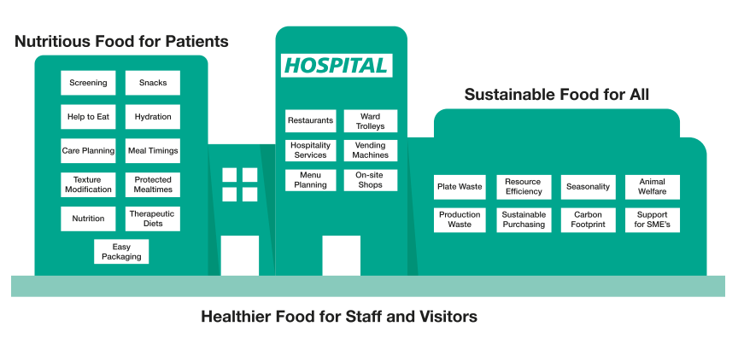
St George’s Hospital Patient & Retail Catering teams take pride in working proactively, through effective steering groups, in partnership with patient partners dietetics, speech and language, chaplaincy, and nursing to achieve those improvements resulting in better nutritional outcomes, financial savings, and reduced length of hospital inpatient stay.
Benefits to staff of a high-quality food and drink retail offer at reasonable prices has also been highlighted on the Tooting site in relation to increased satisfaction and improved health at work.
Leading in Service
St George’s Hospital demonstrates a proactive, service orientated and collaborative approach that values human relationships, cooperation and the overarching believe that Nutrition and hydration are part of the patient healthcare plan, as well as an integral necessity for our staff to perform at the highest level, saving lives. Representation of HCA, HEFMA and AHCP registered key personnel ensures that we are all performing at the top of our abilities.
The Picker Trust-wide staff survey conducted in 2022 highlighted areas that our teams and colleagues across the Trust felt could be more supportive of their culinary needs. A subsequent case study was produced, highlighting progress, and suggesting follow-up actions to maximise project benefits and build upon successes.
The retail offer launched in February 2023 smashed all previous records for restaurant footfall and the team are continuing to refine a cost effective and attractive selection every day of the year. Ranging from a budget £2.00 staff meal to £6.50 main meals, healthy options, revamped, extremely popular salad bar and a guaranteed Vegan option.

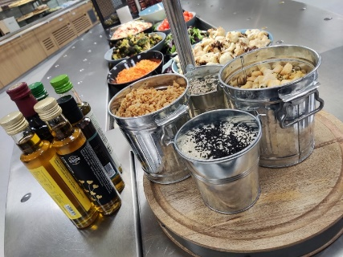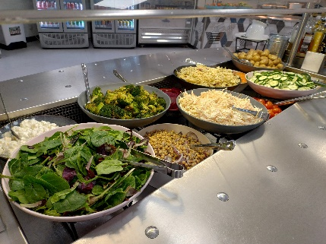
Our staff restaurant, ‘Ingredients’ has collaborated on and delivered several Trust well-being initiatives, particularly in the recent past and ongoing. We are proud to embrace Christmas, Diwali, Ramadan, Chinese New Year, Jamaican Independence Day, and many more landmark events, with our colleagues across the Trust, inclusive of retirement parties funded by the Facilities budget.
The overwhelming success of our staff retail offer presents the trust with great opportunities to enhance staff wellbeing further and this year’s staff survey may yet support that (we are awaiting results). The increase in uptake indicates that there is appetite for change and improvement beyond what has been achieved with limited resources. And all of it whilst maintaining viability.
Our biggest challenges to date are like many other Trusts and hospitality businesses throughout the UK, namely staffing and infrastructure. Our plans to address those challenges are systematically approached and are highly likely to yield the desired results in the medium to long term future.
The Trust has an abundant number of green / blue space available to the patients and staff as well as multiple parks and recreation grounds close by within the borough.

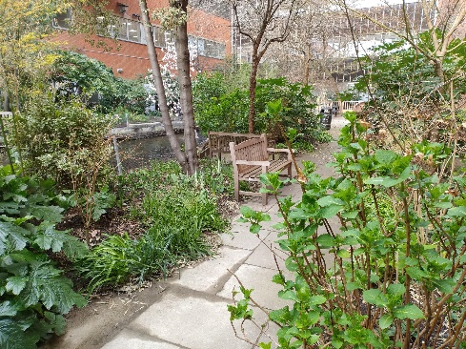
Summary
St George’s Catering Services takes pride in its proactive approach to patient and staff dining, environmental as well as financial sustainability and we tirelessly drive to deliver outstanding care, every time, savings lives.

