
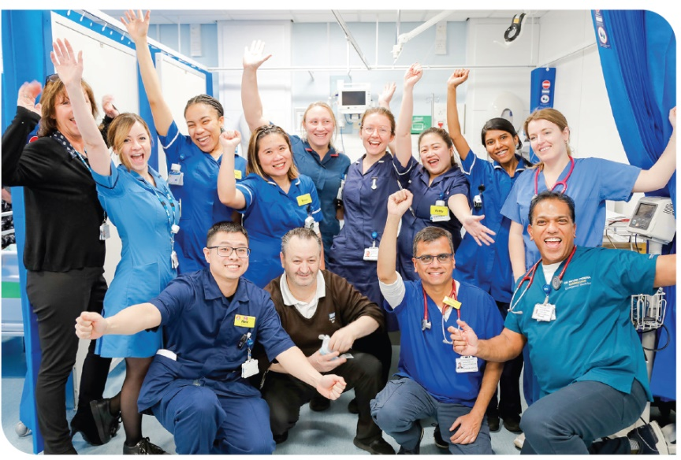
Our people

As of 31 March 2024, our workforce profile is broadly comparable to last year. Data shows by Protected Characteristics:
Staff Demographics
This section provides an overarching analysis of St George’s, Epsom and St Helier University Hospitals and Health Group (GESH). Combining data from Epsom and St ESTH and SGUH University Hospitals NHS Foundation Trust to assess workforce trends across key protected characteristics (PC. By examining, starters and leavers within GESH as a unified organisation, this analysis identifies overarching patterns and highlights areas of alignment or divergence with the individual trusts. It offers insights into GESH's collective efforts in promoting diversity, inclusivity, and retention while addressing workforce dynamics across ethnicity, disability, gender, sexual orientation, and age.
Pay Band by Protected Characteristics (PC)
This section examines workforce representation trends across pay bands, focusing on ethnicity disability and gender:

Starter and leavers
This section covers the analysis of ethnicity and disability, gender, age sexual orientation, religion and belief, marital status representation within ESTH, SGUH and GESH combined, focusing on the diversity of starters and leavers across these categories.

Recruitment
This section analyses the demographics of staff candidates throughout the recruitment process, focusing on the progression from application to shortlisting and final appointment. The aim is to identify patterns and trends in recruitment practices, providing insights into diversity and inclusivity at each stage. Please note, the complete SGUH data is currently unavailable at this stage therefore the analysis will focus on ethnicity and disability.

Disciplinary and Grievance
This section examines the demographics of staff members entering the formal disciplinary and grievance process, categorised by protected characteristics. The data offers insights into age, ethnicity, sexual orientation, marital status, disability, gender, and religion/belief. Understanding these patterns can help assess whether any specific groups may be disproportionately represented and identify areas for improved equity and support within ESTH policies. Please note , SGUH only collate on two of the PCs due to their current systems. 2025 will see SGUH move to Celenity which will look to capture all the PCs for the next reporting period for the 2026 PSED .
Promotions
This section examines GESH combined workforce promotions and representation trends across pay bands, focusing on ethnicity disability and gender.

Non-Mandatory Training
This section examines the access to non-mandatory training by protected characteristics within GESH Combined.



Workforce Staff Demographics
ESTH, SGUH and GESH Combined

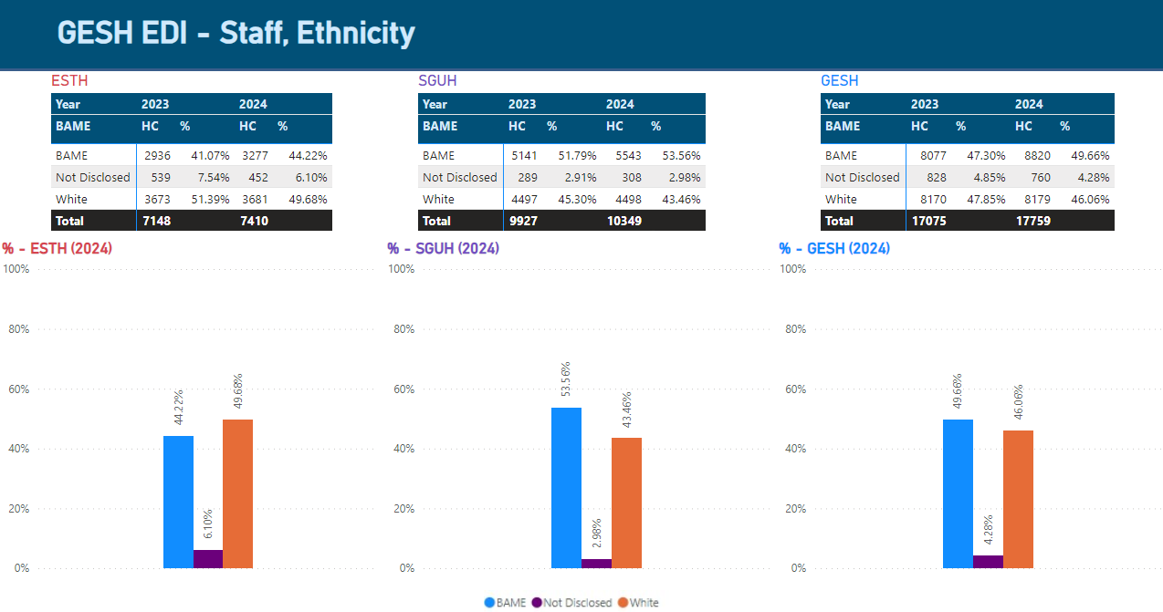

Staff Ethnicity Breakdown - ESTH, SGUH, and GESH Combined (2024):

This section presents the ethnicity data for ESTH, SGUH, and the merged entity, GESH (comprising both ESTH and SGUH). The analysis covers the ethnic composition of the workforce in 2024, highlighting trends in BAME (Black, Asian, and Minority Ethnic) representation, White representation, and the Not Disclosed category.

Some specific points on language
Please note the use of the term "BAME." For further details, refer to Section 1 of the methodology in the report.

The data reflects the diversity efforts across the two organisations, particularly with GESH, where the combined workforce's ethnic profile is analysed post-merger. Key insights from this analysis show steady growth in BAME representation, improved data transparency, and a notable shift in the workforce's ethnic composition. The report provides valuable insights into how the organisation is evolving in terms of diversity and inclusion.

That said, it is important to closely monitor demographic imbalances in the workforce and carefully track any shift that may result in the disproportionate impact on the ethnic group we are aiming to support. While promoting diversity and inclusion is essential, we must ensure that efforts to address one imbalance do not unintentionally create new disparities. By continuously monitoring the impact of these efforts, we can ensure that progress is made in a balanced and fair way, benefiting all groups without favouring one over another.
To address the shortage of representation in senior management roles, it’s essential to use data, employee survey insights, and staff experience to ensure equity, offering equal opportunities for all employees, regardless of race, ethnicity, or gender. For example, board and senior management demographics often show lower BAME representation compared to the lower bands, indicating barriers to progression. A workforce should reflect the diversity of its staff and the community it serves.
While a fair and equitable approach is important, sometimes a ‘positive action approach’ is needed, especially when traditional methods have not led to sufficient change. A more deep-seated approach may be necessary to ensure that underrepresented groups have equal opportunities to advance to senior roles. This approach helps address systemic imbalances while maintaining a commitment to fairness and inclusion for all groups. This area need close monitoring for equity of imbalance.
What is the data telling us?

ESTH: employs 7,410 staff, broken down as 3,277 BAME (44.22%), 3,681 White (49.68%) and 452 not disclosed (6.1%).

SGUH: employs 10,349 staff, broken down as 5,543 BAME (53.56%), 4,498 White (43.46%) and 308 not disclosed (2.98%).

GESH combined: employs 17,759 staff, broken down as 8,820 BAME (49.66%), 8,179 White (46.06%) and 760 not disclosed (4.28%).

The data highlights the growing diversity across the organisations, driven by increasing BAME representation and a reduction in the "Not Disclosed" category. The GESH report, representing the combined entities of SGUH and ESTH, reflects these shifts and provides an insightful overview of workforce diversity for 2024. Whilst ESTH employs 5.46% more white staff than BAME, SGUH employs 10.1% more BAME staff than White. Combined GESH, the split between the two is closer at 3.6% more BAME staff.

Clinical staff at GESH are more notably BAME (53.26%) compared to White (43.53%). In comparison, non-Clinical Staff is broken down as BAME (38.58%) and White (53.85%).

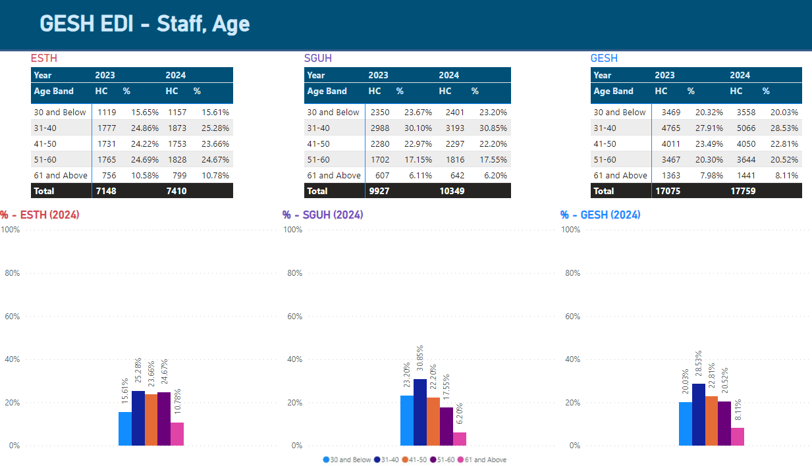

Staff Age Breakdown - ESTH, SGUH, and GESH Combined (2024):
This section examines the age distribution across ESTH, SGUH, and the combined GESH workforce, highlighting trends and shifts in demographic composition.
What is the data telling us?
The analysis reveals key insights into the dominance of the 31-40 age groups as the largest segment, a decline in the 41-50 group suggesting a potential transition phase, and gradual growth in the 61+ category, reflecting an aging workforce. These trends provide valuable context for workforce planning, helping to ensure that organisational strategies align with evolving age demographics.
ESTH: Proportions are well-distributed, with the 31-40 and 51-60 groups being the largest segments (25% each)
SGUH: Younger age groups dominate, particularly 31-40 (31%) and 30 and below (23.2%).
GESH combined: A balanced distribution, with 31-40 showing the highest percentage (28.53%).

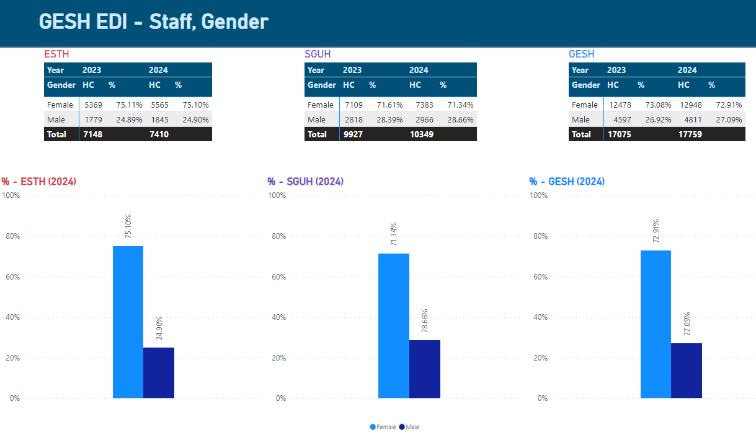
Staff Gender Breakdown - ESTH, SGUH, and GESH Combined (2024):
Gender diversity is an essential factor in creating an inclusive and equitable workforce. This section delves into the gender distribution within GESH, the merged organisation built upon the trusts foundations of ESTH and SGUH.
It shows how gender diversity is represented in each of the two respective organisations and how they come together in GESH for 2024. Understanding this helps highlight the importance of gender balance in building a strong and inclusive workforce.
What is the data telling us?

Total Staff Numbers (2024):
- ESTH: 7,410 total staff.
- SGUH: 10,349 total staff.
- GESH: 17,759 total staff.
The total headcount for GESH (17,759) matches the sum of ESTH (7,410) and STGUH (10,349), confirming that the GESH report is a consolidated view of the two organisations.

ESTH: employs 7,140 staff, broken down as 5,565 Female (75.1%) and 1,845 Male (24.90%).

SGUH: employs 10,349 staff, broken down as 7,383 Female (71.34%) and 2,966 Male (28.66%).

GESH Combined employs 17,759 staff, broken down as 12,948 Female (72.91%) and 4,811 Male (27.09%).

The overall gender distribution of GESH reflects a female-dominated workforce, aligning closely with the proportions seen in both ESTH and SGUH.

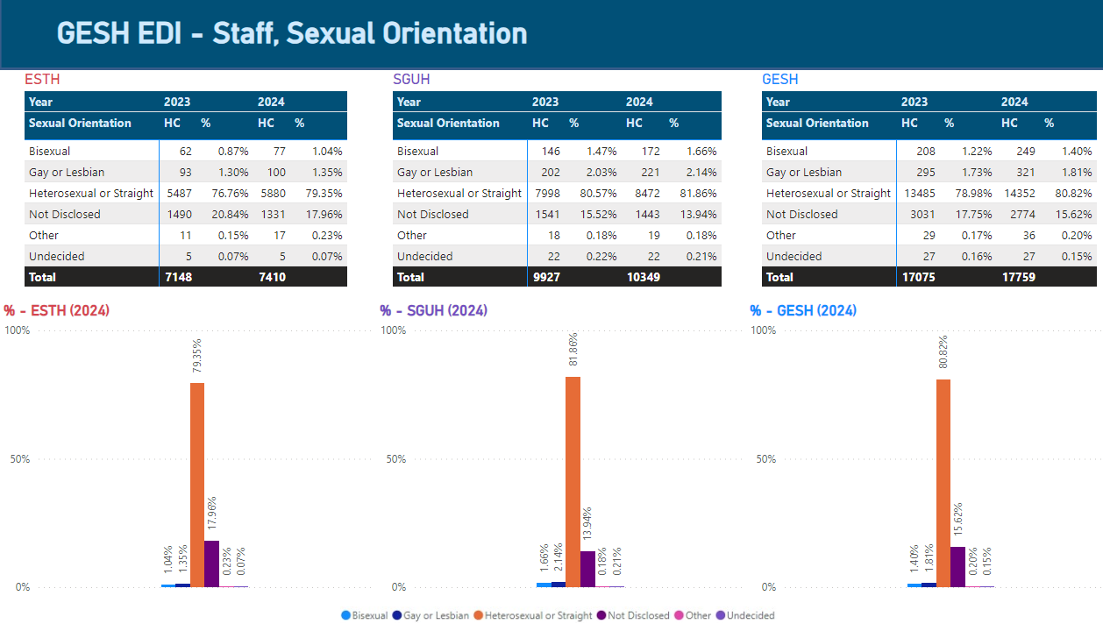
Staff Sexual Orientation Breakdown - ESTH, SGUH, and GESH Combined (2024):
This section explores the sexual orientation profile of the workforce across ESTH, SGUH, and the combined GESH organisation, offering insights into diversity and disclosure trends. The analysis highlights Heterosexual or Straight employees as the majority across all entities, with SGUH reporting the highest proportion.
Some specific points on language

Please note the use of the term "Sexual orientation." For further details, refer to Section 1 of the methodology in the report.

What is the data telling us?
It also underscores higher non-disclosure rates at ESTH, pointing to opportunities for improved transparency.
Representation of Gay, Lesbian, and Bisexual employees shows growth, particularly at SGUH, reflecting progress in fostering diversity and inclusion within the workforce. These findings provide valuable context for understanding how sexual orientation diversity evolves across the organisation.

ESTH:
Heterosexual or Straight: Reports (79.35 %,) the lowest among the entities, suggesting slightly more diversity or undisclosed responses.
Not Disclosed: Reports the highest non-disclosure rate at (17.96%), indicating potential gaps in data transparency.
Gay or Lesbian and Bisexual: Represents the lowest percentages in these categories.

SGUH:
Heterosexual or Straight: Leads with (81.86%), the highest proportion among the entities.
Not Disclosed: Reports a (13.94%) non-disclosure rate, lower than both ESTH and overall GESH.
Gay or Lesbian and Bisexual: Shows the highest representation for Gay or Lesbian (2.14%) and Bisexual (1.66%).

Overall GESH
Heterosexual or Straight: Sits between SGUH and ESTH at (80.82%), reflecting a balanced profile.
Not Disclosed: Averages at (15.62%), influenced by the higher non-disclosure rates at ESTH.
Gay or Lesbian and Bisexual: Shows slightly increased representation for diverse sexual orientations, consistent with proportional trends observed at SGUH and ESTH.
Both SGUH and ESTH saw headcount increases from 2023 to 2024.

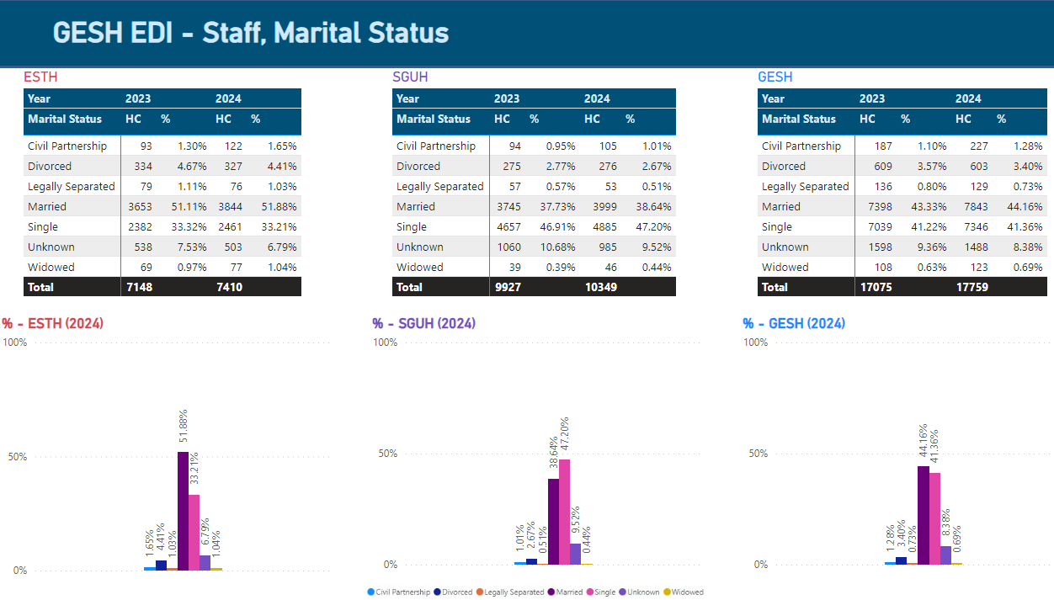
Staff Marital Status Breakdown - ESTH, SGUH, and GESH Combined (2024):
This section provides an overview of the workforce's marital status distribution across ESTH, SGUH, and the combined GESH for the year 2024.
By examining the marital status data, we can gain insights into the workforce demographic structure, highlighting the differences in marital status across the organisations. Key trends include variations in the proportions of married and single employees, the prevalence of divorced individuals, and the impact of unknown responses.
This analysis helps in understanding the social composition of the workforce and can inform strategies for further promoting diversity and inclusivity within the workforce.
What is the data telling us?

Married Employees:
ESTH has the largest proportion of married employees (51.88%).
SGUH: has the smallest proportion of married employees (38.64%).
GESH Combined: reflects (44.16%).

Single Employees:
SGUH: has the highest percentage of single employees (47.20%).
ESTH: has a small number of single employees (33.21%)
GESH combined: reflects (41.36%).
Divorced Employees:
The proportions are consistent across both trusts, with a GESH combined (3.40%) showing a slightly lower rate in comparison.

Unknown Marital Status:
SGUH reports the highest percentage of unknown marital statuses (9.52%), with ESTH having the lowest at (6.79 %.)

The combined GESH data balances these trends, offering insights into the overall workforce composition.

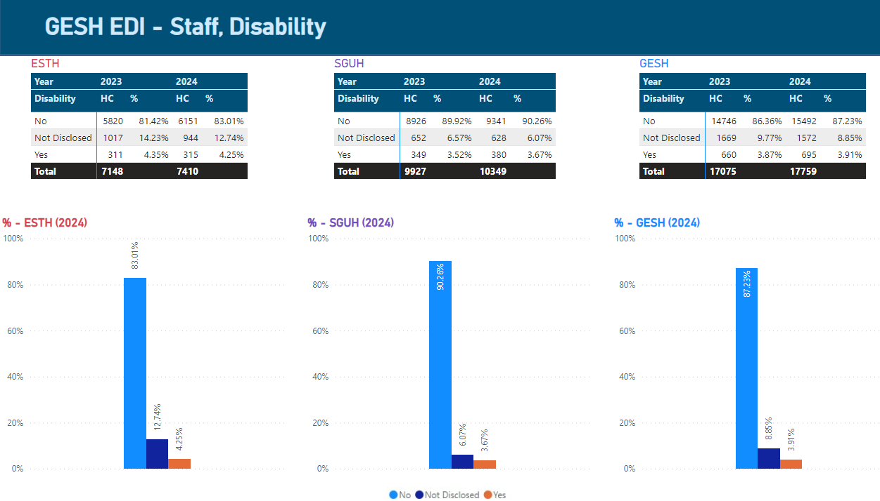
Staff Disability Status Breakdown - ESTH, SGUH, and GESH Combined (2024):
This section examines disability disclosure rates and representation among staff at ESTH, SGUH, and the combined GESH workforce for 2024. The data sheds light on the progress being made in fostering inclusivity and transparency around disability within the workforce.
Addressing disability representation is a key priority for the NHS, aligning with its broader equity, diversity, and inclusion (EDI) goals.
Encouraging openness and ensuring that staff feel supported in disclosing disabilities is essential to creating an inclusive environment where all employees can thrive.
Specific Points on Language:
Please note the use of the term "Disability" For further details, refer to Section 1 of the methodology in the report.
What is the data telling us?

ESTH:
No Disability: (83.01%) of staff, up from (81.36%) in 2023.
Yes: Slightly decreased to (4.25% from (4.35 %.)
Not Disclosed: (12.74%), a minor decrease from (14.23%).

SGUH:
No Disability: (90.26%) of staff, up from (89.92%) in 2023.
Yes: Slight increase to (3.67% from 3.52%).
Not Disclosed: Reduced to (6.07% from 6.57%).

GESH Combined:
There is a consistent trend of improvement in disclosure rates and slight increases in the number of staff declaring disabilities.

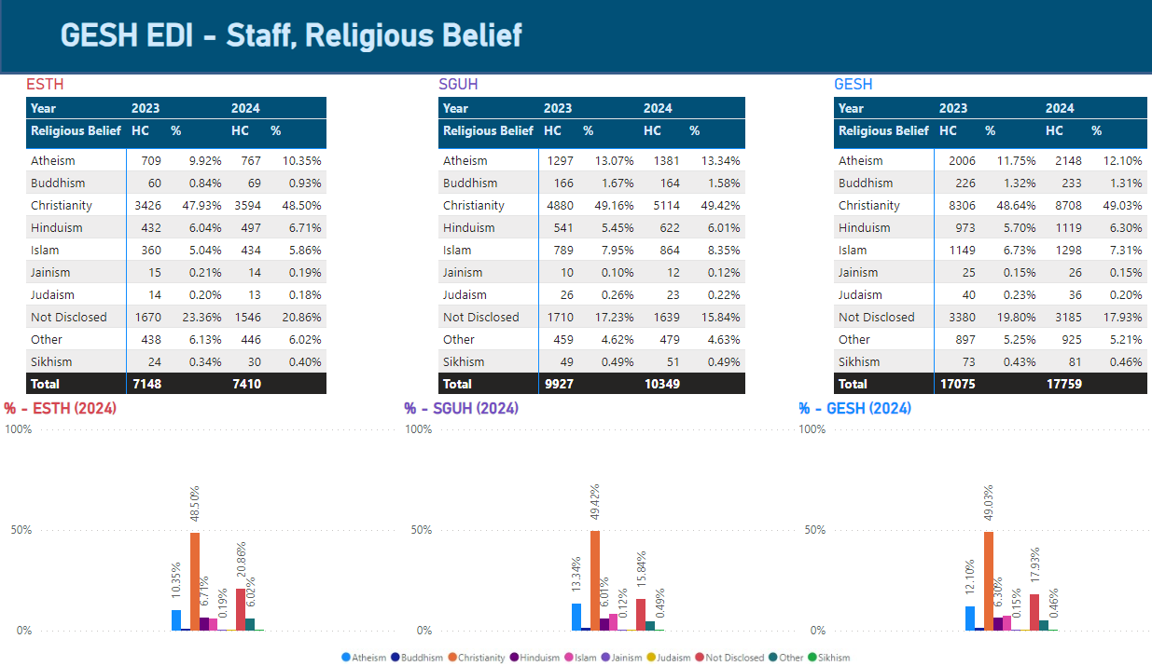
Staff Religion Belief Status Breakdown - ESTH, SGUH, and GESH Combined (2024):
Understanding the religious beliefs of staff is vital to fostering an inclusive workplace that respects and accommodates diversity. This section provides an analysis of the distribution of religious beliefs across ESTH, SGUH, and the combined GESH workforce for 2024. By examining this data, organisations can identify patterns, address potential gaps, and ensure that their practices and policies reflect and support the diverse faith backgrounds of their workforce.
What is the data telling us?
ESTH:
Christianity remains the most prevalent religion, comprising (48.50%) of staff (3,594 staff members), with a slight increase from 2023.

Atheism: accounts for (10.35%) of the workforce, showing a marginal rise from the previous year.

Islam (5.86%) and Hinduism (6.71%) are also represented, reflecting the diverse beliefs within the staff.

The Not Disclosed: category accounts for (20.86%) of staff highlighting potential gaps in transparency or comfort with sharing such information.

SGUH:
Similar to ESTH, Christianity is the dominant religion, representing (49.42%) of staff (5,114 staff members).

Atheism has a significant presence at (13.34%), showing higher representation than in ESTH.

Islam (8.35%) and Hinduism (6.01%) are also notable groups, reflecting the diversity of the SGUH workforce.

The Not Disclosed category accounts for (15.84%), showing a slight improvement in transparency compared to the prior year.

GESH Combined:
Across GESH, Christianity comprises the largest proportion of staff at (49.03 %.)

Staff Demographics – Detail Analysis by Grade

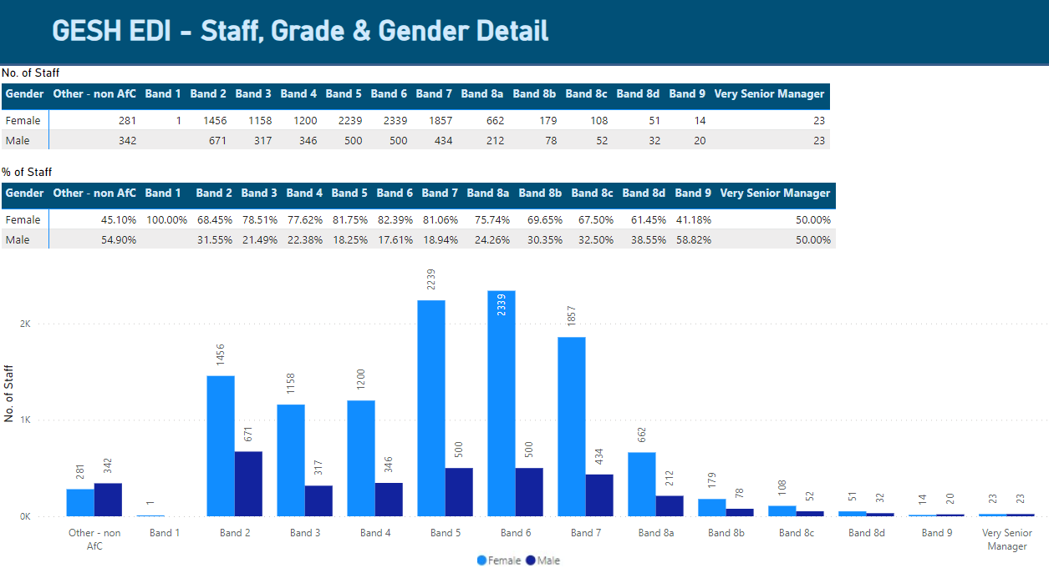
Staff, Grade & Gender Detail - ESTH, SGUH, and GESH Combined (2024):
This section provides a breakdown of the staff across GESH by pay grade and gender. The analysis highlights gender distribution across the NHS Agenda for Change (AfC) bands, from Band 1 to Very Senior Manager roles, showcasing trends in representation and opportunities for diversity at various levels. This also includes staff Facilities workforce on local contracts at ESTH, categorised as Other – Non AfC. Understanding this distribution is important for evaluating equity in career progression, pay, and leadership opportunities

What is the data telling us?
Female Representation:
Women represent the majority in all AfC bands up to Band 8a, ranging from 68.45% in Band 2 to (82.39%) in Band 6.

Female representation begins to decline at higher grades, particularly in Band 9 (41.18%) and Band 8d (61.45%).

At the Very Senior Manager level, women constitute (50.00%), indicating parity in leadership roles at the highest level.

Male Representation:
Male representation is comparatively higher in senior positions, particularly in Band 9 (58.82%) and Very Senior Manager level (50%).

At lower and mid-level AfC bands (Bands 2 to 8a), male staff representation remains below (31.55 %.)

Specific to ESTH, Estates and Facilities workforce categorised under Other – Non AfC, male staff representation is high at (54.9%)

Grade Distribution Overview:
Band 5 (2,739 staff) and Band 6 (2,839 staff) have the highest proportion of staff, with 2,239 female and 500 male staff in Band 5, and 2,339 female and 500 in Band 6.

The number of staff decreases significantly at senior levels, with 23 staff each in the Very Senior Manager category, equally distributed between men and women.

Insights and Opportunities:
Strong female presence at entry- to mid-level bands reflects equitable hiring practices at these grades.

Declining female representation in senior grades highlights a potential area for improvement in progression opportunities for women.
The parity at the Very Senior Manager level is a positive indication of gender balance at the highest level, though efforts should be made to ensure similar balance across all senior grades.
This analysis highlights the importance of maintaining equity in career development opportunities while ensuring diverse representation at all levels.

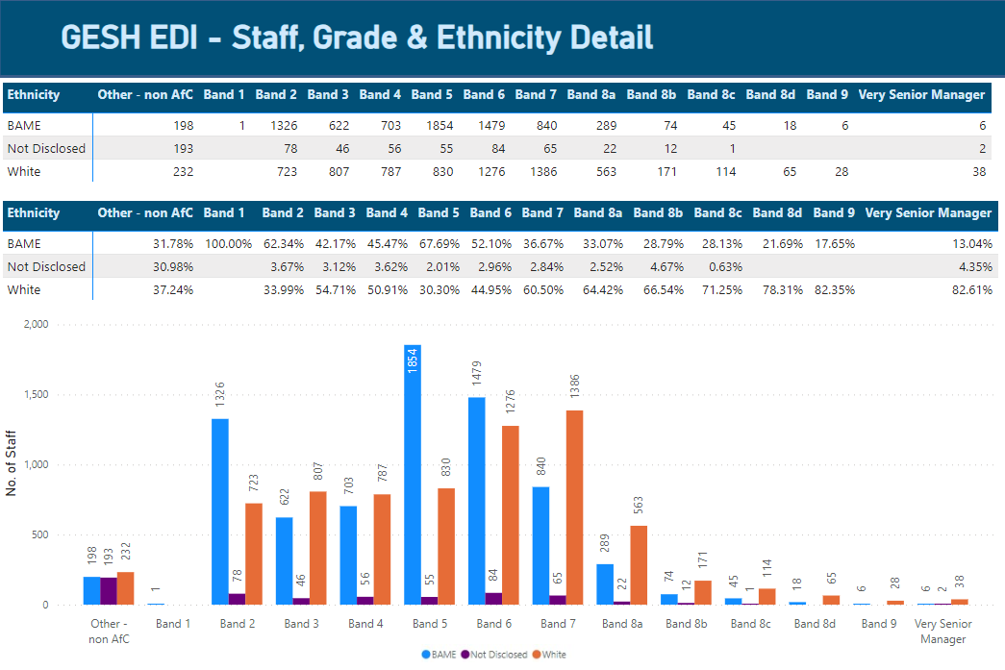
Staff, Grade & Ethnicity Detail - ESTH, SGUH, and GESH Combined (2024):
This section highlights the distribution of staff by ethnicity across different pay bands within GESH. It focuses on representation trends for BAME (Black, Asian, and Minority Ethnic) staff, White staff, and those who chose not to disclose their ethnicity. Key patterns are evident, including the concentration of BAME staff in lower to mid-level bands and their reduced presence in senior roles, contrasted with the predominance of White staff in higher pay bands. These insights emphasise the need for targeted strategies to address disparities and promote equity across all levels of the workforce.
What is the data telling us?
BAME Representation:
BAME Staff are most highly concentrated in Bands 2, 5, and 6, peaking at 1,854 staff in Band 5 (67.69% of Band 5 workforce). BAME representation decreases significantly at senior levels, with13.04% in Very Senior Manager (VSM) roles and (17.65%) at band 9.

White Representation:
White staff dominate higher pay bands, especially in Bands 8c (71.25%), Band 9 (82.35%), and VSM roles (82.61%).

In lower pay bands, such as Band 2, representation is (33.99%), growing significantly at band 8a (64.42%).

Specific to ESTH, Estates and Facilities workforce categorised under Other – Non AfC, White staff representation is high at (37.24%).

Not Disclosed:
A consistent minority across all bands, ranging from (0.63%) at Band 8c to (4.67%) at Band 8b.

Specific to ESTH, Estates and Facilities workforce categorised under Other – Non AfC have a non-disclosure of (30.98%.)

Key Takeaways: Entry-Level Diversity: Strong BAME representation in lower pay bands demonstrates robust diversity in entry-level positions.
Leadership Gap: A stark underrepresentation of BAME staff in senior roles highlights the need for initiatives to support equitable career progression.
Transparency: Efforts are needed to reduce "Not Disclosed" rates, particularly in non-AfC roles.

The data reveals a clear need for equitable progression opportunities and development for BAME staff to achieve diversity at higher grades. While junior bands reflect greater ethnic diversity, strategic interventions are essential to extend this representation to senior leadership.

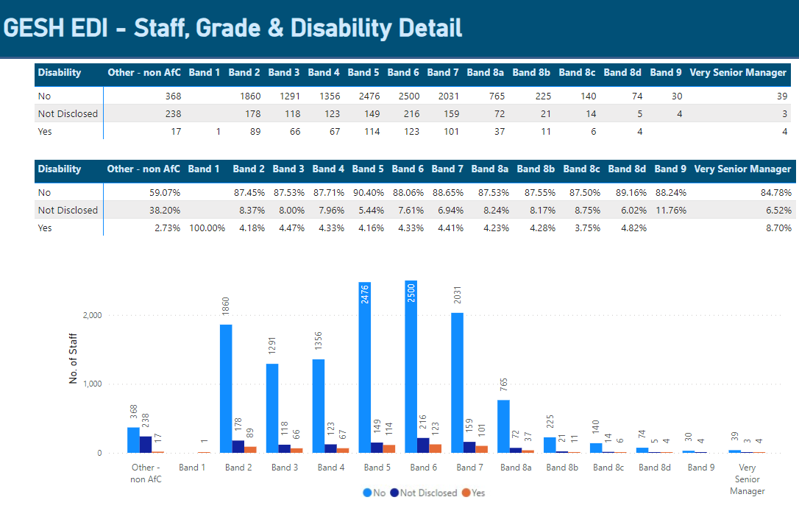
Staff, Grade & Disability Detail - ESTH, SGUH, and GESH Combined (2024):
This section provides an analysis of disability representation across various pay bands in GESH. The data illustrates the number and percentage of staff that identify as having a disability, those who do not, and those who have not disclosed their disability status. The findings highlight the following trends:
What is the data telling us?
No Disability: The majority of staff across all pay bands identify as having no disability, with representation ranging from (84.78%) in Very Senior Manager (VSM) roles to over ( 90%) in Bands 5.
Disability Declared: Staff with declared disabilities represents a small minority in each band; peaking at (4.82%) in Band 8d. VSM roles also see a slightly higher percentage (8.70%), indicating some progress in inclusivity at the highest levels.
Not Disclosed: The proportion of staff not disclosing their disability status varies across bands, with higher non-disclosure rates observed in band 9 (11.76%) and lower rates at band 5 (5.44%).
Specific to ESTH, Estates and Facilities workforce categorised under Other – Non AfC have a non-disclosure of (38.2%.)

These insights underline the need to continue fostering transparency and inclusivity for staff with disabilities, particularly in middle and senior-level roles.

Starters & Leavers by PC

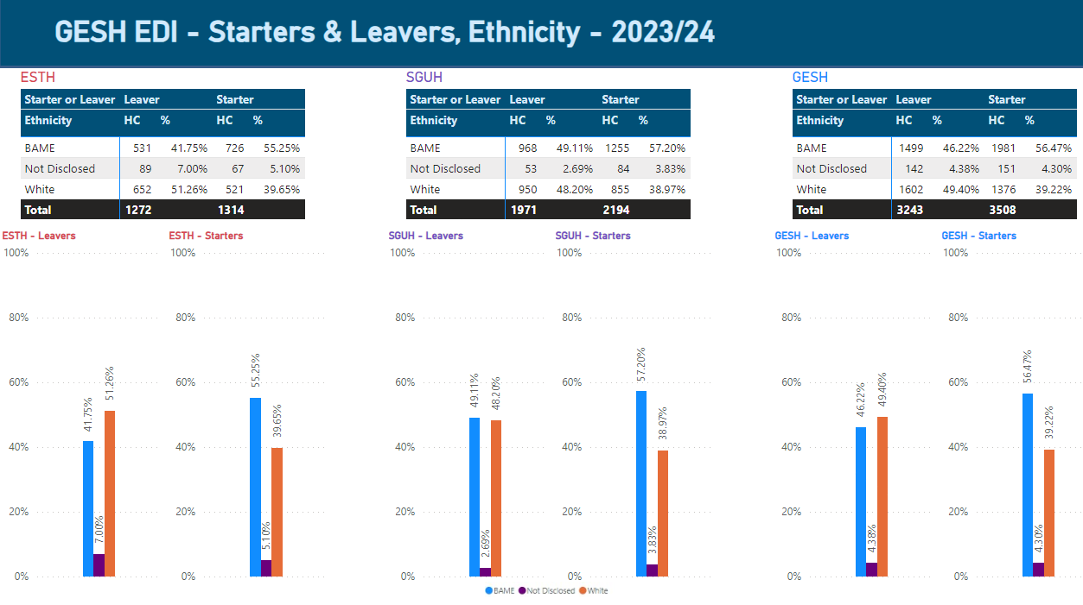
Starters and Leavers, Ethnicity Detail - ESTH, SGUH, and GESH Combined (2024):

This section covers the analysis of Ethnicity representation within ESTH, SGUH and GESH combined, focusing on the diversity of starters and leavers across these categories.

The analysis highlights the trends in workforce diversity, specifically the representation of BAME (Black, Asian, and Minority Ethnic) individuals. It explores the differences in representation between starters and leavers and provides insights into the inclusivity efforts across the trusts, as well as any disparities that may exist.

What is the data telling us?

GESH combined demonstrates a strong representation of BAME starters (56.47%), aligning closely with SGUH (57.2%) and slightly higher than ESTH (55.25%).

Similar to ESTH and SGUH, GESH shows a positive trend where BAME individuals are more represented in starters than leavers, indicating on-going efforts to enhance workforce diversity.

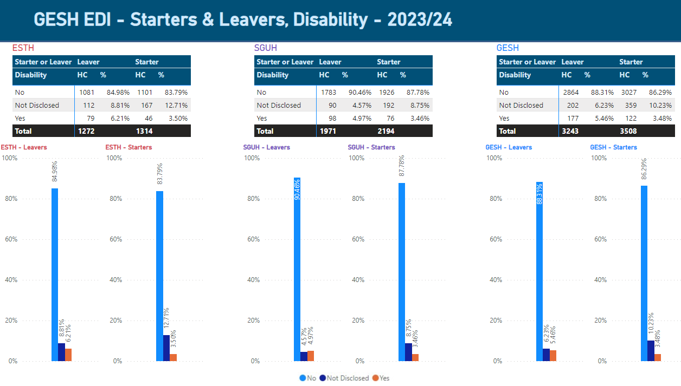
Starters and Leavers, Disability Detail - ESTH, SGUH, and GESH Combined (2024):
This section covers the analysis of Disability representation within ESTH, SGUH and GESH combined, focusing on the diversity of starters and leavers across these categories.
The analysis highlights the trends in workforce diversity, specifically the representation of employees with disabilities. It explores the differences in representation between starters and leavers and provides insights into the inclusivity efforts across the trusts, as well as any disparities that may exist.
What is the data telling us?
The table and graphs present the distribution of disability status among starters and leavers across ESTH, SGUH, and the combined GESH data.
The analysis focuses on three categories: individuals who disclosed having a disability ("Yes"), those who reported no disability ("No"), and those who chose not to disclose their disability status ("Not Disclosed").
Disability:
Across all organisations, the percentage of employees who disclosed a disability is higher among leavers compared to starters.
ESTH reports the lowest percentage of starters with disabilities (3.50%), while SGUH and GESH combined are slightly higher, with (3.46% and 3.48 %,) respectively.
Not Disclosed:
GESH combined shows a higher rate of not disclosed statuses compared to individual trusts, particularly among starters (10.23 %,) reflecting a trend toward increased privacy in reporting.

SGUH has the highest percentage of individuals without disabilities across both leavers and starters.
ESTH reports the largest proportion of non-disclosure among starters,
Across GESH combined, while the overall proportions align closely with the individual trusts, the percentage of non-disclosure among starters reflects an on-going shift in disclosure patterns for new hires
- The higher proportion of leavers disclosing disabilities compared to starters suggests that retention of employees with disabilities could be a focus area for improvement across all organisations.
- The increasing trend in non-disclosure among starters highlights the importance of fostering a workplace culture where employees feel comfortable sharing this information, should they wish to do so.

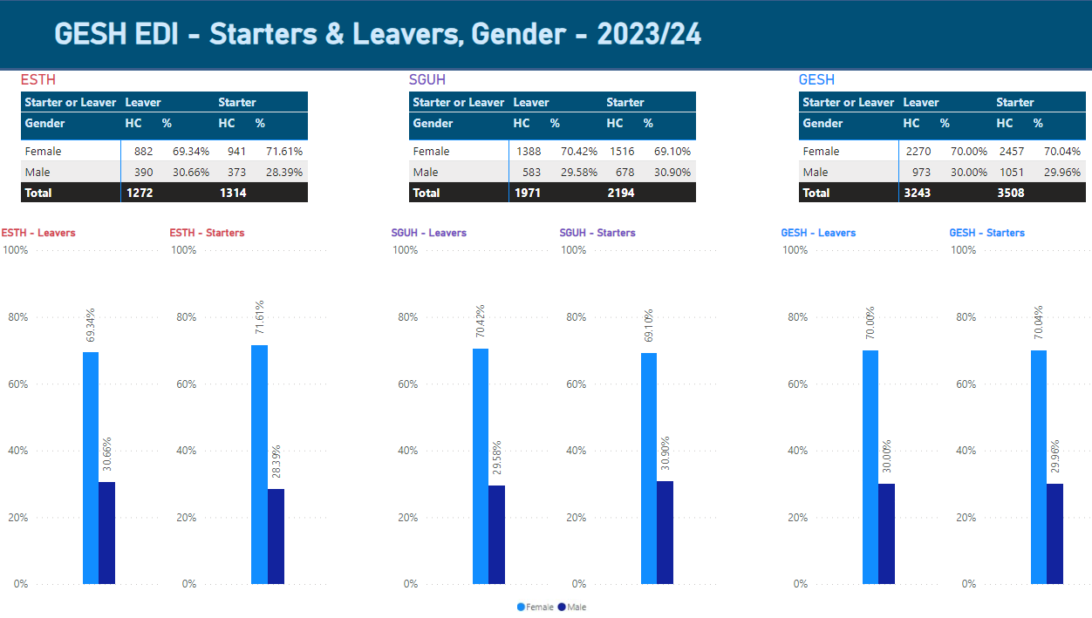
Starters and Leavers, Gender Detail - ESTH, SGUH, and GESH Combined (2024):
This section provides an overview of the gender distribution among starters and leavers across ESTH, SGUH, and the combined GESH data. It identifies key trends and patterns in workforce representation, with a particular focus on gender balance. The analysis aims to highlight areas where progress can be made to improve equity, diversity, and inclusivity within the workforce.

What is the data telling us?

ESTH:
Leavers: (69.34%) are female, and (30.66%) are male.
Starters: 71.61% are female, and 28.39% are male.

SGUH:
Leavers: (70.42%) are female, and (29.58%) are male.
Starters: 69.10% are female, and 30.90% are male.

GESH (Combined Trusts):
GESH shows similar trends, with (70%) of leavers and (70.04%) of starters being female. This gender consistency suggests shared workforce dynamics across the trusts.

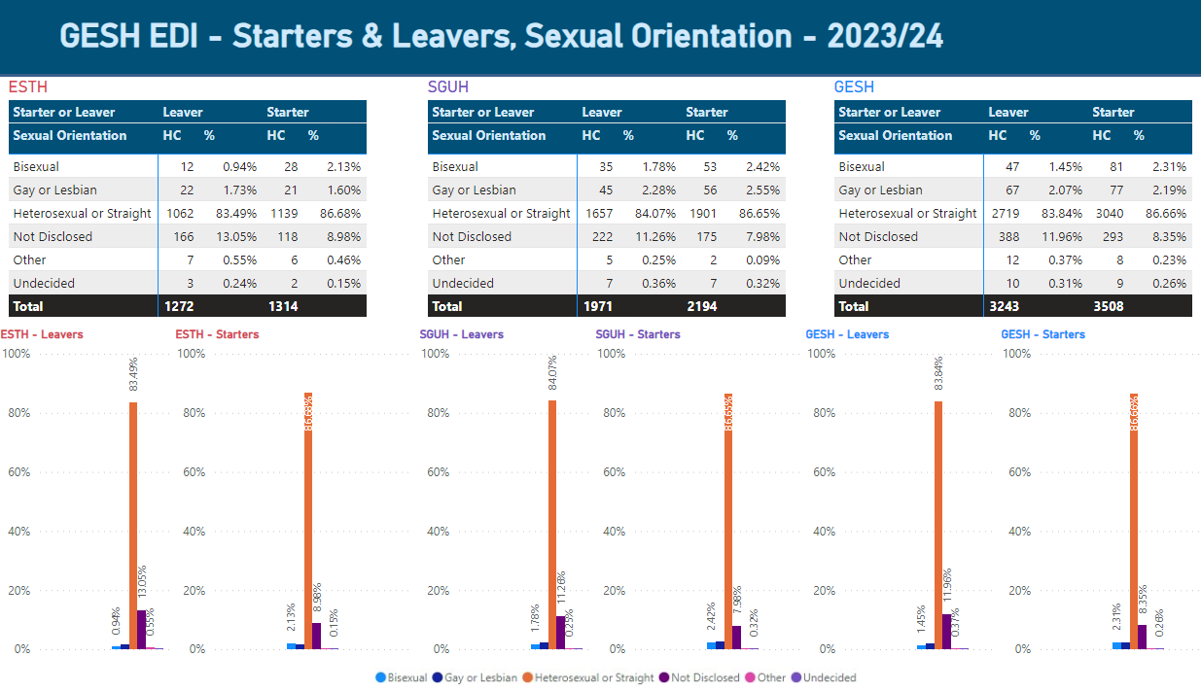
Starters and Leavers, Sexual Orientation Detail - ESTH, SGUH, and GESH Combined (2024):
This section provides an overview of the sexual orientation distribution among starters and leavers across ESTH, SGUH, and the combined GESH data. It identifies key trends and patterns in workforce representation, with a particular focus on inclusivity related to sexual orientation. The analysis aims to highlight areas where progress can be made to improve equity, diversity, and inclusivity within the workforce.

What is the data telling us?

ESTH:
Heterosexual staff forms the majority, with (86.68%) of starters identifying as heterosexual, while bisexual and gay or lesbian staff remain underrepresented at (2.13% and 1.60%), respectively.

Non-disclosure among leavers is relatively high at (13.05%), suggesting the need for improved inclusivity and trust-building.

SGUH:
Heterosexual individuals make up (86.65%) of starters, with bisexual and gay or lesbian staff comprising (2.42%) and (2.55%), respectively. Non-disclosure rates among leavers are (11.26%), highlighting similar trends to ESTH.

GESH (Combined Trusts):
Across GESH, heterosexual staff account for (86.66%) of starters, with bisexual and gay or lesbian staff at (2.31% and 2.19%), respectively. Non-disclosure among leavers stands at (11.96%), consistent with the individual trust trends, reinforcing the importance of inclusivity initiatives across the organisation.

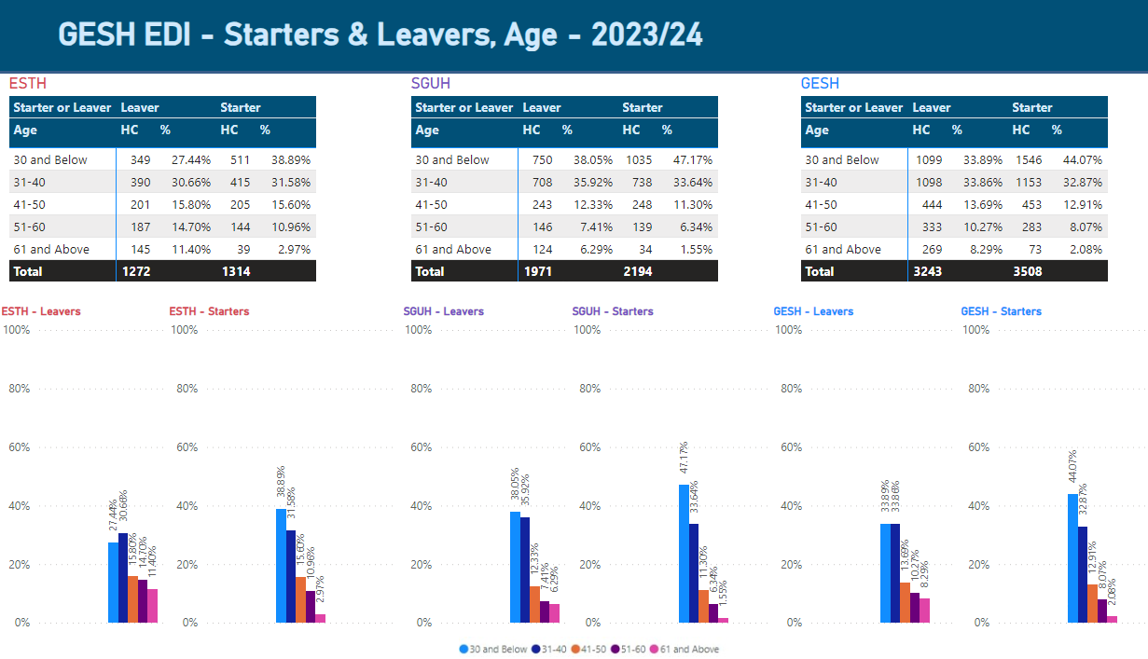
Starters and Leavers, Age Detail - ESTH, SGUH, and GESH Combined (2024):
This section provides an overview of age distribution among starters and leavers across ESTH, SGUH, and the combined GESH data. It highlights key trends and patterns in workforce representation, focusing on age balance and inclusivity. The analysis aims to identify areas for improvement in promoting equity, diversity, and inclusion within the workforce.

What is the data telling us?

Starters:
Across the three trusts, the 30 and below age group consistently dominates among starters, indicating a strong emphasis on recruiting younger talent:

ESTH: (38.98%) of starters fall into this category
SGUH: 47.17% of starters are aged 30 and Below
GESH (combined): (44.07%) of starters belong to this group

The 31-40 age groups is the second most prominent among starters:

ESTH: (31.58%) of starters fall into this category.
SGUH: (33.64%) of starters are aged 30 and below.
GESH (combined): (32.87%) of starters belong to this group.

Leavers:
For leavers, the data reflects a higher proportion of older individuals exiting the workforce, particularly in the 51-60 and 61+ age groups:

ESTH: (14.70%) of leavers are aged 51-60. (11.4%) are aged 61+.
SGUH: (7.41%) are aged 51-60. (6.29%) are aged 61+.
GESH (combined): (10.27%) are aged 51-60. (8.29%) are aged 61+
Younger Talent Recruitment:
The 30 and below age group dominates recruitment efforts across all three trusts, showing consistency in prioritising younger talent. A higher proportion of older leavers in the 51-60 and 61+ age groups at GESH compared to ESTH suggest that workforce aging may be a more pronounced challenge for GESH as a whole.

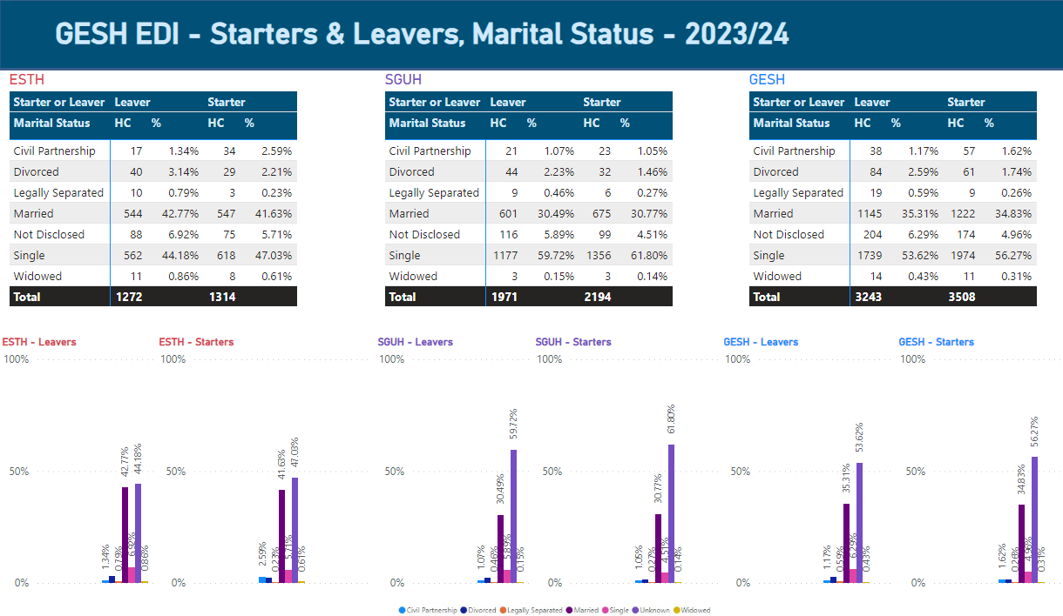
Starters and Leavers, Marital Status Detail - ESTH, SGUH, and GESH Combined (2024):
This section provides an overview of marital status among starters and leavers across ESTH, SGUH, and the combined GESH data. It highlights key trends and patterns in workforce representation, focusing on marital status, and inclusivity. The analysis aims to identify areas for improvement in promoting equity, diversity, and inclusion within the workforce.

What is the data telling us?

Married individuals consistently form the second-largest group:
Starters:
ESTH records (41.63 %,) SGUH (30.77%), and GESH combined (34.83%).
Leavers:
ESTH has (42.77 %,) SGUH (30.49%), and GESH combined (35.31 %.)
Marital statuses such as civil partnerships, legal separation, and widowed are less commonly reported across all organisations. However, GESH combined shows a higher proportion of employees with undisclosed marital statuses (6.29% leavers, 4.96% starters).

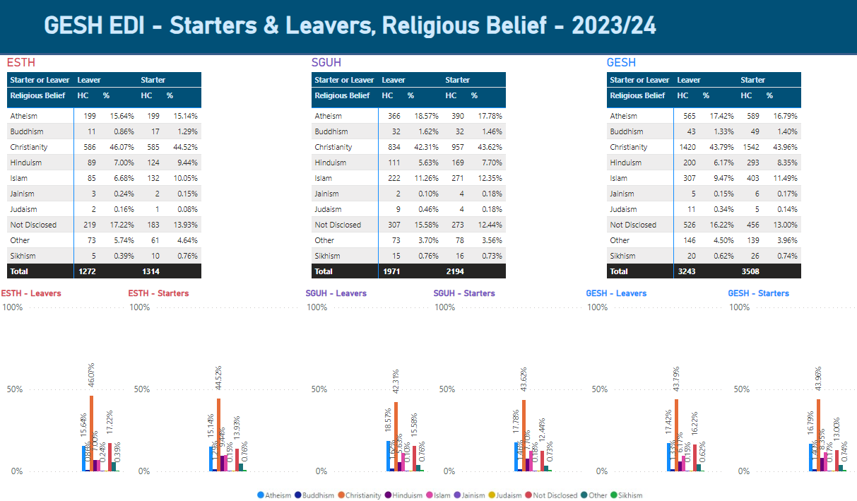
Starters and Leavers, Religious Belief Detail - ESTH, SGUH, and GESH Combined (2024):

This section provides an overview of religious beliefs among starters and leavers across ESTH, SGUH, and the combined GESH data. It highlights key trends and patterns in workforce representation, focusing on religious beliefs, and inclusivity. The analysis aims to identify areas for improvement in promoting equity, diversity, and inclusion within the workforce.

What is the data telling us?

Christianity is consistently forming the largest group:

Starters: ESTH records (44.52%), SGUH (43.62%), and GESH combined 43.96%.

Leavers: ESTH has (46.07%), SGUH (42.31%), and GESH combined (43.79 %.)

Atheism: accounts for (17.42%) of leavers and (16.79%) of starters across GESH.
Hinduism: accounts for (6.17%) of leavers and (8.35%) of starters across GESH.
Islam accounts for (9.47% of leavers and 11.49%) of starters across GESH.

GESH Recruitment 2023-2024
By
Protected Characteristics (ESTH)

Ethnicity

This chart displays recruitment data segmented by ethnicity, covering four stages: applications, shortlisting, interviews, and appointments. High-level summary:
Applications:
The Black ethnic group has the highest number of applicants (14,096), followed by Asian (13,875), White (4,922) and Other (1,459). Mixed and Not Disclosed groups have significantly fewer applicants.

Shortlisting:
White applicants are leading the shortlist stage (1,760), followed by Asian (1,730), with Black (1,262) and Other (265) lagging behind. Mixed and Not Disclosed groups have minimal representation in the shortlisting stage.
Interview Attendance:
White candidates (1,133) are leading in interviews attended, followed closely by Asian (1,077), Black (790), and Other (174). Mixed and Not Disclosed groups have much lower attendance rates.
Appointments:
The highest number of appointments are for White applicants (306), followed by Asian (198). The Black group has fewer appointments (119), and Mixed and Other groups have even fewer. Not Disclosed has very few appointments (15).

Key Insights:
White candidates are the most represented throughout the process (shortlisted onwards), followed by Asian candidates.
Black and Mixed ethnic groups see significantly lower numbers at stages except applications, especially in appointments. Not Disclosed ethnicity group has low participation across all stages. This data suggests a dominant participation from Asian and White groups, with Black and Mixed ethnic groups experiencing higher drop-offs throughout the recruitment process.
Gender
The chart shows recruitment data segmented by gender across four stages: applications, shortlisting, interviews, and appointments.
Key points:
- Female Dominance: Females lead in applications (25,745), shortlists, interviews, and appointments (543), consistently outperforming males at each stage.
- Male Representation: Male applicants are fewer (10,279), with proportionally lower numbers shortlisted, interviewed, and appointed.
- Minimal Non-disclosure: Very few (88) candidates did not disclose their gender, with negligible impact on outcomes.
- Attrition Across Stages: There’s a significant drop-off in numbers from applications to appointments for all groups.

Overall, females are highly represented and successful throughout the recruitment process.
Age

This chart shows recruitment data segmented by age group across four stages: applications, shortlisting, interviews, and appointments.
High Applicant Numbers: The 25-29 age group has the most applicants (11,075), followed by 30-34 (7,377) and 20-24 (5,372). Younger age groups (under 30) dominate the application process.
Lower Representation in Older Groups: As age increases, the number of applicants, shortlisted candidates, interviewees, and appointments decreases significantly.
Appointments: Most appointments are made for the 25-39 age groups, while older groups see very few appointments.
Key Insight:
The recruitment process is largely driven by younger candidates, with a sharp decline in representation and success rates as age increases.

Observation:
Recruitment by Disability Description:
- Applications are highest from individuals with "Learning disability/difficulty" (303), "Long-standing illness" (250), and "Other" disabilities (285).
- Appointment rates are low across all categories, with "Learning disability/difficulty" seeing the most appointments (17).
- Other disability categories, like "Sensory impairment," have minimal participation and success rates.
Recruitment by Disability:
- The majority of applicants (34,603) have no disability, followed by a smaller group with a disability (1,108).
- Appointments favour candidates without disabilities (643 out of 696 total appointments), however proportional to the number applicants, disabled staff have a slightly higher rate of being appointed.
- Candidates with disabilities see a significant drop-off at each stage, with only 39 appointed.
Recruitment by Guaranteed Interview Scheme:
- The majority of applicants (35,314) do not fall under the Guaranteed Interview Scheme.
- Only 18 appointments were made through the Guaranteed Interview Scheme, suggesting a low conversion rate.
- Excluding not stated, candidates not eligible for the scheme dominate the appointment stage (670 out of 688 appointments).

Observation:
Recruitment by Sexual Orientation:
- The majority of applicants identify as "Heterosexual or Straight" (33,823), while other categories e.g. "Gay or Lesbian" (284) and "Bisexual" (522) have much lower representation.
- Appointments mirror application trends, with (628) heterosexual candidates appointed versus 10 for "Gay or Lesbian" and (12) for "Bisexual."
Recruitment by Transgender:
- The vast majority of applicants identify as non-transgender (13 applicants), with just one transgender applicant.
- Only one person in the " Did not wish to disclosed progressed to the interview stages, and they were unsuccessful at appointment.
Recruitment by Marital Status:
- Applications are nearly evenly split between single (17,492) and married (16,682) candidates, while other categories like civil partnerships (423) and widowed (125) are far smaller.
- Appointments are highest for single (273) and married candidates (345), with minimal success for other groups.
Recruitment by Religion or Belief:
- Christianity dominates the applicant pool (20,224), followed by Hinduism (6,812) and Islam (3,965).
- Appointments are mostly among Christians (366), followed by Hindus (61) and Muslims (50). Other belief systems have much smaller appointment numbers.
Recruitment by Convictions:
- Most applicants (36,005) have indicated they have no convictions affecting recruitment, compared to (99) who declared convictions.
- Candidates without convictions dominate appointments (685), with only (4) appointments for those who declared convictions.

GESH Recruitment 2023-2024
By
Protected Characteristics (SGUH)

Awaiting WRES and WDES Recruitment data from SWL Recruitment Hub

SGUH: Recruitment 2023-2024
By
Protected Characteristics

Disciplinary and Grievance Data (ESTH)

Age  Under 31: 8.33% (3 staff)  31–40: 13.89% (5 staff)  41–50: 22.22% (8 staff)  51–60: 41.67% (15 staff)  61 and above: 13.89% (5 staff)  Key Insight: Staff aged 51–60 are the largest group undergoing disciplinary actions (41.67%), while younger staff (under 31) has the lowest representation (8.33%). This may suggest older staff face greater challenges, potentially due to tenure-related issues or differences in workplace expectations. |  |  |  |  |  |  | Age group | Number of Staff | % of Staff
 |  |  |  |  |  |  | Under 31 | 3 | 8.33%
 |  |  |  |  |  |  | 31 - 40 | 5 | 13.89%
 |  |  |  |  |  |  | 41 - 50 | 8 | 22.22%
 |  |  |  |  |  |  | 51 - 60 | 15 | 41.67%
 |  |  |  |  |  |  | 61 and above | 5 | 13.89%
 |  |  |  |  |  |  | Total | 36
Ethnicity  White: 38.89% (14 staff)  Black Asian Minority Ethnic (BAME): 36.11% (13 staff)  Not disclosed: 25.00% (9 staff)  Key Insight: There is a nearly equal representation of White (38.89%) and BAME (36.11%) staff undergoing disciplinary processes. However, (25.00%) non-disclosure limits a definitive assessment of potential disparities. |  |  |  |  |  |  | Ethnicity | Number of Staff | %
 |  |  |  |  |  |  | White | 14 | 38.89%
 |  |  |  |  |  |  | Black Asian Minority Ethnic | 13 | 36.11%
 |  |  |  |  |  |  | Not disclosed | 9 | 25.00%
 |  |  |  |  |  |  | Total | 36 | 100%
Gender  Female: 50.00% (18 staff)  Male: 50.00% (18 staff)  Key Insight: Gender representation in disciplinary processes is evenly split, reflecting no immediate imbalance in disciplinary actions by gender. |  |  |  |  |  |  | Gender | Number of Staff | %
 |  |  |  |  |  |  | Female | 18 | 50.00%
 |  |  |  |  |  |  | Male | 18 | 50.00%
 |  |  |  |  |  |  | Total | 36
Sexual Orientation  Heterosexual: 72.22% (26 staff)  Gay or Lesbian: 2.78% (1 staff)  Bisexual: 2.78% (1 staff)  Not disclosed/Other: 0%  Key Insight: The majority of staff undergoing disciplinary actions are heterosexual (72.22%), while representation of LGBTQ+ groups is minimal (5.56%). This aligns with overall workforce representation and suggests no immediate disproportionality. |  |  |  |  |  |  | Sexual Orientation | Number of Staff | %
 |  |  |  |  |  |  | Gay or Lesbian | 1 | 2.78%
 |  |  |  |  |  |  | Bi-sexual | 1 | 2.78%
 |  |  |  |  |  |  | Heterosexual | 26 | 72.22%
 |  |  |  |  |  |  | Not disclosed | 0 | 0.00%
 |  |  |  |  |  |  | Undecided | 0 | 0.00%
 |  |  |  |  |  |  | Other sexual orientation not listed | 0 | 0.00%
 |  |  |  |  |  |  | Total | 36
This section analyses the demographic breakdown of staff undergoing the disciplinary process by protected characteristics, including age, ethnicity, sexual orientation, marital status, disability, gender, and religion/belief. The goal is to identify any disparities among groups and highlight areas requiring further investigation to ensure fairness and inclusivity in disciplinary processes.
ESTH: Analysis of Staff Undergoing Disciplinary Process by Protected Characteristics

ESTH: Analysis of Staff Undergoing Disciplinary Process by Protected Characteristics

Marital Status  Married: 38.89% (14 staff)  Single: 27.78% (10 staff)  Civil Partnership: 8.33% (3 staff)  Legally Separated: 2.78% (1 staff)  Not disclosed: 22.22% (8 staff)  Key Insight: Married staff (38.89%) makes up the largest proportion, followed by single staff (27.78%). Non-disclosure rates remain high (22.22%), limiting insights into potential trends in marital status and disciplinary actions. |  |  |  |  |  |  | Marital Status | Number of Staff | %
 |  |  |  |  |  |  | Divorced | 0 | 0.00%
 |  |  |  |  |  |  | Married | 14 | 38.89%
 |  |  |  |  |  |  | Single | 10 | 27.78%
 |  |  |  |  |  |  | Civil Partnership | 3 | 8.33%
 |  |  |  |  |  |  | Widowed | 0 | 0.00%
 |  |  |  |  |  |  | Not disclosed | 8 | 22.22%
 |  |  |  |  |  |  | Legally Separated | 1 | 2.78%
 |  |  |  |  |  |  | Total | 36
Disability  Yes (Disabled): 8.33% (3 staff)  No (Not Disabled): 63.89% (23 staff)  Not disclosed: 27.78% (10 staff)  Key Insight: Only (8.33%)of staff involved in disciplinary actions disclosed having a disability. High non- disclosure rates (27.78%) may obscure potential patterns or indicate discomfort in self-identification. |  |  |  |  |  |  | Disability | Number of Staff | %
 |  |  |  |  |  |  | Yes | 3 | 8.33%
 |  |  |  |  |  |  | No | 23 | 63.89%
 |  |  |  |  |  |  | Not disclosed | 10 | 27.78%
 |  |  |  |  |  |  | Total | 36
Religion/Belief  Christianity: 55.56% (20 staff)  Atheism: 8.33% (3 staff)  Hinduism: 5.56% (2 staff)  Other: 5.56% (2 staff)  Not disclosed: 25.00% (9 staff)  Key Insight: A majority of staff undergoing disciplinary actions identify as Christian (55.56%), consistent with broader representation in the workforce. However, 25.00% non-disclosure prevents further conclusions about disproportionate impacts across beliefs. |  |  |  |  |  |  | Religion/Belief | Number of Staff | %
 |  |  |  |  |  |  | Atheism | 3 | 8.33%
 |  |  |  |  |  |  | Buddhism | 0 | 0.00%
 |  |  |  |  |  |  | Christianity | 20 | 55.56%
 |  |  |  |  |  |  | Hinduism | 2 | 5.56%
 |  |  |  |  |  |  | Islam | 0 | 0.00%
 |  |  |  |  |  |  | Jainism | 0 | 0.00%
 |  |  |  |  |  |  | Judaism | 0 | 0.00%
 |  |  |  |  |  |  | Sikhism | 0 | 0.00%
 |  |  |  |  |  |  | Other | 2 | 5.56%
 |  |  |  |  |  |  | Not disclosed | 9 | 25.00%
 |  |  |  |  |  |  | Total | 36

Conclusion

The most notable disparities exist in age, with older staff disproportionately represented, and high non-disclosure rates in ethnicity, disability, and religion/belief categories. These gaps may mask other potential disparities and highlight areas where trust, inclusivity, and transparency could be improved to ensure equitable disciplinary processes. Addressing these disparities through targeted interventions can help foster fairness and inclusivity within ESTH.

This section analyses the demographic breakdown of staff undergoing the grievance process by protected characteristics, including age, ethnicity, sexual orientation, marital status, disability, gender, and religion/belief. The goal is to identify any disparities among groups and highlight areas requiring further investigation to ensure fairness and inclusivity in grievance processes.
ESTH: Analysis of Staff Undergoing Grievance Process by Protected Characteristics

Age  The majority of grievances are filed by staff aged 41–50 (26.32%) and 51–60 (26.32%), indicating middle-aged staff are more likely to raise grievances. That said younger staff under 31 and older staff aged 61+ are less represented, each accounting for (15.79% and 10.53 %,) respectively. |  |  |  |  |  |  | Age group | Number of Staff | %
 |  |  |  |  |  |  | Under 31 | 3 | 15.79%
 |  |  |  |  |  |  | 31 - 40 | 4 | 21.05%
 |  |  |  |  |  |  | 41 - 50 | 5 | 26.32%
 |  |  |  |  |  |  | 51 - 60 | 5 | 26.32%
 |  |  |  |  |  |  | 61 and above | 2 | 10.53%
 |  |  |  |  |  |  | Total | 19
Ethnicity  White staff files the majority of grievances (57.89%), but BAME staff also contribute significantly (26.32%). That said, a high non-disclosure rate (15.79%) limits a full understanding of ethnicity-related trends. |  |  |  |  |  |  | Ethnicity | Number of Staff | %
 |  |  |  |  |  |  | White | 11 | 57.89%
 |  |  |  |  |  |  | Black Asian Minority Ethnic | 5 | 26.32%
 |  |  |  |  |  |  | Not disclosed | 3 | 15.79%
 |  |  |  |  |  |  | Total | 19
Gender  Females (68.42%) are overrepresented in grievance filings compared to males (31.58%), indicating a potential gender imbalance in workplace grievances |  |  |  |  |  |  | Gender | Number of Staff | %
 |  |  |  |  |  |  | Female | 13 | 68.42%
 |  |  |  |  |  |  | Male | 6 | 31.58%
 |  |  |  |  |  |  | Total | 19
Sexual Orientation  Most grievances come from heterosexual staff (78.95%), with smaller proportions of gay or lesbian staff (10.53%). Non-disclosure is also (10.53%). |  |  |  |  |  |  | Sexual Orientation | Number of Staff | % of Workforce
 |  |  |  |  |  |  | Gay or Lesbian | 2 | 10.53%
 |  |  |  |  |  |  | Bi-sexual | 0 | 0.00%
 |  |  |  |  |  |  | Heterosexual | 15 | 78.95%
 |  |  |  |  |  |  | Not disclosed | 2 | 10.53%
 |  |  |  |  |  |  | Undecided | 0 | 0.00%
 |  |  |  |  |  |  | Other sexual orientation not listed | 0 | 0.00%
 |  |  |  |  |  |  | Total | 19

ESTH: Analysis of Staff Undergoing Grievance Process by Protected Characteristics

Marital Status  Married staff (52.63%) account for over half of grievance cases, with single staff (26.32%) also notable. Other marital categories, such as civil partnerships (5.26%), have minimal representation. |  |  |  |  |  |  | Marital Status | Number of Staff | %
 |  |  |  |  |  |  | Divorced | 0 | 0.00%
 |  |  |  |  |  |  | Married | 10 | 52.63%
 |  |  |  |  |  |  | Single | 5 | 26.32%
 |  |  |  |  |  |  | Civil Partnership | 1 | 5.26%
 |  |  |  |  |  |  | Widowed | 0 | 0.00%
 |  |  |  |  |  |  | Not disclosed | 2 | 10.53%
 |  |  |  |  |  |  | Legally Separated | 1 | 5.26%
 |  |  |  |  |  |  | Total | 19
Disability  Staff with disabilities account for a smaller proportion of grievances (10.53%), but this matches their likely representation in the workforce. |  |  |  |  |  |  | Disability | Number of Staff | %
 |  |  |  |  |  |  | Yes | 2 | 10.53%
 |  |  |  |  |  |  | No | 17 | 89.47%
 |  |  |  |  |  |  | Not disclosed | 0 | 0.00%
 |  |  |  |  |  |  | Total | 19
Religion and Belief  Christian staff (47.37%) files the most grievances, aligning with their majority representation. Atheists and Islam both account for (10.53%) of grievances each. "Other" represents (15.79%).  Non-disclosure (10.53%) and the broad "Other" category limit a deeper understanding of religious diversity in grievances. |  |  |  |  |  |  | Religion/Belief | Number | %
 |  |  |  |  |  |  | Atheism | 2 | 10.53%
 |  |  |  |  |  |  | Buddhism | 0 | 0.00%
 |  |  |  |  |  |  | Christianity | 9 | 47.37%
 |  |  |  |  |  |  | Hinduism | 1 | 5.26%
 |  |  |  |  |  |  | Islam | 2 | 10.53%
 |  |  |  |  |  |  | Jainism | 0 | 0.00%
 |  |  |  |  |  |  | Judaism | 0 | 0.00%
 |  |  |  |  |  |  | Sikhism | 0 | 0.00%
 |  |  |  |  |  |  | Other | 3 | 15.79%
 |  |  |  |  |  |  | Not disclosed | 2 | 10.53%
 |  |  |  |  |  |  | Total | 19

Conclusion
The grievance process reveals notable disparities across various groups. Middle-aged (41–60) and female staff are the most represented demographics, while White and Christian staff dominates grievance filings, reflecting their majority workforce presence. However, BAME staff, Atheists, Muslims, and the "Other" religious group also show significant representation. High non-disclosure rates in ethnicity, religion, and sexual orientation hinder a comprehensive understanding of potential disparities, highlighting the need for improved data transparency to address any underlying workplace inequalities.

Disciplinary and Grievance data needed from (SGUH)

SGUH: Analysis of Staff Undergoing Disciplinary Process by Gender

This section examines SGUH disciplinary data, focusing on the gender distribution of disciplinary cases. Currently, SGUH reports only on gender for disciplinary data; however, a transition to the Celenity system is planned, which will enable the collection of comprehensive protected characteristic information. Whilst the data reveals more females are going through disciplinary and grievance cases, in proportion to overall female and male staff, we can see that:
- Disciplinary – (0.50%) of total males have gone through a disciplinary case, compared to (0.58%) of females.
- Grievance – (0.53%) of total males have gone through a grievance case, compared to (0.28%) of females.
Gender in Disciplinary Cases:
Female Representation in Disciplinary Cases:
Female staff account for the majority of the disciplinary cases, making up approximately (74%) of the total (41 out of 55 cases).
Male Representation in Disciplinary Cases:
Male staff represent the remaining (26%) of the disciplinary cases 14 out of 55. While lower than female cases, this is proportional to overall male workforce.
Potential Implications:
Whilst more females are going through disciplinary cases, in proportion to overall female and male staff there is no disparity noted.
______________________________________________________________________________________________________
Grievance
This section examines SGUH disciplinary data, focusing on the gender distribution of grievance cases. The data shows a relatively even balance between male and female staff, with female staff being slightly more represented. Specifically, 20 grievances were recorded for female staff compared to 15 for male staff.
Gender Distribution:
- Female staff account for (57%) of the grievances (20 out of 35 cases).
- Male staff represents the remaining (43%) of grievances (15 out of 35 cases).

Observations on the Data:
Whilst there are more females going through a grievance case, in proportion to overall workforce, males are slightly more likely to go through a grievance case (0.53%), compared to females (0.28%).

Potential Implications:
The close distribution may reflect general equity in reporting grievances between male and female staff.
However, it is important to investigate the types and causes of grievances raised by both groups to identify any recurring issues or trends.
_______________________________________________________________________________________________________ Conclusion
The analysis of SGUH’s disciplinary and grievance data highlights important opportunities to enhance equity and inclusion within the organisation. While disciplinary data shows a relatively balanced gender distribution, with female and male staff, grievance cases reveal a slight disparity, with male staff being more likely to go through the process. These findings present a valuable opportunity to explore potential systemic factors, such as workplace dynamics or policy application, and implement targeted improvements. By addressing these disparities, SGUH can strengthen its commitment to fairness.

Promotions – 2023-24
ESTH, SGUH and GESH Combined

 | ESTH |  |  | SGUH |  |  | GESH
Gender | Total Staff | Promotions | % of Promotions | Total Staff | Promotions | % of Promotions | Total Staff | Promotions | % of Promotions
Female | 5,565 | 532 | 9.56% | 7,383 | 818 | 11.08% | 12,948 | 1,350 | 10.43%
Male | 1,845 | 138 | 7.48% | 2,966 | 257 | 8.66% | 4,811 | 395 | 8.21%
Total | 7,410 | 670 | 9.04% | 10,349 | 1,075 | 10.39% | 17,759 | 1,745 | 9.83%
GESH: Promotions, by Gender
Staff Promotions by Gender - ESTH, SGUH, and GESH Combined (2024):
Gender diversity is an essential factor in creating an inclusive and equitable workforce. This section delves into promotions by gender within GESH, the merged organisation built upon the trusts foundations of ESTH and SGUH.
It shows how promotions by gender are represented in each of the two respective organisations and how they come together in GESH for 2024. Understanding this helps highlight the importance of gender balance and promotions in building a strong and inclusive workforce.
What is the data telling us?
The graph represents the % of promotions as a proportion of the total number of staff within the total protected characteristics groups.

ESTH: employs 7,410 staff - 5,565 Female (75.1%) and 1,845 Male (24.90%). There were 670 promotions during 2023/24, broken down as:

532 female staff (9.56% as a proportion of this group)

138 male staff (7.48% as a proportion of this group)

SGUH: employs 10,349 staff - 7,383 Female (71.34%) and 2,966 Male (28.66%). There were 1,075 promotions during 2023/24, broken down as:

818 female staff (11.08% as a proportion of this group)

257 male staff (8.66% as a proportion of this group)

GESH Combined: employs 17,759 staff, broken down as 12,948 Female (72.91%) and 4,811 Male (27.09%). There were 1,745 promotions during 2023/24, broken down as:

1,350 female staff (10.43% as a proportion of this group)

395 male staff (8.21% as a proportion of this group)

Across ESTH, SGUH and GESH, female staff are more likely to be promoted.
Note that these figures may include increases to grades where someone was temporarily moved to a lower grade due to a lapsed registration.

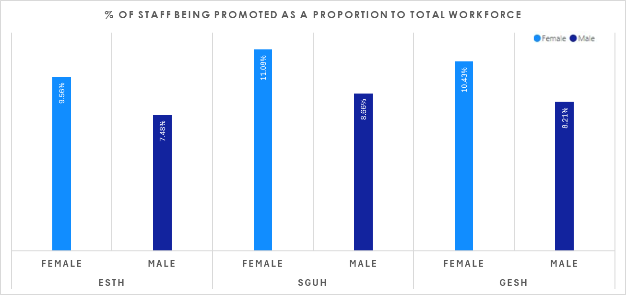

Staff Promotions by Ethnicity - ESTH, SGUH, and GESH Combined (2024):
Ethnicity diversity is an essential factor in creating an inclusive and equitable workforce. This section delves into promotions by ethnicity within GESH, the merged organisation built upon the trusts foundations of ESTH and SGUH.
It shows how promotions by ethnicity are represented in each of the two respective organisations and how they come together in GESH for 2024. Understanding this helps highlight the importance of ethnicity balance and promotions in building a strong and inclusive workforce.
What is the data telling us?
The graph represents the % of promotions as a proportion of the total number of staff within the total protected characteristics group.

ESTH: employs 7,410 staff – 3,277 BAME (44.22%), 3,681 white (49.68%) and 452 not disclosed (6.10%). There were 670 promotions during 2023/24, broken down as:

382 BAME staff (11.66% as a proportion of this group)

274 white staff (7.44% as a proportion of this group)
- 14 Not Disclosed staff(3.10% as a proportion of this group)

SGUH: employs 10,349 staff – 5,543 BAME (53.56%), 4,498 white (43.46%) and 308 not disclosed (2.98%). There were 1,075 promotions during 2023/24, broken down as:

612 BAME staff (11.04% as a proportion of this group)

433 white staff (9.63% as a proportion of this group)
- 30 Not Disclosed staff( 9.74 % % as a proportion of this group)

GESH Combined: employs 17,759 staff – 8,820 BAME (49.66%), 8,179 white (46.06%) and 760 not disclosed (4.28%). There were 1,745 promotions during 2023/24, broken down as:

994 BAME staff (11.27% as a proportion of this group)

707 white staff (8.64% as a proportion of this group)
Across ESTH, SGUH and GESH, BAME staff are more likely to be promoted.
Note that these figures may include increases to grades where someone was temporarily moved to a lower grade due to a lapsed registration.

GESH: Promotions, by Ethnicity
 | ESTH |  |  | SGUH |  |  | GESH
Ethnicity | Total Staff | Promotions | % of Promotions | Total Staff | Promotions | % of Promotions | Total Staff | Promotions | % of Promotions
BAME | 3,277 | 382 | 11.66% | 5,543 | 612 | 11.04% | 8,820 | 994 | 11.27%
Not Disclosed | 452 | 14 | 3.10% | 308 | 30 | 9.74% | 760 | 44 | 5.79%
White | 3,681 | 274 | 7.44% | 4,498 | 433 | 9.63% | 8,179 | 707 | 8.64%
Total | 7,410 | 670 | 9.04% | 10,349 | 1,075 | 10.39% | 17,759 | 1,745 | 9.83%
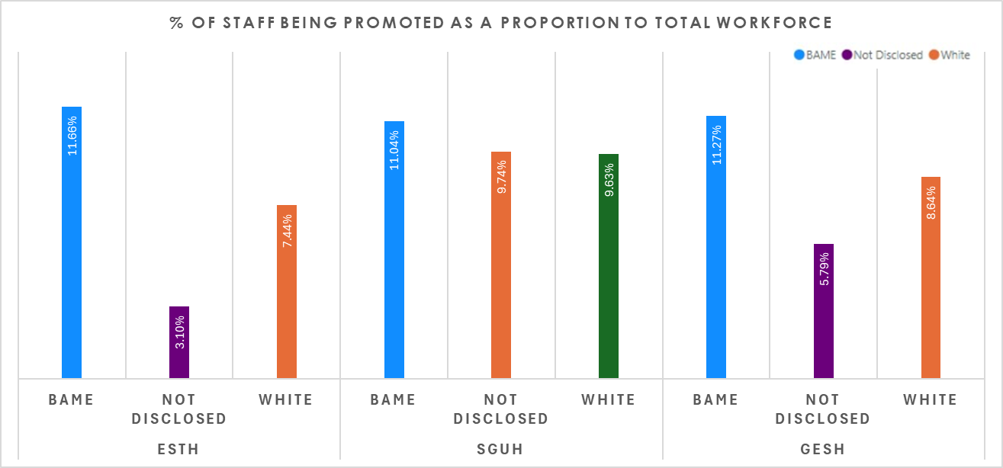

 | ESTH |  |  | SGUH |  |  | GESH
Age | Total Staff | Promotions | % of Promotions | Total Staff | Promotions | % of Promotions | Total Staff | Promotions | % of Promotions
30 and below | 1,157 | 166 | 14.35% | 2,401 | 415 | 17.28% | 3,558 | 581 | 16.33%
31 - 40 | 1,873 | 232 | 12.39% | 3,193 | 382 | 11.96% | 5,066 | 614 | 12.12%
41 - 50 | 1,753 | 157 | 8.96% | 2,297 | 184 | 8.01% | 4,050 | 341 | 8.42%
51 - 60 | 1,828 | 94 | 5.14% | 1,816 | 77 | 4.24% | 3,644 | 171 | 4.69%
61 and above | 799 | 21 | 2.63% | 642 | 17 | 2.65% | 1,441 | 38 | 2.64%
Total | 7,410 | 670 | 9.04% | 10,349 | 1,075 | 10.39% | 17,759 | 1,745 | 9.83%
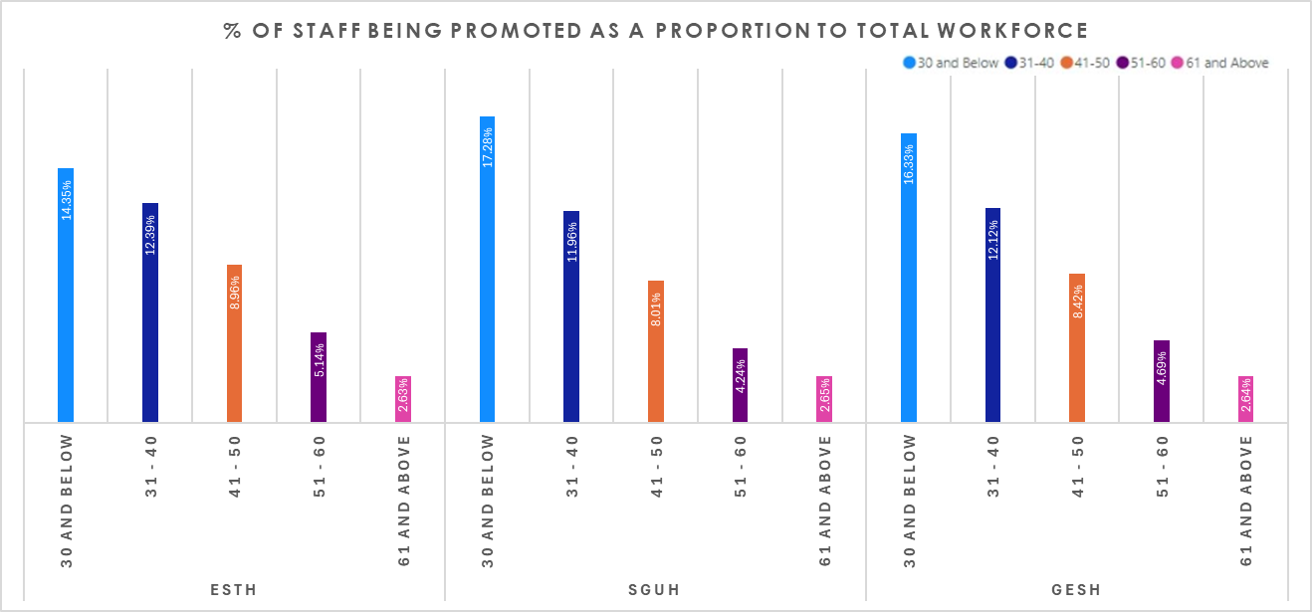
GESH: Promotions, by Age
Staff Promotions by Age - ESTH, SGUH, and GESH Combined (2024):
This section delves into promotions by age within GESH, the merged organisation built upon the trusts foundations of ESTH and SGUH.
What is the data telling us?
The graph represents the % of promotions as a proportion of the total number of staff within the total protected characteristics group.

ESTH: employs 7,410 staff with 670 promotions during 2023/24, broken down as:

1,157 ‘30 and below’ (15.61%), with 166 promotions (14.35% as a proportion of this group)

1,873 ‘31 – 40’ (25.28%), with 232 promotions (12.39% as a proportion of this group)

1,753 ’41 - 50’ (23.66%), with 157 promotions (8.96% as a proportion of this group)

1,828 ’51 - 60’ (24.67%), with 94 promotions (5.14% as a proportion of this group)

799 ’61 and above’ (10.78%), with 21 promotions (2.63% as a proportion of this group)

SGUH: employs 10,349 staff with 1,075 promotions during 2023/24, broken down as:

2,401 ‘30 and below’ (23.20%), with 415 promotions (17.28% as a proportion of this group)

3,193 ‘31 – 40’ (30.85%), with 382 promotions (11.96% as a proportion of this group)

2,297 ’41 - 50’ (22.20%), with 184 promotions (8.01% as a proportion of this group)

1,816 ’51 - 60’ (17.55%), with 77 promotions (4.24% as a proportion of this group)

642 ’61 and above’ (6.20%), with 17 promotions (2.65% as a proportion of this group).

GESH Combined: employs 17,759 staff with 1,745 promotions during 2023/24, broken down as:

3,558 ‘30 and below’ (20.03%), with 581 promotions (16.33% as a proportion of this group)

5,066 ‘31 – 40’ (28.53%), with 614 promotions (12.12% as a proportion of this group)

4,050 ’41 - 50’ (22.81%), with 341 promotions (8.42% as a proportion of this group)

3,644 ’51 - 60’ (20.52%), with 171 promotions (4.69% as a proportion of this group)

1,441 ’61 and above’ (8.11%), with 38 promotions (2.64% as a proportion of this group).

Across ESTH, SGUH and GESH, younger staff are more likely to be promoted which decreases as you progress through the other age brackets. This is more noticeable at SGUH.
Note that these figures may include increases to grades where someone was temporarily moved to a lower grade due to a lapsed registration.

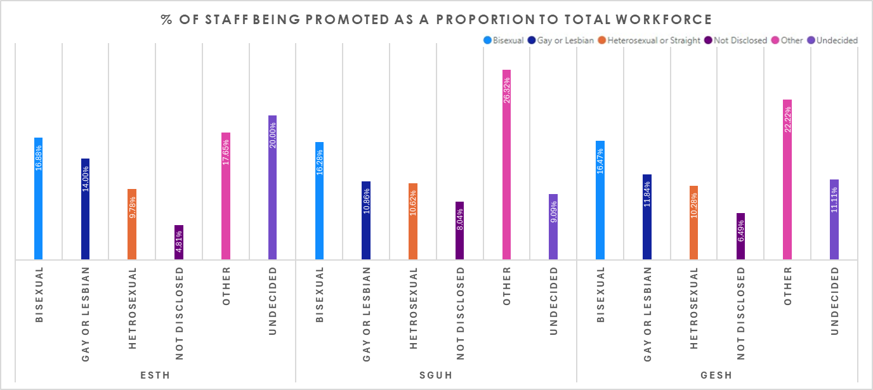
Staff Promotions by Sexual Orientation - ESTH, SGUH, and GESH Combined (2024):
This section explores promotions within the sexual orientation profile of the workforce across ESTH, SGUH, and the combined GESH organisation, offering insights into diversity and disclosure trends. The analysis highlights Heterosexual or Straight employees as the majority across all entities, with SGUH reporting the highest proportion.
What is the data telling us?
The graph represents the % of promotions as a proportion of the total number of staff within the total protected characteristics group.

ESTH: employs 7,410 staff – 5,880 heterosexual (79.35%), 100 gay or lesbian (1.35%) and 77 bisexual (1.04%) making up majority of groups. There were 670 promotions during 2023/24, broken down as:

575 heterosexual staff (9.78% as a proportion of this group)

14 gay or lesbian staff (14.00% as a proportion of this group)
- 13 bisexual staff (16.88% as a proportion of this group)

SGUH: employs 10,349 staff – 8,472 heterosexual (81.86%), 221 gay or lesbian (2.14%) and 172 bisexual (1.66%) making up majority of groups. There were 1,075 promotions during 2023/24, broken down as:

900 heterosexual staff (10.62% as a proportion of this group)

24 gay or lesbian staff (10.86% as a proportion of this group)
- 28 bisexual staff (16.28% as a proportion of this group)

GESH Combined: employs 17,759 staff – 14,352 heterosexual (80.82%), 321 gay or lesbian (1.81%) and 249 bisexual (1.40%) making up majority of groups. There were 1,745 promotions during 2023/24, broken down as:

1,475 heterosexual staff (10.28% as a proportion of this group)

38 gay or lesbian staff (11.84% as a proportion of this group)
- 41 bisexual staff (16.47% as a proportion of this group)
Across ESTH, SGUH and GESH, bisexual workforce appears to have greater chance in receiving a promotion.
Note that these figures may include increases to grades where someone was temporarily moved to a lower grade due to a lapsed registration.

GESH: Promotions, by Sexual Orientation
 | ESTH |  |  | SGUH |  |  | GESH
Sexual Orientation | Total Staff | Promotions | % of Promotions | Total Staff | Promotions | % of Promotions | Total Staff | Promotions | % of Promotions
Bisexual | 77 | 13 | 16.88% | 172 | 28 | 16.28% | 249 | 41 | 16.47%
Gay or Lesbian | 100 | 14 | 14.00% | 221 | 24 | 10.86% | 321 | 38 | 11.84%
heterosexual | 5,880 | 575 | 9.78% | 8,472 | 900 | 10.62% | 14,352 | 1,475 | 10.28%
Not Disclosed | 1,331 | 64 | 4.81% | 1,443 | 116 | 8.04% | 2,774 | 180 | 6.49%
Other | 17 | 3 | 17.65% | 19 | 5 | 26.32% | 36 | 8 | 22.22%
Undecided | 5 | 1 | 20.00% | 22 | 2 | 9.09% | 27 | 3 | 11.11%
Total | 7,410 | 670 | 9.04% | 10,349 | 1,075 | 10.39% | 17,759 | 1,745 | 9.83%
GESH: Promotions, by Marital Status
Staff Promotions by Marital Status - ESTH, SGUH, and GESH Combined (2024):
This section provides an overview of the workforce's promotions within the marital status distribution across ESTH, SGUH, and the combined GESH for the year 2024.
By examining the marital status data, we can gain insights into the workforce demographic structure and promotions, highlighting the differences in marital status across the organisations.
What is the data telling us?
The graph represents the % of promotions as a proportion of the total number of staff within the total protected characteristics group.

ESTH employs 7,410 staff – 3,844 married (51.88%) and 2,461 single (33.21%) making up majority of groups. There were 670 promotions during 2023/24, broken down as:

345 married staff (8.98% as a proportion of this group)

253 single staff (10.28% as a proportion of this group)

SGUH employs 10,349 staff – 3,999 married (38.64%) and 4,885 single (47.20%) making up majority of groups. There were 1,075 promotions during 2023/24, broken down as:

371 married staff (9.28% as a proportion of this group)

605 single staff (12.38% as a proportion of this group)

GESH Combined employs 17,759 staff – 7,843 married (44.16%) and 7,346 single (41.36%) making up majority of groups. There were 1,745 promotions during 2023/24, broken down as:

716 married staff (9.13% as a proportion of this group)

858 single staff (11.68% as a proportion of this group)

Across ESTH, SGUH and GESH, BAME staff, the single workforce appears to have greater chance in receiving a promotion.

Note that these figures may include increases to grades where someone was temporarily moved to a lower grade due to a lapsed registration.

 | ESTH |  |  | SGUH |  |  | GESH
Marital Status | Total Staff | Promotions | % of Promotions | Total Staff | Promotions | % of Promotions | Total Staff | Promotions | % of Promotions
Civil Partnership | 122 | 18 | 14.75% | 105 | 9 | 8.57% | 227 | 27 | 11.89%
Divorced | 327 | 13 | 3.98% | 276 | 17 | 6.16% | 603 | 30 | 4.98%
Legally Separated | 76 | 5 | 6.58% | 53 | 5 | 9.43% | 129 | 10 | 7.75%
Married | 3,844 | 345 | 8.98% | 3,999 | 371 | 9.28% | 7,843 | 716 | 9.13%
Single | 2,461 | 253 | 10.28% | 4,885 | 605 | 12.38% | 7,346 | 858 | 11.68%
Unknown | 503 | 32 | 6.36% | 985 | 67 | 6.80% | 1,488 | 99 | 6.65%
Widowed | 77 | 4 | 5.19% | 46 | 1 | 2.17% | 123 | 5 | 4.07%
Total | 7,410 | 670 | 9.04% | 10,349 | 1,075 | 10.39% | 17,759 | 1,745 | 9.83%
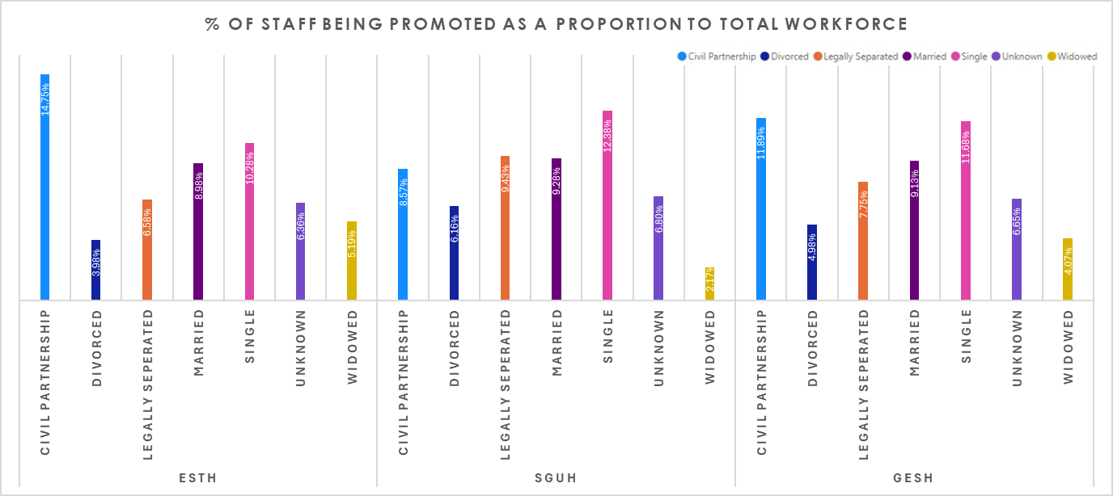

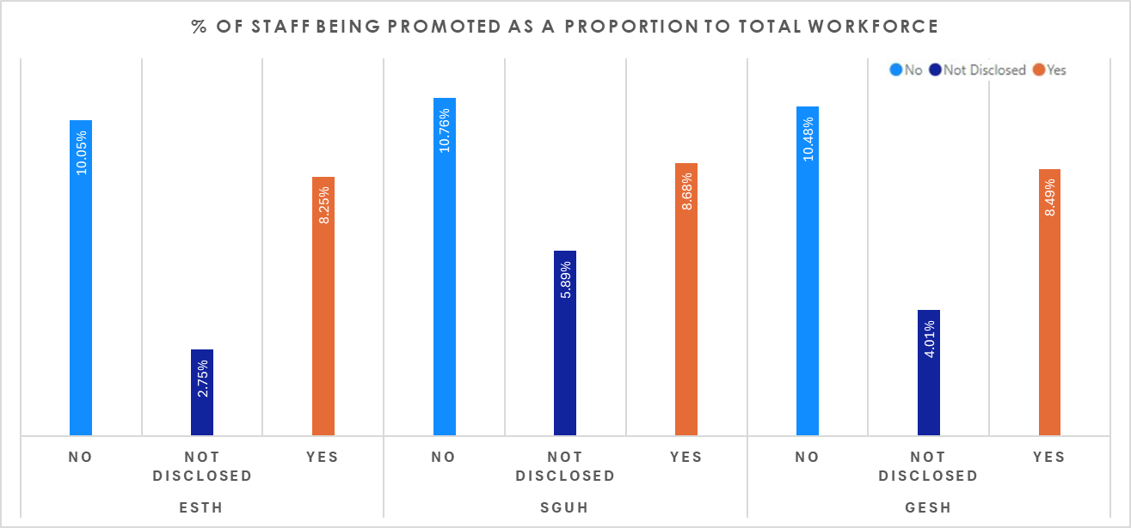
Staff Promotions by Disability - ESTH, SGUH, and GESH Combined (2024):
This section examines disability disclosure rates and promotions among staff at ESTH, SGUH, and the combined GESH workforce for 2024. The data sheds light on the progress being made in fostering inclusivity and transparency around disability within the workforce.
By examining the disability data, we can gain insights into the workforce demographic structure and promotions, highlighting the differences in disability across the organisations.
What is the data telling us?
The graph represents the % of promotions as a proportion of the total number of staff within the total protected characteristics group.

ESTH: employs 7,410 staff – 6,151 not disabled (83.01%), 315 disabled (4.25%) and 944 not disclosed (12.74%). There were 670 promotions during 2023/24, broken down as:

618 not disabled staff (10.05% as a proportion of this group)

26 disabled staff (8.25% as a proportion of this group)

26 not disclosed staff (2.75% as a proportion of this group)

SGUH employs 10,349 staff – 9,341 not disabled (90.26%), 380 disabled (3.67%) and 628 not disclosed (6.07%). There were 1,075 promotions during 2023/24, broken down as:

1,005 not disabled staff (10.76% as a proportion of this group)

33 disabled staff (8.68% as a proportion of this group)

37 not disclosed staff (5.89% as a proportion of this group)

GESH Combined employs 17,759 staff – 15,492 not disabled (87.23%), 695 disabled (3.91%) and 1,572 not disclosed (8.85%). There were 1,745 promotions during 2023/24, broken down as:

1,623 not disabled staff (10.48% as a proportion of this group)

59 disabled staff (8.49% as a proportion of this group)

63 not disclosed staff (4.01% as a proportion of this group)

Across ESTH, SGUH and GESH, non-disabled workforce appears to have greater chance in receiving a promotion, though the disclosure of disability remains low overall.

Note that these figures may include increases to grades where someone was temporarily moved to a lower grade due to a lapsed registration.

GESH: Promotions, by Disability
 | ESTH |  |  | SGUH |  |  | GESH
Disability | Total Staff | Promotions | % of Promotions | Total Staff | Promotions | % of Promotions | Total Staff | Promotions | % of Promotions
No | 6,151 | 618 | 10.05% | 9,341 | 1,005 | 10.76% | 15,492 | 1,623 | 10.48%
Not Disclosed | 944 | 26 | 2.75% | 628 | 37 | 5.89% | 1,572 | 63 | 4.01%
Yes | 315 | 26 | 8.25% | 380 | 33 | 8.68% | 695 | 59 | 8.49%
Total | 7,410 | 670 | 9.04% | 10,349 | 1,075 | 10.39% | 17,759 | 1,745 | 9.83%

Staff Promotions by Religious Belief - ESTH, SGUH, and GESH Combined (2024):
Understanding the religious beliefs of staff and promotions is vital to fostering an inclusive workplace that respects and accommodates diversity. This section provides an analysis of the distribution of religious beliefs across ESTH, SGUH, and the combined GESH workforce for 2024. By examining this data, organisations can identify patterns, address potential gaps, and ensure that their practices and policies reflect and support the diverse religion, faith and spiritual backgrounds of their workforce.
What is the data telling us?
The graph represents the % of promotions as a proportion of the total number of staff within the total protected characteristics group.

ESTH: employs 7,410 staff – 767 Atheism (10.35%), 3,594 Christian (48.50%), 497 Hinduism (6.71%) and 434 Islam (5.86%). There were 670 promotions during 2023/24, broken down as:

64 Atheism staff (8.34% as a proportion of this group)

381 Christian staff (10.60% as a proportion of this group)

63 Hindu staff (12.68% as a proportion of this group)

21 Islam staff (4.84% as a proportion of this group)

SGUH: employs 10,349 staff – 1,381 Atheism (13.34%), 5,114 Christian (49.42%), 622 Hinduism (6.01%) and 864 Islam (8.35%). There were 1,075 promotions during 2023/24, broken down as:

163 Atheism staff (11.80% as a proportion of this group)

520 Christian staff (10.17% as a proportion of this group)

89 Hindu staff (14.31% as a proportion of this group)

83 Islam staff (9.61% as a proportion of this group)

GESH Combined: employs 17,759 staff – 2,148 Atheism (12.10%), 8,708 Christian (49.03%), 1,119 Hinduism (6.30%) and 1,298 Islam (7.31%). There were 1,745 promotions during 2023/24, broken down as:

227 Atheism staff (10.57% as a proportion of this group)

901 Christian staff (10.35% as a proportion of this group)

152 Hindu staff (13.58% as a proportion of this group)

104 Islam staff (8.01% as a proportion of this group)

Note that these figures may include increases to grades where someone was temporarily moved to a lower grade due to a lapsed registration.

GESH: Promotions, by Religious Belief
 | ESTH |  |  | SGUH |  |  | GESH
Religious Belief | Total Staff | Promotions | % of Promotions | Total Staff | Promotions | % of Promotions | Total Staff | Promotions | % of Promotions
Atheism | 767 | 64 | 8.34% | 1,381 | 163 | 11.80% | 2,148 | 227 | 10.57%
Buddhism | 69 | 11 | 15.94% | 164 | 10 | 6.10% | 233 | 21 | 9.01%
Christianity | 3,594 | 381 | 10.60% | 5,114 | 520 | 10.17% | 8,708 | 901 | 10.35%
Hinduism | 497 | 63 | 12.68% | 622 | 89 | 14.31% | 1,119 | 152 | 13.58%
Islam | 434 | 21 | 4.84% | 864 | 83 | 9.61% | 1,298 | 104 | 8.01%
Jainism | 14 | 1 | 7.14% | 12 | 1 | 8.33% | 26 | 2 | 7.69%
Judaism | 13 | 0 | 0.00% | 23 | 2 | 8.70% | 36 | 2 | 5.56%
Not Disclosed | 1,546 | 80 | 5.17% | 1,639 | 142 | 8.66% | 3,185 | 222 | 6.97%
Other | 446 | 41 | 9.19% | 479 | 60 | 12.53% | 925 | 101 | 10.92%
Sikhism | 30 | 8 | 26.67% | 51 | 5 | 9.80% | 81 | 13 | 16.05%
Total | 7,410 | 670 | 9.04% | 10,349 | 1,075 | 10.39% | 17,759 | 1,745 | 9.83%

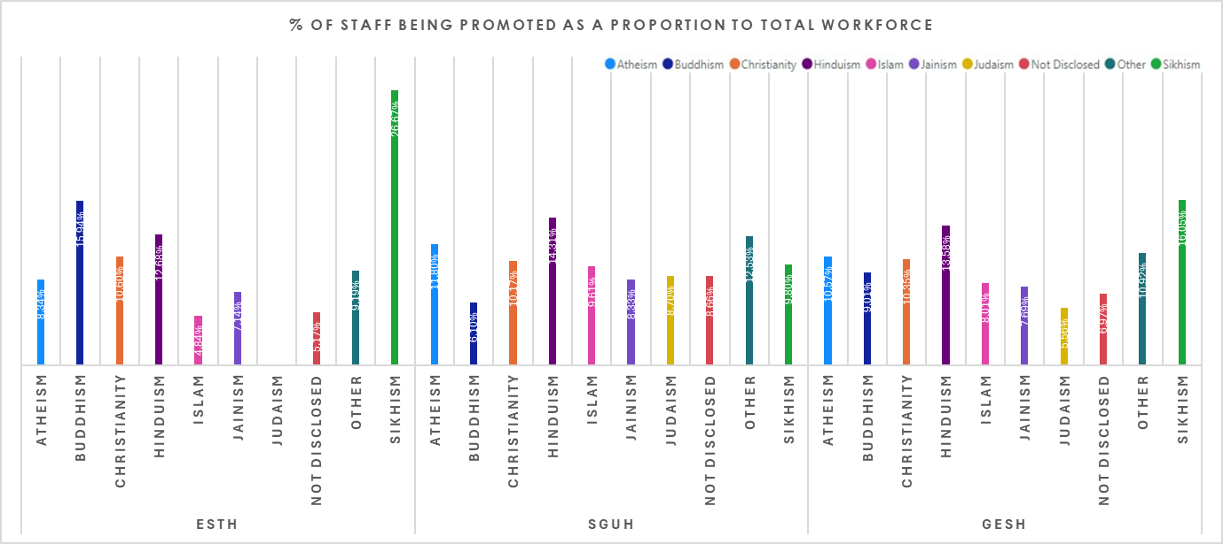

GESH Non-Mandatory Training – 2023-24
Validated

Trust | Gender | Total Staff | Training | % of Non-Mandatory Training
GESH | Female | 12,948 | 1,223 | 9.45%
GESH | Male | 4811 | 272 | 5.65%
Staff non-mandatory training - GESH Combined (2024):
Understanding the protected characteristics of staff and their access to non-mandatory training is essential for cultivating an inclusive workplace and ensuring equity. We report annually on the access to non-mandatory training through our Workforce Race Equality Standard (WRES) by White and Black staff, along with some of the other protected characteristics accessing such training. This section also addresses these protected characteristics GESH combined.
What is the data telling us?
The graph represents the % of staff accessing non-mandatory training as a proportion of the total number of staff within the total protected characteristics group.
Gender

GESH Combined employs 17,759 staff, broken down as 12,948 Female (72.91%) and 4,811 Male (27.09%). There were 1,495 instances of staff accessing non-mandatory training during 2023/24, broken down as:

1,223 female staff (9.45% as a proportion of this group)

272 male staff (5.56% as a proportion of this group)
Across GESH, female staff are more likely to be promoted.

Sexual Orientation

GESH Combined employs 17,759 staff – 14,352 heterosexual (80.82%), 321 gay or lesbian (1.81%) and 249 bisexual (1.40%) making up majority of groups. There were 1,495 instances of staff accessing non-mandatory training during 2023/24, broken down as:

1,285 heterosexual staff (8.95% as a proportion of this group)

27 gay or lesbian staff (8.41% as a proportion of this group)
- 15 bisexual staff (6.02% as a proportion of this group)
Across GESH, heterosexual and gay or lesbian staff are more likely to be promoted.

Staff Non-mandatory training - GESH Combined (2024): Gender and Sexual Orientation
Trust | Gender | Total Staff | Training | % of Non-Mandatory Training
GESH | Female | 12,948 | 1,223 | 9.45%
GESH | Male | 4,811 | 272 | 5.65%
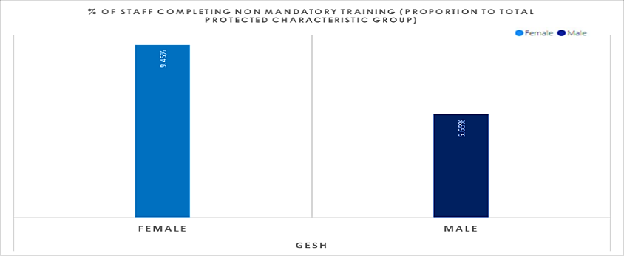
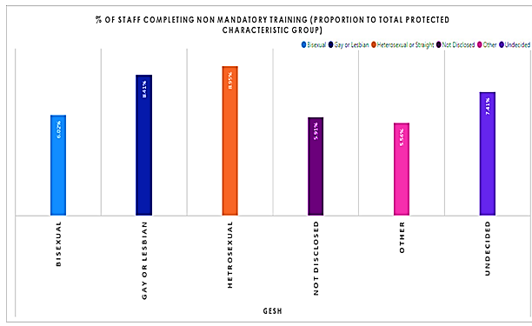
Trust | Sexual Orientation | Total Staff | Training | % of Non-Mandatory Training
GESH | Bisexual | 249 | 15 | 6.02%
GESH | Gay or Lesbian | 321 | 27 | 8.41%
GESH | Heterosexual | 14,352 | 1,285 | 8.95%
GESH | Not Disclosed | 2,774 | 164 | 5.91%
GESH | Other | 36 | 2 | 5.56%
GESH | Undecided | 27 | 2 | 7.41%

Trust | Ethnicity | Total Staff | Training | % of Non-Mandatory Training
GESH | BAME | 8,820 | 752 | 8.53%
GESH | Not Disclosed | 760 | 1 | 0.13%
GESH | White | 8,179 | 742 | 9.07%
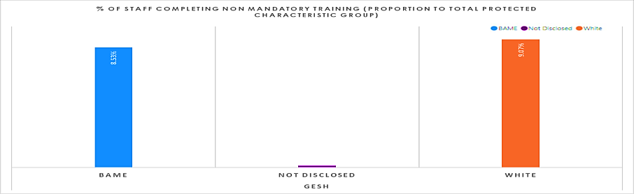
Ethnicity
This section examines the access to non-mandatory training within GESH Combined,

GESH Combined employs 17,759 staff – 8,820 BAME (49.66%), 8,179 white (46.06%) and 760 not disclosed (4.28%). There were 1,495 instances of staff accessing non-mandatory training during 2023/24, broken down as:

752 BAME staff (8.53% as a proportion of this group)

724 white staff (9.07% as a proportion of this group)
Disability

GESH Combined employs 17,759 staff – 15,492 not disabled (87.23%), 695 disabled (3.91%) and 1,572 not disclosed (8.85%). There were 1,495 instances of staff accessing non-mandatory training during 2023/24, broken down as:

1,315 not disabled staff (8.49% as a proportion of this group)

93 disabled staff (13.38% as a proportion of this group)

87 not disclosed staff (5.53% as a proportion of this group)
Age

GESH Combined employs 17,759 staff with 1,495 instances of staff accessing non-mandatory training during 2023/24, broken down as:

3,558 ‘30 and below’ (20.03%), with 193 promotions (5.42% as a proportion of this group)

5,066 ‘31 – 40’ (28.53%), with 896 promotions (17.69% as a proportion of this group)

4,050 ’41 - 50’ (22.81%), with 222 promotions (5.48% as a proportion of this group)

3,644 ’51 - 60’ (20.52%), with 115 promotions (3.16% as a proportion of this group)

1,441 ’61 and above’ (8.11%), with 69 promotions (4.79% as a proportion of this group)

Staff Non-mandatory training - GESH Combined (2024): Ethnicity , Disability and Age
Staff Non-mandatory training - GESH Combined (2024): Ethnicity Disability and Age
Trust | Disability | Total Staff | Training | % of Non-Mandatory Training
GESH | No | 15,492 | 1,315 | 8.49%
GESH | Not Disclosed | 1,572 | 87 | 5.53%
GESH | Yes | 695 | 93 | 13.38%

Trust | Age | Total Staff | Training | % of Non-Mandatory Training
GESH | 30 and Below | 3,558 | 193 | 5.42%
GESH | 31 - 40 | 5,066 | 896 | 17.69%
GESH | 41 - 50 | 4,050 | 222 | 5.48%
GESH | 51 - 60 | 3,644 | 115 | 3.16%
GESH | 61 and Above | 1,441 | 69 | 4.79%
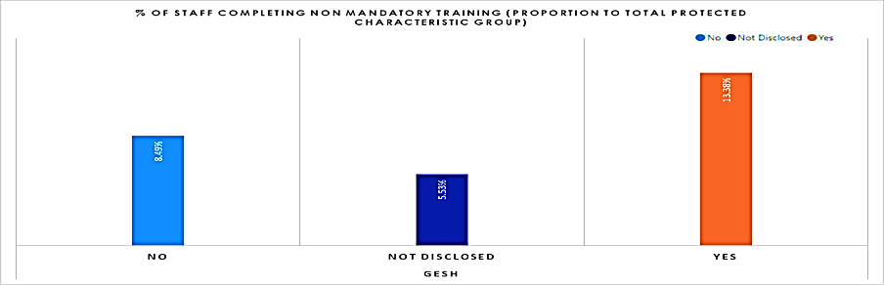
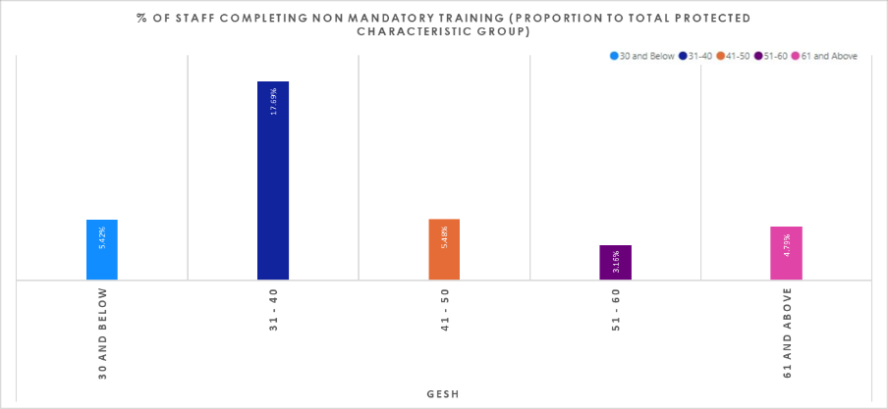

Religious Belief

GESH Combined employs 17,759 staff – 2,148 Atheism (12.10%), 8,708 Christian (49.03%), 1,119 Hinduism (6.30%) and 1,298 Islam (7.31%). There were 1,495 instances of staff accessing non-mandatory training during 2023/24, broken down as:

197 Atheism staff (9.17% as a proportion of this group)

805 Christian staff (9.24% as a proportion of this group)

83 Hindu staff (7.42% as a proportion of this group)

94 Islam staff (7.24% as a proportion of this group)

Marital Status

GESH Combined employs 17,759 staff – 7,843 married (44.16%) and 7,346 single (41.36%) making up majority of groups. There were 1,495 instances of staff accessing non-mandatory training during 2023/24, broken down as:

647 married staff (8.25% as a proportion of this group)

634 single staff (8.63% as a proportion of this group)

Across GESH, the majority of the workforce are either single or married. Both groups appear to be accessing non-mandatory training.

Staff Non-mandatory training - GESH Combined (2024): Religion Belief and Marital Status
n

Trust | Religious Belief | Total Staff | Training | % of Non-Mandatory Training
GESH | Atheism | 2,148 | 197 | 9.17%
GESH | Buddhism | 233 | 20 | 8.58%
GESH | Christianity | 8,708 | 805 | 9.24%
GESH | Hinduism | 1,119 | 83 | 7.42%
GESH | Islam | 1,298 | 94 | 7.24%
GESH | Jainism | 26 | 1 | 3.85%
GESH | Judaism | 36 | 1 | 2.78%
GESH | Not Disclosed | 3,185 | 207 | 6.50%
GESH | Other | 925 | 77 | 8.32%
GESH | Sikhism | 81 | 10 | 12.35%
Trust | Marital Status | Total Staff | Training | % of Non-Mandatory Training
GESH | Civil Partnership | 227 | 30 | 13.22%
GESH | Divorced | 603 | 68 | 11.28%
GESH | Legally Separated | 129 | 12 | 9.30%
GESH | Married | 7,843 | 647 | 8.25%
GESH | Single | 7,346 | 634 | 8.63%
GESH | Unknown | 1,488 | 96 | 6.45%
GESH | Widowed | 123 | 8 | 6.50%
