**gesh Annual Patient Experience Report**

**2023-24**

**1.0**

**Introduction**

St George’s and Epsom and St Helier are committed to providing outstanding care, every time. To achieve this, we need to ensure the care provided is safe, high quality and compassionate. To understand if we are meeting this commitment, we need to work with our patients, carers, and our staff, listening to their experience, and making improvements as a result of these insights and learning.

The importance of partnership working in providing care to patients, was highlighted in NHS England’s statutory guidance titled Working in Partnership with People and Communities, outlining the responsibilities for organisations to work with the people we treat, to improve the health and wellbeing of communities. The principle of this guidance highlights the expectations of working in partnership with our patients and the community to ensure we are working to serve their needs.

The gesh Group Strategy 2023-2028 sets out our vision for 2028, with a focus on collaboration, partnership, and engagement, empowering staff, and patients, across our large organisation, to work together, to achieve the best we can, driven by our patients.

This first gesh annual patient experience report aims to overview patient experience for St George’s (SGH) and Epsom and St Helier (ESTH), reviewing our progress against priorities, and ensuring that we are working in partnership to improve the experience of all our patients and carers.

**2.0**

**Background**

* 1. The design for this annual report is different to previous reports as St George’s have chosen to adopt the style co-designed by patients and staff from Epsom and St Helier following a public working group. This style is due for renewal in 2024-2025, where we will aim to adopt a Group co-designed style for this report and will involve a gesh wide public working group.

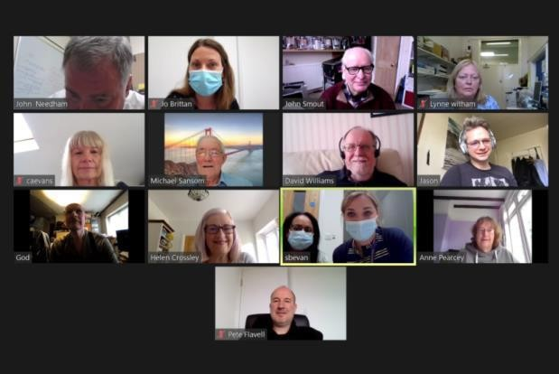

**3.0**

**Analysis**

# Progress against priorities set in 2023-2024

There were several identified priorities across the group to improve patient experience throughout the 2023/24. Group priority progress is detailed as follows, with updates given for each priority achieved during the year:

|  |  |  |  |
| --- | --- | --- | --- |
| **Priority** | **Objective** | **SGH** | **ESTH** |
| Carers | Embed and reinforce the carers project.  Continue to encourage staff to attend training and raise awareness.  Recruit carers to attend the carers forum.  Develop method to capture carers details in Cerner (iClip)  Develop methods to support staff to refer/signpost carers to support services | ICB wide steering group implemented.  Partnership in progress with Wandsworth Carers Centre (WCC) who are providing Carers Awareness training for staff. Sessions have been running every month open to all staff. 53 staff have attended sessions to date and WCC have attended divisional meetings further awareness for staff.  Agreement from ESTH Carers Forum to expand to become gesh Carers Forum  Go live planned for 23 April 2024.  Intranet site went live in April 2024, Information hub planned for May 2024, quarterly | Quarterly steering group and forum meetings in place  E-learning package in place since June, replacing face to face training.  Current take up is very low (16 staff). Plans are in place to raise awareness to increase take up.  Expansion from site to group will increase carers numbers in attendance.  Go live planned for 23 April 2024  Systems in place, close working with Sutton and Surrey Carers in place with |

|  |  |  |  |
| --- | --- | --- | --- |
|  |  | newsletter in place, Back to the Floor held focussing on identifying and signposting Carers, Go live for iClip planned for 23 April 2024, Daily ward visits by WCC | robust referral system. |
| Discharge | Raise profile of the importance of identifying, involving, and working in partnership with carers  Raise awareness of community support available and how to signpost patients. | Worked closely with Transfer of Care (TOC) team to improve discharge planning through partnership working with community. Effective support for carers at home can improve discharge and reduce readmission rates.  3 events held this year to raise profile of partnership working including Carers Week, Young Carers Action Week, Carers Rights Day  Work in partnership with the ICB | Systems in place with Surrey and Sutton Carers, new leaflets introduced.  Carers Ward packs available on every ward.  3 events held this year to raise profile of partnership working including Carers Week, Young Carers Action Week, Carers Rights Day  Work in partnership with the ICBs |
| Armed Forces/Veterans | Embed and reinforce the Armed Forces Project at SGH and ESTH | Steering group in progress, 3 workstreams identified with plans in place in 2024 to launch iClip tab to record identified members of the armed forces, training to be made available for staff, information hub to be launched in May 2024. | Steering group relaunched and in progress.  E-learning training to be moved to ESR to make it more visible and to improve compliance. |

|  |  |  |  |
| --- | --- | --- | --- |
|  | Raise awareness and continue to encourage staff to attend training | Intranet site launched in April 2024  Armistice Day recognised by Trust. | Emergency Department packs in place.  Armistice Day recognised by Trust |
| Friends and Family Testing (FFT) | Reinforce the importance of FFT with staff and patients | CQC training organised for MedCard and two sessions were held focussing on FFT and patient experience.  Review of all local surveys with FFT included undertaken to refresh surveys and to raise profile within divisions.  New surveys added for Pharmacy and Therapy to increase feedback | Training sessions held across organisation to raise awareness and to encourage staff to gather feedback. |
| Voluntary services | Encourage recruitment of volunteers, work experience (ESTH) and patient partners representing the diversity of our communities | Several workstreams in place that increased voluntary recruitment.  Encouraging divisions to consider needs and to create new roles for volunteers. | Onboarding systems reviewed and delays fixed.  Visits to local colleges and community areas in progress to encourage  volunteer recruitment. |
| Improve diversity of participation | Continue to engage with all community groups; faith groups, protected group forums and local community groups, | Improved communications through posters, external website, and community advertising to encourage participation | Improved communications through posters, external website, and community advertising to  encourage participation |
| Partnership working | Continue to inspire partnership working  through patient user | Several new groups started at SGH this year | Collaborate with Comms team who  People Panel |

|  |  |  |  |
| --- | --- | --- | --- |
|  | groups, support groups, events, focus groups and meetings (PPEG and People Panel) | with further plans in progress.  Workshop being planned to increase awareness of user groups and encouraging and supporting staff to help set up new groups. | currently sit with and mapping process in place to identify what current groups are in progress to be able to identify where new groups are needed.  Workshop being planned to increase awareness of user groups and encouraging and supporting staff to help set up new  groups. |

# National surveys

St George’s and Epsom and St Helier are required to take part in all relevant national surveys. These surveys are run by either the Care Quality Commission, or NHS England to explore patient experience, to identify tangible improvements in patient care, with robust action plannings for improvements directly resulting from patient feedback.

|  |  |  |  |
| --- | --- | --- | --- |
| **Survey** | **Frequency** | **Cycle/timeframe** | **Updates** |
| Inpatients (Adults) | Annual | Sampling period is November 2023 (there are exclusions) and patients will be sent a survey if  included in the random sample. | Fieldwork starts April 2024 |
| Under 16 Cancer | Annual | Fieldwork January – March 2024 |  |
| Maternity | Annual | Sampling period February 2024 | Changed from September to February |
| Adult Cancer (CPES)  2024 | Annual | Display opt out posters during  April – June 2024 |  |
| Urgent and Emergency Care 2024 | Annual | Sampling period is February 2024. | Fieldwork April – July 2024 |
| Neonatal new (Pilot) | tbc | Sampling period March 2024 |  |
| Children and young  people |  | Fieldwork July – October 2024 | Publication date  March 2025 (tbc) |

The cycle of national surveys is a busy and resource intensive process involving:

* Co-ordination with the CQC and NHS England to ensure the governance surrounding each survey is completed, on time and correctly.
* Ordering, printing, and displaying posters and comms within required timeframe.
* Liaison with clinical teams, Caldicott Guardian and the analysts to ensure clarity around timeframes, samples, inclusions, exclusions, and that sample requirements are followed.
* Ensuring all data is supplied within timeframe and following correct processes.
* Co-ordinating queries, between CQC and NHS England ensuring that appropriate governance is completed for each cycle of sending surveys to participants.
* Survey completion and contact for results from Picker, CQC and NHS England
* Working with teams to review survey outcomes.
* Data analysis including outcomes, response rates, demography, comparative data, insights, free text analysis, analysing impact of actions and survey revisions.
* Working with departmental teams to draft action plans to address areas of focus.
* Collating, drafting, and presenting outcomes at relevant committees/meetings such as PSQG or IPEC as part of assurance framework.

# Local surveys, including FRIENDS AND FAMILY TEST (FFT)

* + - 1. FFT is a nationally set question to capture patient experience. Patients receiving treatment and care in our Trust can provide immediate feedback about their experience after an episode of care. From April 2020, the nationally set question asked of all our patients is:

**Thinking about your stay in the hospital overall, how was your experience of our service?**

Patients are asked to respond from a number of options from "very good" to "very poor", and they also have the opportunity to tell us the main reason for their answer. You can find out more about the Friends and Family Test (FFT) by visiting [www.nhs.uk/friendsandfamily.](http://www.nhs.uk/friendsandfamily)

We actively seek patient feedback and promote the FFT widely. The method for capture is different at St George’s and Epsom and St Helier. At St George’s, annual national surveys are mirrored in local surveys such as outpatients or inpatients and the FFT question is embedded within that survey. When patients are discharged, they are invited to complete the survey and

this can be done via several methods such as by text message, QR code or via the intranet. An in-house platform called RATE is used to track survey responses allowing review by teams to track FFT and survey responses, monitoring feedback by patients.

At Epsom and St Helier, there are also multiple ways to complete the FFT, but this is a standalone question, and patients can complete it either via:

* + - * + Postcard (available on ward/in clinical areas)
        + Text message
        + Online
        + QR code
        + Automated voice message

A company called HCC are commissioned to support FFT at Epsom and St Helier, allowing staff to extract information, statistics, and reports. At ESTH, a staff training guide was completed in August 2023 and training sessions have been run for staff to support reporting and to enable staff to look for trends and implement improvements guided by patient feedback.

* + - 1. **Group annual FFT Performance Epsom and St Helier**

|  |  |  |  |
| --- | --- | --- | --- |
| **Year** | **Number of FFT**  **responses** | **Positive** | **Negative** |
| 2021/2022 | 69,525 | 91.3% | 4.7% |
| 2022/2023 | 59,762 | 91.2% | 5.0% |
| 2023/2024 | 56,646 | 93.1% | 3.8% |

**St George’s**

|  |  |  |  |
| --- | --- | --- | --- |
| **Year** | **Number of FFT**  **responses** | **Positive** | **Negative** |
| 2021/2022 | 58,952 | 89.7% | 8.1% |
| 2022/2023 | 59,885 | 89.8% | 8.0% |
| 2023/2024 | 67,532 | 92.3% | 6.1% |

* + - 1. **Capturing learning /Lessons learnt from our FFT results**

At ESTH, departments review FFT feedback on a weekly or monthly basis and look to see what improvements they can make to improve the patient experience. ‘You said, We Did’ is therefore used at ward / department level to identify the feedback and relevant actions.

At SGH, the patient feedback from the FFT question and related surveys are provided on a weekly basis to Ward Matrons and Heads of Nursing for their review and learning. Monthly metrics are also provided for display within all ward and service areas alongside other important performance data, for example the number of pressure ulcers and falls.

# Priority area of focus for FFT

Work with teams to increase knowledge and awareness of the importance of FFT, and purpose, enabling staff to understand how FFT can support departmental improvements through learning from patient feedback. We need to work towards improving FFT response rates across the

group, with a particular focus on the Emergency Department and Maternity at Epsom and St Helier, due to these areas flagging for exception narrative in IQPR in April 2024, and the patient experience team will be working with teams to support this improvement as a priority for 2023/24.

The learning from You said, We did can be used positively in many ways to:

* + - * + Support services to identify what improvements patients would like to see to improve their experience.
        + Support staff by recognising positive patient experiences and use this information to identify where we are providing exemplar care, to enable replication across other services.
        + Provide a platform to enable staff to work closely with patients to identify improvements through the promotion of patient user groups, encouraging co- design.
        + Provide a monitoring system, identifying when services are struggling through metric monitoring systems.
        + To feed into GESH wide learning repository to demonstrate to patients our ability to learning through their feedback on a continual basis.

# Local Surveys

Local surveys are used routinely at SGH to monitor patient experience on a continual basis, in addition to annual or bi-annual national surveys. Local surveys, such as the outpatients survey at St George’s which runs all year round, allow consistent monitoring of patient experience, and the RATE system in place allows staff to review responses and participation rates on a weekly basis. Support and advice are given to departments on a case-by-case basis to support the development of new, bespoke, or specific local surveys as required to support quality improvement projects.

A similar system is in place at ESTH, allowing staff to create new surveys to measure patient feedback and to review participation rates to inform improvement. The Patient Experience team have supported departments to set up several local surveys. For this reporting period these includes the Pre-Op Diabetes, Community Reception for SHC and a number of surveys for children and their parents where children are transitioning into care from Children Services to Adult Services. To date these have had a fantastic response rate from our patients. The Patient Experience team will be having regular reviews with the departments to support local learning and service development.

The Patient Experience team have been working with Dementia teams at both ESTH and SGH to try to capture information from carers about their experience to help support service improvements in this area, as well as linking this information to the Carers Project and raising

awareness of John’s Campaign across the group.

The Patient Experience team at ESTH have launched a children’s bespoke Friends and Family Test survey for Severe and Profound Learning Difficulties Test (SALT)that had been tailored for children to complete. Since this launch, we have seen a 65% increase in responses and expect their response rate to continue to increase, thank you to the team for their amazing work.

# Stroke Patient Reported Experience Measures (PREMS)

The Stroke Association in partnership with NHS England ran the first annual Stroke Patient Reported Experience Measures (PREMS) Survey in 2022/23 and the Trust has signed up to be part of this. The purpose of the Stroke PREMS survey is to undertake a national survey which captures the patient experience of stroke care; to use the survey findings to inform quality improvement activity at local, regional, and national level – in line with the NHS’s statutory responsibility for quality improvement. No such patient experience tool or data exists at a national level, and yet this is part of the Stroke Long Term Plan ambitions for England. Patients who have not asked for exclusion from the survey have been contacted if they were admitted with a primary diagnosis of a stroke between 16 May and 16 September 2022. The results of this survey were reported during 2023 and can be found at [SSNAP - Stroke PREMs 2022/23](https://www.strokeaudit.org/Results2/Stroke-PREMs-2022-23.aspx) [(strokeaudit.org)](https://www.strokeaudit.org/Results2/Stroke-PREMs-2022-23.aspx)

# Accreditation – St George’s

The Corporate Nursing team supports through the accreditation programme at St George’s which runs every week. In recent months the way in which the accreditation assessments are carried out has been adjusted due to patient, carer, and staff feedback and therefore some additional detail in terms of questions and areas of focus has been added. Additional questions now are being asked regarding dementia care, safeguarding and medicines management. These changes were implemented in December of 2023.

The Accreditation programme includes patient experienced questions which are asked by a patient partner (volunteer) during most inspections. The only inspection types that do not include patient feedback are Theatres and the Mortuary as it is agreed they are not appropriate for these areas. In outpatient services where there is sufficient patient feedback survey data (at least 200 responses in 3 months), this is used instead of patient partner interviews.

The accreditation programme currently inspects 118 services across all St George’s sites, from 2023, this includes all therapy outpatient areas and some radiology and diagnostic

areas. Additional patient partners have been recruited to support this work and to ensure there are sufficient numbers of volunteers to undertake the patient interviews.

Further discussions across gesh are currently taking place to extend the scope of accreditation to all departments and areas.

# Patient Led assessment of the care environment (PLACE)

**St George’s**

The annual PLACE assessment ran at St George’s, including Queen Mary’s, in November 2023, supported by volunteers and patient partners to assess quality of environment, focussing on areas that have not been assessed in previous years. PLACE requires covering 10 areas or 25% of the site.

# Mandatory areas covered included:

* + - * + Communal Areas
        + External Areas
        + Emergency Department

Wards and Outpatient areas covered were as follows:

|  |  |
| --- | --- |
| **Ward** | **Outpatients** |
| Benjamin Weir  Caroline (Including Mealtime Observation) Nye Bevan (Including Mealtime Observation)  Gordon Smith (Including Mealtime Observation) Major Trauma  Thomas Young (Including Mealtime Observation) William Drummond  Cheselden Delivery Suite Dalby | Neuro OPD  Cardiac Investigations Willow Annex  Hand Unit Rose Centre  Child Development Centre Colposcopy  Clinic C |

# Key findings and table with annual scores

* + - * + Cleanliness score was the highest St George’s has achieved in this category since 2019.
        + Food improved on 2022
        + Organisational and ward food scored above national average
        + Privacy, dignity and wellbeing findings scored above national average
        + Condition, appearanance and maintenance scored above national average and improved on last years score
        + Dementia and disability findings scored much better than the previous year and for dementia, above national average and for disability, very close to national average.

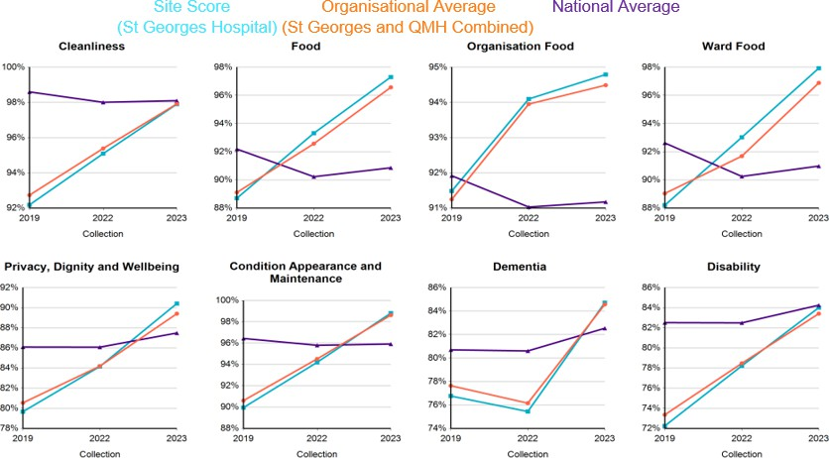

# Risks

Due to much improved scores, no significant risks noted and local plans in place in line with continuous improvement prinicples. Special thank you to all those volunteers who took part, and staff for the excellent arrangements in place ensuring the event went well.

# Epsom and St Helier (ESTH)

PLACE also ran at Epsom and St Helier within the reporting timeframe. The PLACE assessments were undertaken using teams comprising of patient assessors, making up at least 50% of the team, and staff.

The scores for ESTH were very good, with all scores for both sites scoring consistently higher than the national average. Epsom General Hospital scored significantly higher than the national average for food and privacy, dignity and well being. The scores can be seen in the below table split by Epsom General Hospital, St Helier, combined and national average.

# Combined 2023 scores



87.49%

90.86%

84.25%

82.54%

95.91%

98.10%

91.33%

80.17%

85.75%

96.64%

97.46%

97.05%

97.11%

89.02%

93.07%

84.00%

84.26%

84.13%

Site Score - Epsom General Hospital

Site Score - St Helier Hospital Combined Site Score - Average PLACE National Averages Per Domain

2023

Privacy,

Dignity and Wellbeing

Disability Combined

Food

Dementia

Condition,

Appearanc e and Maintenan ce

96.22%

97.86%

97.04%

99.11%

99.42%

99.27%

Cleanliness

100.00%

90.00%

80.00%

70.00%

60.00%

50.00%

40.00%

30.00%

20.00%

10.00%

0.00%

**8.0 Partnership working**

At St George’s, the ethos of working in partnership with patients continued, with a unified and cemented Patient and Partnership Experience Group (PPEG) working hard as a unit, to maintain assurance of this principle through a full project review at each PPEG meeting to ensure patients were involved in all Trust projects. Consideration of how to align the partnership working principles at St George’s and Epsom and St Helier are in progress, noting the differences in structure and remit across Communication, Patient Experience and Voluntary Services.

# 8.1 PPEG and Patient Partners

PPEG is a group made up of key staff and volunteers (the aim is a 50/50 staff and volunteer ratio) working together to ensure the patient voice is a key feature in all Trust projects. There have been 6 patient partners as members for many months, but during December 2023, an additional 5 patient partners were recruited increasing numbers to 11. Patient partners are volunteers, but those who work specifically on corporate projects, including PPEG. A key aim is to be assured that patients are seen as partners and treated as such by ensuring the patient voice is heard, patient views are considered and that patients are seen as partners is service improvements.

Patients partners work closely with the Associate Director of Patient Experience and the

Voluntary Services Manager, often wearing multiple ‘hats’ and covering key related projects such

as PLACE inspections, Accreditation inspections, projects, such as Outpatient Transformation including MyCare and PIFU, Patient Information incuding leaflets and posters, and Carers and Veterans. A special thank you is made to all the Patient Partners for their commitment, time and expertise in so many areas projects across St George’s.

An overview of the PPEG content for the year is as follows, noting that the project spreadsheet overview is reviewed at every meeting as business as usual.

|  |  |  |  |
| --- | --- | --- | --- |
| **Date** | **Speakers** | **Presentation** | **Purpose** |
| **May 2023** | Karen Sleigh, Senior Programme Manager  Estelle Le Galliot, Macmillan Health & wellbeing Coordinator  Sue Fox, Patient Partner and Chair of Voice | Southeast Genomic Medicine Service Alliance  Surgery, Neurosciences, Theatres and Cancer (SNCT) divisional update/ Voice update.  Cancer Voice update | Asked PPEG for advice in how to involve patients.  Annual update  Annual update |
| **July 2023** | Jo Hunter, Divisional Director of Nursing and Governance  Ana Barranco-Ventham & Brenda, LD Liaison practitioner  Laura Carberry Strategy and Partnership Manager | Medicine and cardiovascular update  Learning Disabilities PPEG update  GESH Strategy | Annual update  To welcome an update at the SGH PPEG group from the LD group.  Update PPEG |
| **September 2023** | Luci Etheridge/ Natilla Henry Site Chief Nurse and Site Chief Medical Officer  Joseph Pavett-Downer, Head of Equality, Diversity, and Inclusivity  Wendy Doyle | Patient involvement in quality and safety  The Accessible Information Standard status  Patient Experience Annual Report overview | To ask PPEG how to ensure the patient voice is active in the 7 areas of fundamental areas of care.  Overview status and work in progress  Overview of progress and priorities. |
| **November 2023** | NHS England  Wendy Doyle | Paediatric consultation  Carers Partnership Board (Wandsworth) Charter | To ask PPEG to feedback on the consultation. |

|  |  |  |  |
| --- | --- | --- | --- |
|  |  |  | PPEG asked for their comments on the revised  charter |
| **January 2024** | Wendy Doyle | Bi-annual Patient Experience Report | For PPEG to consider and approve areas of focus |
|  | Wendy Doyle | Update on the Carers Project | To share project progress with PPEG |
|  | David Maher, Group Stakeholder Communications Manager | New Intensive Care Unit | To share overview of project with PPEG |
| **March 2024** | Caroline Knox, Deputy General Manager, Corporate Outpatients | Veterans Project | Overview and progress |
|  | Liz Aram and Josephine Jackson – Patient Partners | Corporate Poster Project | Overview, outcomes, and  actions |
|  | Kath Brook, Strategy and Planning Manager | Quality Strategy Development | Emerging priorities for  strategy domains with a focus on positive experience |

New dates for PPEG are to be confirmed for 2023/24.

# Patient Support Groups/ Patient User Groups

During 2022/23, new patient support groups and peer groups were started at St George’s and Epsom and St Helier, with a centralised record of all groups in progress. These groups offer support, improvement opportunities and partnership working with many teams across St George’s. New patient partners have been recruited in 2023, and plans are in place to host a patient support group workshop, hosted by Sue Fox, Patient Partner and Former Chair of Voice.

# Strategy

A clear vision of postive patient experience was drafted in February 2024, and presented to PPEG by the Strategy teamin March 2024, detailing the importance of embedding the patient voice, through co-production, in everything that we do. This was welcomed and supported by PPEG.

# People Panel

The People Panel at Epsom and St Helier, sits under the remit of the Communications team,

and the Associate Director for Patient Experience has met with the team, and a mapping exercise has started to identify and centrally record patient user groups/support groups at Epsom and St Helier.

Plans are in place to consider how partnership working can be demonstrated through the People Panel and Voluntary Services, to identify what further approaches are needed at Epsom and St Helier to be able to evidence partnership working to meet the requirements of the recent NHS England publication, Working in partnership with People and Communities.



# CORPORATE GRATITUDE – Epsom and St Helier

The Trust has been recording and analysing the corporate gratitude (CG) that it receives since April 2015. This allows us to capture areas of excellence and acknowledge the positive feedback received by recognising the individuals, teams and locations that have been highlighted in messages / letters by grateful patients, relatives, and carers.

Corporate gratitude includes letters and emails sent to the Chief Executive; compliments expressed during complaints and contacts with PALS; positive reviews posted on the NHS Review website.

423 corporate gratitude messages were received between April 2023 and March 2024. These were the top themes for the financial year 2023-2024:

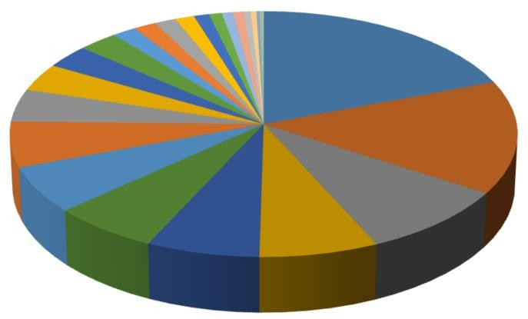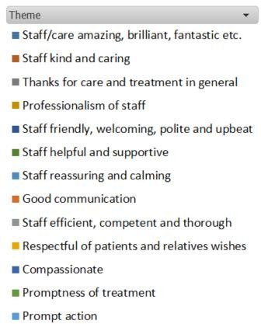

# Voluntary Services

* 1. The purpose of the Voluntary Services Department is to encourage the involvement of local people in the day to day running of our services and to improve patient experience through partnership working. There are currently more than 230 volunteers at St George’s who provide invaluable support to paid staff and service users. This is a significant increase to the previous year where we saw only 90 people return to volunteering after the pandemic.

We aim to:

* + - Meet the needs of our service users though the involvement of volunteers.
    - Continue to promote Trust Values.
    - To offer a rewarding experience to our volunteers.
    - To ensure safe and effective volunteer recruitment and management by adhering to our policy on The Involvement of Volunteers within St George’s University Hospitals NHS Foundation Trust.
    - To offer recognition for the achievements of volunteers.

# Voluntary Services recruitment

It has been a successful and busy year for Voluntary Services at St George’s. Recruitment of volunteers has been steady and since April 2023, we have welcomed 76 new volunteers into a number of roles and 35 people are currently going through the onboarding

process.

Our volunteers reflect the diversity of the local community. Demographic details relating to active volunteers provides an insight into the diversity of volunteers, together with length of service to show the commitment that volunteers make to the Trust.

Voluntary Services is an inclusive service, making people feel welcome, respected, and valued no matter what their background. We are flexible and work hard to support people with disabilities and place them in a role that works for them and the team they are assisting. If there is not a suitable role available, then we can sign post them to other volunteer opportunities within the local community.

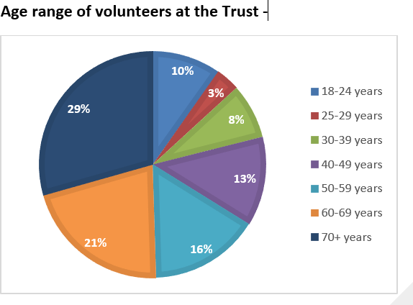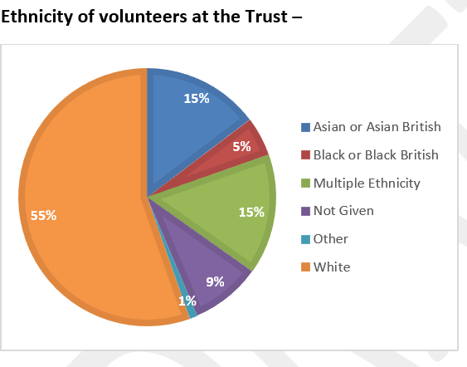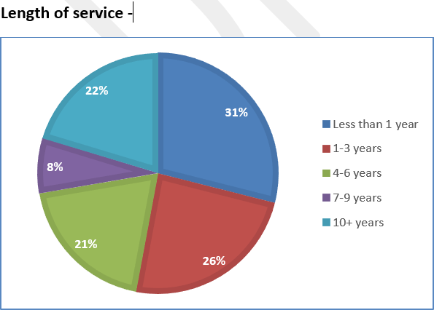

# Activities and initiatives for Voluntary Services at SGH

From April 2023 - March 2024 volunteers were engaged in several activities and initiatives including:

* + - Since April we have welcomed 62 volunteers on to our induction programme. After collating the evaluations, it showed that 90% of the attendees thought the training was excellent and the other 10% thought it was good, none rating it average, poor, or very poor. Some of the

feedback following volunteer induction has included: *“Outstanding performance, the lecturer was excellent. Huge thank you!” “The induction was very informative, interesting and simple to understand.” “I have learnt so much today and will benefit so much form Louise’s talk today.” “Very interesting induction and enjoyable.”*

* + - Each year we celebrate Volunteers’ Week in the first week of June to acknowledge and celebrate the work of our volunteers. Volunteers were invited to the new Volunteer Hub for a tea party. A grant from the St George’s Hospital Charity was secured to provide an area for volunteers to take a break and provide a welcoming space for volunteers.
    - Five volunteers reached their 10 years long service milestone. It is great to see how many volunteers stay with us for much longer than the minimum commitment of six months!
    - Volunteers who support the Macmillan team began hosting ‘George’s Green Club’. This provides an opportunity with people affected by cancer to discover all the beautiful green spaces within St George’s. Attendees learn about biodiversity and how to take photos of these beautiful spaces on their smartphones. The photos will be displayed at a yearly exhibition in November.
    - As recognition and to say thank you to our amazing volunteers, a summer trip to Windsor was organised. The volunteers who attended had a lovely day and enjoyed catching up with other volunteers they may not see on a weekly basis. Travel and lunch were provided by an annual grant from the Hospital Charity.
    - Two new volunteers who are ex Neonatal Unit (NNU) parents have started as Neonatal Peer Supporters. They offer support to current parents with their neonatal unit journeys.
    - A new befriender role has been created to support the Major Trauma ward. Patients are often admitted following an unexpected injury and present significant physical injuries. The befrienders would support these patients who may not get visitors or have family near, by establishing a befriending relationship, talking, and joining in with activities.
    - The Rapid Access Acute Rehabilitation (RAAR) Service is a new innovation within London, to support individuals with conditions affecting their brain and/or spinal cords, with some also having additional traumatic injuries. Two new volunteer roles have been developed to support patients. A reading volunteer who will establish a reading group, allied to The Reading Agency’s “Reading Friends” and “Reading Groups” work. Also, an activities volunteer who will support engagement in patients’ structured programme of rehabilitation.
    - Marie Curie is partnering with St George’s to provide Marie Curie Companions. Marie Curie Companions provide emotional and practical companionship for people at or approaching the end of life, and those close to them. The companion volunteers will also be Trust volunteers so will complete the same recruitment checks and onboarding process. St George’s Hospital will be the pilot site before introducing the scheme to other Trusts in the SWL area.
    - Nine volunteers took part in the Patient Led Assessment of the Care Environment (PLACE) at St George’s and Queen Mary’s sites. The volunteers made up half of the assessors, the other half being staff.
    - Seven more volunteers have joined the Emergency Department volunteer team and three current volunteers are now supporting the accreditation team on ward visits.
    - Pets As Therapy (PAT) team has now reached 20 volunteers. This is great as for many years there have only been one or two visiting patients. The rota is being reviewed to streamline the process, so patients and our PAT volunteers get the most out of their visits.
    - In November one of our volunteers did a reading at the Armistice Day service, and another presented her patient story to the Board about her role as an unpaid carer.
    - The volunteers were invited to lunch over the Christmas period. 40 volunteers attended which is not as busy as usual, but it was lovely to see some new faces and welcome those volunteers who had just started to the St George’s team.
    - The SGH voluntary services manager has been working with Central London Community Healthcare NHS Trust who will be providing additional breastfeeding peer support volunteers for the maternity ward.
    - The voluntary services manager from SGH attended the Voluntary Sector Forum to spread the word about volunteer recruitment in the local area. She will also be attending the Balham and Tooting Community Association BACTA Funday in June.
    - Trust volunteers have also supported the Hospital Charity at several of their fundraising events. The abseil down the Pelican Hotel in the grounds of St George’s Hospital and cheering on the runners in the London Marathon.
    - Four of our volunteers are supporting the Dementia and delirium team with the patient survey for the National Audit of Dementia. They have attended a Dementia Awareness session and will be starting in the next couple of weeks.
    - A couple of our volunteers supported the recent career support workshop for people who have experiences homelessness. They gave accounts of what it’s like to volunteer at the Trust, what they get out of it and how they support patients to provide a positive patient experience.
  1. **Voluntary services at ESTH**

The service is asked daily for volunteers in all areas of our hospitals, and we have at least 20 new expressions of interest every week, not all of the people coming forward are suitable for the Hospital environment, and in those cases the Voluntary Services Manager re-directs to other voluntary groups in the community.

Volunteering activity levels at Epsom and St Helier has reached 199 volunteers, including all corporate volunteers and volunteers that give their time regularly each week to support our patients and staff from the 12 supporting Charities. In this year 3 volunteers have become HCA’s in our Trust as a result of their experience Volunteering on our wards.

Work Experience started in July 2023, and we placed 33 students across the Trust in Physiotherapy, Nursing, IT, the nursery, EME and the SALT team, between July and September.

The Voluntary Services Manager, along with the Associate Director of Nursing and Work Experience Co-ordinator for Medical Work Experience are now going back into Schools and Colleges to give talks on volunteering and Work Experience at our Trust. The talks include - the process of becoming a volunteer or having a work experience placement, the benefit and enrichment gained from both and the value that volunteers bring to our patients, visitors, carers, and staff.

The majority of Hospitals do not host work experience or volunteering for students under 18 years old, but ESTH have hosted students aged 16+ for over ten years, as we understand that if we nurture and guide these students, they are more than likely to work for our Trust in the future.

In this reporting period two volunteers have become full time HCAs employed in our Trust.

We are working with “Surrey Choices” who support disabled people, autistic people, those with sensory needs, and those with mental health problems. Their objective is to allow every person the chance to fulfil their potential and reach their goals, through enjoying, learning and achieving, and we can tailor volunteering roles to suit the person without bias or judgement to enable and benefit all parties, we currently have three young people from surrey choices currently helping with wayfinding at EGH.

Plans are in place to work with the Rehabilitation units at both EGH and STH to format a weekly plan of activities – Bingo, Knit & Natter, arts and crafts, colouring, puzzles, reading groups, history groups, afternoon teas and much more.

# University Placements

We have had 12 placements from colleges and Universities, these students need to complete a minimum of 100 hours for their assessments.

Merton college – 5 students on a Health and Social Care level 2 course 4 students on a Health and Social Care level 3 course

Coulsdon College- 1 student on a Health and Social Care level 3 course Kingston University – 1 student on a Nursing, Midwifery and Public Health course

Plymouth University - 1 student who needed experience to decide whether to swap from Biomed Science to Medicine

These students were on boarded as volunteers and 4 have continued to volunteer after their 100- hour placement.

The student from Kingston University is considering coming straight to our Trust as soon as a role/apprenticeship becomes vacant. The student from Plymouth University had such a great time at STH on the wards he has decided to go into Medicine and hopes to work at our Trust in the future.

# Volunteer Engagement Events

The voluntary services manager from ESTH has organised 5 local volunteering engagement events and is working with local volunteer agencies and NHS England to list as many opportunities as possible hopefully across all GESH sites.

# Unsung Hero award winner

In March 2023, the annual Unsung Hero Awards took place. The awards celebrate the contributions made by non-medical, clinical NHS staff and volunteers.

It was a very special evening for Lynne Witham, Volunteering Manager, ESTH, who won an award. Lynne had been nominated in the Admin and Clerical category for her work looking after our many volunteers who make a huge contribution to all aspects of hospital life. The award also recognised Lynne's devotion to making ESTH a better place to work with her work as a Culture Champion, and her support for teams such as EDI and Chaplaincy.

# GESH Renal volunteers

As the Renal Development Programme is a St George’s and Epsom and St Helier (GESH) project, when the patient experience team were approached for volunteers, a new approach was developed. The team were supported to recruit GESH Renal Patient Partners. Volunteers who are exclusively GESH, to support partnership working through all elements of this exciting project.

# Patient Involvement and Engagement

There are many examples of patient involvement and engagement initiatives across St George’s and Epsom and St Helier. There are too many to highlight in one report, but two key examples are as follows:

# Spotlight on Outpatients – St George’s

The outpatient team of 380 diverse clerical, managerial and clinical staff work to ensure the smooth running of clinics. Often, we thank the front facing clinical teams who are visible within our organisation. We forget though that there is a powerhouse behind the scenes, making sure that clinicians can see patients in clinics, taking all the blood tests in the hospital, answering patient queries, or guiding lost patients to the correct clinic.

The teams work across 4 sites, see over 57,000 patients/month, deal with over 23,000 referrals/month and answer and respond to 120,000 calls per year. They have also managed Industrial Action, which started in January 2023, and there have only been two months in the past financial year without this impact.

The other operational pillar in Outpatients is digital transformation and we should not forget the human touch that guides and comforts patients, provides reassurance with difficult news and supports patients through their journey by ensuring letters and text messages are sent, results and notes filed.

# Projects and Priorities

Over the last 5 years the outpatient team have ensured the successful delivery of the following projects and priorities:

* + 1. Digital transformation – including launching eCDOF, the Patient Portal and the phlebotomy booking system.
    2. Staff Wellbeing Matters
    3. Healthcare inequality and priority setting partnership with patients leading audits and research projects with medical students.
    4. Support and delivery of vaccine trials during the COVID-19 pandemic
    5. Ongoing staff training and development to hear our outpatients’ voices.

# How have we delivered these projects?

* **Digital transformation:** Conversion of a paper-based system for 19,000 patients/week before the COVID-19 pandemic to a digital notes system allowing increased activity after the pandemic.

Launch of electronic triage systems to allow all referrals to be triaged within 48h. Advice and guidance for GPs integrated within each service with governance reports to ensure requests answered within 48h. Successful launch of a patient portal with 98,000 patients registered has allowed patients to view appointments and results. Launch of digital booking for phlebotomy which has reduced patient waits from 2h to a defined time for their appointment.

* **Staff health and wellbeing:** Our teams have led on wellbeing initiatives such as walking six million steps in May 2023 (raising £1,250 for charity) – this has allowed us to invest in staff thank you lunches and raffles at Christmas. Our staff are so proactive and have led on starting a book donation club, a running club, and an annual sports day event too. The teams introduced mental health first aiders, supporting staff with anxiety or neurodiversity. The team have led

on a creating a culture of continuous improvement and our junior managers lead their own improvement initiatives for 6–8 months. This improved their own capabilities and led to introducing Local Recognition Initiatives called ‘Outpatient NHS Heroes Awards’, where staff can nominate one another for outstanding contributions in the workplace. We also have our weekly Happy Friday emails which share good news across our large Directorate.

* **Healthcare inequality:** seven student projects with university support have investigated topics ranging from socioeconomic inequality and its effect of did not attend rates, childhood obesity and diabetes risk, ethnic diversity and risk of pre-eclampsia, ethnic diversity, and risk of death from a fractured neck of femur admission, socioeconomic group, and risk of late presentation to a breast cancer clinic.
* **Patient partnerships and dissemination of James Lind Alliance report:** The team have aimed to ensure at all points, but particularly when focusing on outpatient transformation, that the patients voice is heard. This includes a patient partner being a member of the Outpatient Steering Group, to ensure our priorities are guided by service users. Furthermore, a priority setting partnership with the James Lind Alliance surveyed over 1,200 patients, clinicians, and administrative staff to prioritise the top ten priorities in research for outpatient service delivery. Our work with the JLA ([https://www.jla.nihr.ac.uk/priority-setting-partnerships/outpatient-service-](https://www.jla.nihr.ac.uk/priority-setting-partnerships/outpatient-service-delivery/) [delivery/](https://www.jla.nihr.ac.uk/priority-setting-partnerships/outpatient-service-delivery/)) has produced a final report detailing what patients, clinicians, administrators and managers have prioritised as the top ten priorities for outpatient service delivery research which has its national launch on 8th April and will be shared with key policy makers to highlight the need for further research into outpatient services. Friends and family feedback rates our outpatients ‘good’ or ‘very good’ in 80-85% of feedback.
* **Further developments, hearing the ‘patient voice’:** Our teams have all undertaken specific customer service training co-designed with the Learning and Education department and tailored specifically for outpatient reception and call centre staff. This has ensured that our staff have been trained to the best of their ability and they know the importance of every interaction that have with a patient.

# 11.4. Spotlight on Marie Curie Companions Service

It has been an incredibly positive start for Marie Curie’s new volunteer-led Companions service, which soft-launched at St George’s Hospital in early February 2024. Our Companion volunteers provide emotional support to patients in their final hours and days, as well as offering essential respite support for all those who care for them.

# Recruitment

Recruitment for volunteers began at the end of November 2023 and the response has been extremely encouraging. There are already almost 40 x applicants who are now either fully recruited, or part way through the onboarding process, with multiple applications coming in each week.

All volunteers go through rigorous checks and training by both Marie Curie and St George’s Hospital. The volunteer teams at both organisations have therefore worked closely and collaboratively from the outset, to help ensure that the onboarding process works as efficiently as possible, and that the high level of interest in the role is maintained and not lost along the process.

# Referring a patient.

Our volunteers provide support on an “on-call” basis, which helps to ensure that we can reach as

many patients as possible, as quickly as possible.

Once a patient has been identified as someone who would benefit from our service, a basic form then needs to be emailed to the Marie Curie referral “Hub” team. The Hub team will then contact the next available volunteer on the rota and ask that they visit the patient as soon as they are able.

Although, not officially termed as a rapid response service, we do aim to complete a visit within 24- 48 hours and will always do our best to provide a volunteer more quickly should a more urgent referral come in.

# Launch & progress so far

The Companions service soft-launched in two wards (Marnham and Trevor Howell) on 5 February 2024. Due to the incredible recruitment progress, we were able to expand our support into four wards within just a few weeks. The service has recently expanded once again, and now offers support across 6 x wards within the hospital: Dalby, Gordon Smith, Heberden, Marnham, Richmond and Trevor Howell.

We are thrilled with how well our Companions service has been received at the hospital - referrals are starting to come in and our Companions have spent some invaluable time with patients. There has been a positive and heartwarming feedback from staff, volunteers, patients, and their families, regarding the difference that our service has made.

# Plans for the future

Recruitment continues at a strong pace, and maximising the fantastic number of volunteers who are now ready to offer their time and support to end of life patients.

It is important to balance the number of active volunteers with the number of referrals coming in from the hospital. It is vital that we can support as many patients as possible, whilst keeping our volunteers engaged and feeling supported, respected, and valued. Therefore, close monitoring of service activity, together with maintaining open channels of communication between myself, St George’s staff and of course our wonderful volunteers, remain a top priority as the service is embedded.

The service will continue to expand over the coming months, building on the number of referrals being received. Contact has already been made with two additional wards, who are now considering implementing the service, and consideration is being given to the next wards to approach after that.

The implementation and launch of the service has been a real team effort. The service and supporting teams are hugely proud of what has been achieved together in a relatively short space of time.

# CARERS

gesh is committed to supporting unpaid carers and is working across the group to ensure unpaid carers have access to consistent systems, advice, and support. In April 2023, St George’s did not have a system in place to support unpaid carers and used the launch of NHS England Carers and Hospital Discharge toolkit in March 2023, to launch this workstream, beginning to explore what was needed at SGH to be compliant with statutory requirements and changes in the Health and Social Care Act.

# Project milestones update for St George’s Carers in 2023/24

|  |  |  |
| --- | --- | --- |
| **Milestone** | **Update** | **Status** |
| Carers Steering Group | Launched in July 2023 | Complete |
| Carers Forum | Advertised between October – December – with minimal interest. Associate Director of Patient Experience presented at the ESTH Forum in March 2024 and asked if this forum could be expanded to become a gesh forum and this was agreed by all  present | Complete |
| Awareness program | Launched in June 2023. Series of events recognising carers days, advertising events, newsletter, intranet page launched, patient story, collaborative event with Healthwatch Wandsworth in the form of listening event for carers exploring discharge experience  and exploration of virtual wards. | In progress |
| Support for staff | Carers contact sheet developed in partnership with carer and  patient in October 2023, making it easy for staff to refer patients to borough specific carer agencies | Complete |
| Training for staff | Rolling program of training in partnership with Wandsworth  Carers Centre with sessions running for all staff | In progress |
| System to capture carers details on iClip | Bespoke form designed in partnership with Associate Director of Patient Experience and Transfer of Care (TOC) Matron  Tested by iClip champions, discharge team, STAR team, TOC team | Complete  Complete |
| Capture if patient  is a carer | Added to Carers tab |  |
| Method for capturing young  carers | Amendment made to new tab following input from carers steering committee | Complete |
| Go live for new  carers tab | Go live date planned for 23 April 2024 | Anticipated |

|  |  |  |
| --- | --- | --- |
| Documentation to support new system for data  capture | SOP drafted by Associate Director of Patient Experience Quick reference guide (QRG) drafted by Transformation Team | Complete Complete |
| Carers Policy | Existing ESTH policy in place. Plan to review and expand to make group wide. | In progress |
| Promote partnership working | SGH Steering group includes members of staff, patient, carer, ICB, Wandsworth and Merton reps, Age UK, Rise +, Dementia team.  Training provided by Wandsworth Carers Centre (WCC) to all staff, with daily visits to the wards at SGH by WCC to identify and support carers. |  |

* 1. **Epsom and St Helier Carers Project**

ESTH has good systems in place supporting unpaid carers. An overview of key achievements within the year are detailed below:

# New Unpaid Carers leaflet

Following feedback from our Carers Forums in October 2023 we launched our new leaflet which incorporates the **“identify, register and support**” campaign themes.

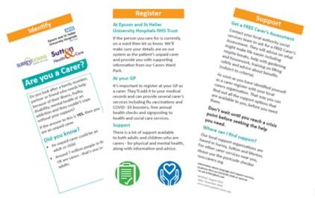

* + - Identify unpaid carers (and help them identify themselves!).
    - Register their carer status on our Patient Administration System.
    - Support and signpost them, so they get the help they need to care for their loved ones and themselves.

Carers Ward Packs are regularly updated to ensure they contain all the information required to help and support a carer when they have been identified on a ward. Our packs include a step-by-step guide to register and record carers on our Patient Administration System.

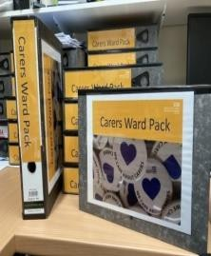

There is also guidance on how to refer carers to their local carer organisation. The new Carer Contact Sheet co-designed with carers/patients is included in the ward packs. This will signpost identified unpaid carers with the support services in their local area. SGH are considering launching a similar pack for wards.

We continue to promote the Carer awareness events during the year and host events with our supporting local carer organisations, Action for Carers (Surrey) and Sutton Carers Centre.

# Recognising carers events at gesh Carers Week

Both St George’s and Epsom and St Helier celebrated Carers Week in June by raising awareness,

engaging with staff, patients, and carers.

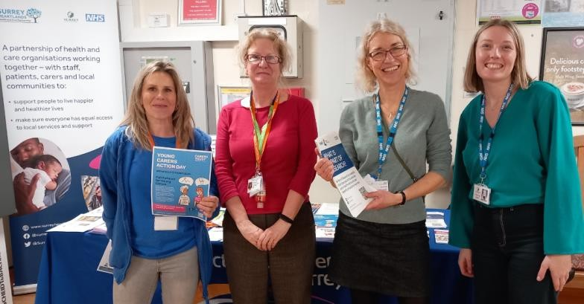

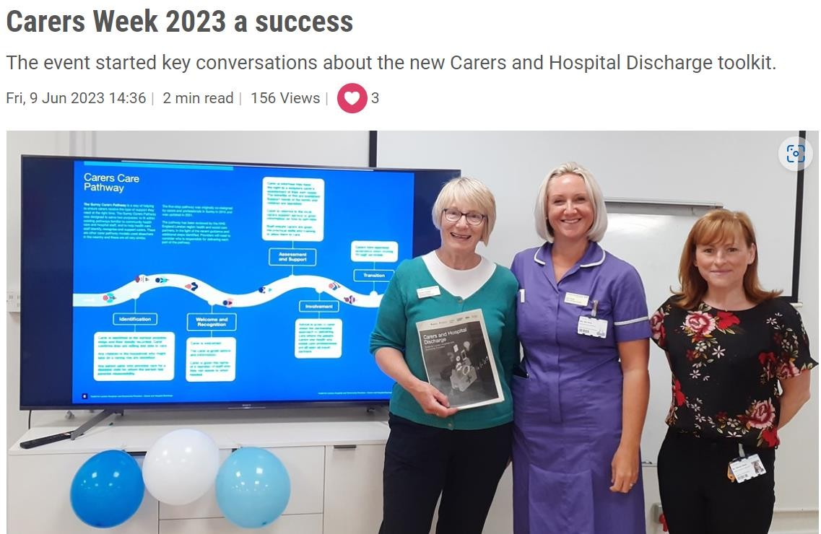

# Carers Rights Days

Gesh supported Carers Rights Day, highlighting that in May 2023; the Carers Leave Bill gained Royal Assent, and is now the Carer’s Leave Act 2023. This will give employees who are juggling work with unpaid care a legal right to request up to five days unpaid leave every twelve months. We expect the Act to become law in 2024.

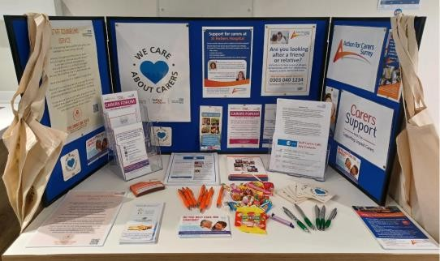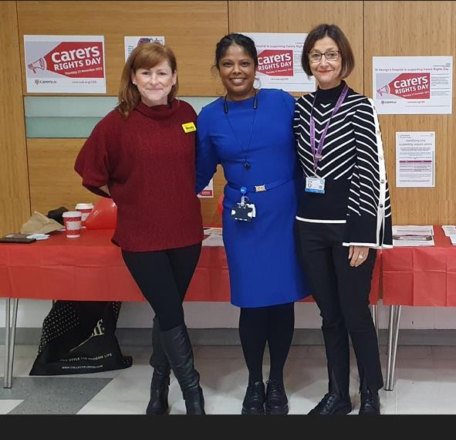

# Young Carers Action Day

Gesh promoted Young Carers Action Day, which was an opportunity to raise awareness of the

struggle’s young carers face on a day-to-day basis. This year’s theme was “fair futures for young carers” focusing on building a more equal future for young carers and removing the barriers that many of their peers do not have to face.



# Carers Awareness training at ESTH

Online training module so now everyone can complete this session when it is convenient for them. The training is open to all staff and volunteers.

The training covers:

* + - The definition of an unpaid carer and how to identify them.
    - Carers and the law
    - Different groups of carers: young carers, veterans, and dementia
    - Support mechanisms in the Trust
    - Support available to staff carers

# Carers Awareness Training at St George’s and Queen Mary’s

This training is delivered in person by Wandsworth Carers Centre, supported by the patient experience team. The creation of an online module at SGH is under consideration if this would make this training more accessible for staff.

# St George’s and Healthwatch Wandsworth collaborative event

A collaborative event was held by St George’s and Healthwatch Wandsworth in December 2023 to explore the views of carers focussed on discharge experience and virtual wards. The findings can be viewed here:

[Carer experiences about hospital arrangements through to discharge | Healthwatch Wandsworth](https://www.healthwatchwandsworth.co.uk/report/2024-03-04/carer-experiences-about-hospital-arrangements-through-discharge)

# Priorities for Carers projects for 2024/25

Whilst 2023/24 saw significant progress for Carers, the need to continue raising awareness for all gesh staff of the need to identify carers, and of the support available through referring them to borough specific services to ensure unpaid carers receive advice and support. Priorities for the year ahead include:

* The creation of a toolkit to support staff to signpost and refer patients and carers to available support agencies including Rise +
* Encouraging staff to attend training.
* Increase in the identification of carers.
* Increase in numbers of carers being referred to support agencies.
* Monitoring tools in place to identify wards and departments identifying and referring carers to support agencies.
* Improvement in safe and effective discharges by identifying, recording carers details, and involving and supporting carers in discharge planning.

# ARMED FORCES COMMUNITY

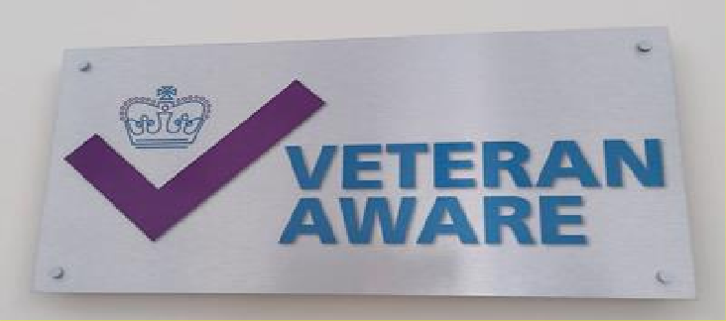

* 1. **Veterans Accreditation**

We are proud to have achieved the Veterans Covenant Healthcare Alliance (VCHA) accreditation and

are now a ‘Veteran Aware’ Trust.

Both ESTH and SGH are being accredited by the VCHA in July 2024. Gesh are committed to having robust processes in place to identify members of the Armed Forces, being able to record this on hospital systems, and to signpost to appropriate services.

A busy period is in place between April-July 2024 in preparing for this accreditation period. gesh have employed a Patient Experience Lead to focus on this workstream, we are proud to announce that this individual is a member of the Armed Forces Community, with strong links to the VCHA, to advise and secure our position as a Veteran Aware organisation.

The SGH Veterans meeting, chaired by the site Managing Director is working hard, establishing new systems, networks, and processes to ensure strong awareness and engagement, communications, and recruitment processes to ensure we can:

* Identify and support staff who are members of the Armed Forces Community
* Identify and support patients and families who are members of the Armed Forces community.
* Ensure staff are supported to identify, record, support, learn about the Armed Forces Community, confident in processes, training, awareness, and systems in place to ensure appropriate care and treatment in line with statutory requirements.

# Recording members of the Armed Forces at ESTH

The Patient Experience team has supported the Trust to have a process in place where veteran reports are shared on a weekly basis between iPM and EMIS to mirror the alerts on both systems and have a definitive log of the total number of armed forces community identified, required as part of our Veteran Aware re-accreditation in 2024. Between October and March, 64 members of the Armed Forces Community were identified. This takes ESTH to a total of 668 members of the Armed Forces Community identified since recording started in June 2022.

# Recording members of the Armed Forces at St George’s

The implementation of a similar system on iClip is in progress, one that can be mirrored when ESTH move to iClip later this year.

# Veterans Aware Steering group at ESTH relaunched

In February 2024, the Patient Experience team re-launched the Veteran Aware working group at ESTH. The group has members from across the Trust within different services. Some of the members are members of the Armed Forces Community, and it is extra special to have them on board. Over the coming months the working group will be working towards our re-accreditation.

# Programme of work for 2024/25

A robust plan for the next few months has been drafted for both ESTH and SGH, ensuring that not only accreditation will be achieved through the VCHA but, in addition, making gesh proud to be called Veteran Aware by having robust systems in place and a strong network of support for all members of the Armed Forces including staff, patients, families and carers. Gesh is working in partnership with patients, volunteers, staff and members of the Armed Forces community to ensure we have a programme of work that covers the following workstreams:

# Epsom and St Helier:

**Epsom and St Helier 3-year accreditation process covering:**

* Training
* Expansion
* Community links
* Awareness
* Digital information
* Events

# Epsom and St Helier Defence Employer Recognition Scheme covering:

* Silver award revalidation
* Policy review for adult volunteers, Cadet leaders and Spouse
* Consideration of award alignment across gesh
* Events
* Gesh alignment of award

# Epsom and St Helier Step into Health for NHS Employers covering:

* Data sharing
* Clarification of responsible staff member
* Events

# St George’s:

**Awareness and engagement workstream covering:**

* Patient identification
* Events including breakfast club.
* Training
* Support and information hub
* Digital information

# St George’s Defence Employer Recognition Scheme covering

* Gold award revalidation
* Policy review
* Gesh alignment of award

# St George’s Step into Health for employers covering:

* Gesh alignment
* Events

# Learning from patient experience 2023/2024

During the last year, clear feedback from patients has been captured from a variety of methods including surveys, listening events, feedback, patient stories and through our patients’ partners and volunteers. Feedback themes captures:

|  |  |  |
| --- | --- | --- |
| **Topic** | **Theme** | **Action** |
| Communication | Patients would like information available in a variety of ways | Review PING processes and policy and ensure information available in digital,  paper, easy read, different formats and accessible ways. |
| Posters for patients | Information displayed on walls should be clear, purposeful and relevant | Corporate Poster group set up to review all corporate posters with clear  learning for the organisation made |

|  |  |  |
| --- | --- | --- |
|  |  | available to inform new gesh branded posters.  Additionally, toolkit for staff drafted to help inform staff when considering posters with clear guidance produced  by patients. |
| Patient letters | Clear information with up-to-date contact details | Review outpatient letters to ensure information contained is clear, concise and contact details are available in  accessible ways |
| Transport for patients with learning disability | Improve efficiency and safety of transport processes for patients with a learning disability | Meeting set up with representative from LD PPEG and the transport team to allow opportunity for patients views to be heard with clear actions for staff  to improve service |
| Accessibility | Information for patients should be available in a variety of formats to ensure compliance with the accessible  information standard | Establish steering group to review patient information and pathway to contact staff and ensure accessible  methods in place |
| Improve discharge process | Carers should be involved in discharge process | Set up carers steering group to ensure the voices of carers is heard and review processes in place that meet statutory requirements for identifying and  involving carers |
| Information available to families at time of diagnosis for children with cancer | As a joint primary treatment centre, ensure consistent information, support and advice available for families around time of diagnosis | Establish joint working group with the Royal Marsden hospital to review information for families and to improve accessibility of information, available in  a variety of formats |
| Food to be available outsides of  mealtimes | Inpatients would like to be able to access food outside of mealtimes | Work with catering team and dieticians to monitor availability of snack packs  for patients |
| Menu visibility | Menus to be available for patients ensuring access to the wide range of food available covering multiple requirements  including cultural and dietary options | Menus now available in paper and electronic format increasing the visibility of all food options for patients  to increase choice |
| Wait times in A&E | Improve patient experience in A&E | Establish a patient user group to work  with patients to improve experience |
| Availability of masks  in outpatients | Immunosuppressed patients would like  staff to wear masks in outpatients | Ensure masks are available in  outpatient areas for patients |
| Wait times in A&E | Improve hydration of those waiting to be  seen and/or admitted. | Dolly Hydration Station implemented in  Epsom ED |
| Lack of gowns | Gowns need to be available for privacy an  dignity reasons | Gowns are now ordered and available  for Outpatients |
| Wound management  advice | Written information required following  hysterectomy | A post-operative wound leaflet is in  progress |

# Learning from feedback in the Emergency Department (ED)/Urgent Treatment Centre (UTC)

Getting care right for patients, consistently, when they attend for emergency care/treatment can be challenging. However, we are committed to making improvements in this area as we recognise the importance of how attendance via the emergency department feeds into and impacts all other areas of the admission. Some examples of learning from St George’s Emergency Department include:

* Urgent Treatment Centre intranet development making improvements to include a designated page for practitioners with relevant operating procedures, guidelines, and patient information leaflets accessible via different formats.
* A working group for the urgent treatment centre, virtual fracture clinic and physiotherapy team has been set up, working collaboratively to streamline patient information leaflets for differing musculoskeletal conditions ensuring consistent information is received by the patient throughout their journey.
* Get U Better App – App is provided to patients on discharge from the ED/UTC and contains useful information, exercises, pain management advice and the ability to refer themselves to their GP and/or to physiotherapy.
* UTC and Virtual Fracture Clinic have a working group and are reviewing referral pathways, follow up criteria and a standard operating procedure.
* Robust learning and feedback channels, making improvements through feedback through FFT and other patient feedback.

At Epsom and St Helier, plans are in place to improve FFT responses, through a refresh of posters and information from patients as well as re-introducing FFT postcards in the ED.

# Patient Stories

The power of the voice of the patient, telling their story, in their words is a priority for the Board. A 30-minute slot is in place at every board meeting, inviting a patient to attend the meeting in person, to share their story.

A variety of stories are invited to the Board, including patients from the respective site where the board is held, to share their experience and for the department to share any learning arising from the patient story. Patient stories are identified from complaints, PALS, the patient experience team, volunteers, and through patient forums and support groups.

Divisions are encouraged to identify potential board stories, showcasing learning from feedback, and to demonstrate to the Board, their commitment in making improvements through listening and being responsive to the voice of the patient.

# LETTERS FOR LOVED ONES at ESTH

Letters for Loved Ones service, was launched in April 2020 in response to the Covid-19 pandemic, continues to run and is now a permanent service. It continues to keep families and friends in touch

with loved ones. Numbers of messages have decreased significantly since visiting rules were relaxed; however, it still brings much comfort to those who aren’t able to visit in person for many other reasons.

From April 2023 - March 2024:

* 67 separate messages were delivered.
* The highest month for receipt of messages was November 2023 (12)

# Visionable – ESTH

In February 2024 we relaunched our Virtual Visiting service, which allows us to facilitate a face time like call between patients and their family or friends if they are unable to visit the patient. Since the launch, we have facilitated 7 virtual visits for our patients, and seen first-hand the joy and happiness these have given to our patients.

We have 6 tablets that can be used to facilitate virtual visiting. 2 are kept in the Patient Experience off at STH and 2 are kept in each of the PALS office at both STH and EGH. Anyone can request a virtual visit, and this can be done by emailing the Virtual Visiting inbox ([esth.virtualvisiting@nhs.net](mailto:esth.virtualvisiting@nhs.net)). This service is available Monday to Friday between 9am – 5pm and we would ideally ask that we are given 24hours notice to facilitate the call, however the patient experience team will do everything they can to facilitate as requested.

# Priorities for 2023-2024

To improve patient experience across the group, close working relationships with patients, volunteers, community groups and staff are needed, working together, in partnership with our patients. This should be done in a variety of ways to ensure the service is accessible to all patients from our rich a diverse community. There are many priorities for the exciting year ahead including:

# Carers

* Continue to train staff and raise awareness to ensure that the tools and processes in place become embedded.
* Involve carers in discharge planning.
* Record unpaid carer status on iClip
* Recruit unpaid carers for the gesh carers forum.
* Carers café

# Veterans

* Successfully VCHA accreditation which is due to take place in June/July 2024
* Work with the L&D team to have the Armed Forces Community training more visible online for staff to complete.
* Veterans wellbeing hub

# Friends and Family Test (FFT)

Continue to monitor the response rate for the Trust and work with all areas to continue to ask our patients to provide their feedback.

# Accessibility

* Develop an Accessibility and Communication policy in partnership with the Communications team.

# Learning from feedback

* Work with senior team to develop robust method for capturing learning across organisation and sharing with patients’ actions arising from feedback.

# Patient Experience Events

* Quarterly events including listening groups, workshops and focus groups.
* Workshop run by volunteers on setting up patient support groups.
* PPEG workshop to consider the patient voice in fundamentals of care.

# Integration

* Continuing to align across the group building on achievements of 2023/24
* Closer working of staff between St George’s and Epsom and St Helier
* Group leadership post in place
* Band 7 Group Patient Experience Lead post in place to support workstreams.
* Aligning Patient Experience Groups and Patient Led Assessment of the Care Environment (PLACE) across gesh
* Patient Experience focus on patients and carers attending our Emergency Departments