PAEDIATRICS

Introduction
Welcome to your Paediatrics attachment at St George’s Hospital! We are a busy tertiary level Children’s Hospital, with lots to keep you busy and learning over the next five weeks.
Below is some useful information for while you are with us at the Trust.
The timetable you will have been sent contains your key information on where to be and when; let us know if you have any questions or queries about this! You will also have been sent a Student Handbook, which contains lots of information.
Canvas contains a wealth of information, including the History taking and Clinical Examination Skills in Paediatrics booklet.
Key Locations Map: Paediatrics
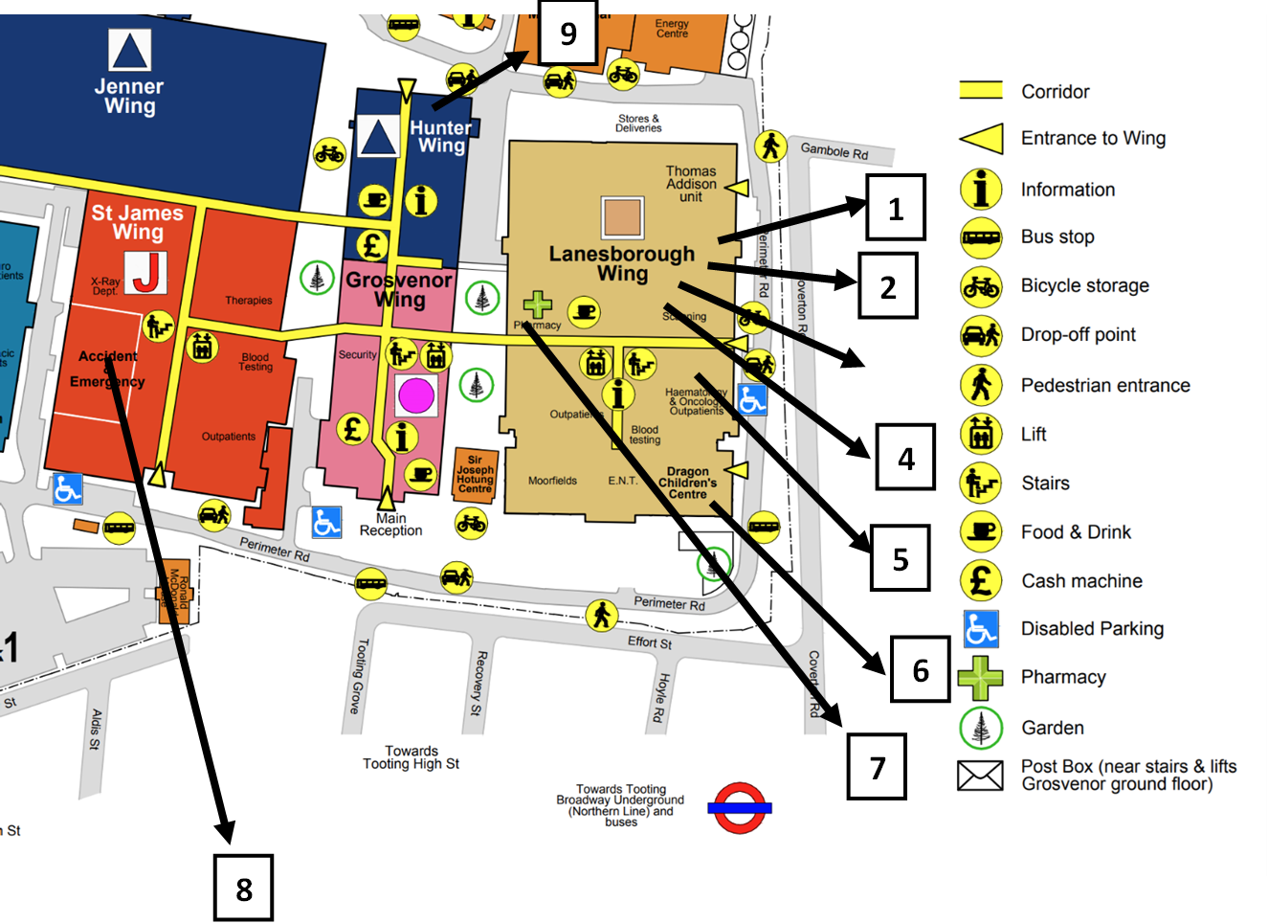

Number on map | Location | Sessions
1 | Paediatric seminar room – 2nd floor Lanesborough  (* see below for directions) | Orientation  Medical student simulation  Medical student teaching (as per timetable)  Paediatric teaching (see table below)  Paediatric handover at 08.30  (Paediatric consultant offices are on the corridor here too)
2 | Neonatal seminar room –  1st floor Lanesborough  (** see below for directions) | Neonatal medical student teaching (as per timetable)
3 | Neonatal unit (NICU)  - 1st floor Lanesborough | NICU ward (handover takes place at 08.00, join the team at 08.30)
4 | Postnatal ward (PNW, Gwillim)  - 4th floor Lanesborough | Postnatal ward sessions (mornings)
5 | Paediatric inpatient wards – 5th floor Lanesborough | Frederick Hewitt, Pinckney, Nicholls wards  Paediatric Doctors Office is on the corridor outside Nicholls ward – meet here for clinical skills tutorials
6 | Dragon Centre – Ground floor Lanesborough | Hot clinics – Tues / Thurs / Fri mornings (arrive at 08.45)
7 | Paediatric Intensive Care Unit (PICU) – 1st Floor Lanesborough | PICU ward – attend the Paediatric Intensive Care Unit Seminar room at 08.30 (opposite entrance to PICU)
8 | ED – Paediatric Emergency Department | ED - for am session, attend paediatric handover in seminar room at 08.30  For pm session, attend directly at 14.00
9 | Hunter wing | Some teaching may take place here (especially Simulation if the seminar room is booked) – refer to your timetable

* How to find the Paediatric Seminar Room
The Paediatric seminar room is located on the 2nd floor, Lanesborough Wing.
From the SGUL library on the 1st floor, walk towards the Lanesborough wing canteen. Keep walking straight on past the canteen all the way to the end of the long corridor. Go through the double doors at the end, turn right and then left (don’t enter the neonatal unit), following the sign to facilities and procurement up the stairs to the 2nd floor.
Walk up the corridor that slopes upwards to the door to the Paediatric offices corridor; you will need to ring the bell if your swipe card doesn’t give you access.
At the end of the Paediatric offices corridor is the seminar room.
Nb: The main Lanesborough wing lifts do not have access to the second floor.

** How to find the Neonatal Seminar Room
The Neonatal seminar room is located on the 1st floor, Lanesborough Wing.
From the SGUL library on the 1st floor, walk towards the Lanesborough wing canteen. Keep walking straight on past the canteen all the way to the end of the long corridor. Go through the double doors at the end and turn left. Go through the door on the right, opposite the lockers – this is the Neonatal offices corridor.
Turn left, go all the way down this corridor; the neonatal seminar room is at the end.

Departmental teaching
Aimed at the paediatric team, but you are very welcome and encouraged to come if available!
Day | Time | Topic | Location
Tuesday | 08.30 – 09.00 | “Tricky” paediatrics | Paeds seminar room
 | 13.00 – 14.00 | Paediatric / neonatal x-ray meeting  - Interesting X-rays, presented by the Paediatric Radiology Consultants. | X-ray dept, St James’ wing
Wednesday | 08.30 – 09.00 | Simulation or QI or Resilience teaching  - If Sim in ED, handover occurs straight after rather than in seminar room | “ “ “ (Sim in Paeds ED)
 | 13.00 – 14.00 | Paediatric SHO teaching (various topics) | “ “ “
Thursday | 08.30 – 09.00 | Journal club | “ “ “
 | 13.00 – 14.00 | Child safeguarding meeting  Case discussions and child safeguarding presentations led by Dr Atefa Hossain | “ “ “

Introduction |  | See above
Map |  | See above
Departmental teaching |  | See above
Placement FAQs | Do I need to wear scrubs? | No, not necessarily (although you are welcome to!). We would recommend light clothes (paediatric wards can be very warm) with pockets!
 | What is the uniform policy? | Clinical clothes (see above)
 | Where can I find information on my placement? | See information above; you will have been sent a timetable and a student handbook. These along with Canvas are a great place to start.
 | What outpatient clinics are available and when? | Paediatric outpatient clinics are located in the Dragon Centre on the ground floor in Lanesborough Wing. All students will be allocated to attend a hot clinic. The reception staff in Dragon Centre will be able to let you know which other clinics are happening on any given day.
 | Is it possible to sign up for outpatient clinics so that the consultant is expecting us | We don’t currently have a system where we allow students to specifically sign up for clinics. Consultants are generally happy to have students attend their clinics. However, please ensure that only 1-2 students attend any given clinic
 | Who should we report to when we are assigned to a specific location? | For Freddie Hewitt, Pinckney, PICU and NICU – please attend morning handover (NICU 8am, PICU/wards 08:30 and please introduce yourself to the attending consultant. N.B. Pinckney and Freddie Hewitt handover is in the paediatric seminar room.  For Hot Clinic – please introduce yourself to the consultant – clinic starts at 9am.  For ED – please introduce yourself to the paediatric registrar/SHO covering ED (usually in majors at the back!) Make sure you are only seeing patients who are under the paediatric team  PNW – Please introduce yourself to the postnatal SHO.
Placement FAQs | Who is able to supervise us when we are doing baby checks? | The postnatal ward SHO will be able to supervise you. Midwives trained in baby checks will also be able to supervise.
 | Will doctors be specifically allocated to provide teaching sessions when on the wards or in ED? | You will have been allocated to various teaching sessions. There is a lot of learning to be gained from ward rounds, clinics, ED, etc., and the medical team will make an effort to teach you. When there are less work load pressures, there may be some opportunities for additional ad hoc teaching sessions.
 | Are we ever able to attend placement during evenings or night shifts? | You are very welcome to do some evenings in ED, and this would be a good learning opportunity. However, we know that this is not possible for all students given other commitments. Please introduce yourself to the registrar and SHO in ED. Evenings are very busy in ED but good learning opportunities. If you would like to do any night hours then this needs to be discussed with the registrar and SHO who are working during any particular night shift. Please note that the trust will be unable to provide any transport for getting home.

Your Paediatric Clinical Teaching Fellows:
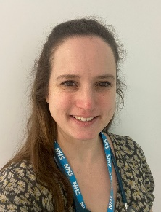 Sara Griffiths (sara.griffiths00@stgeorges.nhs.uk)
Georgina Ndukwe (georgina.ndukwe@nhs.net)

