OBSTETRICS AND GYNAECOLOGY

Introduction
Welcome to your O&G attachment at St George’s Hospital. O&G is an extremely exciting and rewarding specialty and is a great mix of both medicine and surgery. Students have always enjoyed the wide variety of activities, from assisting in surgeries to delivering babies!
You will have been emailed your timetable, which outlines your clinical activity, and a lunchtime tutorial schedule. You will also have been sent an induction booklet, which contains lots of useful information. As part of your O&G placement, you will spend one day at a Genito-Urinary Medicine (GUM) Clinic. This is an opportunity to learn to take a sexual history and manage common genital tract infections.
Introduction |  | See above
What placements do we run? | P year | · Obstetrics  · Gynaecology
Key Locations Map |  | See below
Placement FAQs | Do I need to wear scrubs? | Yes.  - Green scrubs for gynaecological theatres. Please ask the theatre co-ordinators/ the gynaecology team you are with for the card to obtain scrubs from the machine.  - Blue scrubs for labour ward and elective Caesarean section sessions. These scrubs are found in a room on Labour Ward which you will be shown during the tour, alternatively staff on Labour Ward can show you.
 | What is the uniform policy? | Smart and professional clothing for clinics, and bare below the elbows.
 | Where can I find more information on my placement? | Emails from our Clinical Teaching Administrator and Canvas.
Placement FAQs | Will I have opportunities to undertake research projects? | Yes! Please discuss with Lead for O&G Teaching Consultant Ms Pandey and your CTF.
 | Will there be fixed teaching sessions? | Yes. There are tutorials scheduled almost on a daily basis, and mostly consultant led. The tutorials will mostly be at lunchtime, a timetable will be sent at the start of your placement by the administrators. Please inform the consultant leading the tutorial, administrator and your CTF if unable to attend tutorials.

Key Locations Map: O&G
Ground Floor
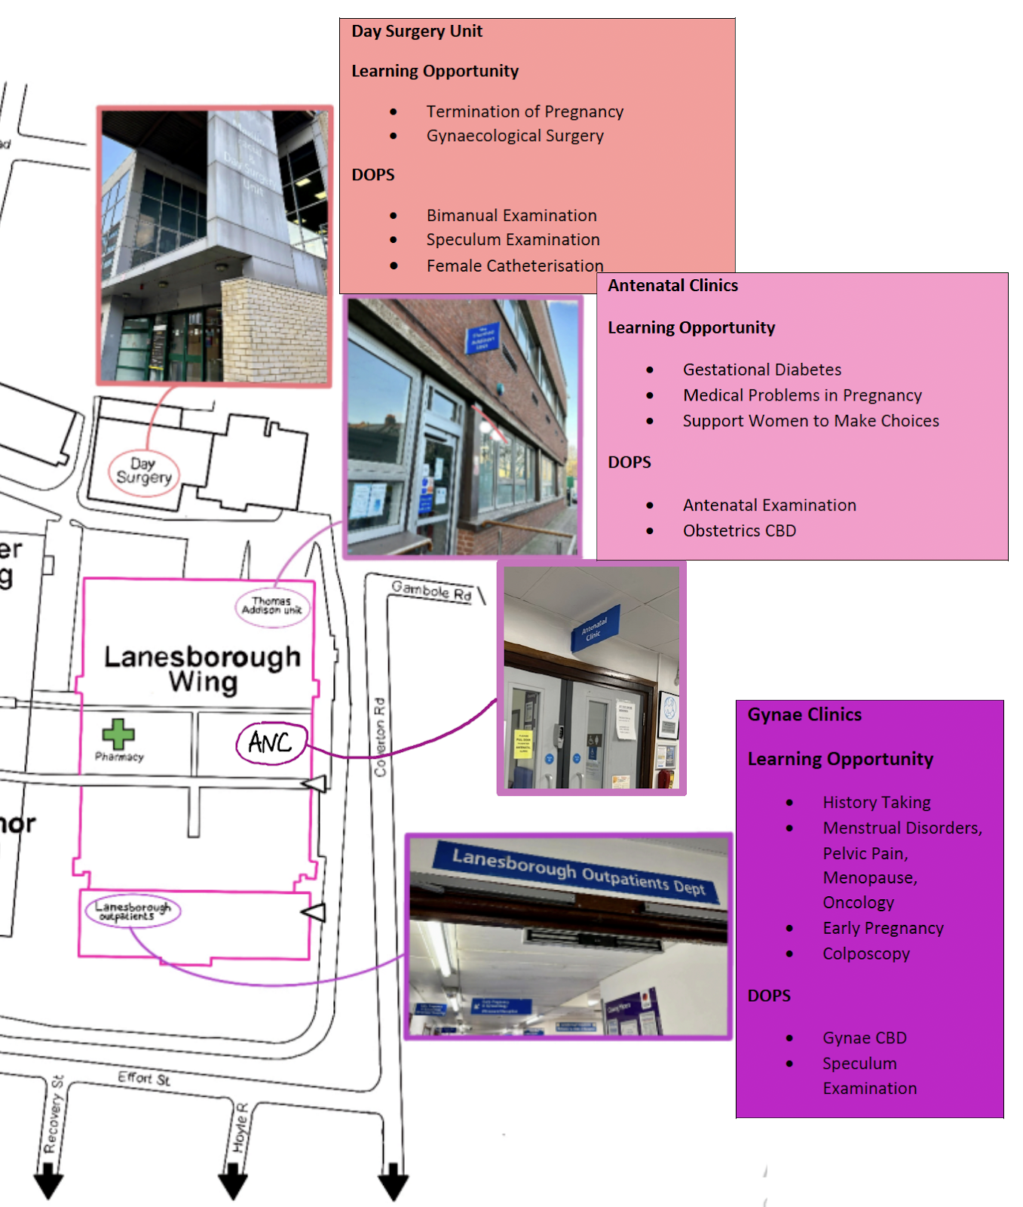

1st Floor
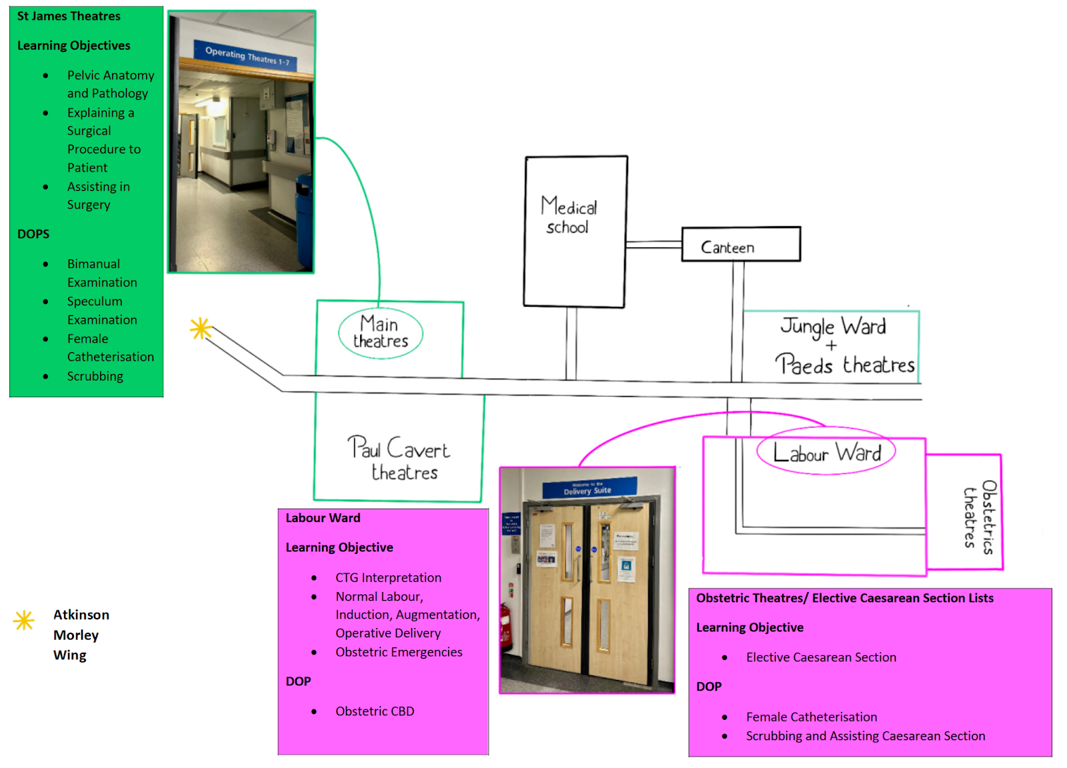

4th Floor
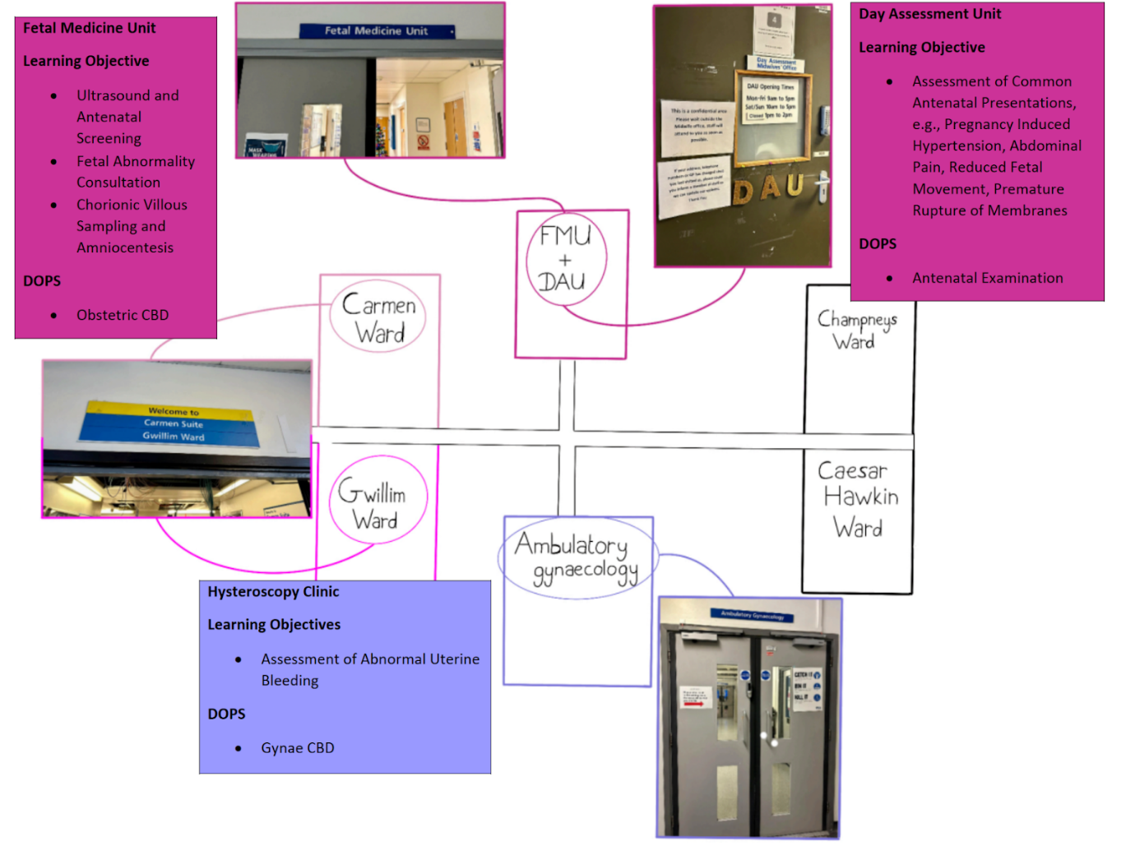

Obstetrics and Gynaecology Textbooks Produced by St George’s Faculty

- Part 1 MRCOG Synoptic Revision Guide by Professor Asma Khalil
- Gynaecological Ultrasound Scanning: Tips and Tricks by Mr Kamal Ojha
- Basic Sciences for Obstetrics and Gynaecology: Core Materials for MRCOG Part 1: Core Material for MRCOG Part 1 (Oxford Specialty Training: Basic Sciences) by Mr Austin Ugwumadu

Your O&G Clinical Teaching Fellow:
Alba Bajrami (alba.bajrami@stgeorges.nhs.uk)

