20210518
Annotated Record of Discussion Guide

The Record of Discussion documents that appropriate consent has been obtained from a patient prior to genetic testing. It should be completed for every patient for whom a test is being ordered. Below, find additional information about the Record of Discussion form.

Please note that verbal consent can be obtained as part of telehealth sessions and can be noted as such under Patient/parent signature (see example below).
1. Results could be shared with family members when necessary to provide appropriate clinical care, e.g. to coordinate a predictive genetic test for a relative.

2. Testing may identify results of unclear clinical significance, such as a “variant of uncertain significance.” Unclear results should not be used to provide clinical guidance. If more information is learned in the future, results may be updated and the clinician and patient may be contacted if the results will impact clinical care.

3. Most genetic testing focuses on a few genes most relevant to a clinical indication, but some tests look at a wider range of genes and may pick up unexpected findings.

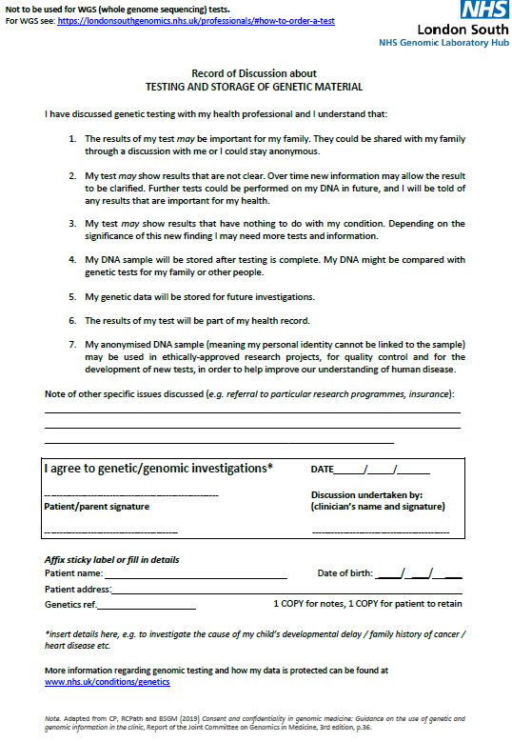
4. Predictive testing involves the use of a positive control whenever possible, and that DNA may come from relatives or others who have been tested previously. The lab also uses samples for quality control checks. DNA is stored long term partly for these reasons.

6. Results are shared with GP and any other relevant healthcare providers

5. Genetic data is stored and may be reassessed in the future if clinically indicated

7. Research is an important part of growing our knowledge of genetics and stored, anonymised DNA may be utilised for research that has been approved by appropriate medical research review committees.

Example: Verbal consent obtained by telephone

