Patient Partner Opportunities

Role: Patient Partner Renal Development Programme
(St George’s & St Helier’s hospitals Renal Services Integration)
Location: St George’s, St Helier’s Sites & remote meetings
Hours: Flexible commitment: Average expectation of 3 to 5 hours per week
Accountable to: Programme Manager Renal Development Programme

Vision:
The combined joint renal service will be one of the largest in the country, bringing together national leaders in renal medicine and transplant surgery, and transforming outcomes for renal patients in the region. This will facilitate understanding and addressing SW London population’s needs, to deliver the right care at the right time, in the right place, to tackle health disparities. A Patient Partner has an interest in the provision of healthcare and wants to become involved to influence how it is planned and delivered to improve patients, relatives and/or carers’ experience.
Patient Partners are essential in terms of collaboration to ensure the diverse patient voice is captured, heard, and considered in Trust improvements and transformation projects.

Objectives:
We are looking for up to 10 Patient Partners with an interest to
- Become involved in specific clinical workstreams, such as home therapies, vascular access, dietetics, admitted patient pathway, pre-dialysis, dialysis, among others.
- Become involved with external partners such as the building design.
- Become involved in the pre-occupancy evaluation exercise.
- Become involved in various patient engagement activities.

Key Tasks:
Tasks will vary depending on the clinical workstream, but general activities will include:
- Attend meetings and consider being part of subgroups, where appropriate
- Commit to reading all papers for the meeting.
- Fulfil any actions to which they have committed.
- To consider how their experience and the experience of other patients and carer’s can improve patient services integration wide.
- Promote equity, diversity, togetherness, and the Trust values of excellent, kind, responsible, respectful.
Personal specification:
- Current and/or recent experience of care at St George’s or St Helier’s as a patient or a relative under the renal department.
- Willing to commit to regular attendance at meetings (combination of in person and online meetings) and prepare to contribute to workstreams or sub-groups on request.
- Able to read and understand meeting papers.
- Able to participate in meetings and communicate their views.
- To be honest and professional.
- To have commitment and motivation.
- To uphold and work within the Trust values.
- To have effective communication and listening skills.
- To have integrity and foresight.
- To be responsible and dependable.
- Be positive and able to take a solution focused approach, respecting others’ views and comments.

General information:
- Patient Partners are bound by the ‘Patient Partner Agreement’ which includes their rights and responsibilities.
- Patient Partners must not undertake any manual handling tasks.
- Patient Partners are reminded of the importance of confidentiality.
- Patient Partners will receive regular support and supervision and training where applicable.

This is the first time we deliver an opportunity to work together as gesh group programme in the integration of services from St George’s and St Helier’s hospitals. Therefore, we would like to receive your feedback on how we have carried out this activity and where there is potential room for improvement. We aim to support staff and patients to live the Trust values and the experience of integrating St George’s and St Helier’s renal services, rather than feeling forced into it.

If you are a patient, carer or relative of a patient at St George’s or Epsom and St Helier Renal Services and are interested in becoming a patient partner for the Renal Services Integration, complete the application form below and submit it by email at gloria.munozfigueroa@stgeorges.nhs.uk And copy in voluntary.services@stgeorges.nhs.uk.

You can submit your application from Monday 08/01/2024 to Sunday 21/01/2024. You will receive an outcome of your application by Tuesday 23/01/2024. If you are a successful candidate, you will be invited to a 15-minute interview, either remotely or face-to-face at St George’s Hospital, on Thursday 25/01/2024.

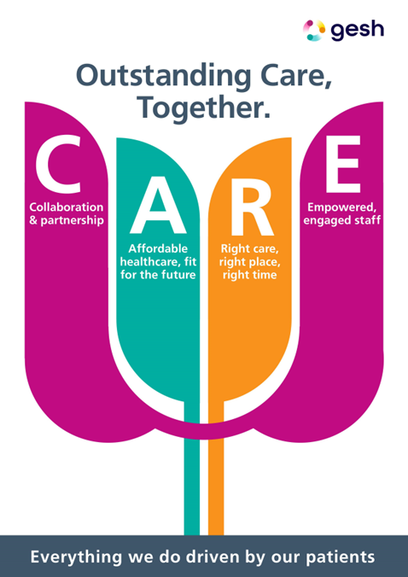
- Collaboration and partnership
- Affordable services, fit for the future
- Right care, right place, right time
- Empowered, engaged staff

Application Form: Renal Development Programme Patient Partner Role
This form should be completed after reading the Role Description leaflet.
If you need assistance completing this form, please contact us at
gloria.munozfigueroa@stgeorges.nhs.uk and voluntary.services@stgeorges.nhs.uk
A | About you
Are you? A patient A carer A relative

Title: | Surname: |  |  | First Name:
Home Address:

Town/City: |  |  |  | Postcode:
Daytime Tel: |  | Mobile:
Email: |  |  | Date of Birth: |  | Sex:

B | Availability
Please tick when you would be available to volunteer:
 | Monday | Tuesday | Wednesday | Thursday | Friday
Morning
Afternoon
Evening
Are you able to give a commitment of at least 8 months? Yes No

C | Experience
Please outline your experience with either renal services, listing the care you might have received or experienced.
(pre-dialysis, peritoneal dialysis, haemodialysis, transplantation, vascular access, renal wards, outpatient etc),

D | Motivation
Please tell us about the skills, knowledge and experience you could use to ensure the diverse patient and public voice will be heard.
For example:
- Excellent customer service
- Reliability
- Caring and compassion
- Teamwork
F | Other information

Do you consider yourself to have a disability? Yes No

If yes, what support or adjustments do you think you will need to attend an interview or take up a volunteering post with us?

Ethnicity – Please tick one option
White: | British |  | Mixed white: | Black Caribbean |  | Asian British: | Indian |  | Black British: | Caribbean
 | Irish |  |  | Black African |  |  | Pakistani |  |  | African
 | Other |  |  | Asian |  |  | Bangladeshi |  |  | Other
 |  |  |  | Other |  |  | Other |  | Other: | Chinese
 |  |  |  |  |  | Other ethnicity: (please state)

Emergency contact – Please give details of someone we can contact in case of an emergency
First name | Surname
Address | Relationship to you
Home telephone | Mobile telephone

G | References
Please supply details of two referees. If you are currently or have recently been in employment or involved in any voluntary work, one of your references should be from that organisation. Other references must be from people 18 or older who have known you for at least one year.
This could be a healthcare professional from either Renal team.
Relatives or partners cannot act as referees.
Referee one | Referee two
Name | Name
Address | Address
Telephone number | Telephone number
Email | Email

H | Declaration

REHABILITATION OF OFFENDERS ACT 1974
Due to the nature of healthcare work, volunteers are exempt from the provisions of the Rehabilitation of Offenders Act. Therefore, you must not withhold any information about convictions (including those which for other purposes are considered “spent” under the Act), previous or pending prosecutions, cautions or bind overs applicable either in the UK or abroad.

Any information provided will not necessarily prevent you being appointed unless the conviction, previous or pending prosecution, caution or bind over means you are unsuitable for the role.

Failure to declare a conviction, previous or pending prosecution, caution or bind over, either in this county or abroad will disqualify you from the application process. For this Patient Partner Role only, successful applicants will NOT be checked by the Disclosure and Baring Service (DBS) before they are able to take up their post.

Please note that you will be asked to provide details, including approximate date, the offence and the authority and country which dealt with the offence, if you are shortlisted for a role.
Are you currently bound over, or have you ever been convicted of a criminal offence, cautioned, warned, or reprimanded in the UK or in any other country? | Yes No
Are you aware of any current police investigation in the UK or any other country following allegations made against you? If yes, please use separate sheet for details. | Yes No
Does your name appear on the Protection of Children Act List? | Yes No
Are you legally entitled to work in the UK? | Yes No

We will keep the information on this form confidential and will not share it with any external organisation. You can ask for your details to be changed or removed at any time.

I declare that the information given on this form is true and complete. By signing this form, you are consenting to us holding your information on the volunteer database.

I understand that to be considered for a role as a volunteer I will be asked to produce evidence of identification, address, and status in the UK when applicable.

I declare that the information given on this form is true and complete. I understand that any false information may result in the withdrawal of any offer of voluntary role or my dismissal if accepted as a volunteer.

Your Signature: | Date:

Please send completed form to:
Gloria Munoz and Zoe Holmes
Via email: gloria.munozfigueroa@stgeorges.nhs.uk AND Voluntary.Services@stgeorges.nhs.uk

Gloria Munoz-Figueroa
Programme Manager
Renal Development Programme
Gesh
George’s, Epsom, and St Helier Hospitals

Zoe Holmes
Voluntary Services
St George’s Hospital
Blackshaw Road
Tooting
London SW17 0QT

