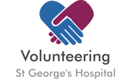
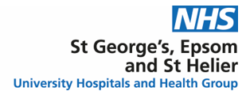
Become a Patient Partner for the Renal Development Programme

Patient Partners influence clinical services’ design and delivery to improve patients, relatives, and carers’ experience.
Apply to ensure the diverse patient voice is captured, heard, and considered in the Integration of St George’s, Epsom, and St Helier Renal Services
Who: Patients, carers, or relatives at St George’s or Epsom, and St Helier Renal Services
When: From Monday 08/01/2024 to Sunday 21/01/2024
How: Scan the QR code below to request the Role Description and Application form
