Exercises to complete when in an above knee cast

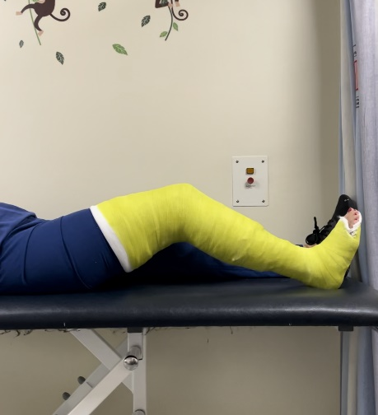
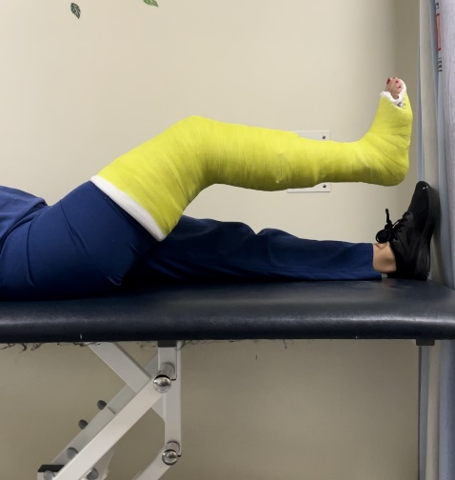
Leg Raise
- Start lying on your back
- Slowly raise your leg up and hold for 3 seconds.
- Return to starting position and repeat ___ times.

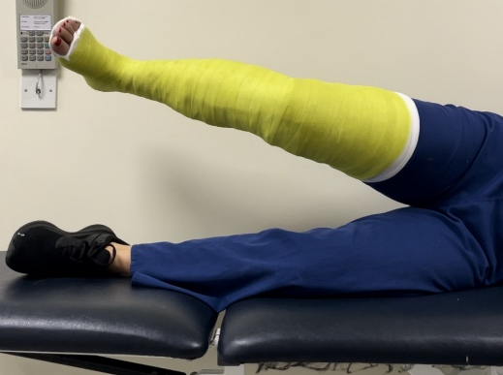
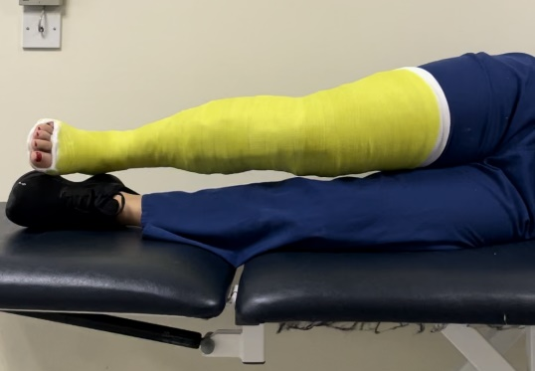
Hip abduction
- Start lying on your side with your casted leg on top
- Slowly raise your leg up and out to the side
- Return to starting position and repeat ___ times.

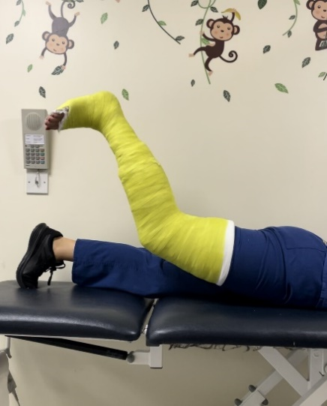
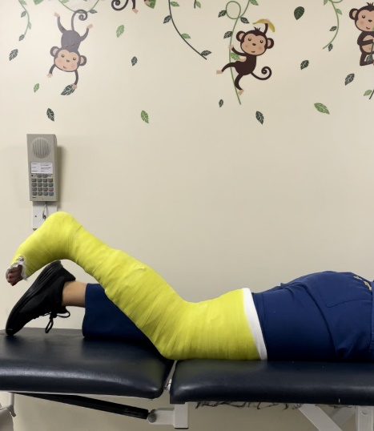
Hip extension
- Start lying on your tummy
- Slowly lift your leg up behind you
- Return to starting position and repeat ___ times.

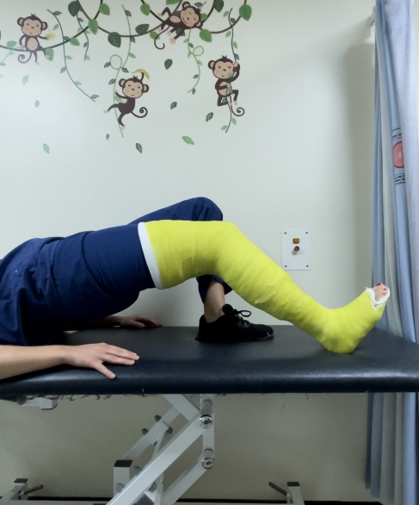
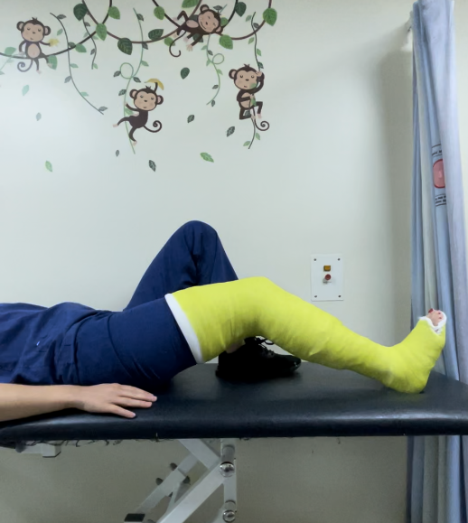
Glute bridges
- Start lying on your back with your uncasted leg bent and your casted leg out in front.
- Squeeze your bottom and lift it off the bed, keeping your heels on the bed
- Hold for 3 seconds before returning to starting position
- Repeat __ times.

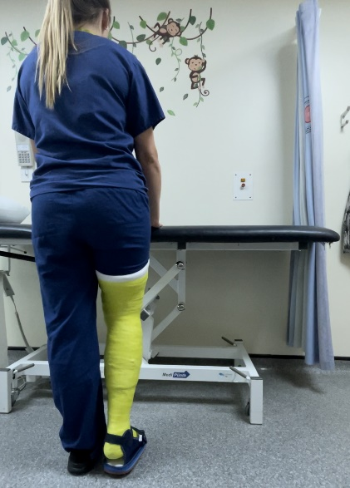
Standing hip abduction
- Start by standing up straight
- Slowly lift your casted leg out to the side
- Hold for 3 seconds before returning to the starting position
- Repeat __ times.

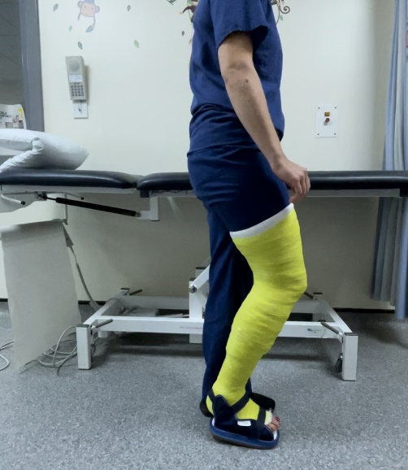
Standing hip extension
- Start by standing up straight
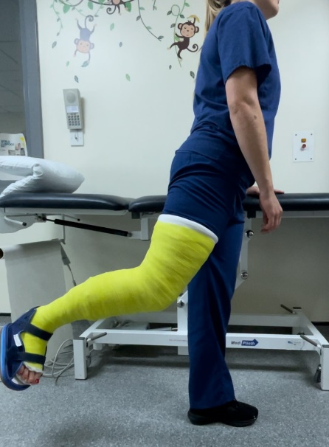
- Slowly lift your casted leg out behind you
- Hold for 3 seconds before returning to the starting position
- Repeat __ times.

