

**Welcome Pack for**

**International Medical Graduates**

Dr Silvana Alcala

IMG Representative

Clinical Fellow ITU

Second Edition

May 2023

# PREFACE

Welcome to St. George’s University Hospitals NHS Foundation Trust! This information pack is designed to assist you during your transition to working in the United Kingdom. It will provide information on the most important questions and steps to follow when you arrive, including useful tips gathered by prior International Medical graduates regarding settling in The UK, St Georges facilities, your duties and entitlements in the Trust, professional career advice and wellbeing support. We hope this helps you prepare yourself in your first weeks in St George’s Hospital as much as possible.

This initiative, along with the IMG forum and special IMG Induction modules, aims to facilitate the adjustment of foreign-trained doctors to the trust. We encourage your active participation and feedback to improve this programme further over the year and make it a success. Do email us at **imginduction@stgeorges.nhs.uk** if you have any questions or suggestions.

We highly recommend you join the IMG WhatsApp Group to make sure you are up-to-date with all the information and can benefit from other members’ experiences.

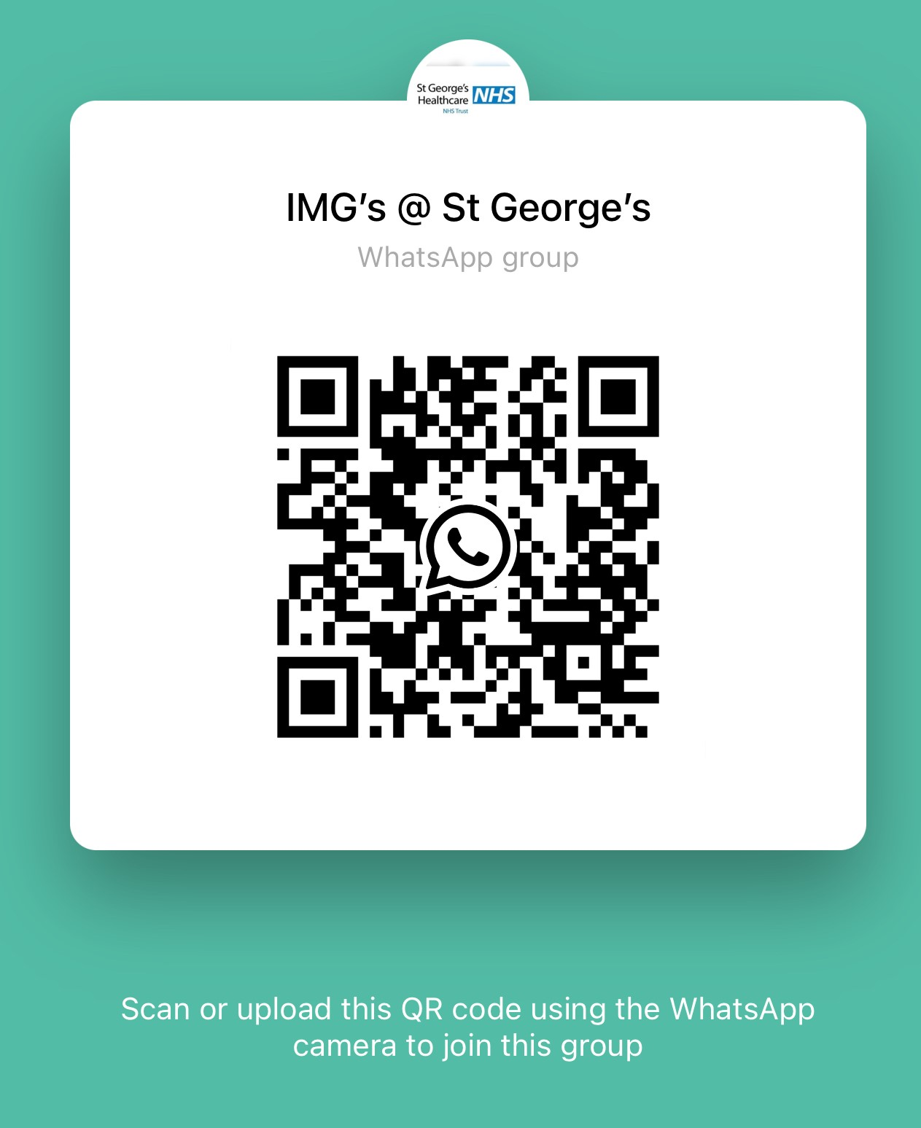

**Table of Content**

**St George’s Hospital layout**

- Map…………………………………………………………………………………………………….…….4

- Departments ………………………………………………………………………………………….…….5

- Restaurants…………………………………………………………………………………………………6

**Settling in the UK**

- Accommodation………………………………………………………….…………………………………7

- Banking Facilities………………………………………………………..………………………………….9

- National Insurance………………………………………………………………………………………..11

- GP……………………………………………………………………….………………………………….11

- Understanding the Tax system……………………………………….…………………………………12

-Tax relief ……………………………………………………………….…………………………………..12

**Your Employment at St George’s**

- Understanding your payslip and salary....…………………….………………………………………..13

- Pension…………………………………………………………………………………………………….15

- Annual leave & Sick pay…………………………………………………………………………………16

- Maternity, Paternity, Shared parental and Adoption Leave…………………………………………..16

- Mandatory training………………………………………………………………………………………..17

- Clinical Supervisor………………………………………………………………………………………..18

- Appraisal/revalidation………………………………………………………………………………….....18

- Useful apps…………………………………………………………………………;…………………….19

**Your Career and Development**

- Medical Indemnity ………………………………………………………………………………………..20

- Professional trade Union……………………………………………….………………………………..20

- E-Portfolio………………………………………………………………………………………………….21

- Library………………………………………………………………………………………………………21

- OpenAthens & Uptodate…………………………………………………………………………………22

**Your Wellbeing**

- Mental Health……………………………………………………………………………………………...23

- Doctor’s Mess……………………………………………………………………………………………..23

- Spiritual Needs...………………………………………………………………………………………….23

- NHS discounts…………………………………………………………………………………………….24

**St George’s Hospital layout**

**MAPS OF ST GEORGE’S:**

Address: St George’s Hospital NHS Trust, Blackshaw Road, Tooting, London, SW17 0QT

Telephone: 020 8672 1255

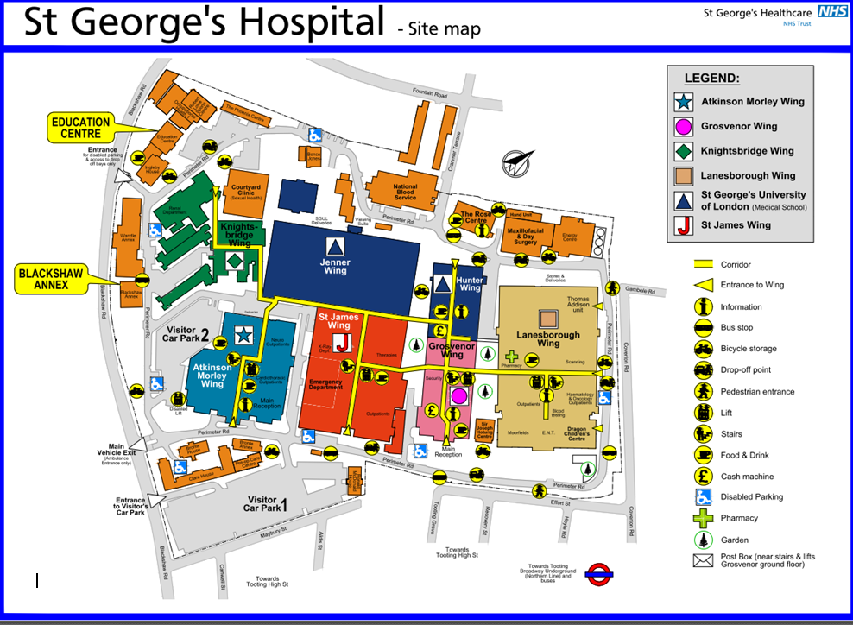

List of Wards:

|  |  |  |  |
| --- | --- | --- | --- |
|  | **Lanesborough Wing** | **St James Wing** | **Atkinson-Morley Wing** |
| **Ground Floor:** | Clinic A (consultation rooms for various specialities)  Moorfields Outpatients (ophthalmology)  MRI scanner  Jungle ward (Paediatrics) | Richmond Ward (Acute Medicine Unit & ambulatory assessment Area)  Nye Bevan (surgery)  Radiology department | Neurosciences Outpatient  Vaccination Centre |
| **1st Floor** | Gynecology & Obstetrics  Neonatal Unit | General ICU  Theatres  Endoscopy | Coronary Care Unit  CathLab  Belgrave (Cardiology)  Benjamin Weir (Cardiac Surgery)  Heart Failure Unit |
| **2nd Floor** | Not for Clinical Use | McEntee Ward (infectious Diseases)  RuthMyles Ward (haematology) | Neurology ICU  Brodie Ward,  McKissock, (Neurology and Neurosurgery)  NeuroRadiology |
| **3rd Floor** | Heberden (Senior Health)  Trevor Howell ( Oncology)  Gordon Smith Ward (Oncology)  Thomas Young (Acute Stroke Unit) | Amyand Ward (GIM)  Marnham Ward (Senior Health)  Allingham (Gastroenterology)  Rodney Smith (Endocrine) | Caroline (cardiothoracic)  Kent (Neurology Charles Pumphrey Unit (cardiology) |
| 4th Floor | Cesar Hawkins Ward (Respiratory)  Champney’s Ward (Renal Medicine and Acute Dialysis Unit  Gwillin (Antenatal & Posnatal cae) | Cheselden (vascular Surgery) [Florence Nightingale (maxillofacial and ENT](https://www.stgeorges.nhs.uk/?post_type=ward&p=2649)) Gray  Vernon (Urology & Surgery) |
| 5th Floor | Dalby (Senior Health) Frederick Hewitt (Pediatrics) Nicholls (Paediatric Surgery) | Gunning  (trauma and orthopaedics)  Keate (Surgery)  Holdsworth (trauma and orthopaedics)  Cavell (General Medicine) |

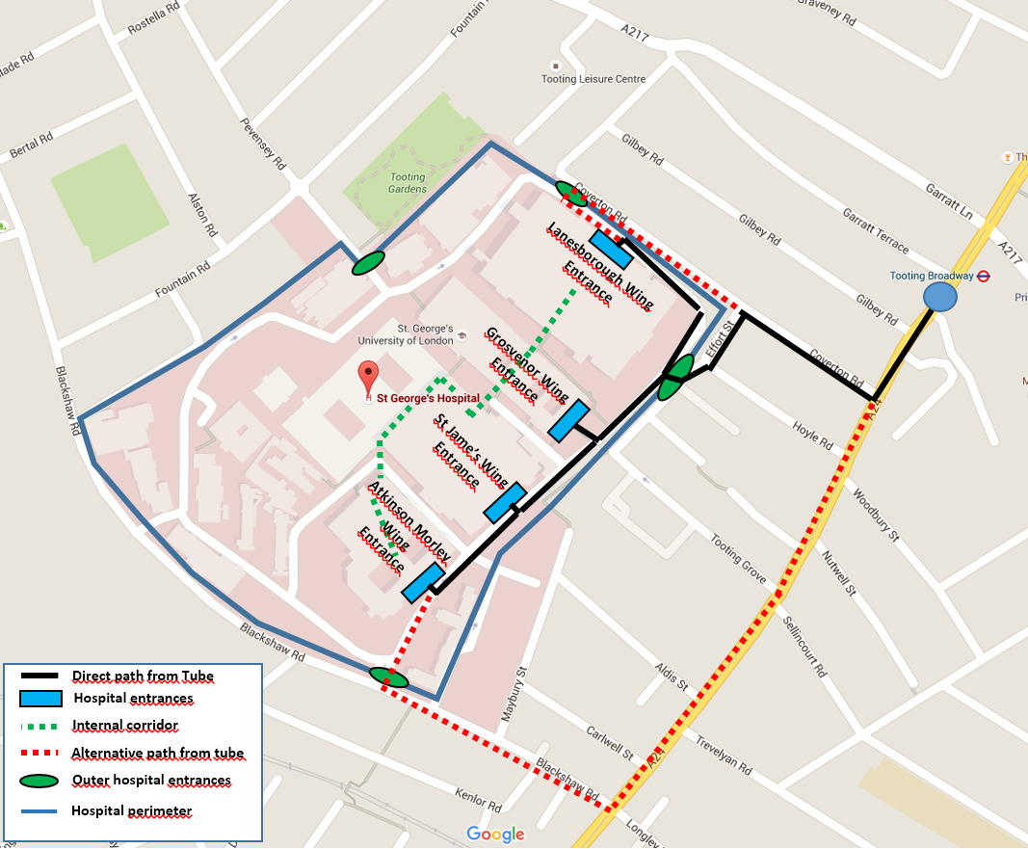

Please bear in mind that the outer entrance in Coverton St is closed at night, on Bank Holidays and over the weekend.

Marks and Spencer (M&S), situated at the main entrance (Grosvenor Wing), is an easy meeting point.

**Where are the Restaurants?**

* + 1st floor of Lanesborough Wing- Ingredients The Main Restaurant
  + Different places to buy food and coffee like:
    1. Marks and Spencer at the main entrance of Grosvenor Wing
    2. Peabodys at the main entrance of St Georges University
    3. Peabodys in St James’s Wing (Outpatients area) and Atkinson Morley Wing, Ground Floor
    4. Pret A Manger on the ground floor of Hunter Wing.

**Settling Down in London**

**1.- Accommodation**

There is no contractual obligation for staff to have accommodation provided for them, upon arrival in London as part of their terms and conditions. The Trust is currently working with local agents in the borough of Wandsworth and Merton to assist in finding accommodation for new staff. Enquiries about rents and availability can be made through:

**Ms Natalie O’Donnell**

**The Manager for Accommodation Services**

**Tel: 0208 725 2759Ex:1617**

**Email:** [**Accommodation.Manager@stgeorges.nhs.uk**](mailto:Accommodation.Manager@stgeorges.nhs.uk)

Some trust accommodation is available at a place called St George’s Grove. The Grove is located a short distance from St George’s Hospital (Buses run every 15-20 minutes), Tooting Broadway tube station and Earlsfield train station, providing excellent transport links to the centre of London.

To request Onsite Accommodation, fill out an application form from the Trust website and send it to Ms Natalie O’Donnell (as above). To find out more about accommodation at St George’s Grove, visit the [Thames Valley Housing website](http://www.tvha.co.uk/rent/keyworker-housing/st-georges/): <http://www.tvha.co.uk/rent/keyworker-housing/st-georges>



If you come from overseas, the Trust can advance the deposit and the first month and you can then give it back over the next 6 months. This can only be done with The Grove or The Pelican Hotel.

**Private Accommodation**

The Pelican Hotel is Onsite which is a privately run Accommodation

<http://www.pelican-london.com>.

**Recommended Accommodation Websites**

|  |  |
| --- | --- |
| [www.rightmove.co.uk](http://www.rightmove.co.uk) | [www.intolondon.com](http://www.intolondon.com) |
| [www.easyroommate.com](http://www.easyroommate.com) | [www.roombuddies.co.uk](http://www.roombuddies.co.uk) |
| [www.spareroom.co.uk](http://www.spareroom.co.uk) | [www.findaproperty.com](http://www.findaproperty.com) |
| [www.moveflat.com](http://www.moveflat.com) | [www.zoopla.co.uk](http://www.zoopla.co.uk) |
| [www.primelocation.com](http://www.primelocation.com) | [www.gumtree.com](http://www.gumtree.com) |
| [www.openrent.co.uk](http://www.openrent.co.uk) |  |

Open Rent and Gumtree, amongst others, are used by landlords directly with no agency fees!

For more information about the contracts and the legal issues about renting a room in house sharing, visit the website: [www.gov.uk/private-renting](http://www.gov.uk/private-renting).

Alternative options for private properties such as studio flats, and house sharing through local estate agents:

|  |  |
| --- | --- |
| Knight Frank  26 Bellevue Road London  SW17 7EB T: 020 8682 7777  [www.knightfrank.co.uk](http://www.knightfrank.co.uk) | Other Key Worker Properties:  Keyworker Housing | Thames Valley Housing  Key Worker Living Options:  Affinity Sutton: <http://www.affinitysutton.com/rent-a-home/rental-options/key-worker-rent/>  HomeBuyServices.co.uk: <http://www.homebuyservice.co.uk/eligibility/key-worker-eligibility.html> |
| Winkworth  17 Upper Tooting Road, Tooting Bec  SW17 7TS T: 020 8767 5221  E: [tooting@winkworth.co.uk](mailto:tooting@winkworth.co.uk)  [www.winkworth.co.uk](http://www.winkworth.co.uk) | Foxtons  47 - 49 Mitcham Rd, Tooting  SW17 9PB T: 020 3728 2150  E: [Tooting@foxtons.co.uk](mailto:Tooting@foxtons.co.uk)  [www.foxtons.co.uk](http://www.foxtons.co.uk) |
| One Housing Group:  City Style Living Ltd:  T: 0300 123 2033  E: [homeowners@onehousinggroup.co.uk](mailto:homeowners@onehousinggroup.co.uk) | Ludlow Thompson  62 Tooting High Street, London  SW17 0RN T: 020 8682 1234  [www.ludlowthompson.com](http://www.ludlowthompson.com) |
| Housing Solutions:  <http://www.housingsolutions.co.uk/rentahome/keyworkerhomes.aspx> | Other Housing Options:  Local Council:  Wandsworth Council Town Hall  Wandsworth High Street London  SW18 2PU T: 020 8871 6000  [www.wandsworth.gov.uk](http://www.wandsworth.gov.uk) |

# 2.- Banking Facilities

In most cases, you would have to book an appointment online to open a Bank account. The following is a list of some of the major bank branches and building societies which are located on Tooting High Street**. Press Ctrl + click the icon to access their Web page**



* HSBC: 55 Tooting Broadway, Tooting, London, SW17 0RN
* Lloyds: 12 Mitcham Road, Tooting, London, SW17 9ND
* Halifax: 50-52 Tooting Broadway, Tooting, London, SW17 0QR
* Barclays Bank: 14-16 Mitcham Road, Tooting, London, SW17 9NA
* NatWest Bank: 30 Tooting High Street, Tooting, London SW17 0RG

Every banking society has slightly different requirements but usually, they would ask you for some of the following documents:

* ***Evidence of identity:*** Passport, Visa/Biometric Residency Permit (If applicable), driver’s licence.
* ***Proof of your address:*** letters from HMRC, Utility bills (electricity, gas, Broadband, water, mobile contract), letters from other companies or authorities, Tenancy agreement. Even your NIN letter will count as proof of Address.
* Your Employment Contract, and job offer letter.



Sometimes It can be challenging to obtain an appointment to open an account with some of the traditional banks so ***you may consider using an alternative Digital Bank or E-Money institution such as: Revolut, Starling Bank, Wise or Monzo.*** You will need a smartphone with a UK number and will probably need to pay a small fee for the debit card to arrive at your door.

|  |  |  |  |
| --- | --- | --- | --- |
| **Bank** | **Best for** | **Pros** | **Cons** |
| [Starling](https://www.starlingbank.com/) | Everyday accounts | Interest on the current account balance. Overdrafts and loans available. | Cash and cheque payments are inconvenient. A replacement card is costly. |
| [Revolut](https://www.revolut.com/) | Top choice (+free £10) | Rates are given in real-time. The basic account is free and full of features. | Optional features cost extra. No cash or cheque options. |
| [Wise](https://wise.com/) | Multicurrency transfers | Competitive fees on international transfers. Access to multicurrency Mastercard. | No cash or cheque options. For larger transfers, specialist providers are often cheaper. |
| [Monzo](https://monzo.com/) | Budgeting | Different pots for budgeting. Instant spending notifications. | App only – no browser option. Fees for paying in cash and cheques. |
| [Monese](https://monese.com/gb/en) | Best all round | Accounts in GBP and EUR. Open an account without credit check. | Limits on cash transactions. Not part of the FSCS scheme. |
| [Chase](https://www.chase.co.uk/gb/en/) | Good Customer Support | 24/7 UK-led customer support, 1% cash back on all debit card payments, Customers can open multiple accounts to help the budget. | Not many extra features yet. No high street branches |
| [bunq](https://www.bunq.com/) | Ethical banking | Innovative and ethically conscious bank. International transfers are available. | The monthly cost for holding an account. Many additional fees. |

# National Insurance Number

The National Insurance Number (NIN) is your own personal account number. It is unique to you and you keep the same one for all of your life. It makes sure that the National Insurance contributions and tax you pay, are properly recorded against your name. It also acts as a reference number when communicating with the Department for Work and Pensions and HM Revenue & Customs (HMRC).

If you are moving to the UK, you can only apply for your national insurance number once you arrive in the UK and it is mandatory. You must have the right to work or study in the UK to get a National Insurance number.



To get a National Insurance number you need to apply online at the following link:

[https://www.apply-national-insurance-number.service.gov.uk/apply/welcome](https://www.apply-national-insurance-number.service.gov.uk/apply/welcome%20)

You’ll need to prove your identity when you apply using:

* a photo of yourself holding your passport
* photos of other identity documents

You can use a smartphone, tablet or digital camera. You’ll be told how to take the photos and what they must look like during the application process.

### If you cannot upload photos You can still apply online but your application will take longer. You may need to attend an appointment or post photocopies of your documents. You’ll get an email telling you what to do after you’ve submitted your application.

After you apply you’ll get an email with your application reference number. The email will tell you if you need to provide further proof of your identity. It can take up to 8 weeks to get your National Insurance number after you’ve proved your identity.

National Insurance number application helpline   
Telephone: 0800 141 2079  
Textphone: 0800 141 2438

**General Practitioner**

General Practitioners (GPs) look after the health of people in their local community and deal with a whole range of health problems. You can register with a GP practice of your choice, as long as you live within its catchment area and it is accepting new patients5.

To find your closest GP type in Google: “Find GP services NHS choice” and write down your postcode. If you wish to find your closest dentist, type “Find dentist services NHS choice”. Bear in mind this is private and there are charges depending on the service

**Understanding UK Tax System**

How much Income Tax you pay in each tax year depends on how much of your income is above your Personal Allowance (the amount of tax-free income), and how much of your income falls within each tax band. The table below shows the tax rates you pay in each band if you have a Personal Allowance of £12,570, which is the standard amount for this year.

| **Band** | **Taxable income** | **Tax rate** |
| --- | --- | --- |
| **Personal Allowance** | Up to £12,570 | 0% |
| **Basic rate** | £12,571 to £50,270 | 20% |
| **Higher rate** | £50,271 to £150,000 | 40% |
| **Additional rate** | over £150,000 | 45% |

**Professional Tax rebate:**

In order to save a bit of money, you can claim a tax refund or tax-deductible expenses such as exams, courses, GMC fees, Royal College fees, medical indemnity policy and other expenses incurred while performing your Job. Check if you meet the criteria to file a claim online on <https://www.gov.uk/tax-relief-for-employees>

**Marriage allowance**

This claim will allow you transfer £1,260 of your husband, wife or civil partner’s Personal Allowance to yourself. It’s free to apply for Marriage Allowance. This can reduce your tax by up to £252 every tax year (6 April to 5 April the next year). To benefit as a couple, your income (Doctor’s income) must be between £12,571 and £50,270 and your partner needs to earn £12,570 or less. You can applyatn <https://www.gov.uk/apply-marriage-allowance>

You can find more information about Financial tips for Doctors at <https://www.medicsmoney.co.uk/medical-accounting-blog/>

# Your Employment at St George’s: Duties and Entitlements

* + - 1. **Understanding your Payslip**

Payroll is the department that keeps all financial records of salaries and deductions paid to employees for services they provide. Every employee of the Trust has their own unique payroll number which you can find below your picture in your ID badge and in your payslip (in the ‘Assignment number’ box).

You can access your payslip online by login into ESR (Electronic Staff Record) on <https://my.esr.nhs.uk/dashboard/web/esrweb>, or even through the ESR App. Payslips will be available a few days before your payday. Usually You will get paid between the 24th and 26th of the month. To get your log-in details to ESR, you can email the assistant manager or rota coordinator in your department or alternatively send an e-mail to: [selfservice@stgeorges.nhs.uk](mailto:selfservice@stgeorges.nhs.uk). Please make sure that you use your Trust e-mail when you send an enquiry.

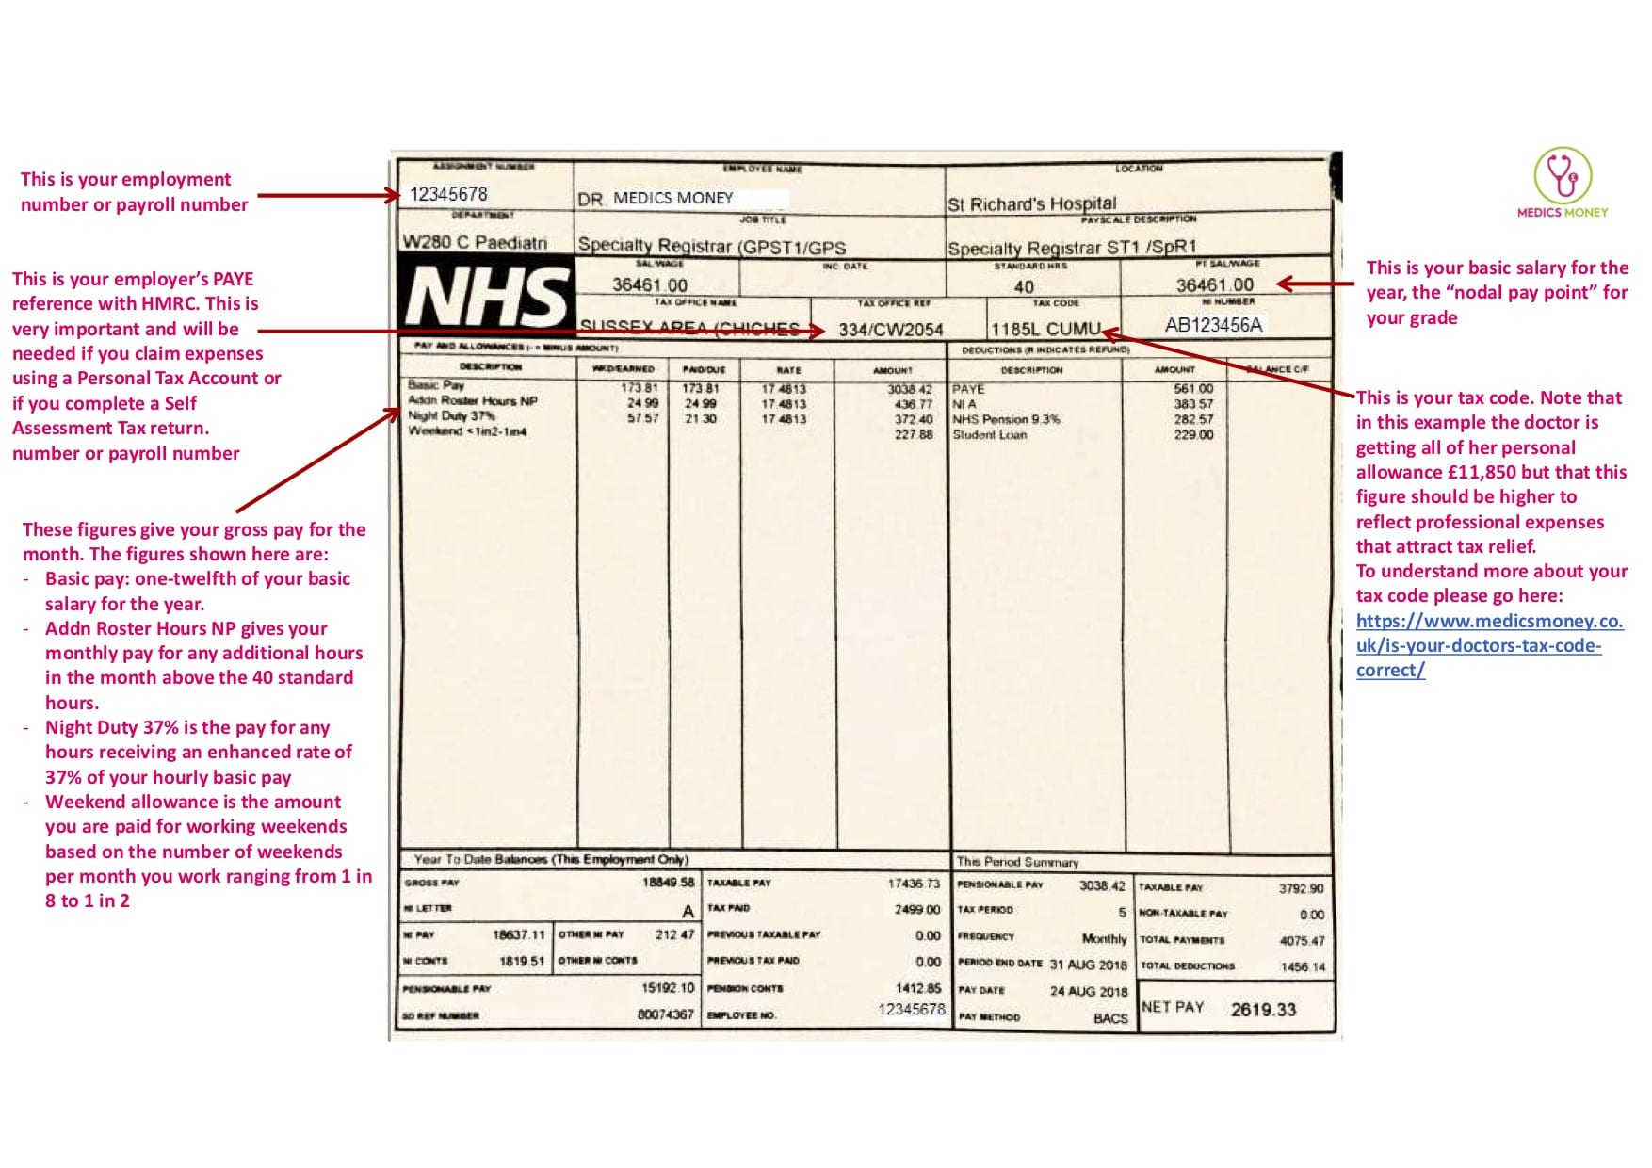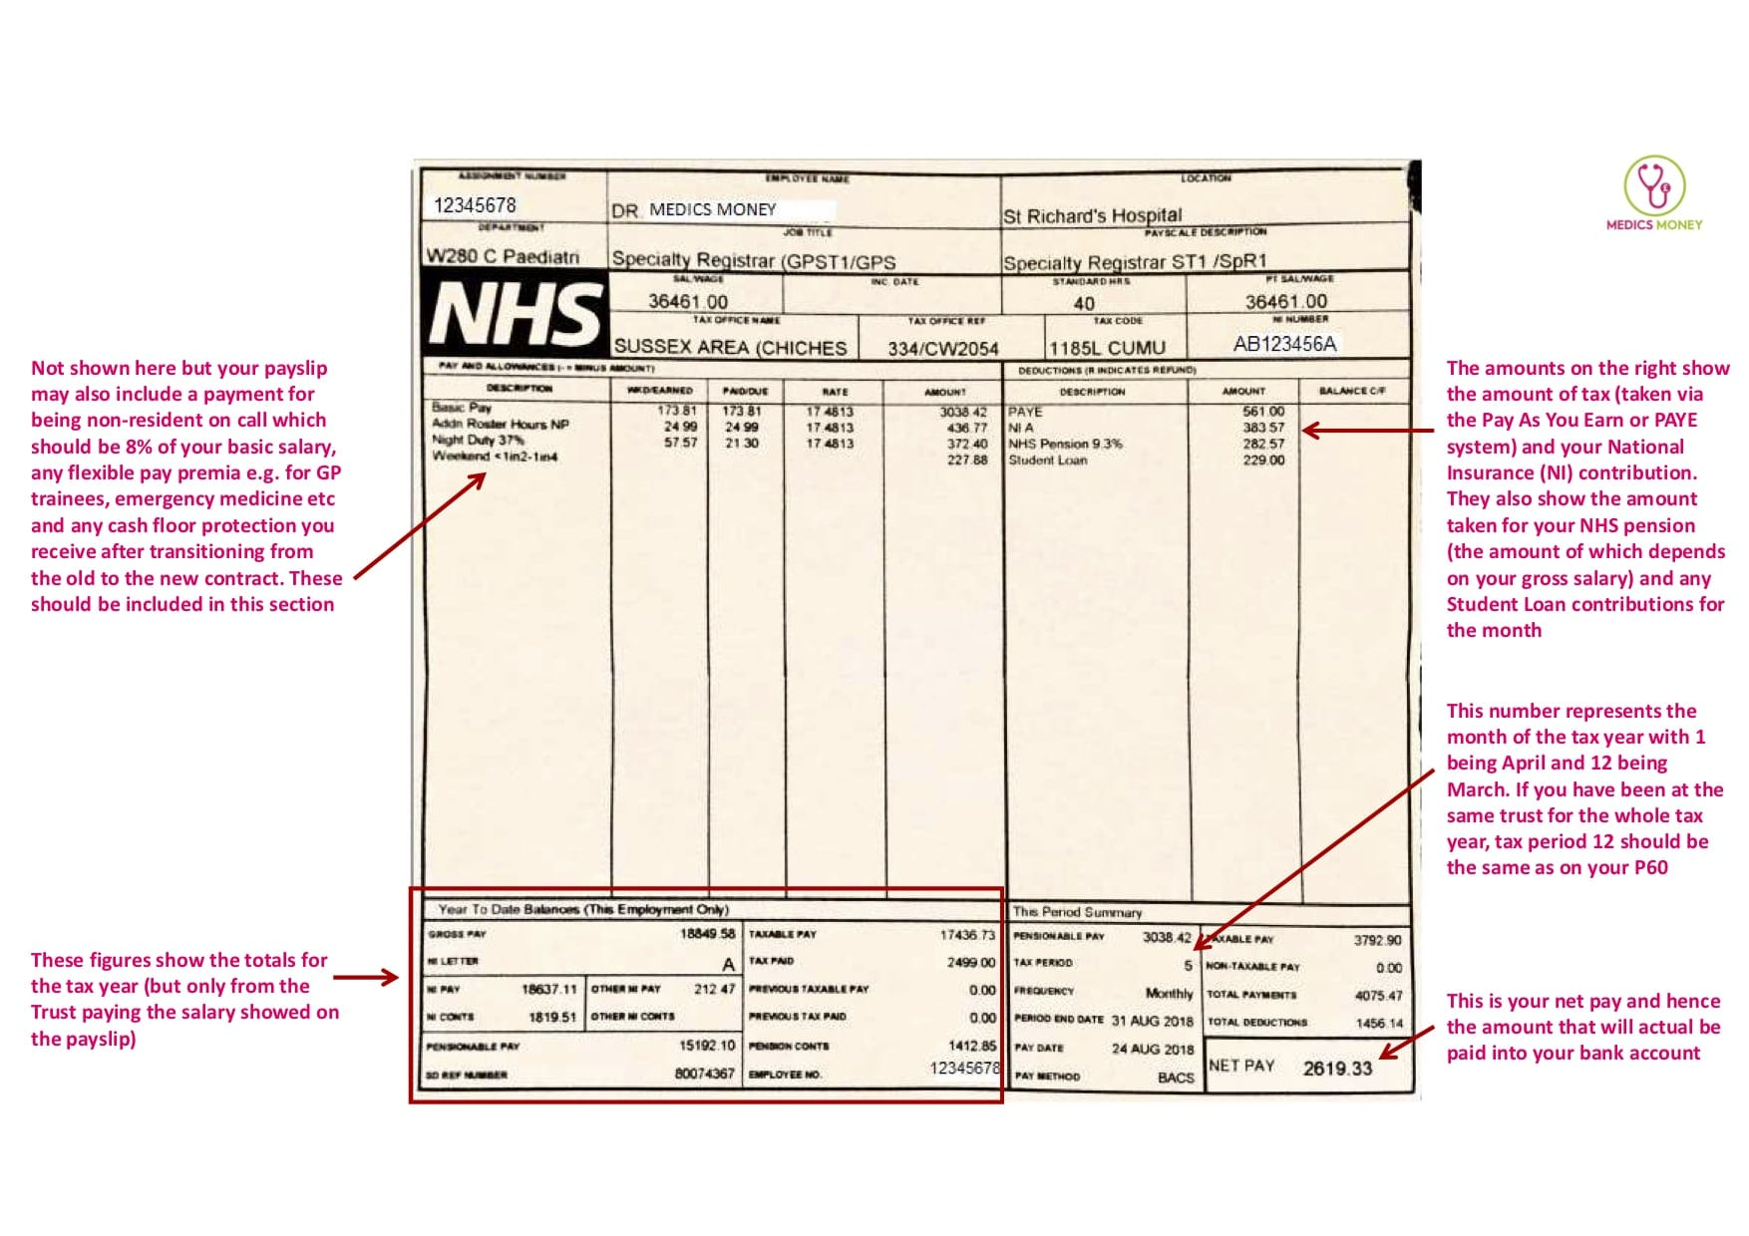

**2.- Your Salary**

You will receive a base salary as detailed in Table 1 Appendix 1 of the Terms and Conditions of Service. Your base salary will be somewhere between £32.000 and £54.000 per annum, depending on your years of experience. In addition to basic pay, you will receive London Weighting of £2162 per annum.

It is very important that you provide evidence of prior employment in the UK or abroad to the HR department/assistant manager, especially if you have more than 2 years of postgraduate experience, so they can adequate your salary to the correct amount.



In addition to your base salary you will receive a supplement at the rate, also called “banding supplement”. The value of this supplement is expressed as a percentage of your basic salary, and it depends on the average number of hours worked in the week and the overall pattern of the hours. For instance, for those working between 40 and 48 hours per week on average, and working mostly antisocial hours, their Banding would be 50% of their Basic Salary (they would earn an additional 50% on top of their basic salary).

**3.- NHS Pension Scheme**

Your appointment in St George’s will be pensionable and your base salary will be subject to deduction of superannuation contributions in accordance with the NHS Pension Regulations 1995 unless you opt out of the scheme. Of note: Any supplement payable to you is not pensionable.

At the moment, the NHS pension contribution is between 5% and 14.5% of your salary, depending on how high your pensionable earnings are. If you want to opt-out, you will need to fill in two forms: one to cancel and stop paying the NHS pension and the second one to claim the money in the first two years.

Link: [www.nhsbsa.nhs.uk/pensions](http://www.nhsbsa.nhs.uk/pensions) Employee helpline: 03003301346

**4.- Annual Leave**

The annual leave full entitlement is 27 days plus 8 bank holidays per annum pro rata during your appointment (E.g.: 13.5 days + bank holidays if your contract is only for 6 months). Different departments use different ways to book annual leave. They could ask you to book it through an online system called “Allocate ME”, via Employee Online (EOL) porta available in St George’s Intranet (for these your department would provide you with your login details) or you could request directly via email to your rota manager, assistant manager or chief registrar.



If you work a long day or night shift on a bank holiday, you are entitled to have one additional off day in lieu that you can take on a standard working day. You will need to claim it formally as a leave in lieu through the usual method in your department.

You can also request Study leave for courses and exams, but you would need to book them a few weeks in advance and only on standard days.

**5.- Sick Leave and Parental Leave**

Although it might not be specified in your contract, Sick leave and parental leave are NHS policies ruled by the NHS Terms and Conditions of Service Handbook which is on NHS Employers. Full document available on: [NHS Terms and Conditions of Service Handbook | NHS Employers](https://www.nhsemployers.org/publications/tchandbook))

* **Sick absence and Pay** [NHS Terms and Conditions of Service Handbook | NHS Employers](https://www.nhsemployers.org/publications/tchandbook#section-14-sickness-absence-england-)-Chapter 14. In General, Sick pay entitlement depends on the amount of years you have been working for the NHS.
* **Maternity leave, Paternity Leave, Adoption Leave Shared Parental Leave :** [NHS Terms and Conditions of Service Handbook | NHS Employers](https://www.nhsemployers.org/publications/tchandbook#section-15-leave-and-pay-for-new-parents-england-wales-and-scotland-) -Chapter15. In General, provided they have been working more than 12 months for the NHS, Mothers will be entitled to 8 weeks of Full pay, then 18 weeks of half pay+statutory pay, then 13 weeks of statutory pay alone. They might choose to enjoy furhter 13 weeks of leave without pay. On the hand, the partners of expectant mothers will be entitled to 2 weeks full pay. For more detail please read the full policy in the link above, including Shared parental leave and leave in case of stillbirth or adoption arrangements.

**6.- Mandatory Training**

***a.- IClip training:***

IClip is the electronic system for medical record keeping, medical orders,

The process for accessing the e-learning is as follows

* Click on the link: <https://iclip.premierit.co.uk/login>
* Click on 'Create new account
* Insert details requested to register for an account (you can use any email account to register)
* Press send
* You will be sent an email by return asking you to confirm account details etc. and details of login.

At the end of the online training print the Certificate - this will be required for your Smart Card Registration when you start.

***b.- MAST training***

Upon starting at the Trust, you will need to complete a series of online e-learning modules which set the standard core skills/topics required of all staff working in NHS. These e-Assessments and content can be accessed from any web-enabled device: phone, tablet, PC or Mac, anytime/anyplace if you have an internet connection. It is recommended that you complete these within the first month of your employment. You can access these modules from St George’s intranet, via the applications directory, or remotely from home via<https://learn.stgeorges.nhs.uk/>

***c.- Resuscitation training***

All Junior Doctors MUST have the necessary resuscitation training to commence clinical work at St George’s. It is vital you confirm your existing compliance or book onto the first able course after your medical induction.

We will keep in touch with you to ensure your training record is updated to show existing compliance as soon as possible and/or that required resuscitation training is scheduled

·         If you are already compliant,  Please email confirmation to [Resus.Services@stgeorges.nhs.uk](mailto:Resus.Services@stgeorges.nhs.uk). Please state your name, GMC number, level and date of training, for example, Dr Joe Jones, 0000000, ALS 1/2/2021;

·         Not compliant? The trust has several training sessions scheduled, following your induction.  Please visit the Resus station during the induction and the team will book you on. te: Management are aware of this mandatory process and you will be released to attend

[**https://www.stgeorges.nhs.uk/education-and-research/education/postgraduate-medical-education/pgmecourses/resus-course-booking/**](https://www.stgeorges.nhs.uk/education-and-research/education/postgraduate-medical-education/pgmecourses/resus-course-booking/)

Resuscitation Services is located in Monckton well, ground floor, Grosvenor wing.

**7.- Clinical Supervisor**

The GMC defines a clinical supervisor as a trainer who is selected and appropriately trained to be responsible for overseeing a specified doctor’s clinical work and supplying constructive feedback during a training placement. This will provide you with the opportunity to discuss individual cases in depth, reflect and review your performance, and identify training and continuing development needs. Most importantly, once you have demonstrated the necessary competencies (through Workplace Based Assessments), they will be able to sign off your CREST for or provide evidence to your Educational Supervisor for the same.

You should be informed in writing of the name of your clinical supervisor at the start of your post, or as part of departmental induction. Please contact your HR Department in case you have not been provided with this information.

You should contact your supervisor at the earliest to arrange an initial meeting. We urge you to be proactive in this regard and make sure you have scheduled a meeting within the first month of your job.

**8.- Appraisal & revalidation**

An appraisal is an annual review of your overall performance, where you can provide supporting evidence to demonstrate that you are meeting the principles and values as set out by GMC’s Good Medical Practice. This evidence shall include courses, teaching sessions, procedure logbooks, clinic logbooks, workplace-based assessments, reflections, thank you letters and feedback from patients and/or colleagues. If for some reason you can’t have your appraisal, you need to agree on this with your responsible officer. Unauthorized non-participation places you at risk of the matter being referred to the GMC. Most doctors will have an appraisal month. If this is your first job in the UK, or you are returning to practice, your appraisal will likely be set 6 months from your start date in the first instance, although this will be looked at on an individual basis. St George’s uses an online appraisal system called L2P (<https://www.l2p.co.uk/authentication/login>). You will be set up on L2P, regardless of whether your appraisal is due whilst working at St George’s, as it is necessary for reporting purposes. There is a list of authorized appraisers in the resources section of L2P, which you can choose from. You do not need to be appraised by someone in your own speciality.

Nicola McDonald is the Revalidation Support Officer and any queries regarding appraisal/revalidation should be directed to nicola.mcdonald@stgeorges.nhs.uk in the first instance.

Revalidation is the process that takes place usually once every five years whereby doctors positively affirm to the General Medical Council (GMC) that they are up to date and fit to practise. This is so that patients receive safe, high-quality care wherever they live in the UK. Each doctor relates to a Responsible Officer (RO), who has legal responsibilities for making sure you have access to an appraisal every year and recommending to the GMC that you are fit to practise,

**8.- Useful Apps**

|  |  |
| --- | --- |
|  | **BNF:** All pharmacological information. It will require your NHS email. |
|  | **MyDuty:** To write down your Rota, share it with others ad make groups with other colleagues. |
|  | **Induction App:** to check bleeps or phone extension numbers for all departments and services within the Trust |
|  | **Microguide:** It displays the Trust’s protocols for antibiotic use, drug monitoring and treatments |
|  | **Allocate Me:** It is used by some departments to book annual leave and study leave |

**Your Career**

**1.- Medical Indemnity:**

We know doctors work hard to deliver good quality healthcare. But sometimes, things go wrong. If a patient has suffered harm as a result of a doctor’s negligence, it’s important that doctors have adequate and appropriate insurance or indemnity to compensate the patient. Insurance and indemnity may also provide you with access to personal regulatory and medico-legal support and advice if you ever need it.  There are different providers for this service. **Press Ctrl + click the icon to access their Web page**



**2.- Medical Trade Union:**

They represent, support and negotiate on behalf of doctors and medical students, fighting for the best terms and conditions as well as lobbying and campaigning on the issues impacting the medical profession. Some of them offer some extra benefits like access to CDP courses. Consider Joining one tho these organizations. **Press Ctrl + click the icon to access their Web page**



## 3.- E-Portfolio:

## The e-portfolio is an electronic tool for doctors to store and record a collection of evidence that demonstrates their learning achievements and abilities. Usually you will have to pay a annual subscription to be able to use one.

An e-portfolio can help you to:

* Keep documents together to evidence your progress and learning, such as Logbook of procedures performed, case-based discussions, mini-Cex, presentations performed, teaching sessions or courses assisted, etc.
* Write reflections on your learning.
* Write about your [personal development plan](https://www.healthcareers.nhs.uk/glossary#Personal_development_plan) (PDP), encouraging you to think about what you need to do next to help you progress in your career.
* Document discussion/meetings with your clinical or educational supervisor.
* Request formal feedback from consultants and other colleagues about your performance.

There are different e-Portfolio providers depending on the specialty you are working or interested in:

* For medical / physician specialties: Join the e-portfolio of the Royal College of Physicial making an application through <https://www.jrcptb.org.uk/non-training-application-forms>
* For A&E you can joing via the Royal College of Emergency Medicine <https://rcem.ac.uk/kaizen-eportfolio/>
* For Surgical Specialties: <https://www.iscp.ac.uk/register.aspx>
* For Anesthetics and Intensive Care Medicine: <https://www.rcoa.ac.uk/training-careers/lifelong-learning>
* For Pediatrics: <https://www.rcpch.ac.uk/resources/rcpch-eportfolio-guidance-doctors#how-to-get-an-account>
* For Gynaecology and Obstetrics: https://www.rcog.org.uk/careers-and-training/training/resources-and-support-for-trainees/sas-and-le-doctors/eportfolio-for-sasleds/

## 4.- ST GEORGE'S LIBRARY

The main library site is in St George’s, the University of London on the first floor of Hunter Wing, and offers a range of study spaces and computer rooms. There is also a small self-service library at Queen Mary’s Hospital, on the first floor, in the Jasmine Suite.

Members of the library can access material from our print books, e-book, and journal collections, and make use of support in finding reliable information to underpin research, patient care, and CPD. The library also offers a range of spaces for work.

To join the library complete [the registration form](https://www.sgul.ac.uk/about/our-professional-services/information-services/library/nhs-staff/services-available-to-nhs-staff/online-registration-form) on our website. For general enquiries about the library service, contact the library help desk on 020 8725 5466 or email [library@sgul.ac.uk](mailto:library@sgul.ac.uk).

***5.- OpenAthens and UptoDate***

Upon Library registration, you can also sign up for a very useful **OpenAthens account.** This is an authentication system that will give you free access to a range of quality information online via institutional login, that otherwise, you would have to pay for.

With an NHS OpenAthens account, you can access nationally purchased bibliographic databases, including Ovid, BMJ Best Practice, AMA, Medline, Uptodate, and e-Learning for Healthcare resources.

**UpToDate** is an online evidence-based medicine resource, that also provides point-of-care clinical information. This can be found in st Georges Intranet, in the Applications directory, or can be accessed online at home via NHS OpenAthens as well as through the UpToDate app for easy access on the go.

Every time your UpToDate account to review Topics, you will be accumulating CPD points, which you can provide as evidence for your appraisal. You just need to request the CPD certificate in the Uptodate App. It’s quick and easy!



**YOUR WELLBEING**

**1.- Mental Health Support**

The staff Support team offers confidential support from experienced therapists. Appointments are available face to face, via Zoom, or over the phone. There are early morning and evening appointments available to suit your working pattern The support is confidential, free of charge, and open to all health and social care staff from all services and settings. You can reach Staff Support by calling extension 3368 or emailing [staffsupport@stgeorges.nhs.uk](mailto:staffsupport@stgeorges.nhs.uk)

**2.- IMG forum:**

IMG forum it’s a space that runs every 2-3 months when international doctors can meet each other, share their experiences, and learn more tips about practising medicine in the UK. Feel free to drop any questions about topics that you would like to be addressed, doubts or requests for pastoral support to [imginduction@stgeorges.nhs.uk](mailto:imginduction@stgeorges.nhs.uk).

You can Also Join the WhatsApp IMG Group:

**3.- Doctor’s Mess :**

Located on the 1st floor of Lanesborough Wing, The Mess is a space that provides rest facilities and refreshments for staff. In addition, the mess team organises regular gatherings for Junior Doctors Such as Free payday drinks, and Christmas dinner, among other events. You can join the Mess WhatsApp Group (find their QR code in the mess room) to keep up-to-date with the news.

**4.- Do we have Free WI-FI? Yes. Connect to *eduroam.***

Wifi > eduroam > and enter your St George’s email account (example.exmple@stgeorges.nhs.uk) and your email password.

**5.- Where could I go to express my religious preference?**

There is a Spiritual Care Centre which is located on the ground floor of Grosvenor Wing and is open 24 hours a day as a place for quiet prayer and reflection.

The facilities include Christian Chapel, a Muslim Prayer room and a Multifaith quiet room. Contact information for General enquiries: 02087253285.

**6.- Discounts for NHS Staff**

Register to the following websites with your workplace email and detail to Enjoy some discounts

[**https://healthservicediscounts.com/**](https://healthservicediscounts.com/)

[**https://www.edenred.uk.com/Scripts/Secure/Login/Login.aspx?so_SID=**](https://www.edenred.uk.com/Scripts/Secure/Login/Login.aspx?so_SID=)

[**https://www.bluelightcard.co.uk/index.php**](https://www.bluelightcard.co.uk/index.php)

**NHS Discounts nearby Tooting** with the NHS ID Badge:

|  |  |  |
| --- | --- | --- |
| **Name** | **Type of Business** | **Discount** |
| **TOTA**  102 Tooting High Street | Restaurant | 10% Monday to Friday until 6 pm |
| **The Long Room**  130 Mitcham Road, Tooting | Bar | 12.5% off food and drinks |
| **Dominos**  124 Mitcham Rd | Pizzeria | 50% on collection |
| **Kaspas**  **250 Upper Tooting Rd** | Café/Ice cream | 10% |
| **Pedal Back Café**  Tooting Broadway market | Café | £3 deal –any drink and cake |
| **Delta**  **76 Tooting High Street** | Café | 10% |
| **Adventure Bar**  Clapham Junction, Clapham High street | Bar | 25% |
| **Brickwood**  Tooting Market | Café | 25% off the total bill over £7.5 |
| **Honest Burger**  72 Tooting High Street | Restaurant | 10% |
| **Dawat Restaurant**  256-258 Upper Tooting Rd | Restaurant | 10% |
| **Broadway Kitchen**  89 Tooting High Street | Café | 10% |
| **PULP**  252 Upper Tooting Rd | Smoothie Bar | 10% |
| **Nandos**  224-226 Upper Tooting Rd | Restaurant | 20% |
| **Manor**  196 Tooting High St | Bar/Restaurant | 10% |
| **Bodeans**  Balham branch only | BBQ Restaurant | 20% |
| **Tangia**  108 Mitcham Rd | Restaurant | 10% |
| **Dip & Flip**  115 Tooting High St | Restaurant | 10% |