Quick Reference Guide – Referral to Pelvic Health Physiotherapy Outpatients

- Search for the patient you want to refer on PowerChart
- On the left-hand side, click add next to the orders tab 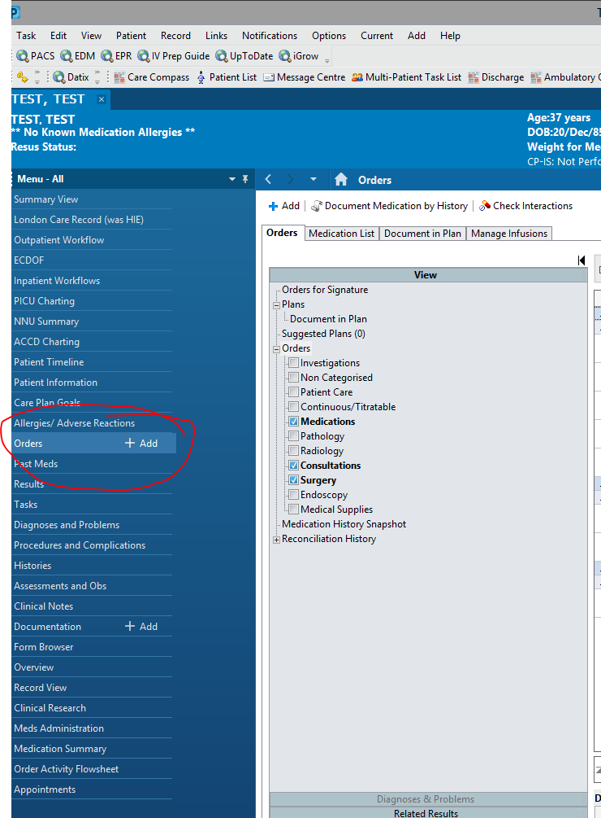

- Search “refer to Pelvic Health Physiotherapy” and select.
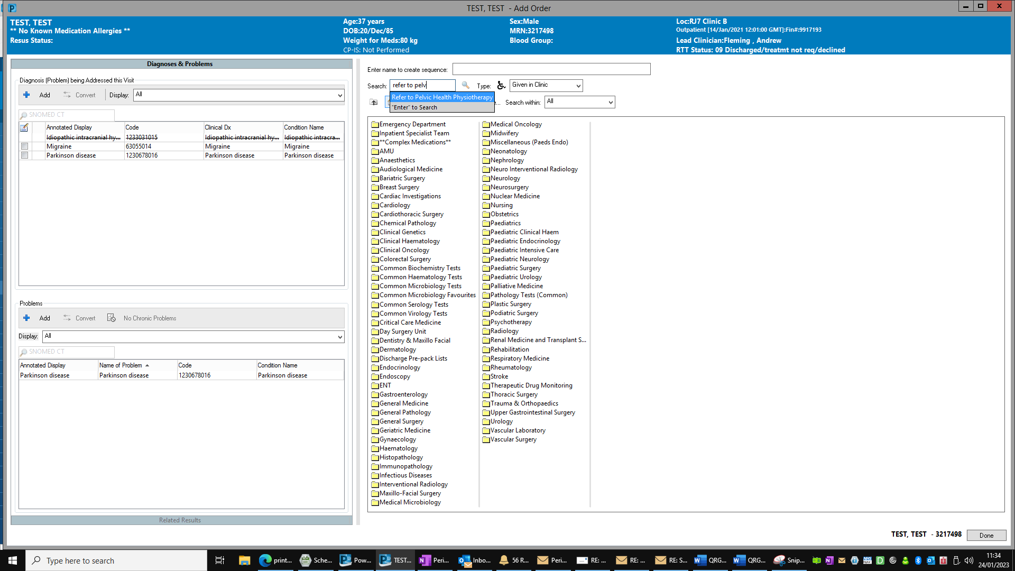

- Complete referral and then sign form by selecting the green tick on the top left of the form. 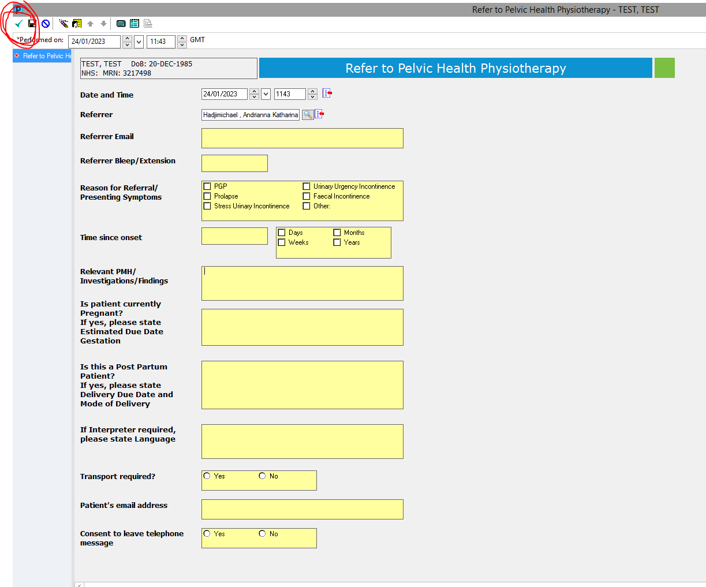

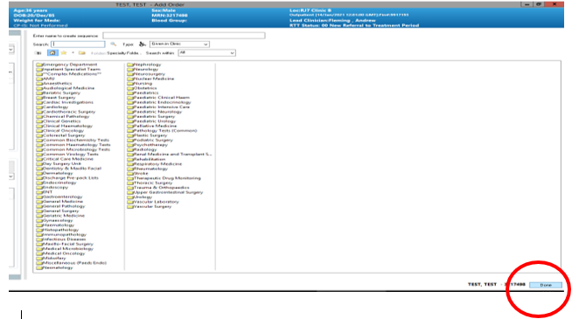
- Then select done at the bottom right of the screen which will take you back to the orders page

- Your order should be visible now, select this order and click sign on the bottom right.

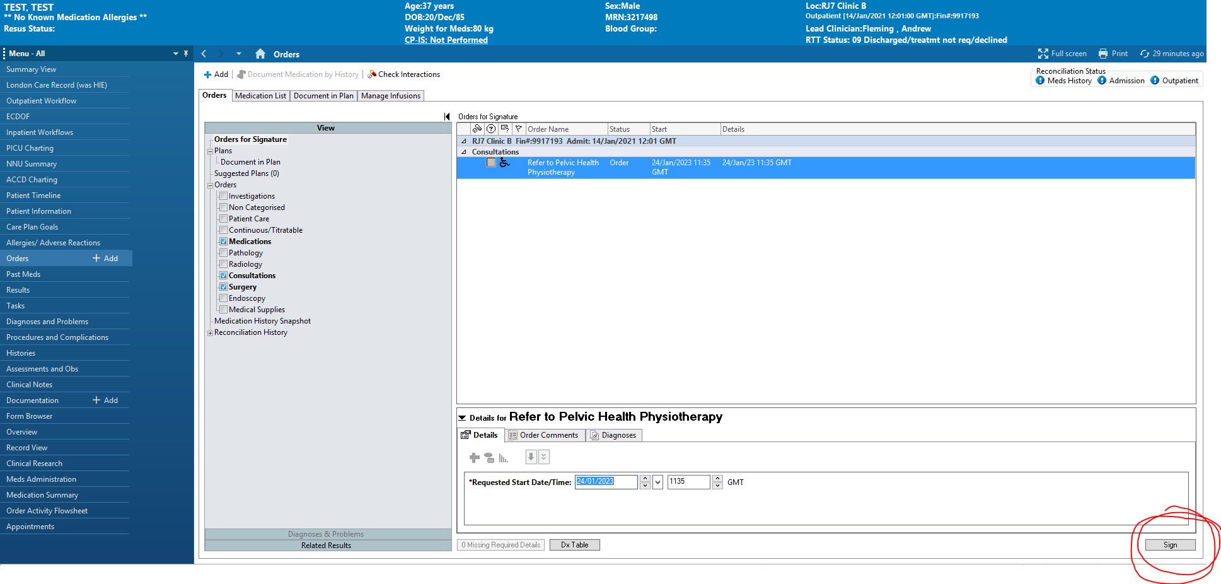

- The referral will now be processing, click refresh and this should then be completed.

- You can check the referral details on documents. Please note you must sign the order as per step 6 otherwise the referral will be visible on the patient’s documents but not sent to physio for triage.

