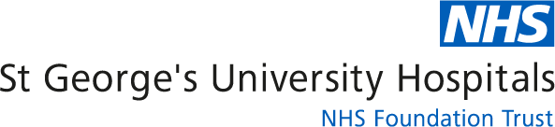


Non Alcoholic Fatty Liver Disease
This leaflet offers more information about Non Alcoholic Fatty Liver Disease (NAFLD). If you have any further questions or concerns about NAFLD, please speak to the staff member in charge of your care.
What is NAFLD and why have I got it?
NAFLD is the name given to a condition in which fat accumulates in the liver in people who drink little or no alcohol. NAFLD is most commonly associated with being overweight or obese and / or having diabetes. It also linked to high cholesterol levels and high blood pressure. Most people with NAFLD do not develop serious liver problems but in some people, the build-up of fat in the liver can lead to serious liver disease (cirrhosis). People with non-alcoholic fatty liver disease also have an increased risk of having a heart attack and stroke. NAFLD is a common problem, affecting more than a third of the population in the UK, but the good news is that it is reversible once identified.

What are the signs and symptoms?
There are often no symptoms with NAFLD although an enlarged fatty liver can cause mild pain in the right upper side of the abdomen. If the liver starts to fail yellowing of the eyes, confusion, abdominal swelling due to a build-up of fluid in the abdomen and spontaneous bleeding and bruising can occur. These though are rare symptoms. Most commonly you will not have any symptoms and NAFLD is diagnosed when you have blood tests carried out that detect abnormal liver tests or fat in the liver is seen on an ultrasound scan of the liver. This may be undertaken because you have risk factors for NAFLD or found when you have a scan for another reason.
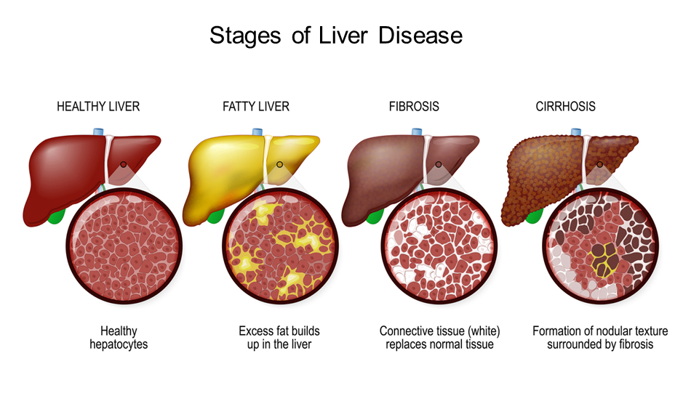

Do I need any tests to confirm the diagnosis?
When abnormal liver tests are detected on your blood tests it is important to ensure that there is no other cause for the abnormal liver tests so you will need to have further blood tests carried out to look for other causes eg viral and immune causes. An ultrasound scan of the liver will also be carried out to look for fat within the liver and ensure there is no other cause for the abnormal liver tests. A ‘fibrosis score’ can then be calculated (a score using blood tests and your age) that looks at your risk of developing scarring in the liver and whether you can be looked after by your GP or need to be seen in the Liver Clinic at St George’s Hospital.
Is there any treatment for NAFLD?
There are currently no effective drug treatments for NAFLD although there is a lot of research being undertaken in this area. If you would be interested in taking part in a research project in NAFLD at St George’s Hospital please do let our Hepatology Clinical Assesment Nurse know.
Is there anything I can do to help myself?
Currently the best way to treat NAFLD is through reversing the underlying cause: This includes weight loss if you are overweight (a sustained10% reduction in body weight can reverse the fatty liver and prevent damage developing), both a low fat diet and a Mediterranean diet helping reduce fat in the liver. Regular moderate exercise (30 minutes 3-5 times a week), so you feel the effort and get a little warm and sweaty but not too out of breath helps burn fat in the liver. If you have diabetes it is vital you get good control of your blood sugar because high blood sugar levels can cause more fat to be laid down in the liver. Avoid drinking alcohol as it causes a fatty liver and is high in calories.


Useful sources of information
British Liver Trust:
https://britishlivertrust.org.uk/information-and-support/living-with-a-liver-condition/liver-conditions/non-alcohol-related-fatty-liver-disease
NHS:
https://www.nhs.uk/conditions/non-alcoholic-fatty-liver-disease
https://www.nhs.uk/live-well
Contact us

If you have any questions or concerns about NAFLD, please contact the hepatology team on 020 8725 7158 (Monday to Friday, 10am to 4pm).
For more information leaflets on conditions, procedures, treatments and services offered at our hospitals, please visit www.stgeorges.nhs.uk

Additional services
Patient Advice and Liaison Service (PALS)
PALS can offer you on-the-spot advice and information when you have comments or concerns about our services or the care you have received. You can visit the PALS office between 9.30am and 4.30pm, Monday to Friday in the main corridor between Grosvenor and Lanesborough wings (near the lift foyer).
Tel: 020 8725 2453 Email: pals@stgeorges.nhs.uk
NHS Choices
NHS Choices provides online information and guidance on all aspects of health and healthcare, to help you make decisions about your health.
Web: www.nhs.uk
NHS 111
You can call 111 when you need medical help fast but it’s not a 999 emergency. NHS 111 is available 24 hours a day, 365 days a year. Calls are free from landlines and mobile phones.
Tel: 111
AccessAble
You can download accessibility guides for all of our services by searching ‘St George’s Hospital’ on the AccessAble website (www.accessable.co.uk). The guides are designed to ensure everyone – including those with accessibility needs – can access our hospital and community sites with confidence.

