
Scar Tissue Management Post Natal

This leaflet explains the management of post natal perineal and caesarean section scar tissue. If you have any further questions, please speak to the healthcare professional in charge of your care.

Postnatal perineal scar massage
If you have had an episiotomy or a perineal tear the scar tissue can become sensitive, painful or raised. This may cause discomfort during intercourse and daily activities. Scar massage can help reduce these symptoms.

When should I start massaging?
Wait until you have had your postnatal check with your GP, which is usually at six weeks. Ensure your stitches have fully healed before beginning. You should not start massage if you have any vaginal infection as this could make it worse.

The perineal area
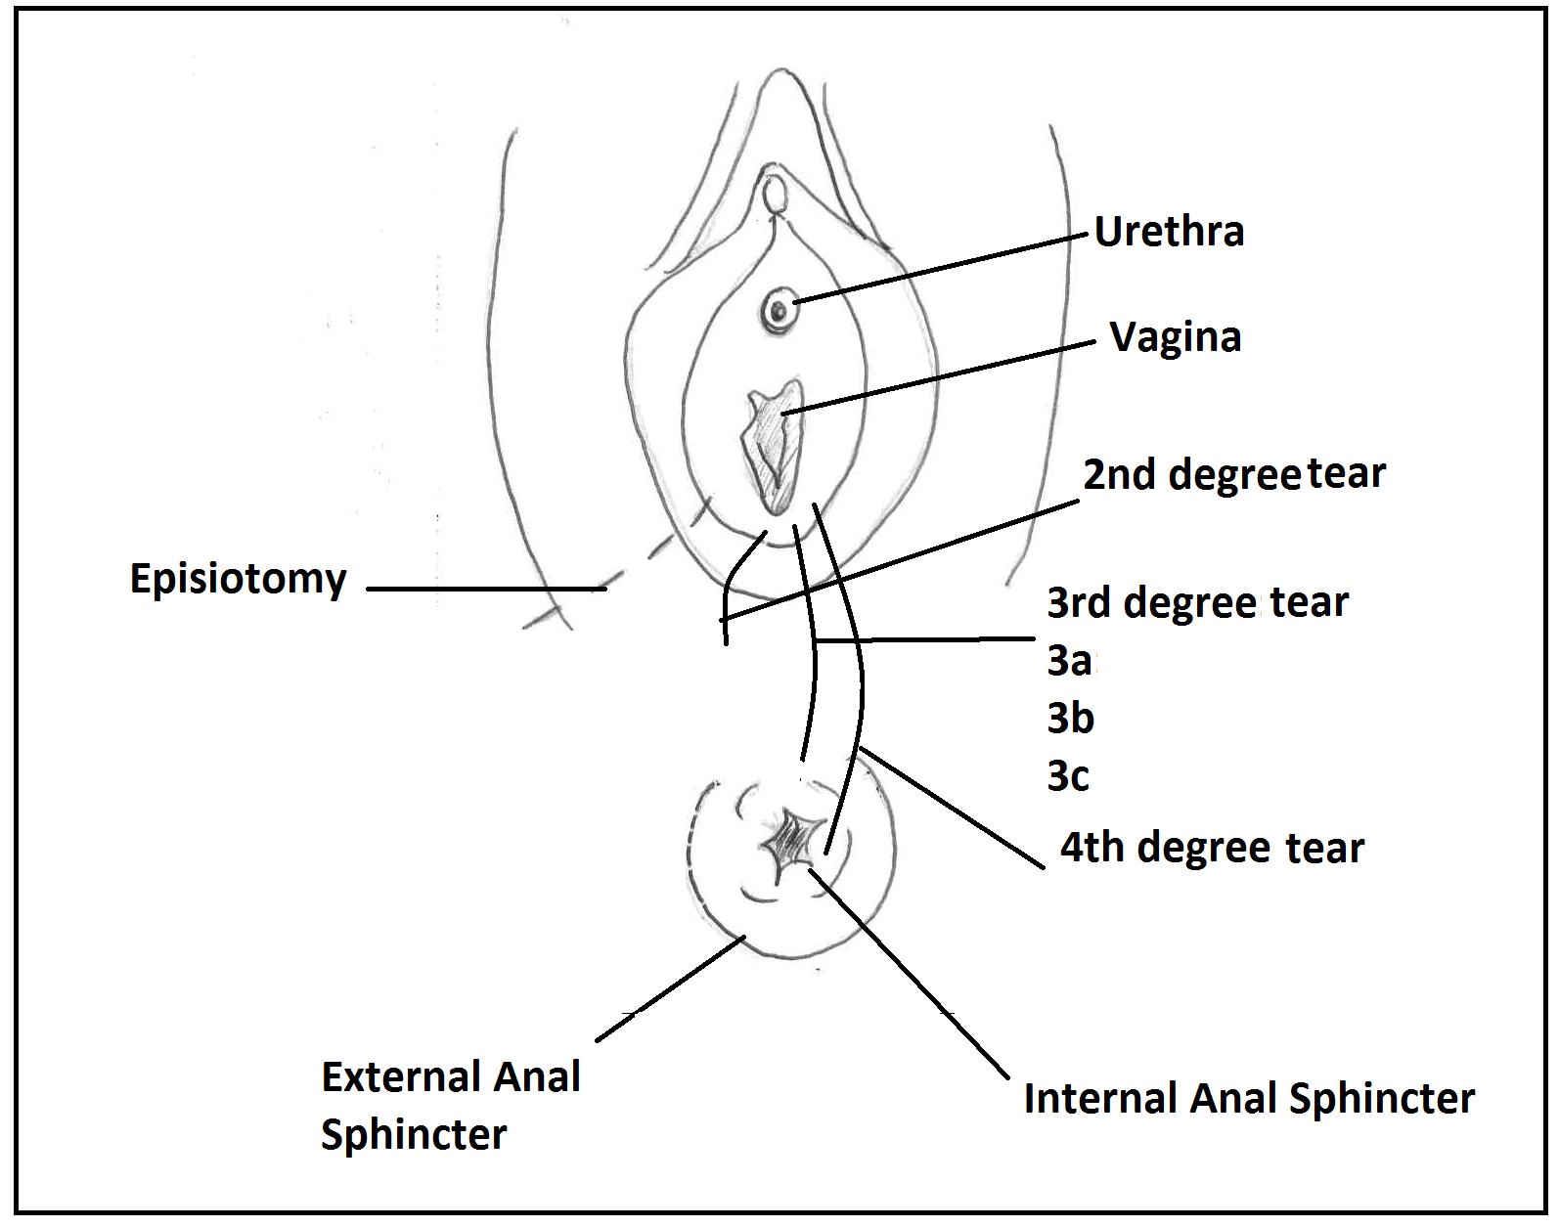

Perineum

How do I massage perineal scar tissue?
- Prepare the area:
It helps to have a warm bath or use a warm compress before starting to help relax the muscles and increase blood flow to the area
- Prepare yourself:
Get into a comfortable position, lying or semi sitting, use pillows as required.
A natural oil or lubricant can be used for comfort – e.g. almond, coconut, or olive oil (as long as you are not allergic to it)
- Duration of massage:
You should massage the scar tissue in three directions for 5-10 minutes daily or every other day, using the technique below.

Technique- Perineal massage
- Start externally. With the pad of your thumb or fingers as below, apply pressure and firmly massage in circles over the scar, across the scar (vertical) and along the line of the scar (horizontal), see diagram below. Work over all parts of the external scar towards the anus.
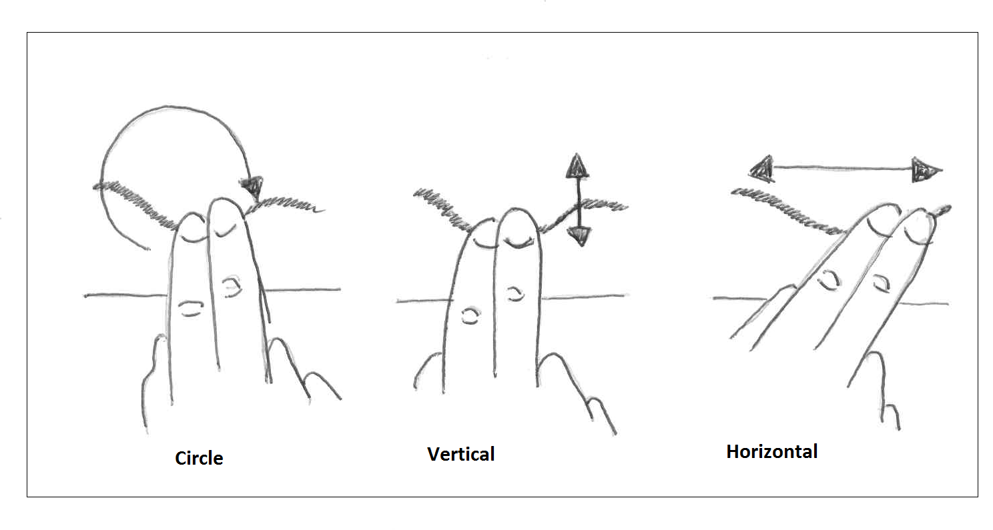
- For internal stitches: Get into a comfortable position with your legs gently opened. Insert your thumb into the entrance of your vagina so the pad of your thumb is facing down towards the anus. Place your index finger over your perineum; you should be able to feel the scar beneath your finger, and massage by repeating the patterns above.
- 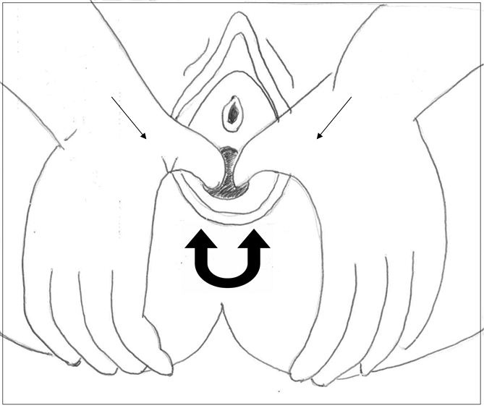
- Next, apply a firm pressure on the back of the vaginal opening with your thumb and make firm “U” shapes (going from 4 to 8 if imaging a clock) over the scar area. This might feel a little bit tender to start with but persevere, it will get better.

Caesarean scar massage
It takes approximately six weeks for your scar to heal fully. It may feel tender, itchy and numb in the first few weeks and can heal to be pink or red and slightly raised. Once healed, it should not be excessively painful or sensitive or prevent you from doing any of your everyday activities. It can take two years for your scar to fade to a smooth white line.

As your scar heals, the scar tissue can become sensitive, painful or raised. Scar massage can help reduce these symptoms.
Wait until your scar is fully healed before starting scar massage – there must be no open areas or scabs. Check with your GP or Consultant before you begin if you have concerns.

How do I massage Caesarean scar tissue?
- Prepare the area:
It helps to have a warm bath or use a warm compress before starting to help relax the muscles and increase blood flow to the area
- Prepare yourself:
Get into a comfortable position, lying or semi sitting, use pillows as required.
Natural oil can be used for comfort – e.g. almond, coconut, or olive oil (as long as you are not allergic to it)
- Duration of massage:
You should massage the scar tissue in three directions for 5-10 minutes daily or every other day, using the technique below.

Technique- Caesarean section massage

- Start by gently massaging around the scar, focusing on tissue immediately above and below it. As it becomes less sensitive, place the pads of your fingertips just above the scar line. Move the skin in circles, gently up and down and side to side along the length of the scar, see diagram below. Work more into areas of resistance where the skin feels tighter. You should feel stretching in the tissue but it should not be painful.

- As this becomes easier, push your fingers firmly down into the tummy muscles and repeat the circular, up and down and side to side movements. Feel free to massage the entire lower tummy area. You must be firm but not aggressive as you massage: let pain be your guide. A slight tingling sensation as you stretch tissues is normal. Keep massaging into deeper areas as pain allows.
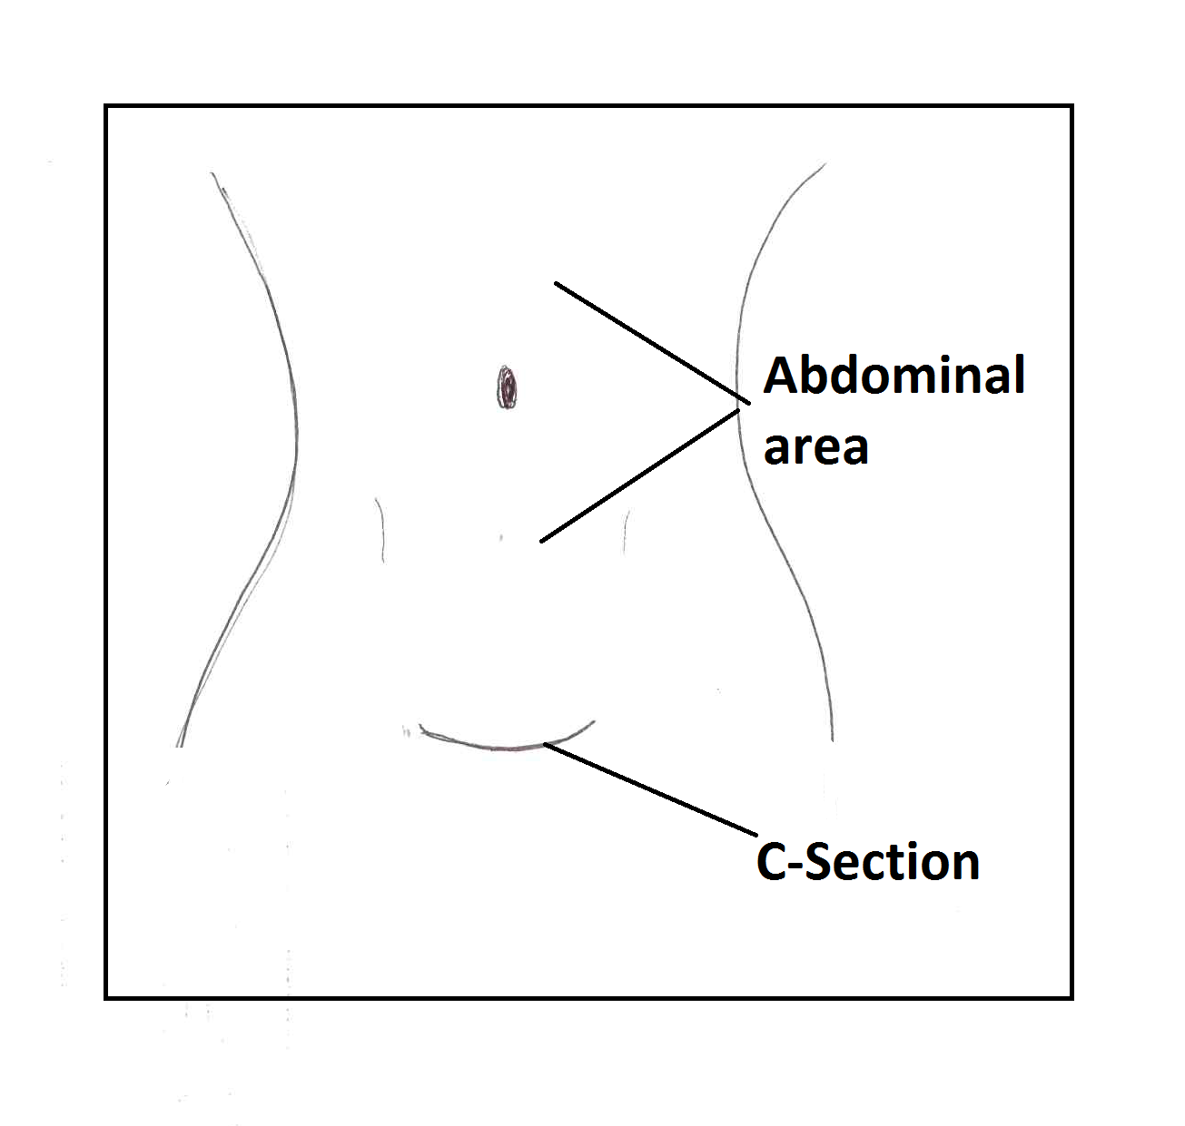
- When you are comfortable with the first two, roll the scar between your thumb and finger. It may take some days or weeks before you can do this one.
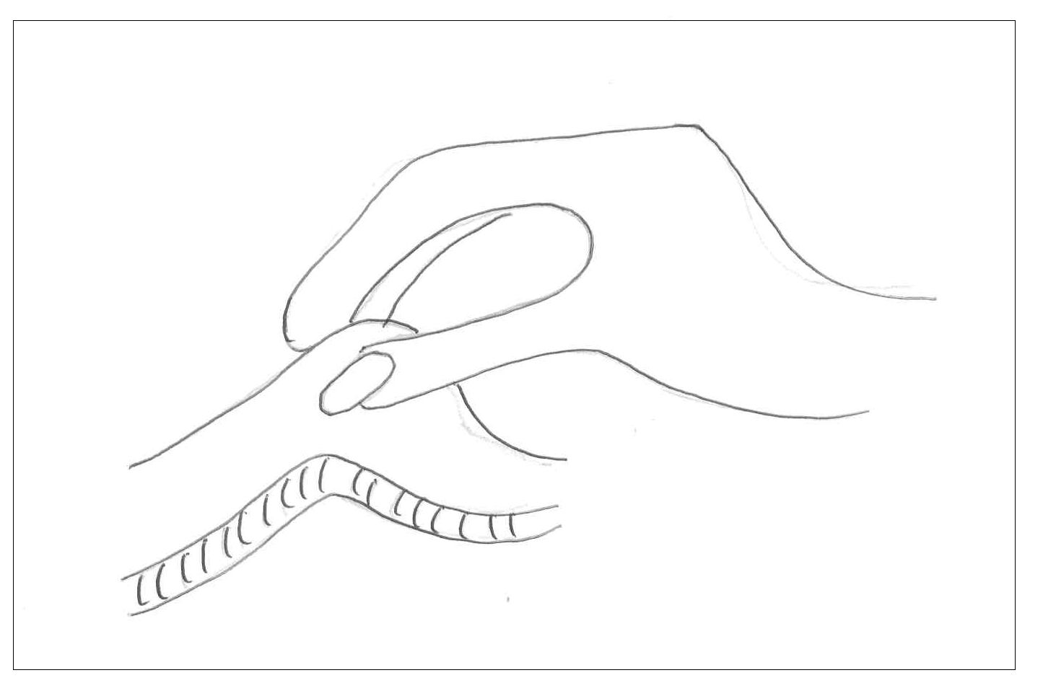
Continuing problems - when to seek advice

Speak to your GP or midwife if you have any signs of infection: worsening redness, heat, oozing or discharge and generally feeling unwell.

If you have any of the symptoms below seek advice from your GP or midwife, who can then refer you to a Pelvic Health Physiotherapist.
- If you have excessive weakness around the abdominal area
- Heaviness/bulging sensation in your perineal area
- Any problems with loss of bladder or bowel control – such as leaking, soiling or having to rush to the toilet.
- Difficulties or pain with sexual intercourse

Glossary of terms:

- Episiotomy: an incision along a straight line from the lowest edge of the vaginal opening toward the anus.
- Perineal: describing the area between the vagina opening to the anus
- External anal sphincter: a circular muscle that constricts the anal passage. When relaxed, the sphincter allows faeces to pass through the opening. When contracted, it closes the anus.
- Internal anal sphincter: as above but located inside the external sphincter.

Useful sources of information
You may find it useful to contact some of the following organisations for further information after your delivery

- Pelvic, Obstetric and Gynaecological Physiotherapy: www.pogp.csp.org.uk
- Continence Foundation www.continence-foundation.org.uk
- Women’s Health www.womenshealthlondon.org.uk
- Patient UK www.patient.co.uk

Contact us

If you have any questions or concerns about your perineal area, please contact our pelvic health physiotherapy team on:
020 8725 1333 (Monday to Friday). Please leave a voicemail message for us and we will contact you as soon as possible.

For more information leaflets on conditions, procedures, treatments and services offered at our hospitals, please visit www.stgeorges.nhs.uk

Additional services

Patient Advice and Liaison Service (PALS)
PALS can offer you on-the-spot advice and information when you have comments or concerns about our services or the care you have received. You can visit the PALS office between 9.30am and 4.30pm, Monday to Friday in the main corridor between Grosvenor and Lanesborough Wing (near the lift foyer).
Tel: 020 8725 2453 Email: pals@stgeorges.nhs.uk
NHS Choices
NHS Choices provides online information and guidance on all aspects of health and healthcare, to help you make decisions about your health.
Web: www.nhs.uk

NHS 111
You can call 111 when you need medical help fast but it’s not a 999 emergency. NHS 111 is available 24 hours a day, 365 days a year. Calls are free from landlines and mobile phones.
Tel: 111

AccessAble
You can download accessibility guides for all of our services by searching ‘St George’s Hospital’ on the AccessAble website (www.accessable.co.uk). The guides are designed to ensure everyone – including those with accessibility needs – can access our hospital and community sites with confidence.

