Quick Reference Guide – Referral to MSK physiotherapy outpatients

- Search for the patient you want to refer on PowerChart
- On the left-hand side, click add next to the orders tab 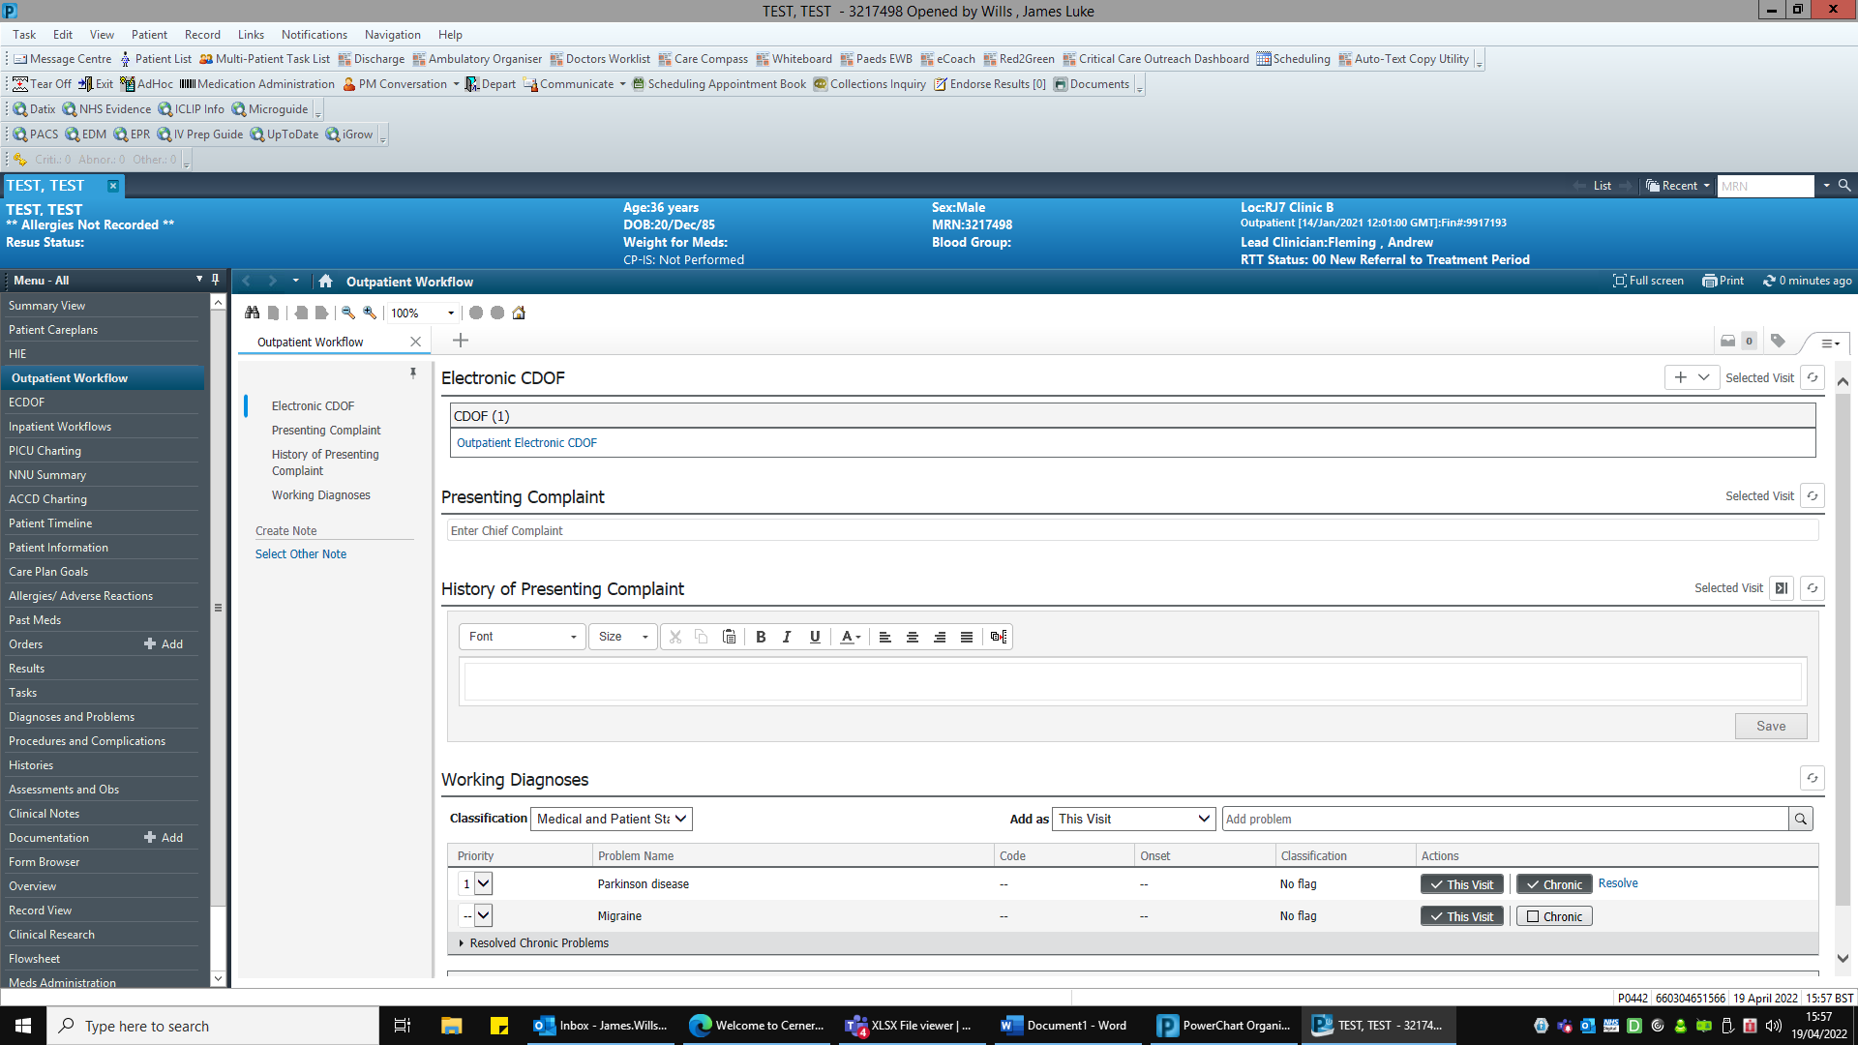
- Search “refer to MSK” and select (this will soon change to “refer to MSK OP Physio”)
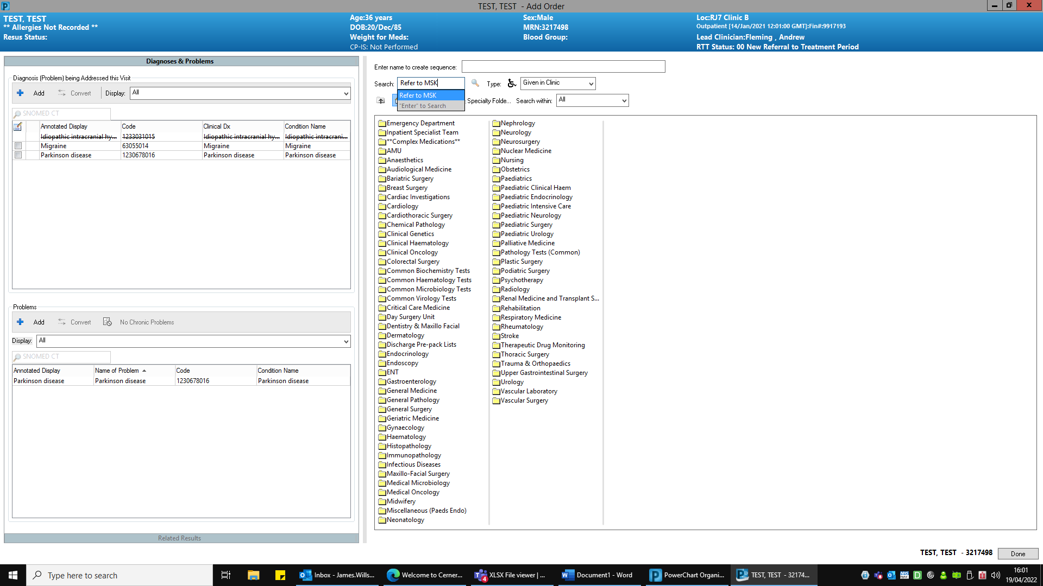
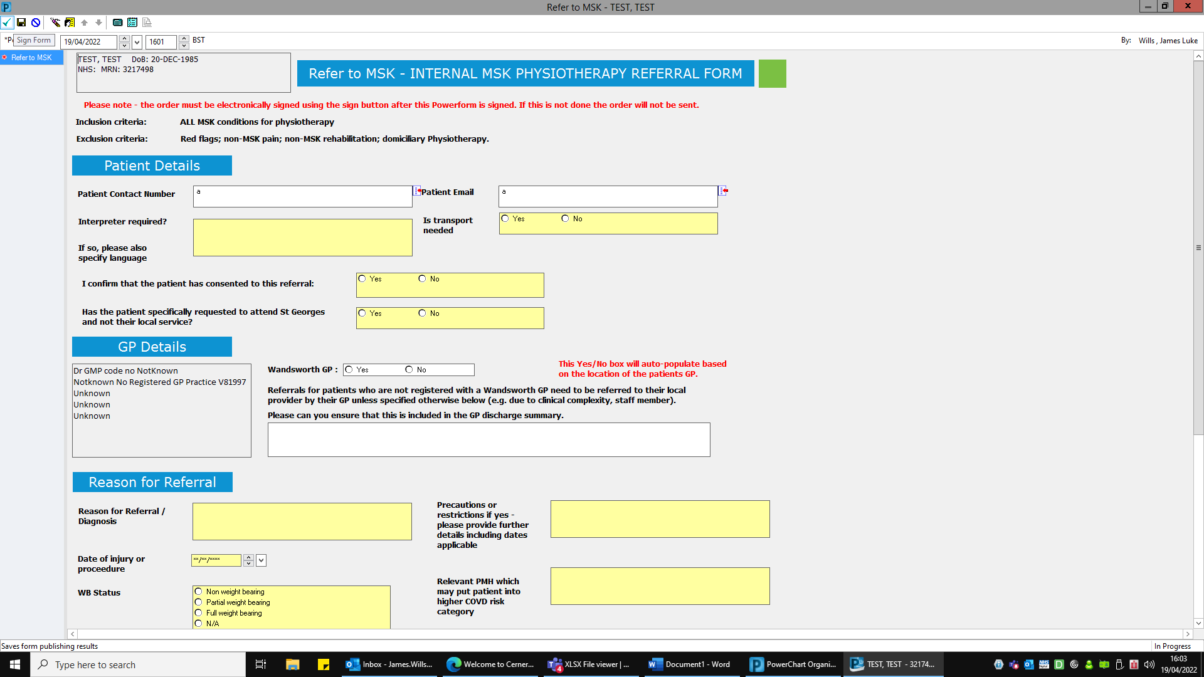
- Complete referral and then sign form by selecting the green tick on the top left of the form

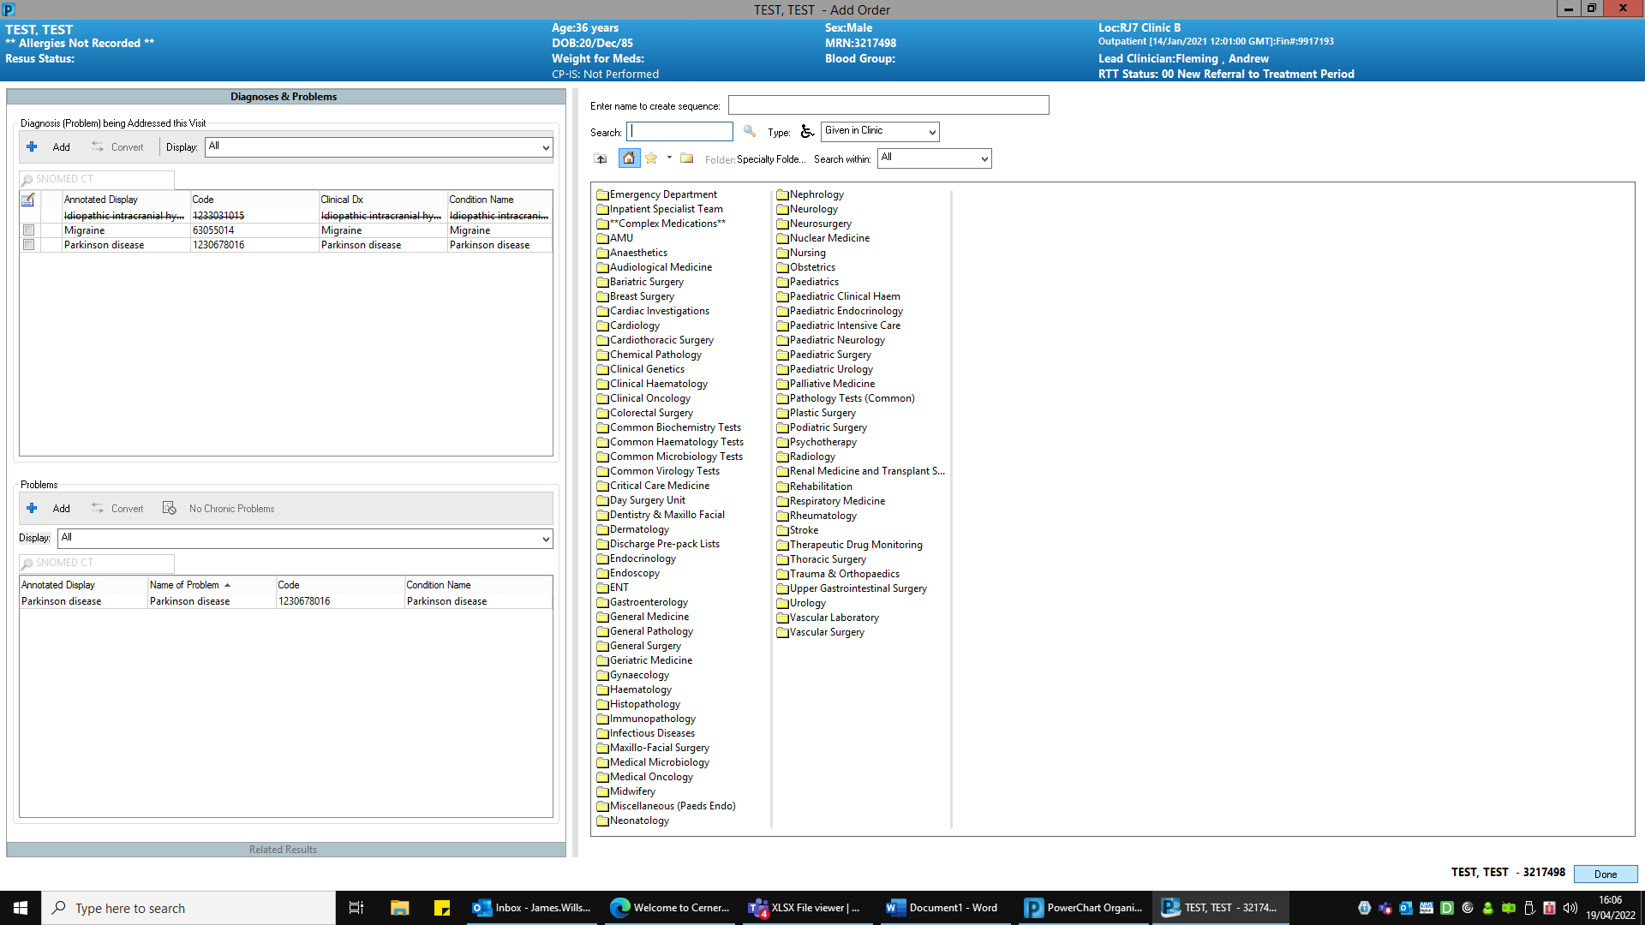
- Then select done at the bottom right of the screen which will take you back to the orders page

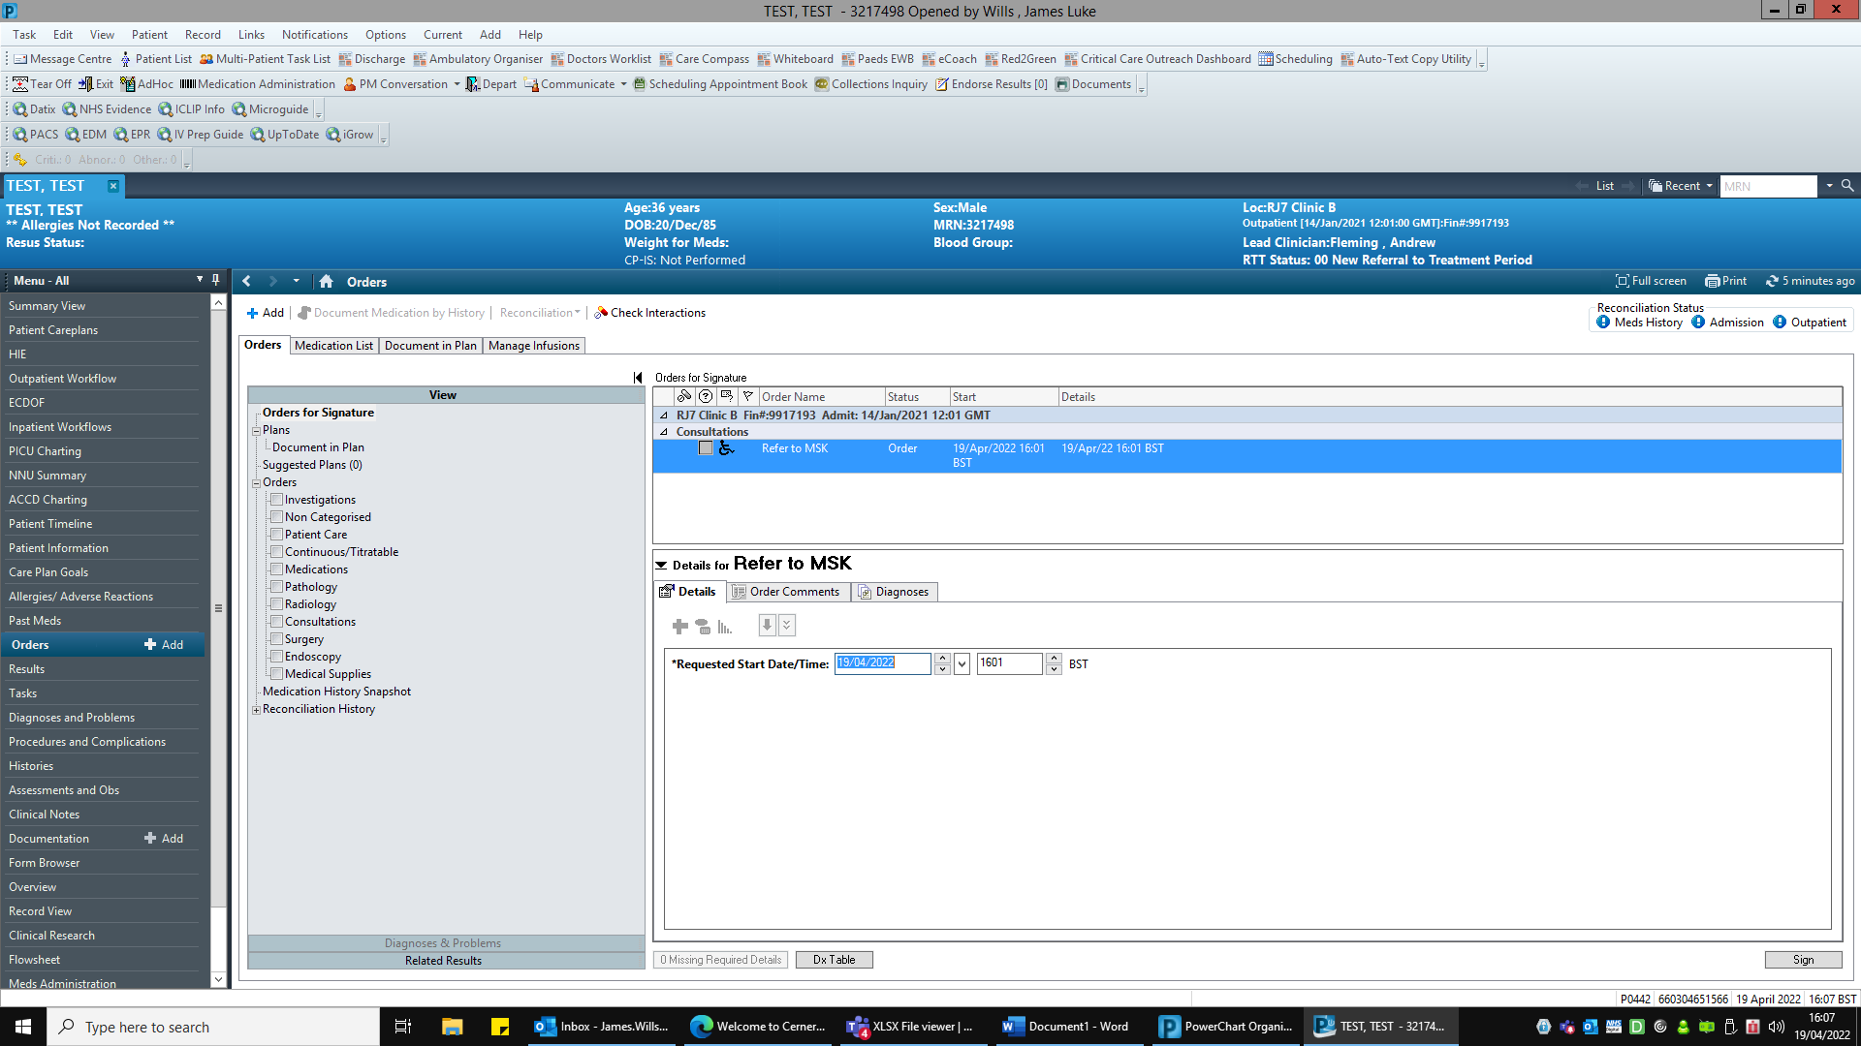
- Your order should be visible now, select this order and click sign on the bottom right.

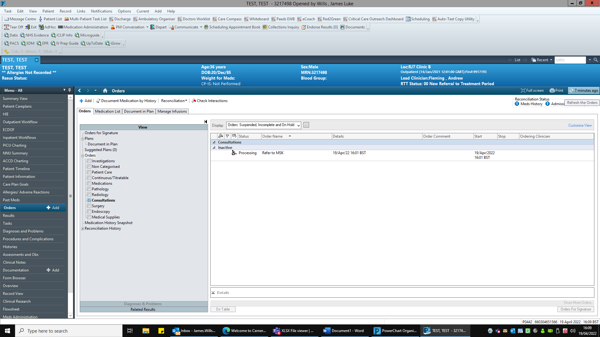
- The referral will now be processing, click refresh and this should then be completed.

- You can check the referral details on documents.

Please note you must sign the order otherwise the referral will be visible on the patient’s documents but not sent to physio for triage.

