Wolfson Neurorehabilitation Centre

INFORMATION BOOKLET
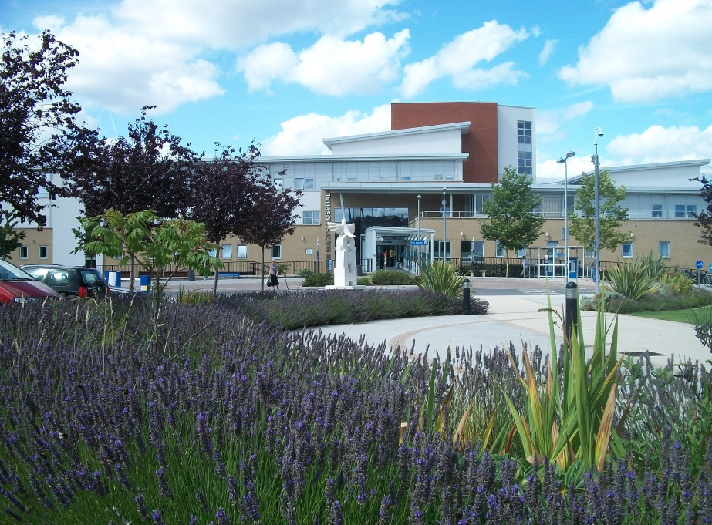

Queen Mary’s Hospital

My team is the Blue / Green / Yellow Team

My key-worker is ………………….

Contact Details: Telephone:

Address:

Gwynne Holford Ward
Queen Mary’s Hospital
Roehampton Lane,
Roehampton
London SW15 5PN

Hospital Switchboard 020 8 487 6000
Gwynne Holford Ward 020 8487 6128 / 0208 487 6127

Blue team base 020 8487 6367
Green team base 020 8487 6480
Yellow team base 0208 487 6145

Our philosophy

Our aim is to provide every person who comes for neurorehabilitation with a team of passionate professionals, offering the best opportunity to work on realistic goals towards independence.
We achieve this through offering a comprehensive range of highly specialised regional multidisciplinary assessment and rehabilitation services for people with acquired neurological conditions. We are integrated from hospital through to the community, and work collaboratively with people and their families to re-engage in valued roles and lifestyles. We stand alongside patients in facing the enduring challenges of neurodisability to realise their potential at every point on their journey.
The team is guided by St George’s values of Excellent, Responsible, Respectful and Kind. As part of a regional neurosciences centre, we aim to maintain a leading programme of teaching and research to underpin the highest possible quality in our work. We work with patients and teams to find the right time and place to meet their individual rehabilitation needs, using a flexible and responsive pathway to maximise the benefit of our work together. We are inspired by the courage and determination shown by our patients and respect their expertise in governing their own lives. Our outlook is real and grounded, and we focus our expertise where it makes a real difference, partnering and supporting patients to recapture their lives and to adjust to new or different ones. We are committed to fostering a warm, positive and equitable environment to allow patients to grow in strength and hope, and to begin rebuilding their lives.

What is inpatient neurorehabilitation?

Inpatient neurorehabilitation is often the first step in a longer journey that you will be responsible for leading both now and after you are discharged from hospital. Your inpatient admission provides an opportunity to learn the skills to manage your condition in the future. The team's role is to guide and support you. It’s a little bit like the role of a personal trainer at the gym. They suggest what exercises to do, but at the end of the day, you have to practice them to become better at what you are trying to achieve. How well you do depends on the point you are starting from (i.e. the severity of your condition) and how much you want to take part. Sometimes factors outside of the team's and your control can prevent progress. In our experience the best outcomes are achieved when you and the team have a shared understanding of your long-term objectives or goals; and when you are able to integrate the skills and strategies learnt into your everyday life. It’s essential for your long-term well-being to get a balance between quality of life and investment in rehabilitation. Too little or too much investment in rehabilitation can result in a poor quality of life. Getting the balance right takes time.

Neurorehabilitation is a partnership between you and the team, working together towards specific goals. Sometimes progress is quick. Sometimes, despite the best efforts of you and the team, progress is very slow or does not happen. Throughout your stay, we will support you to consider whether you are benefiting from being in this environment. We use goals to help you measure what benefit rehabilitation is having for you. If you achieve your goals, stop making progress or lose motivation towards them, we know it’s time to stop inpatient rehabilitation and help you get back to your everyday life. The ultimate goal is to get back to living the life that you want to lead. Research has shown that the best outcomes are achieved by returning to live in community settings as soon as it is practical to do so. For this reason we need to work together to enable you to leave hospital as soon as it is feasible.

Your rehab, your role

We know that neurorehabilitation is most effective when it is guided by your values and goals. It does not only happen in sessions between you and the team but should be integrated throughout your day. We will encourage you to take responsibility for your own behaviour and well-being and the continuation of working towards your goals in between sessions and on discharge. This may be through providing you with specific exercises and tasks to complete, asking you to implement new techniques as you complete your daily routine or asking you to seek feedback from others. Please let your team know if you feel you have too much or not enough to do. However, please also be aware that as your journey progresses you will require less support from the team and will become increasingly independent in managing your rehabilitation programme. Less need for the team and more independence over time indicates a good outcome!

Terms we use

Gwyn Holford Ward: the name of the ward where you will sleep.

Wolfson Neurorehabilitation: an inpatient service at Queen Mary’s hospital. This includes Occupational Therapists, Speech and Language Therapists, Physiotherapists, Doctors, Nurses, Clinical Psychologists, Dieticians and Social Workers. This term also refers to the therapy spaces that you will use during your admission.

Treating Team: This includes staff involved with your rehabilitation – ward staff, therapy staff, your family/friends and you!

Keyworker: The keyworker is part of your treating team. They are a contact person for you, your family and the treating team, and will help to coordinate your stay and discharge plans.

Exercise programme: This is a set of exercises for you to do on your own on the ward. These will complement what you do in therapy sessions.

Goals:

- Discharge goals = the goals that will mean you are safe to leave hospital
- Long term goals = longer term and ‘life’ goals

Values: The things that are important to you in life. Discussing your values in life may help the team understand what is important to you and what goals you might want to work towards.

Goal planning meeting: A regular meeting held every 2 weeks to discuss your goals and plans for discharge with your treating team. One of your family or friends can be invited to attend this remotely.

Self management: supporting you to have the actions and confidence to manage the medical and emotional aspects of your condition to maintain or create new life roles.
Who makes up the treating team?

The Matron is responsible for the operational management and professional leadership of clinical areas and staff.

The Ward Manager leads and co-ordinates the nursing team and is responsible for the management and organisation of the ward. The Deputy ward Manager wears a grey uniform with red trim and deputises for the ward manager. Senior Staff Nurses wear grey with white trim and are usually the nurse in charge of the shift.

The Practice Educator supports the training and development of staff.

The Clinical Nurse Specialist is a nurse who specialises in rehabilitation for people with neurological conditions. They also have special skills to advise about your continence.

You will have daily contact with the Staff Nurses. They will support your independence with personal care, your medications and meal times. They will implement your rehabilitation programme on the ward.

Healthcare/Rehabilitation Assistants will support the nursing staff to help you through the day.

The team of Doctors include four Consultants - specialised in Rehabilitation Medicine, Neurology and Neuropsychiatry - and junior doctors. Your Consultant will see you every week on ward round and will regularly discuss your medical care and rehabilitation goals with the team

Speech and Language Therapists will work with you and your family on your communication and swallowing goals.

Physiotherapists look at how you are able to move around, your balance and how you maintain your fitness.

The Occupational Therapist will look at how you are able manage your daily activities and make any changes or suggestions to maximise your independence. The OT will find out about your home to find out what your environment will be like when you go home and advise on any adaptations or equipment which may be beneficial prior to discharge.

The Clinical Psychologist/ Clinical Neuropsychologist will work with you and your family to support you with your emotions and adjusting to your neurological condition. They will also help you manage any changes to your thinking and memory.

The Social Worker will work with you on discharge planning and accessing the care you may need. The Benefits Advisor will assist you on the benefits you are entitled to.

Therapy Technicians and assistants support the therapy team to carry out rehabilitation programmes set up by the therapists.

The Dietician will monitor your weight and advise about any diet changes and supplements that may be required.

The Service Manager and Administration Team will support your rehabilitation journey.

Rehabilitation Journey

On the day you arrive:
- You will meet some of the nursing, medical and therapy team
- You will be shown around the ward
- You will be provided with a timetable
- You will be provided with a wheelchair if you need one

In your first few days and weeks:

You will meet your key worker and discuss your goals

Your treating team will assess your current abilities and start your rehabilitation programme

This may include assessing your physical ability, communication skills, how you are thinking and feeling and how these relate to everyday life

The Occupational Therapist (OT) will discuss your home situation with you. They may wish to see photos or videos of your home to assess its suitability for your needs.

The team will contact family or friends who need to be involved in your rehab or discharge planning. You will be asked to identify one key contact person (you may have already done this before admission).

Your on-going admission:

- Unfortunately, the COVID-19 crisis is currently impacting on all of the NHS. We have had to change the way we work and our primary aim is now to offer rehabilitation to support people to be safely discharged from hospital.
- You will receive a weekly therapy timetable each weekend for the following week. Your timetable will not show all of your sessions when you first receive it, these will be added by therapists throughout the week depending on your need.
- Therapy sessions are Monday to Friday, but rehabilitation continues throughout your daily activities.
- Therapists may advise you about things you could be working on outside therapy sessions independently, or with the nursing team.
- You will receive a copy of your goals, so that you can refer back to them at any time
- We encourage you to talk to your keyworker about any concerns you and your family might have.
- If you stay longer than 2 weeks, your keyworker will arrange a meeting with your team to discuss your goals, progress and discharge. Your family/ friends can be invited to attend this meeting remotely, using technology.

Your discharge:

We are not currently able to set definite discharge dates, as the length of your stay will depend on the progress you make towards your goals, how quickly an appropriate discharge location can be identified and what level of pressure the NHS as a whole is under from the virus. Your stay will be reviewed by the team every week and you will be kept informed as to the outcome of these discussions, but you may be discharged at very short notice.

Due to the COVID-19 pressures on the NHS, discharges are needing to be progressed more quickly. This means that you do not have as much choice as usual about where you are discharged to, however all discharge placements are currently being seen as temporary and will be reviewed once the crisis is over.
- Throughout your stay, your treating team will be working with you, your family and friends to prepare for discharge. This may involve referring you to social services or other services to support you on leaving hospital.
- Your team will ensure you have all the necessary equipment and two weeks supply of medication for your discharge.
- You will receive your discharge report on the day of your discharge.
- You will also receive a ‘management book’ that will contain advice and exercises for your ongoing rehab.

After you leave hospital:

We would recommend that you follow the current government guidance for ‘shielding’.

If you have on-going rehabilitation needs and goals you will be referred to the appropriate service. Due to the crisis, community teams are also not currently able to offer their usual service and you may have to wait to be seen or receive intervention via the phone or technology.

You may need on-going support from Social Services.

You will be offered a follow up appointment with your Consultant to check on your on-going progress. This will include a review of whether any ongoing goals are being met by the community services. If there are outstanding goals, options for ongoing rehab via the Wolfson Centre will be considered. This might be as a day patient/ outpatient/ inpatient or referral to alternative community services as appropriate.
When you arrive

Your property

Full responsibility for any property lies with you. We recommend that all valuables and money be placed in the hospital safe. On admission, you will be asked to sign a form that states the hospital will only take responsibility for items placed in the hospital safe.

Please ensure that all items are clearly marked with your name.

What to bring

Toiletries

Toiletries are not provided by the hospital. You will need to provide your own.

Items most commonly required are:
- Soap/ shower gel
- Flannel or sponge
- Comb or hairbrush
- Toothbrush and toothpaste
- Deodorant
- Talcum powder
- Shaving foam and razors or electric shaver

Family members can drop off toiletries/ clothing items but are not permitted to enter the Hospital. The drop off location is the entrance on the Lower Ground Floor. Please call the ward on 020 8487 6126 and a member of staff will come and collect the items.

Ward facilities available

There will be up to 46 neurorehabilitation beds on Gwynne Holford Ward. Up to 10 patients undergoing amputee rehabilitation are also cared for on this ward. The ward has four single rooms, four 6-bed bays and two 4-bed bays. These are provided as “same sex accommodation”. The single rooms are reserved for patients who have specialist medical needs. Same sex accommodation includes sleeping areas, toilet and washing facilities.

Please be aware that your bed number may change and you might be expected to move bedrooms during your stay. This is to assist with infection control and other ward management issues.

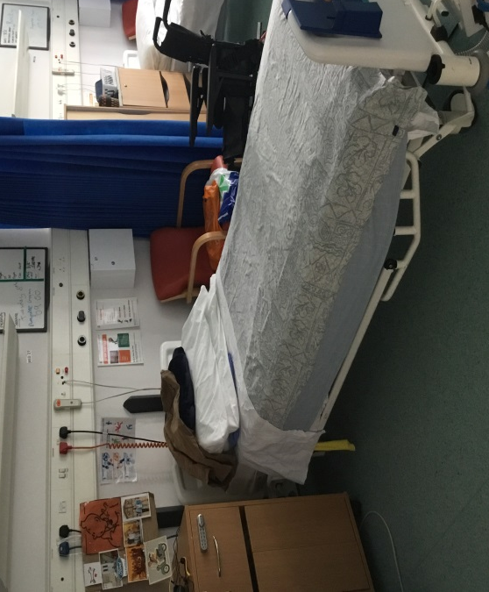
We encourage, if possible, that you make your own bed and tidy your own space each morning.

Television
On Gwynne Holford Ward there is a TV in the patient lounge that is available for you and other patients to watch. Please do not bring in your own TV as this disrupts sleep for other patients.
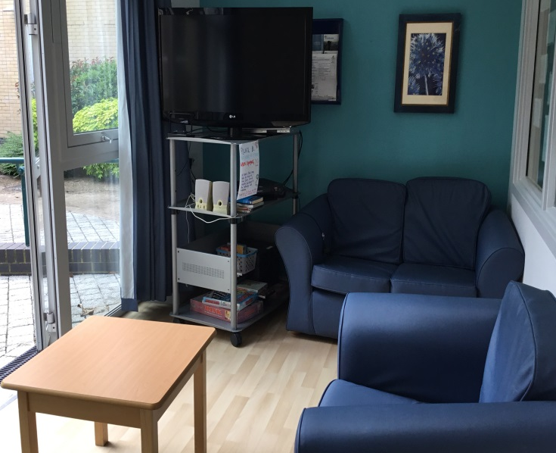
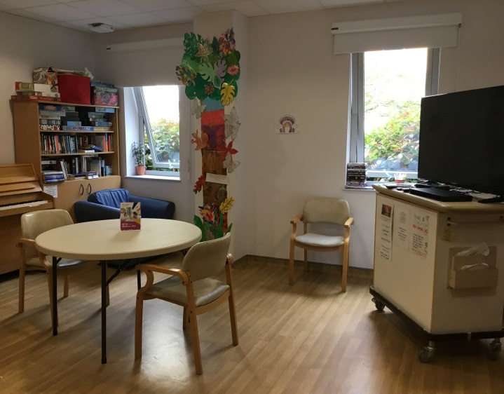

Washing and shower facilities

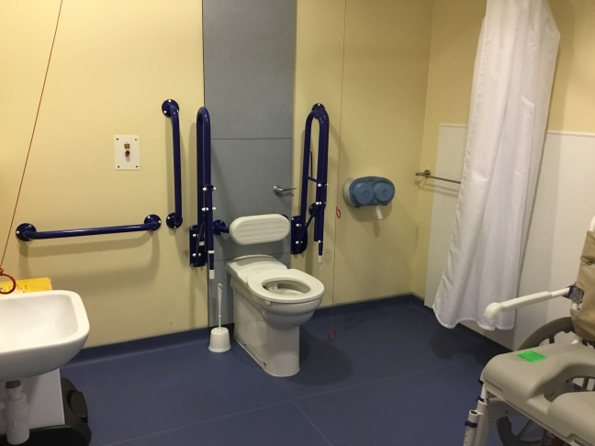
There is a wet room facility with a shower and toilet for each bay. There are separate toilets around the ward that patients can use.
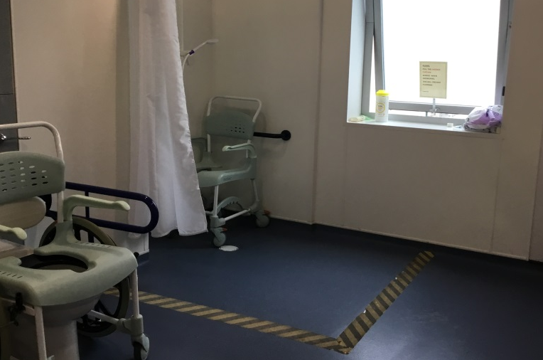

Rehabilitation Centre facilities

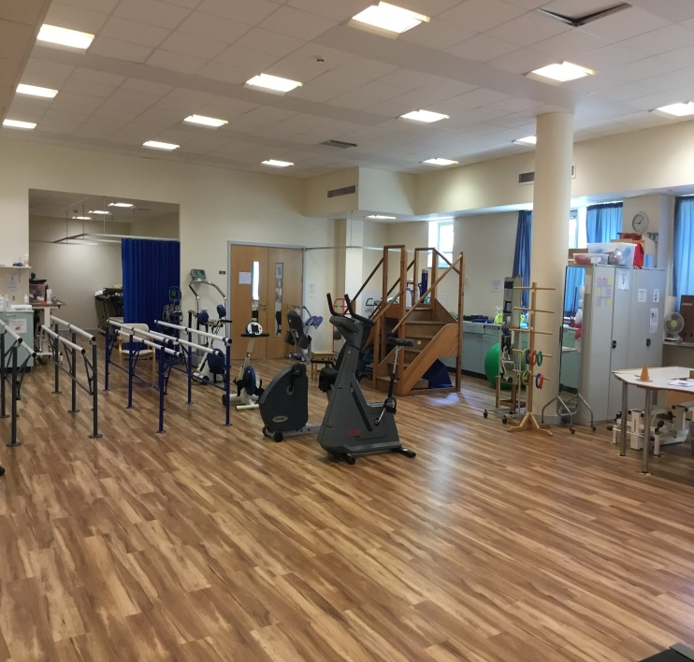
There are treatment rooms and gym spaces on the lower ground and ground floor of the hospital where many of the therapy sessions will take place. Therapy staff may assist you to travel between the ward and these areas. Please ensure you take all necessary rehab equipment (e.g. splints, glasses etc) to and from therapy sessions. Therapy sessions also take place on the ward or outdoors when indicated.
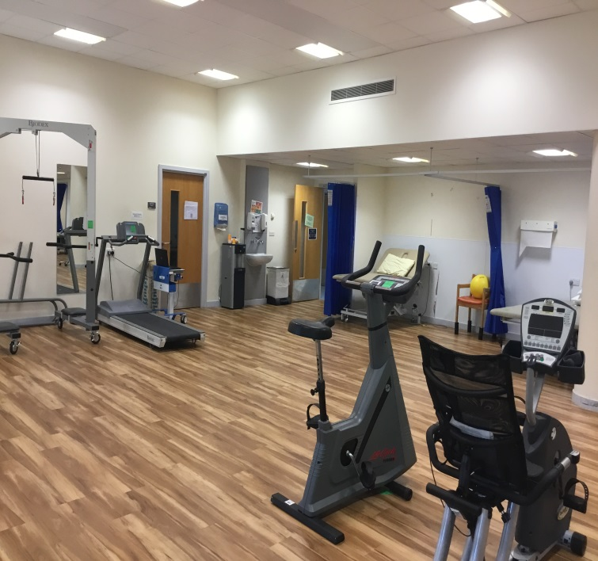

Clothing

For rehabilitation you need practical clothing. If possible, have clothes and shoes which are comfortable to wear and you can easily move in. Flip flops or backless shoes are not recommended. Please bring shoes with a good grip that are suitable to do exercise in. In some cases vest tops and shorts are useful, please discuss with your treating therapist if you are not sure.

It is advised that clothing is clearly marked with your name in case of any loss.

Laundry

There is a washing machine and clothes dryer on the ward for your use. Washing powder can be provided if you are unable to get any. A nurse can show you how to use the washing machine and help if needed.
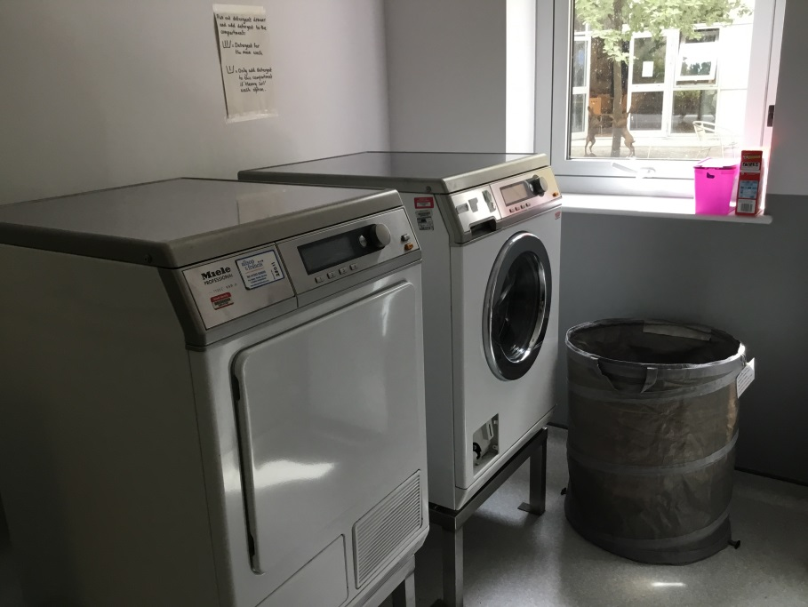

Telephones

You can bring and use your mobile phone on the hospital site. Bear in mind that the ward is on the lower ground floor and the signal can be poor at times. We also ask that you respect others when using your phone, as bedrooms are a quiet area for sleeping. Patients recommend keeping your phone on a lanyard.

Please alert your keyworker if you are having difficulty staying in touch with your family and friends due to difficulties accessing a phone or the internet.

During your stay

Infection control procedures
- We are currently advised to use personal protective equipment when treating all patients.
- Please respect social distancing recommendations that require you to be at least 2 metres away from other people

Leaving the ward
- You will need to sign in and out at the reception of Gwynne Holford ward when you leave / return from the ward e.g. for therapy sessions.

Garden space

- There is a garden located near some of the bedrooms, which is available for you to use. Let the nursing staff know if you are going into the garden.
- No smoking is allowed in the garden.
- Please follow social distancing measures when using the garden, stay at least 2 meters away from others.
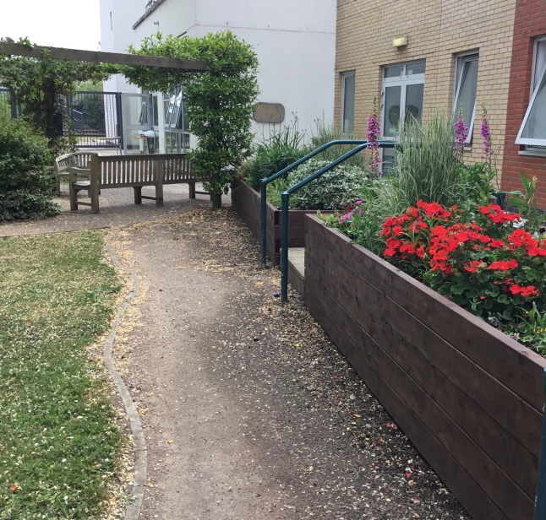
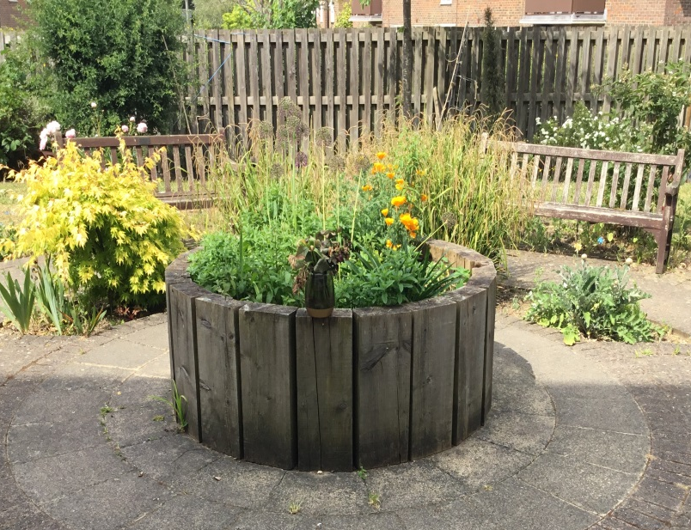

Activities

- There are books, puzzles and activity packs provided on the ward as well as a communal television and video.
- The Douglas Bader Gym is a community gym within the hospital, which patients, staff and members of the public can use independently. If this is appropriate for you, your physiotherapist will set you up with a programme. Please ask your physiotherapist if you have any further queries.
- The Douglas Bader Gym is open Monday-Friday 9-5pm.

Smoking

- Please note that Queen Mary’s Hospital is a no smoking site. If you wish to smoke, this will need to be outside the hospital grounds. If you wish to continue smoking, please let your treating team know as you may require support.
- Should you wish to stop smoking, please speak to the nursing staff about the smoking cessation service.
Prayer room

- There is a non-denominational prayer room; ‘The Sanctuary’ on the lower ground floor where you are able to go for a quiet moment.
- Regular services are held in the prayer room by the chaplaincy service. Speak to the nursing staff about times should you wish to attend.

Other facilities

- Costa is located on the upper ground floor. It is open from 7:30am to 5:00pm Monday to Friday.
- The Courtyard Restaurant is located in the lower ground floor. It is open 10:00am to 3:30pm Monday to Friday.
- Vending machines selling snacks and drinks are available around the hospital.
- You can order your own preferred newspapers for a week at a time. Please let the ward Housekeeper know and they can arrange for the paper to be delivered.
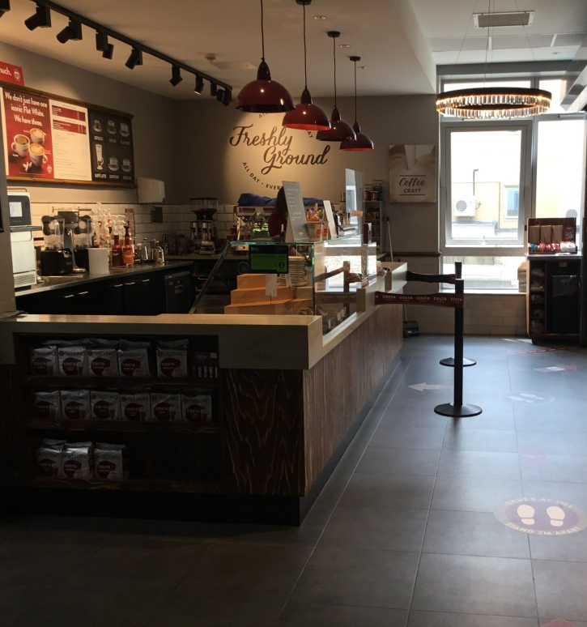
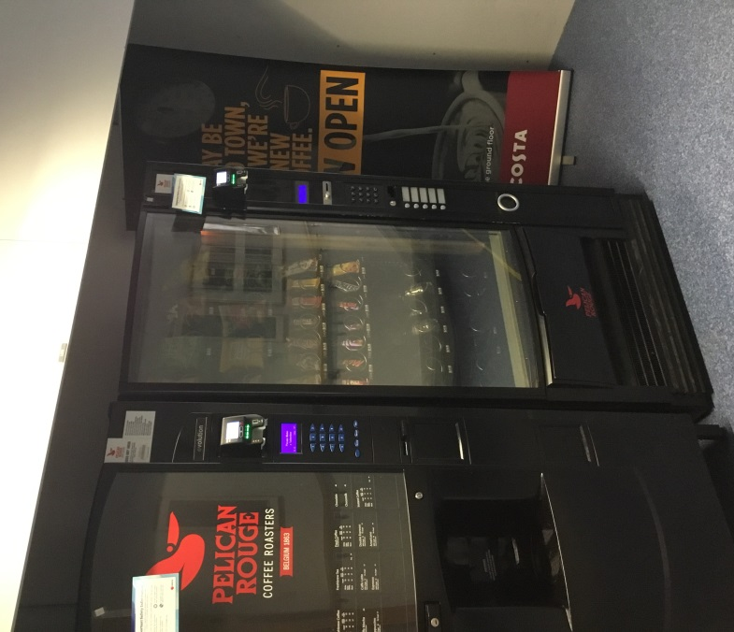

Visitors

- There is currently no visiting allowed. Please let your treating team know if you need support to stay in contact with your family and friends.

Ward routines

Meal Times
Breakfast 7:30 am
Coffee/Tea 10:00 am
Lunch 12:00 pm
Tea/Coffee 2:00 pm
Supper 5.30pm

At Weekends supper is at 6pm.

Individual menus for midday and evening meals will be given to you 24 hours in advance for you to choose your meal.

- If you have any special dietary requirements or any special likes/dislikes, please inform the nursing staff. There is a wide choice of menus.
- If you wish to eat at the Courtyard Restaurant outside the arranged times, you will need to pay for this yourself.

Medicines

Medicine rounds take place at 8.00, 12.00, 18.00 and 22.00hrs. If you need any medication at times other than these, please discuss this with a nurse.

As part of your rehabilitation, you may be able to administer your own medicines with advice and assistance from staff. The nurses will discuss this with you. This is to encourage independence and understanding of your medication before your discharge.

If necessary, the nursing staff will be available to administer your prescribed medication throughout your stay.

Nursing handover

This is when nursing staff share information at the beginning of each staff changeover.

Nursing handover lasts approximately 30 minutes and takes place at 7.30 am and 7:30pm. If possible, please try to direct queries to nurses outside these times.

Ward round

- Depending on your consultant, ward rounds take place on Monday Wednesday and Thursday each week.

- The ward round is to review your medical care. This is an opportunity for you to discuss and ask questions about your treatment.

- In order for you to get the most out of any discussion with the doctor, it is recommended that you write down your questions beforehand. Please ask a member of your treating team if you would like some help with this.
Diet and Nutrition

All patients are screened on admission to identify if they are under or overweight. This is repeated every week. Appropriate patients are then referred to the dietician for further individual specialised support.

It is important to avoid excess weight gain during your rehabilitation (unless you are underweight on admission) as this could affect your progress. Monitoring your weight weekly helps to assess if you are eating the correct balance of foods compared to your activity levels.

The ward menus have been designed to meet energy and protein requirements for both people who need to lose weight and for those who need to increase their weight. The menus are also suitable for people with diabetes. The meals which are suitable for diabetics and healthy choices are coded with a heart symbol. If you are underweight and need to gain weight, the meals marked as high energy would be the best ones to choose.

Additional snacks such as sandwiches can be ordered to have before bed if required.

If you have not been referred to a dietician during your stay, but would like to see one please speak with the nurse looking after you.

Special dietary requirements can be made if needed.

If you have been assessed as needing a modified diet by a Speech and Language Therapist, this will be made available to you. If you have any concerns regarding your nutrition please speak to the nurse in charge.

Policy Regarding the Consumption of Alcohol during In-Patient Stay

The multidisciplinary team within this centre is committed to providing the most efficient care to all its patients. To enable patients to benefit from this care, it is vital that they participate and co-operate with the team in this process.
As part of this, the consumption of alcohol is not permitted.

- It can affect your ability to participate in your rehabilitation programme.

- It can interact with medications you are taking, putting your health at risk.

- Difficulties can arise from alcohol use, which may affect your health, safety and social functioning.

Your behaviour whilst under the influence of alcohol can also pose a threat to the health and safety of other patients, hospital staff and visitors.

If following discussion with you regarding your alcohol intake, you continue to breach the above protocol, your discharge from hospital may be brought forward.

If you become intoxicated and the staff are concerned about the risk to yourself or others, security will be called and the appropriate action taken, which may involve calling the police. If this occurs, your Consultant and a Senior Hospital Manager will be informed.

If you or your carer wishes to discuss any aspect of this protocol, please feel free to speak to a member of the Multidisciplinary Team.
Harassment

The Race Relations Act of 1976 makes it unlawful to verbally or racially abuse any individual or group, regardless of nationality or colour.

This behaviour is viewed as unacceptable by the NHS and St George’s Healthcare NHS Trust. This applies to employers, their employers, their employees and everyone that uses the Trust’s services.

The Trust considers verbal/racial abuse from employees, patient/client/relative or other users of this Trust to be a very serious issue. All complaints must be made in writing giving details of the incident to assist us with our investigation.

The NHS has a Zero Tolerance Policy (2003) for the prevention and management of violence and aggression towards NHS staff from patients, relatives and visitors in the work place.

St George’s Healthcare NHS Trust expects that all its Directors, Managers and other members of staff and all users of the Trust will continue to act responsibly to maintain a happy and professional working environment free of verbal/racial harassment.

Suggestions, Comments & Complaints

We welcome your suggestions and comments, and are interested to hear your views on the services that we provide. If you have a complaint about your treatment, please discuss this with the Ward Manager or Matron who will endeavour to resolve your concerns.

If this is not possible, you can contact PALS (Patient Advice and Liaison Service) based at:

PALS office, St George’s Hospital,
Blackshaw Road,
London.
SW17 0QT.
Tel: 020 87252453
Email: pals@stgeorges.nhs.uk

This service can provide you with:

- Information on NHS services

- Will listen to your concerns and suggestions

- Will help sort out problems and concerns

