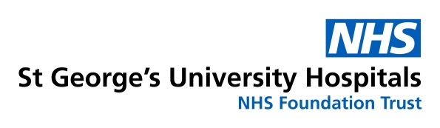
REQUEST FOR DISCUSSION AT THE NEUROVASCULAR MULTIDISCIPLINARY MEETING
Neurovascular MDTM: Tuesday at 12.30. John Ambrose Seminar Room, Atkinson Morley Wing, St.George’s Hospital. London, SW17 OQT
All fields are mandatory
Patient Details | Hospital Details
Surname: | Referring Hospital:
Forename: | Your Name:
Date of Birth: | Your Designation:
NHS Number: | Your email:
Address: | Bleep/Mobile:
Postcode: | Consultant:
Telephone number: | Consultant email:
GP Name and Address: | Neurosurgery/Neuroradiology On-Call referral:  Registrar/Consultant spoken to:  Date:

What question/s regarding this referral would you like answered at the Neurovascular multidisciplinary team meeting?

Clinical Information
To include: Current clinical status, co-morbidities and physical/cognitive capabilities; Brief patient history, views and preferences where known; clinical observations if available:

Smoker N If Yes daily consumption: Alcohol Y/N If yes units per week:
If previously a smoker when did the patient quit:
Where is your patient currently? If inpatient – what ward are they in?

Imaging and Other Relevant Investigations (IEPd to St George’s)

Additional Information that will be useful to us

By using this form you agree to the following:
- That all relevant and contemporaneous imaging is being transferred electronically to St. George’s Hospital via the IEP link
- That you or a relevant practitioner of sufficient seniority will convey the MDTM decision to your patient/their next of kin
Save and send this form to NeurovascularMDT@stgeorges.nhs.uk. The Neurovascular Clinical Nurse Specialists are available during working hours on 020 8672 1255 bleep 7711 or leave a message on 07920 456725. The outcome from this MDTM will be emailed to you usually within 5 working days. All urgent action will be relayed personally by one of the team.

(Below is for use by St George’s Neurovascular MDT)

Date of MDT -
MDT Outcome:
MDT Actions: (email sent and to whom, who to refer to )

