Recommended free apps and offline games for children and families to play at home

You can use the tablet as a tool to play interactive games with your child, take turns, create stories together, look at photos etc.
Below are some ideas for apps which you can use to play language games and activities with your child. There are many apps which your child might enjoy using on their own but the ones below can be used in an interactive way.
This list is based on Apple apps (for iPad/iPhone) but most will have an Android/Amazon equivalent.
Many children have difficulty moving onto other activities and can play with the tablet for hours on end. Think about setting limits on time that your child can use it. Here are some ideas for moving on to other activities:
- If you use a visual timetable at home, put in several slots for the tablet so that your child understands ‘Tablet time’ will finish but there will be more opportunity later on.
- Use a First/Then board to help your child understand what they are going to do after they finish using the tablet. Make sure you follow tablet time with another motivating activity to help move them on.
- Set a timer on the tablet which helps your child understand when their time has finished.
To help children move on to other activities, we have included a number of offline games that you can play together.

(This Recommended Apps resource has been adapted from a similar resource created in partnership with Homerton University Hospital, Hackney Learning Trust, Get Hackney Talking and Hackney Council.)
How to use Guided Access
If you want your child to stay in one app you can use Guided Access. Here’s how to use it:
- Make sure it is set up by going to Settings > Accessibility > Guided Access > switch to ON.
- You will have to set up a passcode the first time you do it.
- Then, go in to the app.
- Press the button 3 times quickly
- The guided access screen will come up around the main screen.
- Touch ‘Start’ in the top right hand corner.
- It will ask for your passcode (if it is the first time you have used it this session).
- Tap this in and it will say Guided Access started.
- Then you can give the iPad to your child.
- To end Guided Access, triple click the button, and put in the passcode.
- Choose ‘End’ in the top left hand corner.
- Carry on as usual.
- Choose ‘End’ in the top left hand corner. The iPad will be ready to use as normal.

Scroll down and select an app to play today

Play as a family
Charades for Kids  Cost: free  Age: 4+  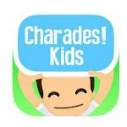  How to use:  This app is a family game where you select a category and then place the phone on your forehead and guess the word with the help of others who act, sing, or describe clues.  If your guess is correct, tilt the phone so the screen faces the floor, if not – tilt the phone so the screen faces the sky. | Double Match Game  Cost: free  Age: 4+  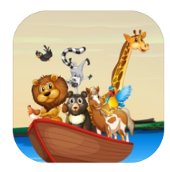  How to use:  This app is a fun matching game, where you can play different games. The main game is to try and find a matching item on both your card and your opponent’s card.
Air Hockey Gold  Cost: free  Age: 4+  How to use:  This is a great two player turning taking game in which you select a puck and then the aim of the game is to try and get the puck into the other person’s goal. | Monster Hunt – Fun Logic Game  Cost: free  Age: 4+  How to use:  This app is a fun memory game where you take it in turns to find a matching pair of monsters.
When iPad is over… here are some games to play with children
- Hide and Seek - either take it in turns to hide around your home, or hide a teddy or favourite toy. Give each other clues (e.g ‘hotter’ and ‘colder’) to help the seeker find the toy.

- I Spy – what can you see in the room, or looking out the window?

- Change Artist – one person leaves the room. The people left change one thing about their appearance, or about the room. Call the person back in and let them guess what you’ve changed!
Attention and Listening games
Sound Touch Lite  Cost: free for animals/transport  Age: 4+  How to use:  Hide the iPad/phone under a sheet and press one of the pictures. Ask your child to listen first and then identify the picture. You can take turns doing this. | Articulation Essential Lite  Cost: free  Age: 4+  How to use:  Practice your articulation by identifying phonics sounds, and matching sounds to activities. You can also record yourself speaking and get feedback.
Fun With Directions Lite  Cost: free  Age: 4+  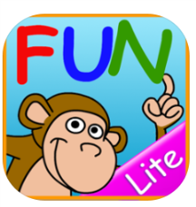  How to use:  This apps helps to strengthen language and listening skills, through following spoken instructions. | SPEAK  Cost: free  Age: 0-6 years  How to use:  There are fun activities that parents / carers can try with children aged between 0-6 years old. This includes introducing new words through play.

When iPad is over… here are some games to play with children
- Simon Says – follow the rules of this simple game and ask your child to listen carefully to the instructions. For example, ‘Simon says… spin around two times’.
- Guess the Noise – collect noisy objects from around your home. Play with them with your child so they can recognise the sounds. Turn your back or ask your child to close their eyes. Can they work out which object made the noise?
- Missing Words – sing familiar songs with your child and miss out words. Can they tell you which words you missed out?

Making sentences
Learn English Sentence Maker  Cost: free  Age: 4+  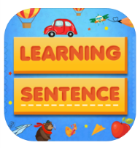  How to use:  This app provides lots of worksheets where the child has to fill in the blanks to complete the sentence. This can help the child to practice building sentences and strengthen their vocabulary. | Sentence Maker: Educational Learning Game for Kids  Cost: free (in-app purchases)  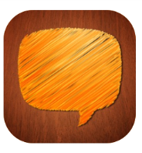  Age: 4+  How to use:  This interactive game helps children to build sentences by touching the screen. Children can also add their own pictures to make sentences and record their own voice.
Sentence Constructor: Hear It!  Cost: free (in-app purchases)  Age: 4+  How to use:  This app helps children to associate written works with spoken words. You can make sentences by dragging words to the line , and pressing play, to hear the sentence you’ve created spoken back to you. | Fun with Verbs and Sentences  Cost: free (until end of April 2020)  Age:2-5 years  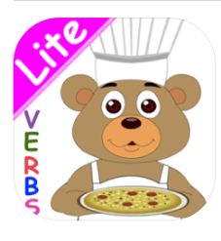  How to use:  Build a sentence by choosing your character, then a verb, and lastly an object. Then try and say the sentence out loud. If you need a break, play a reward game.
When iPad is over… here are some games to play with children
- Word Jars – find four containers and label them ‘people’, ‘actions’, ‘objects’ and ‘places’. Write words from each category on small pieces of paper, fold them up and put them in the jars. Pull out a word from each jar and put them together to make a silly sentence!
- Chain of Words – take it in turns with your child to add one word at a time to make a sentence. Start with ‘A’ or ‘The’ and see how many words you can add to grow your sentence.

Problem-solving and sequencing
Odd one out – what does not belong  Cost: free  Age: 3-6 years  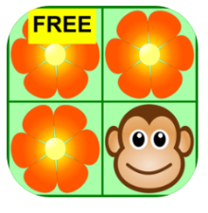  How to use:  Find the item that doesn’t belong to the group, or is different from the others. This game helps children to problem-solve. There are two difficulties levels. When the child answers correctly, a fun animation appears. | Sorting Machine  Cost: free (in-app purchases)  Age: 6-8 years  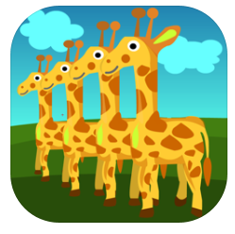  How to use:  This app helps children to understand sequencing by providing some simple challenges, such as arranging objects from shortest to tallest, in alphabetical order, or based on how quickly they move.
How to Make Origami  Cost: free (in-app purchases)  Age: 4+  How to use:  Follow the step by step 3D animated instructions to make different animals and objects. | 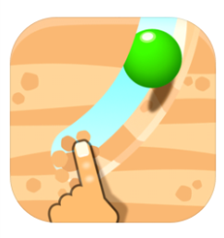  Dig this  Cost: free (in-app purchases)  Age: 12+  How to use:  Dig your fingers in the sand and guide the ball to the cup. Think quickly on your feet as the objects speed up as you change levels.

When iPad is over… here are some games to play with children
- Build a Tower – ask your child to choose items from around your home for you to build a tower with, e.g. pillows, books. Ask them to give you instructions on how to make the tower. What should you do first?
- Bossy Boots – ask your child to give you instructions to complete everyday routine sequences, e.g. how to brush your teeth, how to make a sandwich. Can they remember all the steps? What can they do if you don’t understand the instruction?

Sensory
Heat Pad  Cost: free (in-app purchases)  Age: 4+  How to use:  Create different patterns and colours using the heat of your fingertips when you touch the screen. There are different surfaces available, including sky, heat, glow and many more. The app also features accompanying music. | Bubble Wrap Popping  Cost: free (in-app purchases)  Age: 4+  How to use:  Pop the individual bubbles on the bubble wrap and listen to the sound it makes. You can also change the size of the bubbles.
All Musical Instrument Sounds  Cost: free  Age: 4+  How to use:  This app gives children the chance to play different musical instruments, including the piano, saxophone, flute, drums etc) using their fingers. | 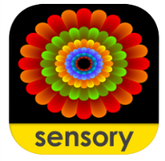  Sensory Coloco  Cost: free  Age: 4+  How to use:  Create fun symmetrical patterns and drawings through selecting your chosen effect, and touching the screen. You can also share the interactive art you’ve created.

When iPad is over… here are some games to play with children
- House Band – what objects can you find around the house that make noise, e.g. pans, shake a water bottle etc. Can you play these ‘instruments’ while you sing your favourite songs?

- Deep Breaths - listen to calming music and practise taking deep breaths – put a book on your stomach and watch it go up and down.

- Make Play-doh – search online for a straightforward recipe. Add herbs, spices or cake flavouring to make it more interesting!

Telling stories
ChatterPix Kids  Cost: free  Age: 4+  How to use:  With this app, you can make anything talk! This could be your pet or toy, a book, football, drawings and more. Simply take a picture, draw a line to make a mouth, and record your voice. Play it back and laugh at your creation. | Imagistory – Creative Storytelling  Cost: free  Age: 3+  How to use:  This is a wordless picture book to encourage you and your child to make up a story yourselves. Choose one of the two free stories available. Talk about what is happening and swipe left to move between pages. You can read the story again and again and use new words each time.
Stop motion  Cost: free (in app purchases)  Age: 4+  How to use:  This is a great movie app where you can create your own stories. You could create stories around the house or even with miniature toy figurines. Encourage your children to make a video and to recall it back. | Story Dice – story telling  Cost: free  Age: 4+  How to use:  Choose up to 10 dice at a time, shake the phone and iPad. Think of a story using the symbols on the dice that have landed on. This is a great way to build up fun narratives and focus on using sequential language.

When iPad is over… here are some games to play with children
- Silly Stories – write ‘beginning’, ‘middle’ and ‘end’ sentences and put them into separate containers. Take out one at a time to build silly sentences. Keep the emphasis on the beginning, middle, and end structure.
- Toy Story – ask your child to get their favourite toys together and act out scenes from their favourite book or film. Follow your child’s lead and see what they come up with!

