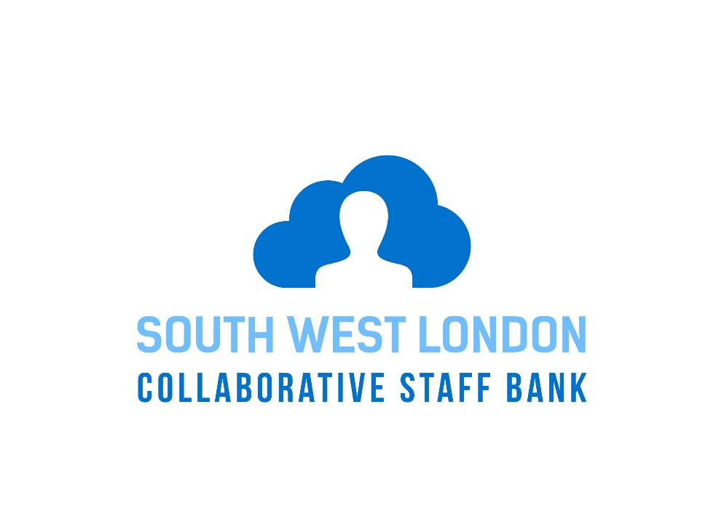
Chris Goulding

This document is intended to provide staff with information about the South West London Collaborative Bank and help answer common questions that the staff may have.
frequently asked questions

SW London Collaborative Staff Bank
Q&A’s
General
1. How can I join the SW London Collaborative Staff Bank?
NHS Trusts in South West London have created a ‘virtual’ Staff Bank which means Band 2 HCA or Band 5 RN registered at one Staff Bank will be able to see and book vacant shifts at Epsom & St. Helier Hospitals; Kingston hospital and St George’s Hospitals.
2. What are the benefits of the Collaborative Staff Bank?
The benefits are many. You can improve your work-life balance, by booking and working flexibly at other Trusts that suits you. The aim is to reduce the use of agency workers, ensuring the quality of care to our patients by enabling our staff across all Trusts to cover vacant shifts.
3. Joining the Collaborative Staff Bank
How do I join the Collaborative Staff Bank?
You will need to download the Me app either by app or to your desktop (see below. Once you have done that you will need to complete 4 forms:
- SWL Collaborative Bank Personal Details Form
- HMRC Starter Checklist (to ensure you are taxed correctly)
- Pensions Questionnaire (ONE for each Trust you are applying to)
- 48 hour per week Opt-Out Form
Me App: What it is and how it works?
Me is a mobile app (from Allocate Software) which you can use to access shifts at your Trust and other Trusts in the SWL Collaborative Bank.
It includes viewing your roster, requesting shifts on future rosters, booking bank duties, viewing your time sheets and seeing who you are working with by viewing team schedules.
You can download and install the app from the App Store and your Desktop Computer at www.allocateme.com Once installed, follow the directions to register yourself, linking your Employee Online account to the Me app and you are good to go.
Your Me account and EOL account;
Q: Is my Me Account and EOL Account the same thing?
A: No.
Your Me account credentials: -
- Username - your email address
- Password - must consist of 8 letters and contain a capital letter and a number
Your Me account is then linked to your EOL account. This is done during the initial set up of Me.
You can also access Me App on desktop computers by visiting http://www.allocateme.com.
Details of relevant clinical policies and procedures, payroll timescales, reporting arrangements and who you can contact for help are available on the Internet site of the Trust where you are booked to work can be found by following the links on the Me app.
4. Are there any restrictions on where I can work?
You will only be able to see and book shifts for which you should have the necessary skills and you should not undertake any duties during the shift which you do not feel competent to perform. You will also be asked to complete a working hours opt-out form when joining .
5. I’m an employee but not yet registered through my Home Staff Bank; can I still join the
Collaborative Staff Bank?
You must first register with your Home Trust Staff Bank in order to join the Collaborative Staff Bank. This can both be done at the same time.
6. Can I continue to work through my Home Bank if I decide not to join the Collaborative Staff Bank?
Yes. Joining the Collaborative Staff Bank is entirely voluntary and you can still download the Me app and use it to manage your shifts at your Home Trust (as an alternative to Employee Online). The nurses who have worked through the SWLCB found it a great experience and continue to book more shifts.

Booking Shifts
7. How do I book a shift at another Trust?
There are 2 ways to do this:
- You can direct book through the Me app and Me web
- You can direct book through Employee Online
8. What additional employment checks will be required?
None. These are already held by your Home Staff Bank. You will need to prove your identity by showing your Home Trust Photographic Identity Badge each time you report for work at the beginning of each shift.

Working at another SW London Trust
9. What arrangements will apply when I work at another Trust?
These are covered in the Joining Instructions and Guidelines available from your Home Bank Office. Essentially, local clinical and other procedures will apply and you should familiarise yourself with these through the Trust website prior to starting work.
10. What uniform & identity badge will I wear?
This is covered in the Guidelines. You should wear your Home Trust uniform (with the exception of mental health roles where no uniform is required) and you will need to clearly display your Collaborative Staff Badge, keeping with you your Photographic Identity Badge from your Home Trust. Issued by your Home Trust when you complete the registration process, the Collaborative Staff Bank Badge will enable patients and colleagues to identify in what capacity you are working.
Pay Rates and Payment
11. When will I get paid if I work through the Collaborative Staff Bank?
The Trust where you work will pay you. All Trusts pay their bank workers through a weekly payroll, although each has slightly different pay days. Details can be obtained through the Trust website where you work. You MUST complete the forms identified in the Joining Instructions, to ensure you are registered to allow payment without delay. The weekly pay period is from Monday to Sunday. If you work a shift during this period, the pay days for each Trust are as follows:
Epsom & St Helier : the second Friday after the end of the pay period (paper timesheets are used at this Trust)
Kingston : the Friday after the pay period
St George’s : the second Wednesday after the pay period. For Bank Holiday’s, payment is on a Thursday

12. What are the Tax Implications?
These are explained in the Guidelines. In most cases, provided you complete the HMRC Starter Checklist, you will be paid at the basic tax rate for each shift you work away from your Home Trust. Tax arrangements are of course personal to individual circumstances and you should contact HMRC for definitive personal tax advice.
13. What are the Pension Implications?
These are explained in the Guidelines. Your pension options are limited by whether you are already in the NHS Pension Scheme and paying the maximum full-time contributions. Depending on your current circumstances, you will be enrolled into the Government Stakeholder Pension Scheme (a 1% deduction) for the payment for your first shift at the Trust where you work through the Collaborative Staff Bank. You can then opt-out of this pension by request. This is because the National Pension Regulations do not allow employers to be seen to be encouraging pension opt-outs.

Leaving the Collaborative Staff Bank
14. What happens if I resign from my substantive employment?
Your registration with your Home Staff Bank continues and your membership of the SWL Collaborative Bank will be unaffected.

Help and support
15. Who should I contact if I have any questions about the Collaborative Staff Bank?
In the first instance you should contact your Home Staff Bank Office.
The email addresses for the Staff Bank at each Trust are as follows:
Epsom & St Helier : esth.cloudstaff@nhs.net
Kingston : khft.staffbank@nhs.net
St George’s : collaborativebank@stgeorges.nhs.uk

