Patient Consent Form – Videofluoroscopic Study of Swallowing (VFS)

Patient name |  | Date of birth
NHS number / Hospital number |  | Ward / Clinic
Referring SLT

Description of procedure
VFS is an x-ray of your swallow. Instead of a single x-ray picture, multiple pictures are taken to produce a video. This allows us to see food and / or fluid passing through your mouth, throat and into the top of your stomach tube. In order to see the food / fluid inside your body we mix it with a radio opaque contrast such as Barium. We may try different fluid and food consistencies and may ask you to try different strategies. At the end of the procedure you will be given a brief summary of what happened and any recommendations. The pictures are recorded onto our hospital system and will be reviewed in more detail to produce a final report with more specific details and advice.

Aims of the procedure:  (Please tick the relevant aims)  - Inform dysphagia diagnosis  - Observe for silent aspiration  - Determine the severity of aspiration  - Inform eating and drinking recommendations  - Determine progress or deterioration of impairment  - Inform a rehabilitation programme  - Inform onward referral e.g. ENT, Gastro | Risks of the procedure:  - Allergic reaction to contrast agent  - Aspiration of contrast – every effort made to limit the risk  - Constipation (Higher risk if already significantly dehydrated)  - Diarrhoea (Rare)  - See supporting information for further details of very rare risks

Allergies: (Please document below any allergies to food, fluids, medications, contrast ingredients and latex.
Please see the supporting information sheet for ingredients of contrast agents)

- No know allergies
- Allergies (list below)

PATIENT

I sign to confirm that the procedure, aims and risks have been explained to be and I have had a chance to ask any questions and I am agreeable to proceed with a VFSS

Signature:…………………………………… Print name:………………………………………………………………….. Date:………………
(If you are unable to sign yourself your SLT can document this and sign on your behalf)

SLT Signature:…………………………… Print name:………………………………………………………………….. Date:………………

If a patient is unable to consent to any aspect or the SLT has reason to doubt the capacity to consent the principles of the Mental Capacity Act should be followed. A best Interest decision may be needed if an individual is found not to be able to consent. Please see overleaf.

Mental Capacity Assessment for consent to undergo a VFS

What is the decision to be made?

The decision to undergo a VFS for the aims listed overleaf.

Has all possible facilitation been provided to support the individual to make the decision? Yes / No

Please outline how the individual has been facilitated / supported:

With facilitation has the individual been able to demonstrate:
(Please only tick the boxes that have been demonstrated)

- Understanding of the decision to be made
- Understanding of the risks / benefits
- Weighing up of the risks vs benefits
- Ability to retain the information
- Communication of a decision

Overall has the individual demonstrated capacity to make this decision? Yes / No
(All of the above boxes must be ticked in confirmation for capacity to have been demonstrated)

Assessor
Print name: |  | Role:
Signature: |  | Date:

BEST INTEREST DECISION

If capacity to make the decision was not demonstrated during the assessment a best interest decision will need to be made. The decision should consider if the VFS is in the individual’s best interest. The decision should be a joint decision between the Speech and Language Therapist and the individual’s relevant Consultant (or appropriate senior medic).

Please outline the discussion / considerations and decision made:

Decision makers:
Print name |  | Print name
Signature |  | Signature
Role |  | Role
Date |  | Date

Supporting Information

Contrast type | Ingredients | Very rare adverse reactions  VFS uses very small quantities of contrast and nationally we are unaware of any reported serious adverse or allergic reactions from a VFS procedure
Omnipaque | Iohexol  Additionally very small amounts of the following:  Trometamol  Sodium calcium edetate  Hydrochloric acid  Sodium hydroxide | Redness and soreness of the eyes  Skin rash  Stomach pain  Swelling of the feet or lower legs  Vomiting
Baritop | Barium sulphate 100%w/v  The other ingredients are:  Sodium carboxymethylcellulose  Tragacanth  Sodium saccharin  Glycine  Sodium ascorbate  Silicon resin emulsion  Sodium benzoate  Sodium dehydroacetate  Cream soda essence flavour | Nausea, vomiting, diarrhoea and abdominal cramping, aspiration pneumonitis, barium sulfate impaction, vasovagal and syncopal episodes  Very rare severe allergic reactions includes:  bronchospasm and other respiratory impairments, rashes and itching.
EZ-HD | E-Z-HD contains excipients including:  Acacia  Artificial cherry flavour  Artificial strawberry flavour  Carrageenan  Citric acid  Ethyl maltol  Polysorbate 80  Saccharin sodium  Simethicone  Sodium citrate  Sorbitol

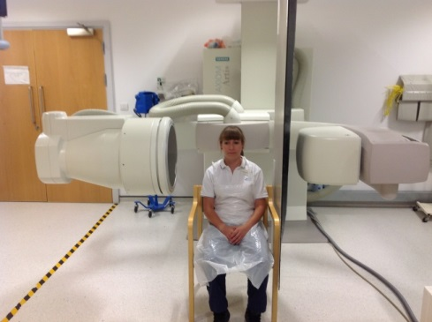 | This picture shows the room & x-ray machine, you will sit in the machine as shown whilst the VFS is completed.
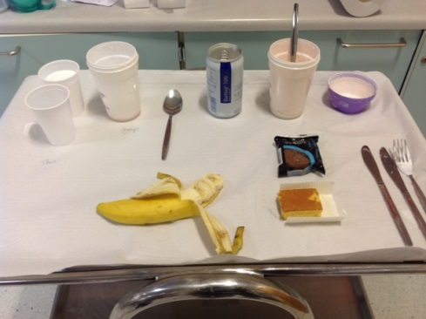 | You will be given drinks &/or foods which are mixed/coated in Barium (the contrast used to show up on the xray).
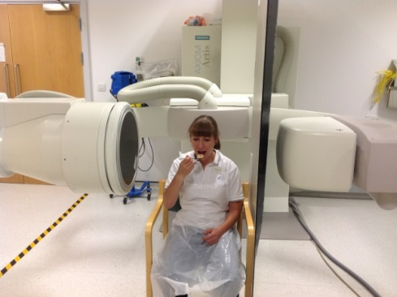  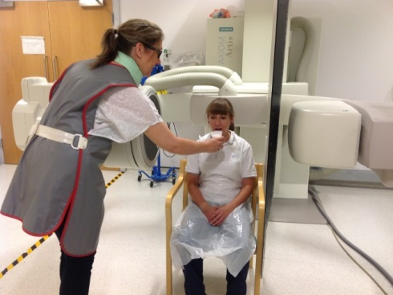 | You will either feed yourself or be supported with feeding by a Speech & Language Therapist whilst the VFS is completed.
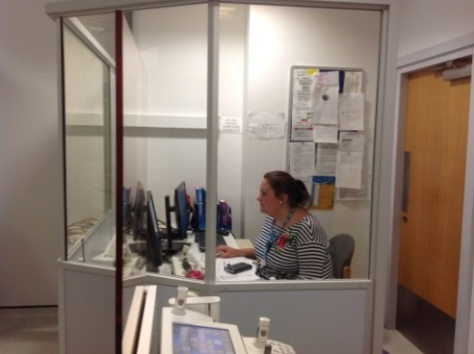 | The images being recorded will be viewed on screen in the x-ray room & watched by a Speech & Language Therapist who will guide the assessment.

