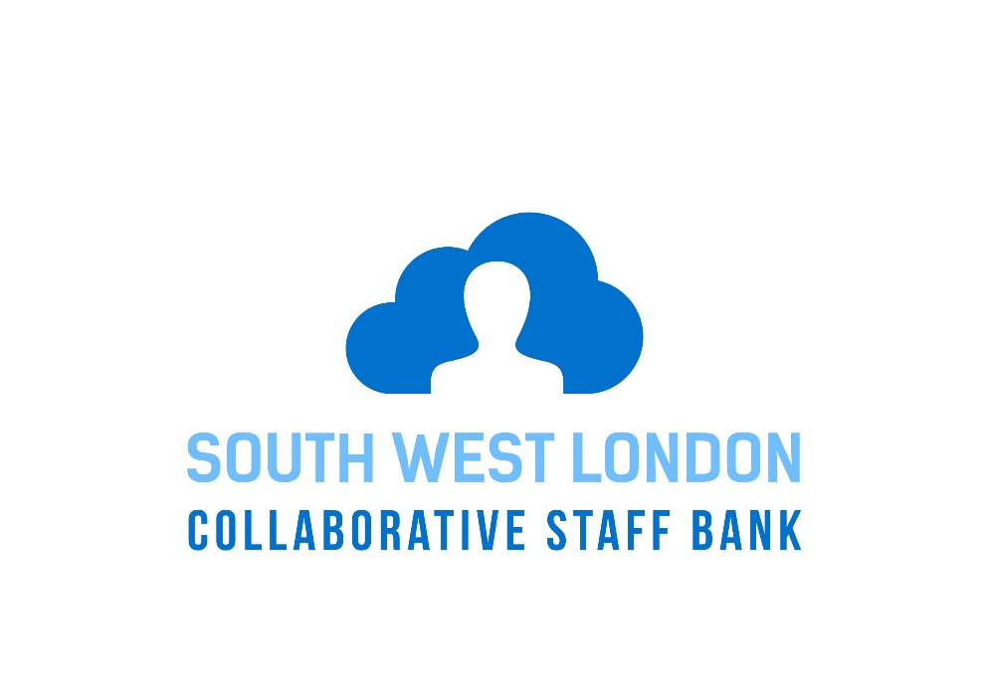
Chris Goulding
[Email address]
This document is intended to provide staff with information about the South West London Collaborative Bank and help answer common questions that the staff may have.
frequently asked questions

SW London Collaborative Staff Bank
Questions and Answers
General
G1 What is the SW London Collaborative Staff Bank?
NHS Trusts in South West London have created a ‘virtual’ Staff Bank. This means that workers registered at one Staff Bank are able to see and book onto vacant shifts at the other participating Trusts. This arrangement integrates and links Rostering and Bank between Trusts and so provides the ability to work across SW London. The Trusts involved have also agreed a number of common processes and practices to make this happen so that you can work and get paid at any of the participating Trusts as follows:
Epsom & St. Helier University Hospitals NHS Trust
Kingston NHS Foundation Trust
St George’s University Hospitals NHS Foundation Trust
(Both South West London St George’s Mental Health NHS Trust and Croydon University Hospital Trust are not involved in the first phase of development but are part of the SWL Collaborative Staff Bank).
For further guidance about working at your home Trust and on the SWL Collaborative Bank please contact the Bank at your home Trust or consult the induction pack.

G2 What are the benefits of the Collaborative Staff Bank?
The benefits are many. For Trusts it maximises the opportunity to match those staff that are registered onto Banks in South West London to the temporary staffing needs of individual Trusts. For staff you will be able to plan your working lives because you will have exclusive access to all available temporary shifts in SW London in advance of the shift being worked and can see and book shifts through a smartphone app called Me, which is simple to use. You will have the opportunity to work in a variety of clinical settings to support your skills and career development.
The aim is to increase our fill rates and reduce reliance on agency workers therefore reducing costs and increasing the quality of care to our patients by enabling our staff across all Trusts to cover vacant shifts.

G3 Me App: What it is and how it works?
Me is a mobile app (from Allocate Software) which you can use to access shifts at your Trust and other Trusts in the SWL Collaborative Bank.
It includes viewing your roster, requesting shifts on future rosters, managing annual leave, booking bank duties, viewing your time sheets and seeing who you are working with by viewing team schedules.

You can download and install the app from the Apple AppStore and from the Google Play Store. Once installed, follow the directions to register yourself and link your Employee Online account to the Me app and you are good to go.

Your Me account and EOL account

Q: Is my Me Account and EOL Account the same thing?
A: No. your EOL account credentials are: -
- Username
  - From your home Trust – your first initial and surname; e.g. jsmith
  - The other Trusts in the SWL Collaborative– your surname and staff number; e.g. Smith123456
- Password - Whichever password you changed it to on initial login

Your Me account credentials: -
- Username - your email address
- Password – whichever password you enter when creating your account (it is a good idea to use the same password as your EOL account; bearing in mind that your Me password must consist of 8 letters and contain a capital letter and a number.

Your Me account is then linked to your EOL account. This is done during the initial set up of your Me Account.

G4 Can I work at any Trust through the Collaborative Staff Bank?
In the first phase, General Nursing Staff at band 5 and Health Care Assistants at band 2 are able to see and access vacant shifts at Kingston, Epsom & St Helier and St George’s. All you need to do is simply register with the Staff Bank at one of the three Trusts mentioned above.

G5 When will the Collaborative Staff Bank go live?
The South West London Collaborative Bank went live on 11th April 2018.

G6 Are there any restrictions on where I can work?
You will only be able to see and book shifts for which you should have the necessary skills and you should not undertake any duties during the shift which you do not feel competent to perform. You may also be subject to restrictions by your home Staff Bank arising from maximum working hours, rest breaks between shifts or recent sickness which may limit access to bank working for a period whilst you fully recover.
The Collaborative Staff Bank will initially be available to book General Nursing Shifts at band 5 and Health Care Assistants at band 2. The aim is to extend the opportunity to other bands and other groups of staff. You will of course be able to continue to book shifts at your home Trust.

G7 Will unfilled shifts still be sent to Agencies to provide cover?
Rosters will be published at least 6 weeks in advance of the roster start date and will usually be available exclusively to Collaborative Staff Bank Workers at 2 weeks before the shift begins. If the shift remains vacant, agencies will have the opportunity to fill the vacant shifts 72 hrs before the shift is worked. However, bank workers will be able to book shifts up to the shift start and displace agency workers where possible. Some particularly hard to fill roles will continue to be sourced through agencies before then, if there is a low likelihood of being able to fill the vacant shift through the bank.

Joining the Collaborative Staff Bank
J1 Who can join the Collaborative Staff Bank?
The first phase is targeted at Band 5 General Nurses (rather than Specialist Nurses) and Band 2 HCAs but the intention is to roll out the Collaborative Bank to all staff.

J2 How do I join the Collaborative Staff Bank?
You will need to download the free Me app from your app provider and electronically accept an invitation to join the Collaborative Staff Bank and the terms and conditions which apply; you will receive this invitation to join via your mobile telephone. You will receive this automatically if you are eligible to join so you do not need to do anything.
The details of how you complete the process are contained in the Joining Instructions and Guidelines (Joining the SWL Collaborative Bank Information Sheet), available from your Home Staff Bank Office or your Home Staff Bank Intranet Site.
In summary, you will need to complete the forms:
- Pensions Questionnaire – One for each Trust you are applying to
- HMRC Starter Checklist Form to ensure you are taxed correctly
- SWL Collaborative Bank Personal Details Form
- 48 hour per week Opt-out Form
- Information for payroll.
You will also need to download the Me app from your app provider and accept an invitation to join the Collaborative Staff Bank. This invitation will require you to agree to the terms that will apply including those that describe the working arrangements during your shift.
You can access Me on desktop computers by visiting http://www.allocateme.com.
Details of relevant clinical policies and procedures, payroll timescales, reporting arrangements and who you can contact for help are available on the Internet site of the Trust where you are booked to work can be found by following the links on the Me app.
J3 I am an employee but not yet registered through my Home Staff Bank; can I still join the Collaborative Staff Bank?
You must register with your Home Trust Staff Bank in order to join the Collaborative Staff Bank. This can both be done at the same time.

J4 Can I continue to work through my Home Bank if I decide not to join the Collaborative Staff Bank?
Yes. Joining the Collaborative Staff Bank is entirely voluntary and if you decide not to participate, your registration with your own Home Staff Bank would be unaffected. You can still download the Me app and use it to manage your shifts at your Home Trusts (as an alternative to Employee Online).
J5 Why do I need a Collaborative Staff Bank Badge and where do I get it from?
The Collaborative Staff Bank Badge will enable patients and colleagues to readily identify in what capacity you are working; just having your home ID badge might be confusing for some Trusts. The Collaborative Staff Bank Badge only gives your role and not your name. You must keep your Home Trust Photographic ID Badge with you at all times. You should as a matter of good practice introduce yourself to patients regardless of whether you are wearing a name badge. The Collaborative Staff Bank Name Badge is issued by your Home Trust when you complete the registration process by completing the joining forms.

Booking shifts
B1 How do I book a shift at another Trust?
There are 3 ways to do this:
- You can direct book through the Me app and Me web
- You can direct book through Employee Online
- You can be contacted and booked in by one of the Trust banks
B2 What additional employment checks will be required?
None - Trusts have agreed to rely on the checks done by your Home Trust. You will need to prove your identity by showing your Home Trust Photographic Identity Badge each time you report for work at the beginning of each shift.
B3 I only want to work at my Home Trust
You can continue to work at your Home Trust whether or not you decide to join the Collaborative bank.

Working at another SW London Trust
W1 What arrangements will apply when I work at another Trust?
These are covered in the Joining Instructions and Guidelines available from your Home Bank Office. Essentially, local clinical and other procedures will apply and you should familiarise yourself with these through the Trust website prior to starting work.
W2 What uniform will I wear?
This is covered in the Guidelines. Essentially, you should wear your Home Trust uniform with the exception of mental health roles where no uniform is required.
W3 What identity badge do I need to wear?
You will need to display on your uniform the Collaborative Staff Bank Badge with your role clearly displayed. You must also keep with you your Photographic Identity Badge from your Home Trust.

Pay rates and payment
P1 What will I be paid?
Pay rates have been agreed for Band 5 General Nursing and Band 2 Healthcare Assistant rates which are detailed below showing the pay by hourly rate and working time directive payment:

Band 5 (Outer London – (Epsom & St Helier, Kingston)
Days: £13.89 WTD £1.67 £15.56 ph Total
Nights & Saturdays: £17.50 WTD £2.11 £19.61 ph Total
Sundays & bank Holidays: £ 21.12 WTD £2.54 £23.66 ph Total
Band 5 (Inner London – St George’s)
Days: £ 14.60 WTD £1.76 £16.36 ph Total
Nights & Saturdays: £ 18.25 WTD £2.20 £20.45 ph Total
Sundays & bank Holidays: £ 21.90 WTD £2.64 £ 24.54 ph Total

Band 2 (Outer London – Epsom & St Helier, Kingston)

Days: £9.22 WTD £1.11 £ 10.33 ph Total

Nights & Saturdays: £12.94 WTD £1.56 £14.50 ph Total

Sundays & bank holidays: £16.07 WTD £1.93 £18.00 ph Total

Band 2 (Inner London – St Georges)

Days: £9.46 WTD £1.14 £10.60 ph Total

Nights & Saturdays: £12.69 WTD £1.53 £14.22 ph Total

Sunday’s & Bank Holidays: £15.91 WTD £1.92 £17.83 ph Total

P2 When will I get paid if I work through the Collaborative Staff Bank?
The Trust where you work will pay you. All Trusts pay their bank workers through a weekly payroll although each has slightly different pay days. Details can be obtained through the Trust website where you will work. You must complete the forms identified in the Joining Instructions to enable you to be paid whenever you work at that Trust. This only has to be done once except when your bank posting is terminated and you would like to re-join then you’ll need to complete the joiners form again.
The weekly pay period is from Monday to Sunday. If you work a shift during this period the pay days for each Trust are as follows:
Epsom & St Helier : the second Friday after the end of the pay period (paper timesheets are used at this Trust).
Kingston : the Friday after the pay period.
St George’s : the second Wednesday after the pay period. For Bank Holiday’s payment is on Thursday.
P3 What are the tax implications?
These are explained in the Guidelines. Essentially, provided you complete the HMRC Starter Checklist, in most cases you will be paid at the basic tax rate for each shift you work away from your Home Trust. Tax arrangements are of course personal to individual circumstances and you should contact HMRC for definitive personal tax advice.

P4 What are the pension implications?
These are explained in the Guidelines. Essentially, your pension options are limited by whether you are already in the NHS Pension Scheme and paying the maximum full-time contributions. Depending on your current circumstances, you will be enrolled into the Government Stakeholder Pension Scheme (a 1% deduction) for the payment for your first shift at the Trust where you work through the Collaborative Staff Bank. You can then opt-out of this pension by request. This is because the National Pension Regulations do not allow employers to be seen to be encouraging pension opt-outs.

Leaving the collaborative staff bank
L1 What happens if I resign from my substantive employment?
Upon leaving substantive employment, you should check the local process for remaining registered with your Home Bank. If your registration with your Home Staff Bank continues, your membership of the SWL Collaborative Bank will be unaffected.

Help and support
H1 Who should I contact if I have any questions about the Collaborative Staff Bank?
You should contact your Home Staff Bank Office in the first instance.
The contact telephone numbers and email addresses for the Staff Bank at each Trust are as follows:
Epsom & St Helier : 0208 296 2626 (esth.cloudstaff@nhs.net)
Kingston : 0333 577 3411(khft.staffbank@nhs.net)
St George’s : collaborativebank@stgeorges.nhs.uk

