HRA Approval

HRA Approval is the new process for the NHS in England that brings together the assessment of governance and legal compliance, undertaken by HRA staff, with the independent REC opinion provided through the National Research Ethics Service (NRES (see www.hra.nhs.uk ).
The phased roll out of HRA Approval started on 11 May 2015. The roll out was complete on 31 March 2016 and HRA Approval is now the process for applying for approvals for all project-based research in the NHS led from England.
The HRA will continue to review and develop HRA Approval and feedback is encouraged to hra.approvalprogramme@nhs.net

Do I need HRA Approval?
If your study requires NRES, is applying for NIHR portfolio adoption then it is likely to need HRA approval.
- Check flow chart 4 (page 5 ) if the study is going to be Sponsored by St Georges (non-student research)

- Check flow chart 2 (page 3) if the study was Sponsored by St Georges (student research)

- Check flow chart 3 (page 4) if the study was Sponsored by another organisation (student research)
If your study is not Sponsored by St Georges, and it is not a student study, it will require HRA approval. (www.hra.nhs.uk )

How do I obtain HRA Approval?
In addition to the documents that you would normally submit to ethics ( see Sponsorship section of the Researcher’s Handbook) for review, you may have to complete two additional documents, the schedule of events and statement of activities. The documents can be found at www.hra.nhs.uk/resources/hra-approval-applicant-guidance/statement-activities-hra-approval . As these documents are regularly updated, it is important that you check the website for the latest version.
If you are planning to apply for NIHR portfolio adoption, the local Network will help with the completion of the schedule of events. Please contact your assigned Governance Officer in the JREO for more information (see contacts insert).

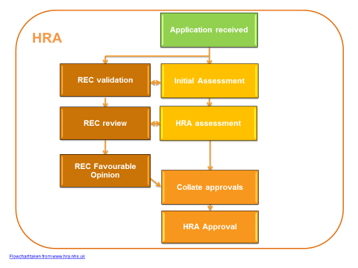
Flowchart 1: The HRA and Ethics process

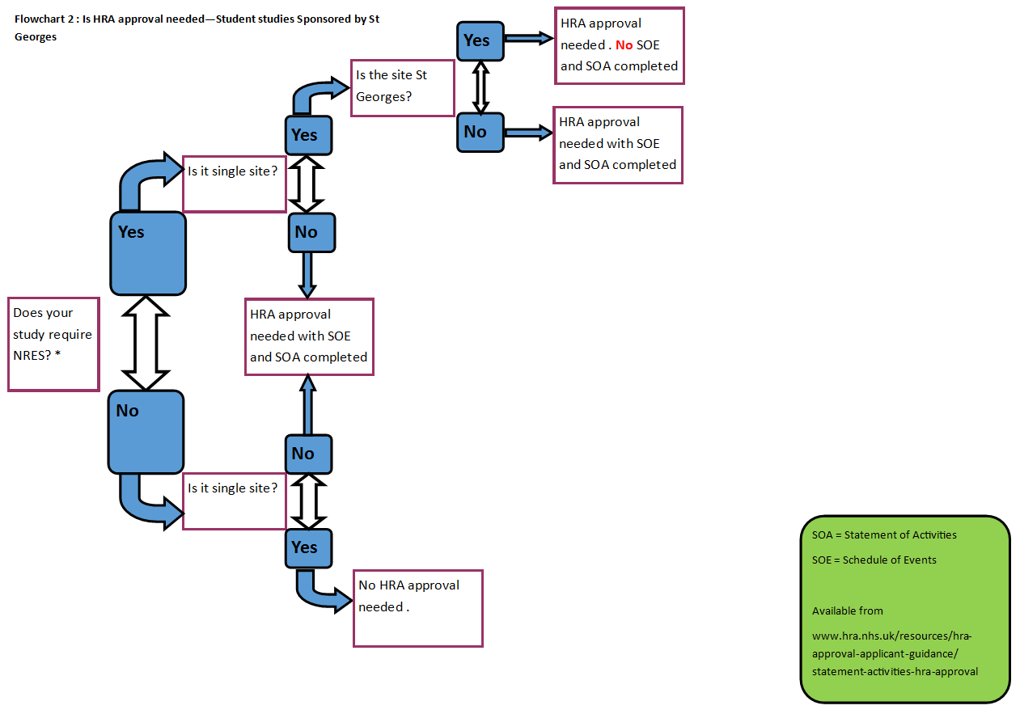
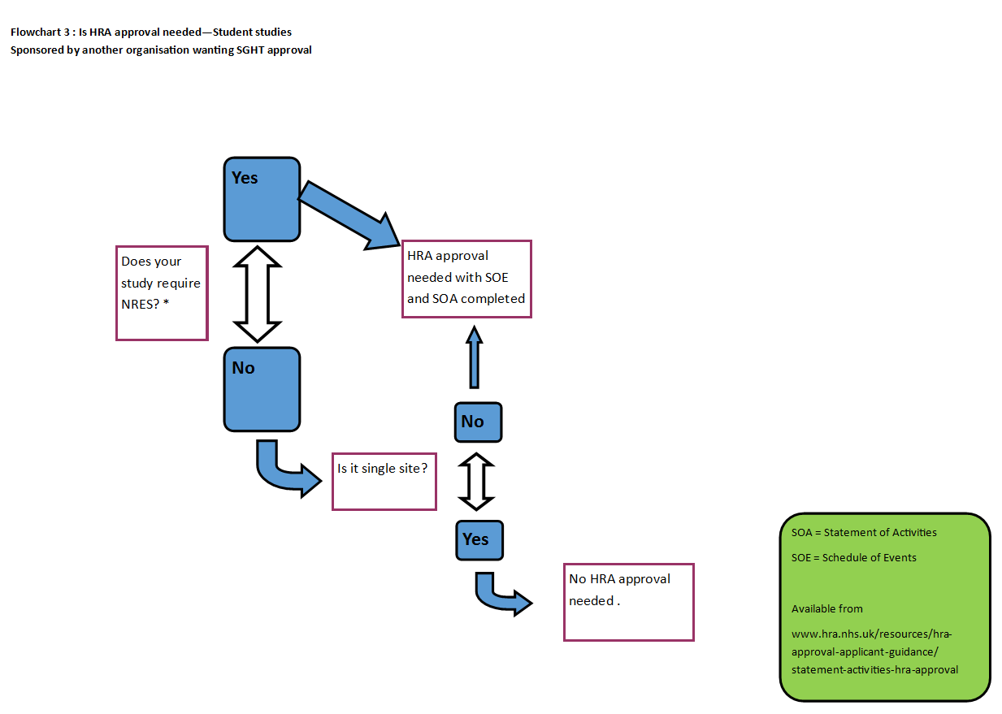
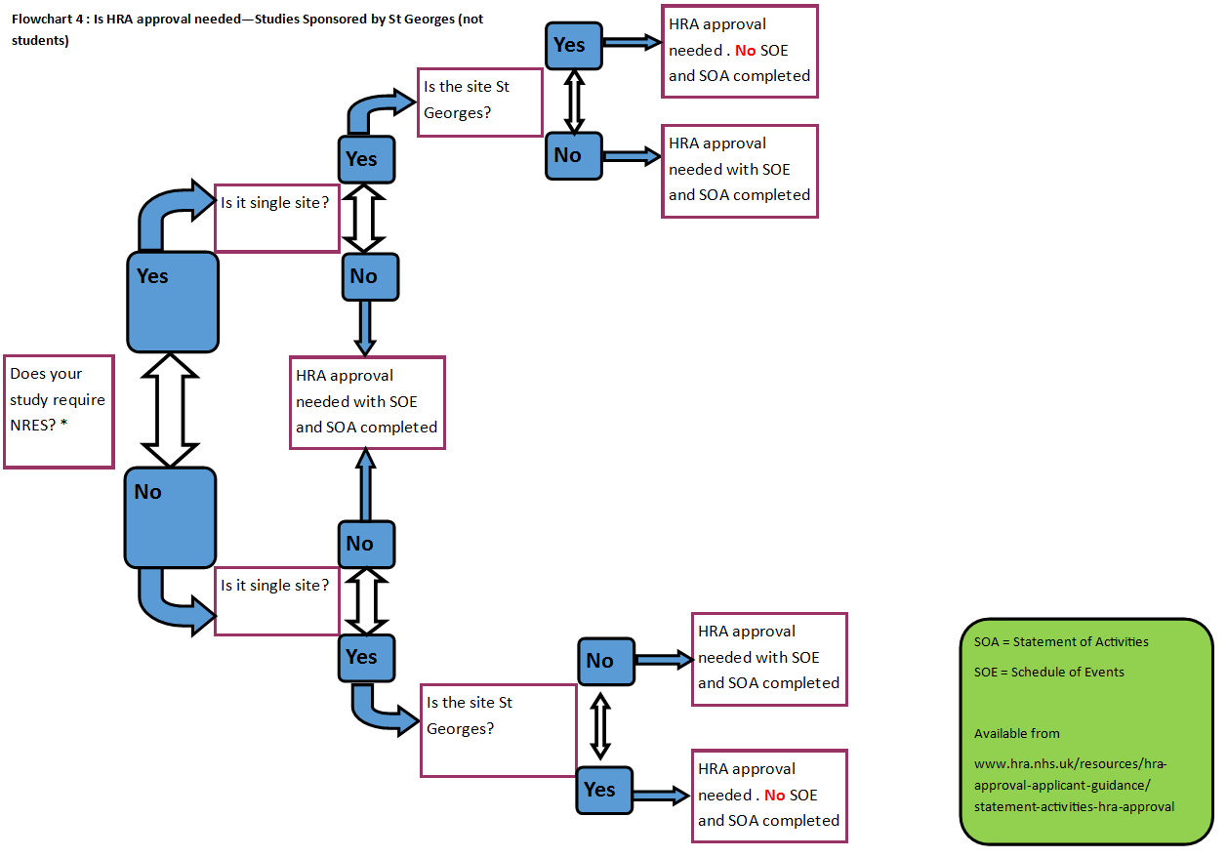

Trust Approval

A study must also obtain Trust approval in order to start a study at an NHS site. There are two routes to obtaining Trust approval dependant on whether your study requires HRA approval.

Prior to the HRA implementation, Trusts were asked to give approval (R&D or Host site permission). Under the new system, the Trust is being asked to assess and confirm their capacity and capability to deliver the research. For the purposes of this document, the term Trust Approval will continue to be used.
St Georges must be named as a site on the IRAS form approved by the HRA in order for the JREO to start assessing the study. If St Georges is not named as site, an amendment must be made to the HRA. (See Amendments page 10 for how to add a new site)

You will need to obtain Care Group Lead (CGL) and Business Manager (BM) approvals as part of obtaining Trust approval. It is recommended that you contact them as soon as possible as your study could be delayed.

JREO RG has a target of 40 days from receipt of a valid document set to give SGHT Trust approval.

- Trust Approval—HRA Approval

There is no need to complete an SSI form for St Georges. You should complete a statement of activities and schedule of events (non- commercial Sponsors) or a validated costing template (commercial sponsors) for St Georges from the HRA approved template(s).

The local information pack should be sent to the study team and the assigned Research Governance Officer.

The local information pack contains:

Final Signed IRAS form as submitted to the HRA
Protocol and all amendments
Participant Information Sheet(s) (do not have to have local logos at this stage)
Consent form(s) (do not have to have local logos at this stage)
Relevant model agreement (if using one)
Statement of activities (non-commercial Sponsor only)
Schedule of events (non-commercial Sponsor only)
Validated costing template (commercial Sponsor only)
Any other documentation
HRA Initial Assessment Letter

We will need the final HRA approval letter before we can issue Trust approval but we can start assessing your study upon receipt of the initial assessment letter and documents as defined in the above local information pack.

All costing templates and agreements submitted to the office must have gone through either the Network or the HRA for approval.

The study will be given approval by either signing the agreed contract or the schedule of events. No Trust approval letter will be issued.

- Trust Approval—HRA Approval not required

There is no need to complete an SSI form for St Georges. You should complete an IRAS R&D form available at www.myresearchproject.org.uk

The local information pack should be sent to the study team and the assigned Research Governance Officer.

The local information pack contains:

Final Signed IRAS R&D form
Protocol and all amendments
Participant Information Sheet(s) (do not have to have local logos at this stage)
Consent form(s) (do not have to have local logos at this stage)
Any other documentation

The PI will be emailed a trust approval letter when the study is approved.

Amendment Approval
It is quite common once a study has started recruiting for the need to amend the study documentation.

Both NRES, HRA, MHRA, and other committees allow you to submit notifications of amendments to your existing ethically approved study, rather than having to submit a fresh application.

For NRES studies, the amendment form is available within your project folder on IRAS.

Where do I submit the amendment documentation?

St George’s sponsored Research
Once you have amended your documents, you should submit them to JREO RG for approval.

The JREO RG will need to ensure that the insurance cover provided for your study remains appropriate. You may also require the review of your named statistician to ensure the data analysis would not be adversely affected

Ethics Committee
Once JREO RG has approved your amended documents, you may submit them to the ethics committee that originally approved your study. NRES committees have 35 days in which to give you an ethical opinion on your proposed amendment.

R&D
You should also submit the amended documents to the Trust R&D offices at the organisation your study is being conducted, bearing in mind that if ethics asks you to change the documents that you should also send the same documents to the R&D offices.

MHRA (if a CTIMP)
If you are conducting a CTIMP, then the revised documents may need to be submitted to the MHRA for approval. Research Pharmacy may also be required to review the amendment package prior to submission, however the JREO RG will be able to advise if Research Pharmacy review and input would be appropriate. The JREO RG named sponsor representative will make the submission on your behalf. The MHRA will review and assess your study amendment within 35 days of receipt of the application and provide the outcome within 35 days of receipt of a valid application.

Do I need HRA Approval?

If your study has HRA approval, you must seek HRA approval for your amendment regardless of whether the amendment is substantial or non- substantial
If you have a study that did not require HRA approval when it was ethically approved, you need to check whether you need to obtain HRA approval because of your proposed changes.

Check flow chart 4 (page 5) if the study was Sponsored by St Georges (non- student research)
Check flow chart 2 (page 3) if the study was Sponsored by St Georges (student research)

If the answer is Yes – you need HRA approval, then you should follow the process in flowchart 5 (page 11).

What needs notifying as an amendment?
When talking about amendments, it is important to know what amendments are considered substantial i.e. must obtain ethics (and MHRA approval if applicable) and what is considered non-substantial (must obtain HRA approval if applicable)

Examples of substantial amendments are:
• Change in sample size
• Change in provision of IMP
• Addition of additional tests to those stated in the current approved PIS

Examples of Minor/Non Substantial Amendments
• Time Extension (NRES study only)
• Correction of typos

If you are unsure of whether you proposed changes would be considered substantial or not, please contact your JREO RG Officer

When can the amendment be implemented?
Unless the proposed amendment is an urgent safety measure, you must wait until you receive Trust approval at each site before you implement the changes.

How long does it take?
JREO RG aims to approve amendments within 35 days of receipt of all the amended documents, REC, HRA and MHRA approval (whichever is applicable) and any amended contracts or agreements.

Adding a new site
Under the new process, adding sites to studies must obtain HRA approval. If it is a CTIMP or device study, then this would be considered a substantial amendment and it would need notifying to REC.

If it is a non CTIMP study, then this would be considered a non- substantial amendment and requires approval from the HRA only.

What documents need to be submitted?
For substantial amendments, the amendment form is available within your project folder on IRAS.

It will need to be submitting with any document that you have modified. There should be clean and tracked changes version of the documents submitted.

You may also have to submit an amended schedule of events and statement of activities if your changes affect those documents.

For non-substantial amendments, the non- substantial amendment form can be found at: www.hra.nhs.uk/resources/during-and-after-your-study/nhshsc-rd-notification-non-substantialminor-amendment-form

It will need to be submitting with any document that you have modified. There should be clean and tracked changes version of the documents submitted.

You may also have to submit an amended schedule of events and statement of activities if your changes affect those documents.

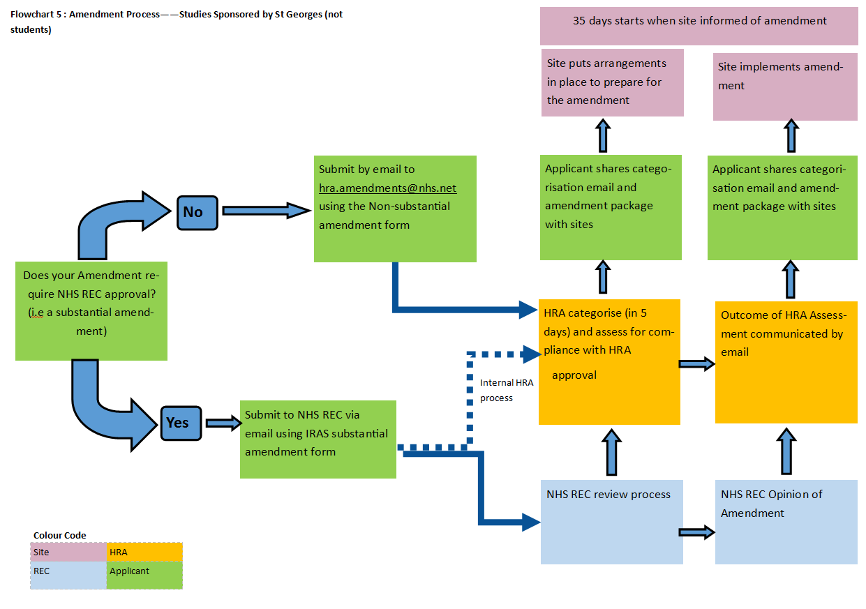
Any queries or feedback on this please contact researchgovernance@sgul.ac.uk

