Adult Hand Trauma Referral Process

Guidelines for internal and external referrals to the hand trauma team, Plastic Surgery Department

Produced by Kate Spiteri, Nurse Practitioner for Hand Trauma and David Gateley, Consultant Hand Surgeon
Document History
Version | Date | Review date | Reason for change
1 | Feb 2014 | Feb 2016

Contents

Paragraph |  | Page
1 | Introduction | 3
2 | Aims of the adult hand service | 3
3 | Referral pathway - external referrals | 3
4 | Referral pathway flowchart - external referrals | 4
5 | Referral pathway - internal referrals | 5
6 | Hand trauma requiring referral to hand surgery team | 6
7 | Hand trauma first aid | 7
8 | Antibiotics for hand trauma | 9
9 | Useful contact numbers | 10
Appendices
A | Hand trauma clinic - patient letter | 11
B | SGH ED/UCC urgency of hand trauma | 13

- Introduction
St George’s Healthcare NHS Trust (SGH) provides a tertiary hand trauma service for the South Thames West Sector. These guidelines will inform Emergency Departments (ED), Urgent Care Centres (UCC) Minor Injury Units (WIU) Walk in Centres (WIC) and GPs about the adult hand service and the referral process.
These guidelines apply to all staff (temporary and permanent) working in any of the locations registered by St. George’s Healthcare NHS Trust or with any of the referring departments.

- Aims of the adult hand trauma service
- To provide a high standard of specialised care to patients with traumatic hand injuries - including surgical intervention, specialist nursing care and hand therapy.
- To see and treat all traumatic hand injuries within an appropriate time frame
- To provide an efficient pathway for hand trauma patients from point of referral to discharge.

- Referral pathway - external referrals
When a patient (aged 16 and above) presents to the ED/UCC/MIU/WIC/GP with a traumatic hand injury, a full and thorough assessment must be undertaken by the clinician. All first aid should be given by the assessing clinician (see section 5).

If the patient requires specialist input from the hand surgery team at SGH then the on call plastics surgeon/nurse practitioner should be contacted via the SGH switch board 020 8672 1255 on bleep 7050.

If the patient meets the referral criteria (see section 4) the on call surgeon/nurse practitioner will give the referring clinician an appointment time for the patient. The medical notes should be photocopied for the patient to bring and the referral should be faxed to the Hand Unit on 020 8725 4771 (this allows the patients to be pre-registered). Any images (XR etc) taken outside of SGH must be transferred on the Image Exchange Portal (IEP).

Please give the patient a copy of the Hand Trauma Clinic letter (Appendix A) which gives them clear instructions on what to expect.

In some circumstances, the on call surgeon/nurse practitioner will ask for the patient to be sent straight to SGH ED/UCC for urgent review. The referring clinician will be informed of this when the referral is made. The images still need to be transferred on the IEP and a copy of the notes given to the patient to bring with them but the referral letter does not need to be faxed to the Hand Unit in this instance.

- Referral pathway flowchart - external referrals

Hand injury assessed in ED/UCC/MIU/WIC/GP
First aid given

Referral made to the on call plastics team on 020 8672 1255 bleep 7050

Appointment made for the Hand Trauma Triage Clinic, Hand Unit
Patient to attend SGH ED/UCC urgently
Referral with patient demographics faxed to the Hand Unit on 020 8725 4771
Medical notes photocopied and given to patient
Copy of Hand Trauma Clinic letter given to the patient
Images transferred on the IEP

Medical notes photocopied and given to patient
Images transferred on the IEP

Patient seen by hand trauma team

- Referral pathway - Internal referrals
When a patient (aged 16 and above) is seen in SGH ED/UCC with a traumatic hand injury, a full and thorough assessment must be undertaken by the clinician. All first aid should be given by the assessing clinician (see section 5).

If the patient meets the referral criteria (see section 4) then the patient can be booked directly in to the Hand Trauma Triage Clinic on iClip by the ED/UCC admin team if the injury is non-urgent (Appendix B). If the injury is urgent then the clinician should refer to the on call SHO/NP on bleep 7050 for urgent review in the ED/UCC.

The appointment should be booked under Plastics as follows:
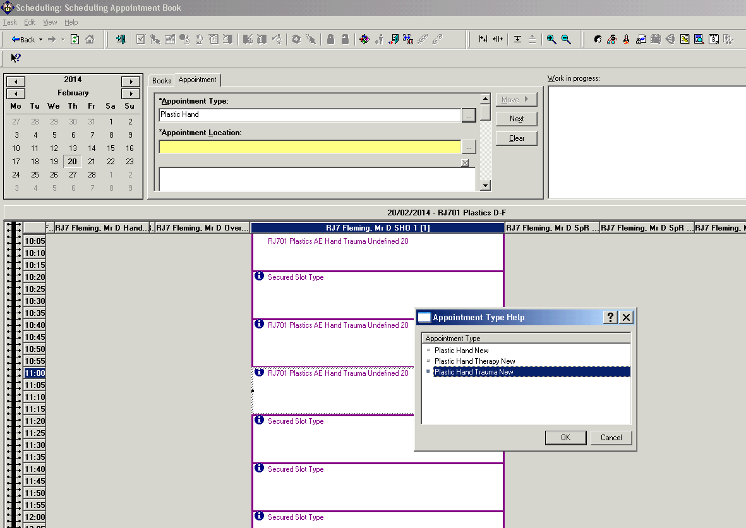

There are currently 5 appointments every morning (Mon-Fri) for direct booking. The admin team should not book patients more than 24 hours in advance unless the assessing clinician documents that it is safe to do so. If there is no capacity in the next 24 hours and the patient needs to be seen, please bleep 7050 to arrange an appointment. Over the weekend, if it is not safe for the patient to wait until Monday to be seen, please refer to the on call team on bleep 7050.

When the admin team book the appointment, the lead consultant differs depending on the day of the week. Lead consultant is as follows:
- Monday - Mr. James Colville
- Tuesday - Ms. Sonja Cerovac
- Wednesday - Mr. David Gateley
- Thursday - Ms. Sonja Cerovac
- Friday - Mr. Drew Fleming

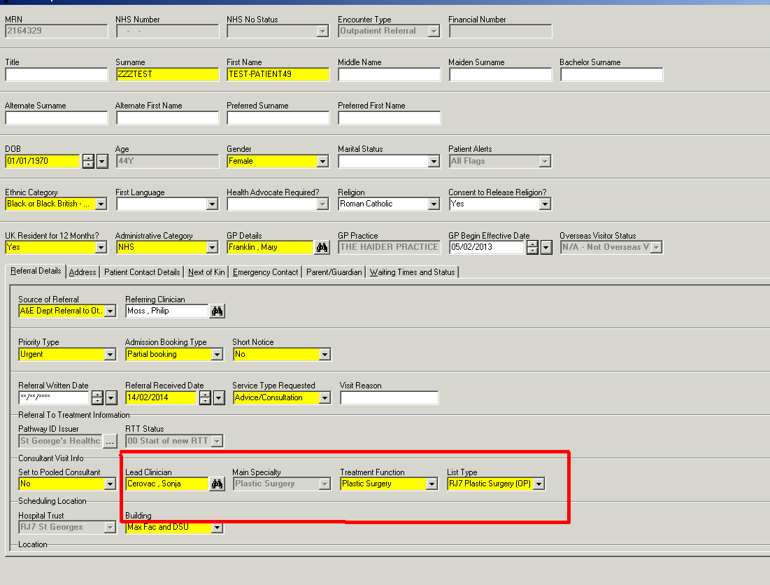
For patients booked to the Hand Trauma Triage Clinic, please give the patient a copy of the Hand Trauma Clinic letter (Appendix A) and a photocopy of the cas card.

- Hand trauma requiring referral to hand surgery team
The below list is to be used in conjunction with your clinical assessment. If the patient has major or multiple injuries, immediately life threatening injuries need to be dealt with first.

- Amputations - total and subtotal
- Avulsion injuries
- Burn to hand
- Closed fractures (excluding distal radius and ulnar)
- Crush injuries with significant tissue damage
- Finger tip injuries (<1cm pulp loss with no bone exposed not accepted)
- High pressure injections
- Infected hands
- Joint dislocations - open and closed
- Ligament injuries - sprain and rupture
- Mammal bites
- Muscle belly lacerations
- Nailbed injuries - with or without fracture
- Nerve injuries - digital and peripheral
- Open fractures (excluding distal radius and ulnar)
- Tendon injuries - open and closed
- Vascular injuries

- Hand trauma first aid
When treating hand trauma in the ED/UCC/MIU/WIC/GP please follow the below first aid guides to ensure that the patient is safe to be transferred to hand surgery team.

Injury | First Aid
Amputations - total and subtotal  (Do not give the patient any guarantees) | - Avoid damage to the stump and the amputated part  - Place amputated part in saline moistened gauze in polythene bag. Lay this on top ice in a container  - Never immerse the part in saline or put in direct contact with ice  - X-ray stump and amputated part  - LA ringblock, cleanse saline or chlorhexidine  - Dressing - Jelonet, gauze, tubinette  - Check immunisations - tetanus status +/- give booster/human anti-tetanus immunoglobulin (HATI)  - TTO antibiotics and analgesics  - High arm sling
Avulsion injuries  (Do not give the patient any guarantees) | - X-ray  - Determine vascular status of the digit  - Send amputated part as above  - LA ringblock, cleanse saline or chlorhexidine  - Dressing - Jelonet, gauze, tubinette  - Check immunisations - tetanus status +/- give booster/human anti-tetanus immunoglobulin (HATI)  - TTO antibiotics and analgesics  - High arm sling
Burn to hand | - Determine source - eg. chemical, fire  - Irrigate with saline +++  - Dressing - Jelonet or Silver Sulfadiazine in a polythene bag  - Check immunisations - tetanus status +/- give booster/human anti-tetanus immunoglobulin (HATI)  - TTO antibiotics and analgesics  - High arm sling
Closed fractures (excluding distal radius and ulnar) | - X-ray  - Reduce displaced fractures then re x-ray  - Splint - POP/zimmer - be mindful of splint position  - TTO analgesics  - High arm sling
Crush injuries with significant tissue damage  NB- secondary swelling may produce compartment syndrome | - X-ray  - Assess sensation and circulation  - LA - washout saline or chlorhexidine  - Dressing - Jelonet or Inadine  - Splint  - TTO antibiotics and analgesics  - Check immunisations - tetanus status +/- give booster/human anti-tetanus immunoglobulin (HATI)  - High arm sling
Finger tip injuries | - X-ray (if indicated)  - LA, cleanse saline or chlorhexidine  - Dressing - Jelonet, gauze, tubinette  - Splint - if indicated  - TTO analgesics and antibiotics  - Check immunisations - tetanus status +/- give booster/human anti-tetanus immunoglobulin (HATI)  - High arm sling
High pressure injections | - X-ray  - Washout saline  - Dressing - Jelonet  - TTO analgesics and antibiotics  - Check immunisations - tetanus status +/- give booster/human anti-tetanus immunoglobulin (HATI)  - High arm sling
Infected hands | - X-ray - if indicated  - LA - washout chlorhexidine  - Dressing - Inadine  - Splint  - TTO antibiotics and analgesics  - Check immunisations - tetanus status +/- give booster/human anti-tetanus immunoglobulin (HATI)  - High arm sling
Joint dislocations - open and closed  NB- Joint dislocations will have significant ligament injury | - X-ray  - LA - reduce dislocation then re x-ray  - Washout with saline or chlorhexidine any open dislocations  - Splint - POP/zimmer  - TTO analgesics +/- antibiotics if open  - Check immunisations - tetanus status +/- give booster/human anti-tetanus immunoglobulin (HATI)  - High arm sling
Ligament injuries - sprain and rupture | - X-ray  - Reduce any malalignement then re x-ray  - Splint - POP/zimmer  - TTO analgesics  - High arm sling
Mammal bites | - X-ray  - LA - washout chlorhexidine  - Dressing - Inadine  - Splint  - TTO antibiotics and analgesics  - Check immunisations - tetanus status +/- give booster/human anti-tetanus immunoglobulin (HATI)  - High arm sling
Muscle belly lacerations | - X-ray (if indicated)  - LA, cleanse saline or chlorhexidine  - Dressing - Jelonet, gauze, tubinette  - Splint  - TTO analgesics and antibiotics  - Check immunisations - tetanus status +/- give booster/human anti-tetanus immunoglobulin (HATI)  - High arm sling
Nailbed injuries - with or without fracture | - X-ray (if indicated)  - LA ringblock, cleanse saline or chlorhexidine  - Dressing - Jelonet, gauze, tubinette  - Splint  - TTO analgesics and antibiotics  - Check immunisations - tetanus status +/- give booster/human anti-tetanus immunoglobulin (HATI)  - High arm sling
Nerve injuries - digital and peripheral | - X-ray (if indicated)  - LA, washout saline or chlorhexidine  - Dressing - Jelonet, gauze, tubinette  - Splint - POP/zimmer  - TTO analgesics and antibiotics  - Check immunisations - tetanus status +/- give booster/human anti-tetanus immunoglobulin (HATI)  - High arm sling
Open fractures (excluding distal radius and ulnar) | - X-ray  - Reduce displaced fractures then re x-ray  - Washout with 1L saline  - Splint - POP/zimmer  - TTO analgesics and antibiotics  - Check immunisations - tetanus status +/- give booster/human anti-tetanus immunoglobulin (HATI)  - High arm sling
Tendon injuries - open and closed | - X-ray (if indicated)  - Washout saline if open  - Reduce displaced fractures then re x-ray - i.e. bony mallet  - Dressing - Jelonet  - Splint - POP/zimmer - be mindful of splint position  - TTO analgesics +/- antibiotics if open  - Check immunisations if open - tetanus status +/- give booster/human anti-tetanus immunoglobulin (HATI)  - High arm sling
Vascular injuries | - X-ray (if indicated)  - Apply pressure if appropriate  - Cleanse saline or chlorhexidine  - Dressing - Jelonet, gauze, tubinette  - TTO analgesics and antibiotics  - Check immunisations - tetanus status +/- give booster/human anti-tetanus immunoglobulin (HATI)  - High arm sling

- Antibiotics
Recommended antibiotic use in adult hand trauma

Clinical diagnosis | 1st choice antibiotic | Frequency and duration | Penicillin allergic alternative | Frequency and duration
Bites +/- scratches - animal or human | Augmentin 625mg  (Co-amoxiclav) | TDS 1/52 | Doxycyline 100mg  Metronidazole 400mg | TDS 5/7  TDS 5/7
Total or subtotal amputation  De-gloving injury  High pressure injection  Open #  Crush injury with significant tissue damage  Vascular injury  Extensor or flexor tendon injury  Nerve injury  Infection (excluding bites) | Flucloxacillin 500mg | QDS 1/52 | Clarithromycin 500mg | BD 1/52

- Useful contact numbers

  - Hand Unit - Monday to Friday 09:00-17:00 - 020 8725 4770
  - On call SHO/NP - cover 24/7 - 020 8672 1255 bleep 7050
  - Hand Trauma Nurse Practitioner - Monday to Friday 09:00-17:00 - 020 8672 1255 bleep 6558

.


Appendix A
Hand trauma clinic

Hand Unit, Perimeter Road
Plastic Surgery Department

Patient information

Dear______________________________________________________________

An appointment has been made for you in the Hand Unit where your injury will be assessed by the specialists.

Please attend on __________________________at________________________

Special instructions
- This clinic can be unpredictable because it is a trauma clinic so be prepared to spend the whole morning at the unit.
- You should have been given a copy of your notes, please bring these to your appointment.
- If you had X-rays taken, these will be sent electronically. However, if you were given a CD please bring this.
- On arrival, report to the reception. You may be required to fill out some forms. Have your GP details ready. If you are not registered with a GP you must arrange this as a matter of urgency.
- You will be asked to complete a pre-registration form regarding your entitlement to NHS treatment.
- Bring a list of all the medications that you take.
- You may need to have an operation on your hand; this will be assessed at your appointment. There may be a possibility we could operate on the same day, however this is not guaranteed. In preparation, do not eat or drink anything on the morning of your appointment - this includes chewing gum and sweets -. You may drink water up until 08:00 hrs.
How to find us
Hand Unit,
Perimeter Road,
Next to the Day Surgery Unit.

Travelling to the Hand Unit
- There is a pay and display car park, with its entrance on Blackshaw Road. There are drop off bays in front of the unit. Please do not drive yourself, as it may not be safe for you to drive yourself home after your appointment with us.
- If you are travelling by public transport please call 020 7222 1234 or visit www.tfl.gov.uk

How to contact us:
- Direct Line Hand Unit: 020 8725 4770
- Direct fax: 020 8725 4771
- Opening Hours: Monday-Friday 09:00-17:00

May 2013, review May 2016

Appendix B
Urgency of hand trauma - referrals from SGH ED/UCC only
Emergency - requiring referral to 7050
- Amputations - total and subtotal
- Avulsion injuries
- Burn to hand - involving most of the hand
- Crush injuries with significant tissue damage
- High pressure injections
- Infected hands
- Joint dislocations - open
- Mammal bites
- Nerve injuries - peripheral
- Open fractures (excluding distal radius and ulnar)
- Vascular injuries

Non-urgent - to be booked to the Hand Trauma Triage Clinic
- Burn to hand - isolated small burn to the hand
- Closed fractures (excluding distal radius and ulnar)
- Finger tip injuries (<1cm pulp loss with no bone exposed not accepted)
- Infected hands - superficial infections ie. Paronychia (without signs of OM)
- Joint dislocations - closed
- Ligament injuries - sprain and rupture
- Muscle belly lacerations
- Tendon injuries - open and closed
- Nailbed injuries - with or without fracture
- Nerve injuries - digital

