**Your hospital stay**

**Our inpatient services**

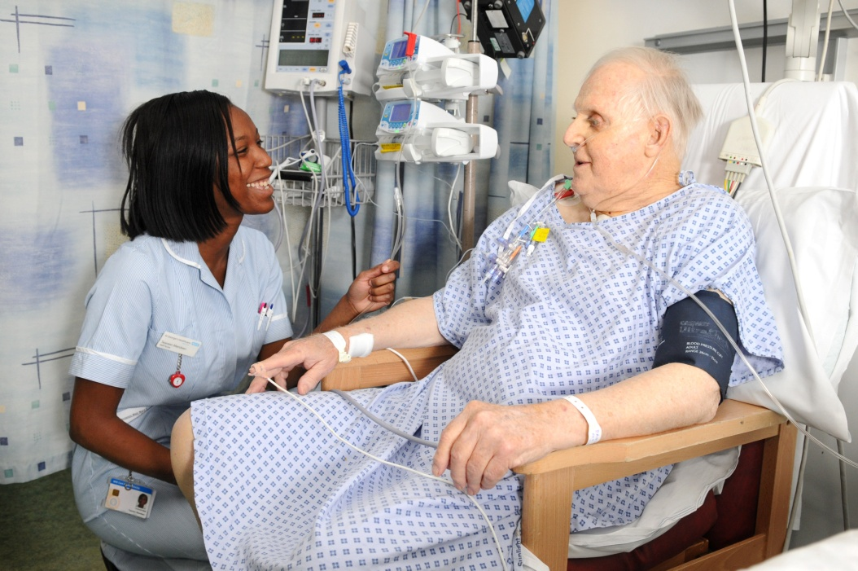



**A welcome from the chief executive**

Welcome to St George’s Hospital. We hope to make your hospital experience as pleasant and comfortable as possible. By living out our core values, our staff aim to ensure that all patients feel safe, respected and informed whilst in our care. We promise to listen to you and your needs, and to deliver excellent and timely services with kindness and empathy.

This information leaflet is part of a set of leaflets designed to provide patients with information about our hospitals. The four leaflets that make up this series are:

* General information booklet
* Your hospital appointment – Our outpatient services
* **Your hospital stay – Our inpatient services**
* Going home – Discharge information for patients

If you would like to read other leaflets from this series please ask a member of staff or visit the patient information pages on our website.

**Your inpatient checklist**

Preparing for a hospital stay can be a stressful time. It is important, however, that you remember to bring details of:

□ your medical and surgical history

□ any relevant recent investigations

□ all your medications (or ideally a bag containing all your medications)

□ your next of kin, including a valid mobile phone number.

In addition, you may wish to refer to the following checklist when thinking about personal items to bring with you for your stay:

□ nightdress or pyjamas

□ dressing gown and slippers

□ toiletries (toothbrush, toothpaste, face cloth, soap, shampoo)

□ towel

□ loose change

□ books and/or magazines

□ box of tissues

□ day clothes (if appropriate) and clothes to go home in.

For your comfort and independence, be sure to remember the following items (if applicable):

□ glasses and/or contact lenses

□ hearing aid(s)

□ walking or dressing aids

□ dentures, plus denture cleaner and a bowl marked with your name.

**Different types of admission to hospital**

Some patients’ admission to hospital is planned, usually when they are scheduled to have surgery. Other patients are admitted after attending the emergency department (ED). We call these two types of admission **pre-operative/planned admission** and **emergency admission**.

**Pre-operative/planned admission**

The majority of patients attending St George’s Hospital for surgery will be pre-assessed in the days/weeks leading up to their operation. This will take place at our pre-operative care centre (POC), located opposite Atkinson Morley Wing, next to the visitor’s car park 1.

The POC is a one-stop-shop where experienced staff will carry out appropriate assessments and investigations to ensure that you are well enough to undergo an operation with the best possible result.

During your appointment at the POC you will be able to ask any questions you may have about your operation. You may also be given information leaflets about your health condition, about the operation itself and about having an anaesthetic.

You will be asked to ensure that you have an adequate supply of your normal painkillers and any other medications you are taking for when you are discharged from hospital. This will help to speed up your discharge and recovery.

On the day of your operation you will be admitted to the surgical admissions lounge (SAL) on the first floor, Grosvenor Wing). This is a designated area for patients coming in for surgery. More detailed information about the SAL and what happens there can be obtained from the POC or the lounge directly.

 

Please bring your admission letter with you and be sure to arrive on time. If you need help finding the ward or SAL you can ask at the main reception area located on the ground floor of Grosvenor Wing (next to Marks & Spencer’s). If you have an iPhone you can also download the St George’s Hospital app, which offers more detailed information about the hospital site.

If you arrive by hospital transport you will be taken directly to the **patient transport lounge** located opposite the main entrance. From there you will be taken to the ward or to SAL, depending on your needs.

**Emergency admission**

If you have suffered from a sudden illness or injury, you may enter the hospital through the **emergency department (ED)**. On arrival you will be assessed by an experienced clinician. This assessment is called **triage** and helps to ensure the sickest patients are seen soonest. You may find it helpful to bring someone with you for support.

ED is staffed with consultants, junior doctors, nurses and therapists, all supported by a team of receptionists and a service manager. This ensures that we have a team of staff on hand to provide any kind of medical care needed.

If you require admission to a ward, the ED staff will make all the necessary arrangements for your transfer. While you are waiting, your health and wellbeing will be monitored according to your needs. This may include checking your temperature, heart rate, blood pressure and respiratory rate, or measuring your oxygen saturation levels. It may also include taking blood samples, electrocardiograms, x-rays or more complex tests and treatments.

**Admission to the ward**

When you arrive on the ward, you will be shown to your bed and the health professionals involved in your care will introduce themselves to you. They will ask you further questions about your health problem so that they can better understand your care needs. If you are unaccompanied and unable to answer questions we will make contact with a relative as soon as possible to talk about your needs.

For your safety, you will be asked to wear an identification wristband at all times.

Your privacy and dignity are important to us and will be respected at all times. Wherever possible you will be placed in a single-sex bay, where all patients are the same sex as you. In exceptional circumstances, however, this may not be possible. If we are unable to offer you single-sex accommodation, your nurse will explain the situation to you/your family.

In some cases you may be allocated a side room of your own. This is usually if you are particularly vulnerable or you have an infection that may be passed on to other patients and staff.

During your stay, please remember that:

* valuables should be left at home or given to a member of staff for safe-keeping in the ward safe – never leave valuables in your bedside cabinet
* there is limited space on the wards, so you should avoid bringing large bags or suitcases
* you may not be able to use mobile phones or other electronic devices on the ward, as they may interfere with equipment or patient care
* there are no laundry facilities for patients on the wards.

**Placement on other wards**

We always strive to allocate patients to a suitable bed on the most appropriate ward. Sometimes, however, there are more beds needed for particular specialty areas than for others. If this happens you may be allocated a bed on a different ward from the referred specialty. If this happens, please be assured that we will do our best to ensure you receive the same degree of care and attention as you would if you were on a specialist ward. We will also try to transfer you at the earliest opportunity if this is in your best interest.

**Transfers to other wards**

Sometimes it is necessary to transfer you from one ward to another. This may be because:

* there has been a change in your condition
* you were initially placed on a ward that does not specifically treat patients with your condition
* you were admitted as an emergency.

Ward transfers can be confusing and distressing, so we will avoid transfers where possible, especially at short notice or at night. If you need to be transferred to another ward, we will discuss the transfer with you in good time. Ward staff will also re-direct your visitors to the correct ward.

**Ward routine**

Ward routine varies but most wards will have a team handover at around 9am followed by a ward round lasting until lunchtime. Some wards and units have several ward rounds per day, particularly for patients that are very ill.

If you have specific questions about the ward/unit you are staying on, please ask a member of staff.

**Meal times**

Meals are usually served on the wards at the following times:

|  |  |
| --- | --- |
| **Meal** | **Time** |
| Breakfast | 8am |
| Lunch | 12pm |
| Dinner | 5pm |

The hospital employs a number of mealtime volunteers to help ensure that food is delivered quickly and efficiently to patients on the wards.

Refreshments are also provided regularly throughout the day. If you require additional snacks, these can be provided on request.

**Entertainment during your stay**

We encourage you not to bring electronic equipment such as radios, tablets, laptops or DVD-players with you. If you choose to bring in your own equipment please check with the nurse-in-charge that it is safe to use it and ensure you wear headphones at all times to avoid disturbing other patients. Please be advised that the hospital takes no responsibility for the loss of valuable equipment.

Each inpatient bed-space is equipped with a bedside entertainment system, which includes a television, radio, telephone and internet connection. Some services are provided free of charge, but standard daily fees apply to most of the services provided. A premium rate applies to phone calls made and received on the bedside unit.

An information leaflet is available and top-up cards for the unit can be purchased outside most wards. Please ask your nurse for more information or speak to the customer care team directly by pressing the ‘operator’ button on the unit.

**Visitors and preventing further illness**

Visiting hours vary from ward to ward and will be on display at each ward entrance. Information is also available on the **Your stay at St George’s Hospital** poster, which should be available on your bedside table.

[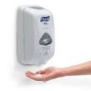](http://www.google.co.uk/url?url=http://www.ebay.co.uk/bhp/hand-sanitizer-dispenser&rct=j&frm=1&q=&esrc=s&sa=U&ei=Du9BVcuzLo_eaJn-gJAB&ved=0CCQQ9QEwBw&usg=AFQjCNGSDeSB7owHjVZCYJCIMPsWNM3H)We advise visitors to avoid coming to the hospital if they are experiencing vomiting, diarrhoea or any other illness that is making them feel generally unwell. Some of our patients are very vulnerable to illness, and being exposed to infection could be detrimental to their recovery.

All staff, patients and visitors should wash their hands when entering and leaving the ward, before and after touching food/ another person or after using the toilet.

**Patient confidentiality**

We treat patient confidentiality very seriously and will always strive to protect your personal information. This will be shared only amongst the staff members caring for you.

During your hospital stay we recommend that you identify one or two family members to liaise with the hospital, if appropriate. We will seek your consent before disclosing information about your wellbeing to carers or family members. If, due to your condition, you are unable to give consent, we will refer to our **consent** and **best-interest policies** to take the most appropriate decision.

If you wish to see your medical records while you are in hospital, please speak to the nurse-in-charge of the ward you are staying on. Medical records are legal documents and we would normally arrange for you to be supervised whilst viewing them.

If you would like to see your medical records after you have been discharged, you can request a copy by completing a form. The Patient Advice and Liaison Service (PALS) can provide further information on this procedure and the costs. You can contact the PALS team on **020 8725 2453**. Out-of-hours calls will be returned within 24 hours or by the next working day.

**Planning your discharge (going home)**

If you are coming to the hospital for a planned admission/operation, discharge planning will take place during your pre-assessment clinic appointment or when you are being admitted.

If you were admitted by emergency services, nursing and medical staff will start planning your discharge within 24hours of your admission, as long as you are well enough.

Our aim is to discharge patients as soon as possible to avoid an unnecessarily long stay in hospital. Long hospital stays can lead to health deterioration, increased risk of infection and loss of independence. This is particularly true for elderly and frail patients. Family support and involvement are very important in ensuring a smooth discharge and can assist in maximising your health recovery.

Discharge co-ordinators work across many wards to help co-ordinate and support discharge. However, a successful discharge depends on the coordinated effort of everyone, from hospital staff, to family, patients, social services and any other agencies involved in your care.

For more information about going home, please ask for a copy of our leaflet, **Going home – Discharge information for patients.**

**The ‘Friends and Family Test'**

The NHS ‘Friends and Family Test’ (FFT) is an important opportunity for you to provide feedback on the services we provide and to help us improve our standards. At St George’s, we collect FFT feedback using electronic computer devices (tablets). These can be found mounted on stands or as mobile devices that are handed to you. Completing the questionnaire is quick and simple, as it contains just a couple of questions. We encourage you to take this opportunity to tell us about your experience at St George’s Hospital.

**For more information leaflets on conditions, procedures, treatments and services offered at our hospitals, please visit www.stgeorges.nhs.uk**

**Notes**

**Additional services**

**Patient Advice and Liaison Service (PALS)**

PALS can offer you on-the-spot advice and information when you have comments or concerns about our services or the care you have received. You can visit the PALS office between 9am and 5pm, Monday to Friday in the main corridor between Grosvenor and Lanesborough Wing (near the lift foyer).

**Tel:** 020 8725 2453

**Email:** pals@stgeorges.nhs.uk

**NHS Choices**

NHS Choices provides online information and guidance on all aspects of health and healthcare, to help you make decisions about your health.

**Web:** www.nhs.uk

**NHS 111**

You can call 111 when you need medical help fast but it is not a 999 emergency. NHS 111 is available 24 hours a day, 365 days a year. Calls are free from landlines and mobile phones.

**Tel:** 111

 [](https://www.stgeorgeshospitalcharity.org.uk/)

**Reference:** TWD_WEL(c)_01 **Published:** January 2016 **Review date:** January 2018