

QUEEN MARY’S ST GEORGE’S

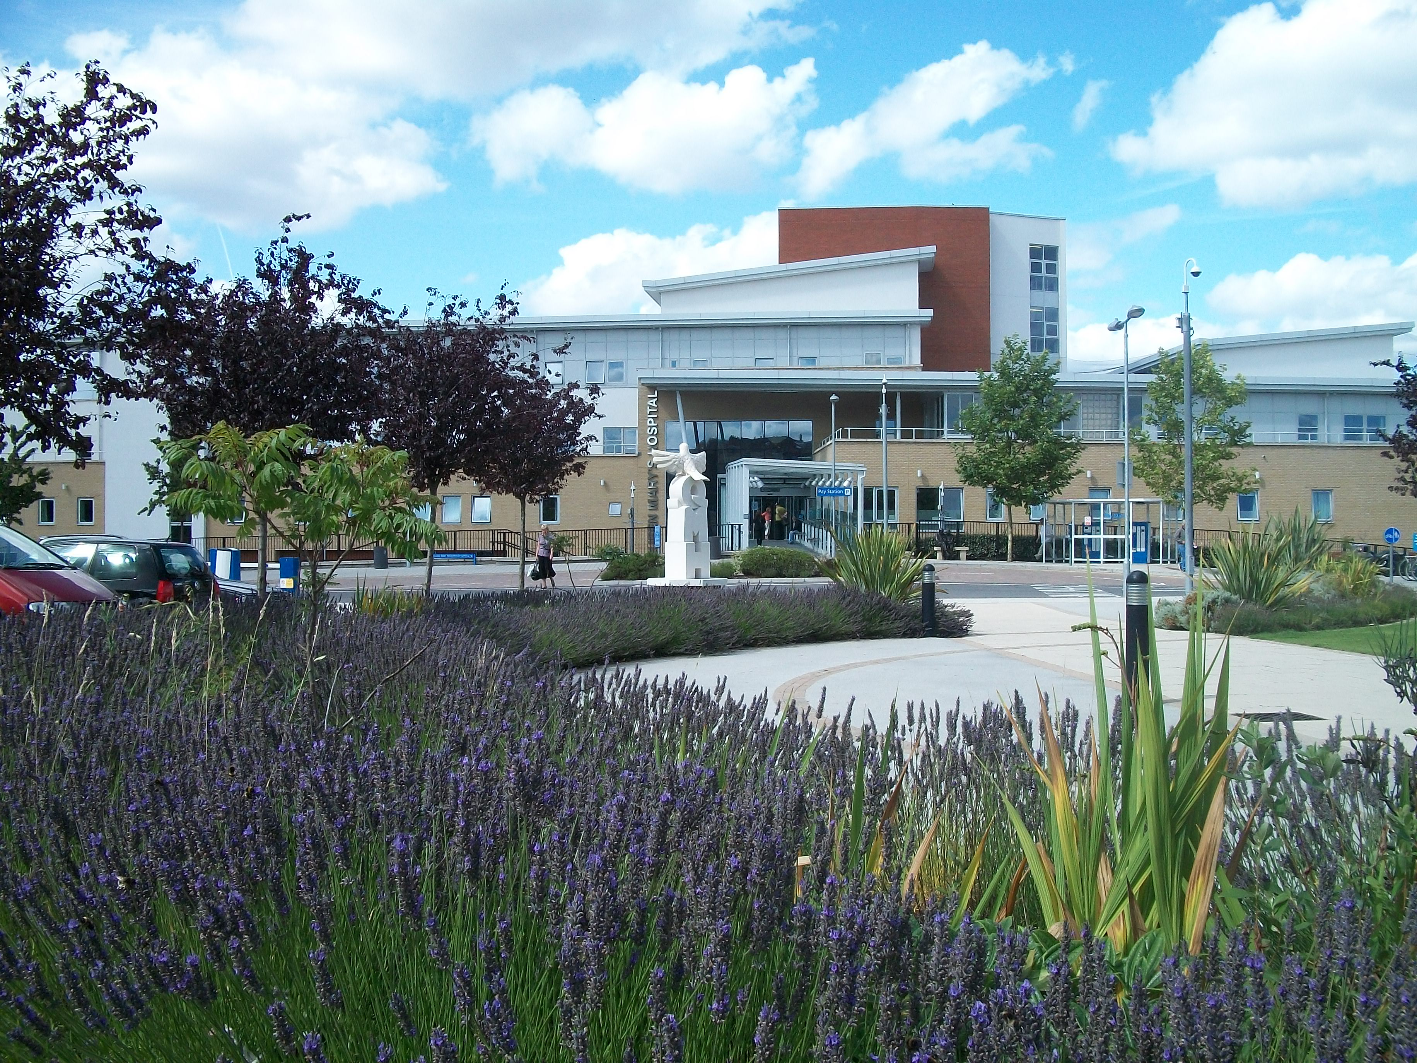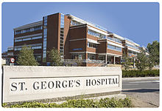

Neurorehabilitation Centre Acute Neurorehabilitation Unit
Thomas Young Ward
Lower Ground Floor 3rd Floor, Lanesborough Wing
Queen Mary’s Hospital St Georges Hospital
Roehampton Lane Blackshaw Road
Roehampton Tooting
London London
SW15 5PN SW17 0QT

020 8487 6126/25 020 8266 6544

Introduction

This booklet has been designed to provide you and your relatives with information of how neurorehabilitation is delivered at St George’s University Hospitals NHS Foundation Trust.

The original idea came from a group of patients and relatives who wanted clearer information on the everyday ‘goings on’ of the neurorehabilitation centres, in order to prepare them for their inpatient admission.

A special thank you goes to everyone who has contributed to, read and commented on this booklet.

July 2016

Introduction

The Wolfson Neurorehabilitation Centre and the Wolfson Acute Neurorehabilitation Unit are part of a regional neurological rehabilitation centre within St. George’s University Hospitals NHS Foundation Trust.

We have two sites; 10 beds at St George’s Hospital (Wolfson Acute Neurorehabilitation Unit) and 36 beds at Queen Mary’s Hospital, Roehampton (Wolfson Neurorehabilitation Centre).

You have been assessed by the inpatient neurorehabilitation team because you have had a neurological illness or injury that has affected your brain, spinal cord and/or your nervous system. This may have resulted in physical, cognitive, communication or emotional difficulties.

What do we offer?

We offer a rehabilitation service supported by a team of professionals who will address your rehabilitation needs and aim to maximise your recovery.

Each patient is individual and has different rehabilitation needs. You will be invited to stay for rehabilitation for a period of time that is based upon your individual needs and will follow a programme that is made especially for you.

The Team

The team will assess your needs during your first week. Depending on your needs, you may be assessed by;

Treating
Team

Occupational
Therapy

Physiotherapy

Clinical Psychology

Doctor

Nursing Staff

Speech
And Language
Therapy

Social Worker

Towards the end of your stay, the Discharge Co-ordinator and/or your key worker will also help facilitate a safe discharge.

The week and your timetable

You will have an individual timetable for the week.
Some of the activities you will see on the time table are written as follows:

Name: Weekly Diary
 | Monday | Tuesday | Wednesday | Thursday | Friday
Date | 17.12.12 | 18.12.12 | 19.12.12 | 20.12.12 | 21.12.12
8:00 | Breakfast | Breakfast | Breakfast | Breakfast | Breakfast | 8:00
15 | and Nursing | and Nursing | and Nursing | and Nursing | and Nursing | 15
30 | ↓ | ↓ | ↓ | ↓ | ↓ | 30
45 | ↓ | ↓ | ↓ | ↓ | ↓ | 45
9:00 | ↓ | ↓ | ↓ | ↓ | ↓ | 9:00
15 | ↓ | ↓ | ↓ | ↓ | ↓ | 15
30 |  | Occupational |  | Occupational |  | 30
45 |  | Therapy |  | Therapy |  | 45
10:00 |  | With Jane | Psychology | With Jane | Psychology | 10:00
15 | Dr Adams | 9.30-10.30am | With David | 9.30-10.30am | With David | 15
30 | ↓ |  | ↓ |  | ↓ | 
45 |  |  |  |  | 10 – 10.45 am
11:00 | PHYSIO | PHYSIO | Goal | PHYSIO |  | 11:00
15 | with | with | Planning | with |  | 15
30 | John | John | Meeting | John |  | 30
45 | 11-11.45 am | 11-11.45 am | ↓ | 11-11.45 am |  | 45
12:00 | LUNCH | LUNCH | LUNCH | LUNCH | LUNCH | 12:00
15 |  |  |  |  |  | 15
30 |  |  |  |  |  | 30
45 |  |  |  |  |  | 45
1:00 | BEDREST | BEDREST | BEDREST | BEDREST | BEDREST | 1:00
15 | BEDREST | BEDREST | BEDREST | BEDREST | BEDREST | 15
30 | BEDREST | BEDREST | BEDREST | BEDREST | BEDREST | 30
45 | BEDREST | BEDREST | BEDREST | BEDREST | BEDREST | 45
2:00 | Upper Limb |  |  | Relaxation |  | 2:00
15 | Group |  |  | Group |  | 15
30 | ↓ |  |  | ↓ |  | 30
45 | ↓ |  |  | ↓ |  | 45
3:00 | Gym |  | SLT |  |  | 3:00
15 | Exercises |  | With |  |  | 15
30 | ↓ |  | Sarah |  | PHYSIO and
45 | ↓ |  | 3-4pm |  | Occupational
4:00 |  |  |  |  | Therapy | 4:00
15 |  |  |  |  | John and Jane | 15
30 |  |  |  |  | 3.30-4.30pm | 30
45 |  |  |  |  |  | 45

The number of sessions on the timetable each day will depend on your rehabilitation needs. Your timetable may appear quieter during the initial assessment period whilst the team are assessing your rehabilitation needs.

Weekend or day leave
During your admission, day or weekend leave can sometimes be arranged by your treating team, after having agreed a multidisciplinary safety assessment and plan.

The Rehabilitation Process

The purpose of rehabilitation is to maximise your physical, communication and cognitive capabilities which may have been affected due to injury, illness or disease. Rehabilitation also includes assisting you to take on compensatory strategies for functioning, once you leave the Wolfson.

Rehabilitation and recovery has varying stages and not every person improves at the same rate. We aim to maximise the potential of each patient, working towards their specific goals.

The rehabilitation process always continues after discharge, using learnt self-management strategies and with the support of community services if required. The time of transition to community rehabilitation will be established and coordinated by our team, based on the type and intensity of the interventions you require.

Goal Planning Meetings (GPMs):

You will work with your treating team to set specific and achievable rehabilitation goals during your admission. These goals will be set during the first two weeks and will be discussed at your goal planning meetings. An estimated discharge date will also be set at your first goal planning meeting, based on your goals and the team’s recommendations.

Goal Planning Meetings will be held approximately every two weeks, in order for you to meet with your treating team and review how your rehabilitation goals are progressing. Your goals and discharge plans will be discussed in this meeting. This is also an opportunity for you to ask your treating team any questions. If you wish, family and friends who are closely involved in your rehabilitation can also attend.

Admission

Things to bring with you:

- Toiletries (shower gel, toothbrush, toothpaste, shampoo, flannel/sponge, comb/hairbrush, deodorant, talcum powder, razor and foam etc.)
- Suitable clothing (tracksuit bottoms, tee shirt, trainers, underwear, sleepwear etc.)
- Any medications you are taking (in original boxes)

Beds and bedrooms

You will be sharing a room with four or six other patients. Your own bed area includes a locker, wardrobe and a shared sink. You are encouraged to keep this area tidy and make your own bed where possible. We ask you not to have visitors in your bedrooms, in order to respect the privacy of other patients.

Property and valuables

For safety reasons, we advise you to only bring in the minimum personal belongings that you need. There is a lockable bedside locker for each patient to use. Whilst we do not have a security problem, regretfully we cannot guarantee the safety of your property. For this reason, you or someone acting on your behalf will be asked to sign a disclaimer when you arrive.

Please ensure that all items are clearly marked with your name.

Meal times and medication rounds

Meal/Break – Wolfson Unit at  St George’s | Time
Breakfast | 8.00 - 10.00 am | Medication
Lunch | 12.00 – 13.00 pm | Medication
Supper | 5.00 pm | Medication

Meal/Break –  Wolfson Centre at Queen Mary’s | Time
Breakfast | 8.00 – 10.00 am | Medication
Lunch | 12.15 – 13.00 pm | Medication
Supper | 5.30 pm | Medication

Hot drinks are available at all times from drinks trolleys on both sites.

St. George’s University Hospitals NHS Foundation Trust has a policy that meal times are protected, with no interruptions from therapy or other appointments. Visitors and relatives are also requested to respect this policy.

Patients (or their relatives/carers) can bring in their own food. All food should be labelled clearly with the patient’s name and date that it is placed in the fridge. A fridge is provided for patients’ use. Some relatives can assist in the dining room if agreed with therapy staff.

As part of your rehabilitation, you may be able to administer your own medicines during your stay, with advice and assistance from staff. The nurses will discuss this with you and start the Self Medication Programme. This is to encourage your independence and understanding of your medication before your discharge.

If necessary, the nursing staff will be available to administer your prescribed medication throughout your stay.

Visiting Times

Visiting times are 16.00 and 21.00 hours Monday to Friday with open visiting at the weekends. Visitors are welcome to attend therapy sessions if agreed with the relevant therapists. Weekend visiting hours at both Centres is between 13.00 and 21.00 hours. Please respect the privacy of others in ward areas.

Facilities available

At St. George’s Hospital, there is a café on the 1st floor of the Lanesborough wing and many other cafes throughout the hospital (open 7 days a week). The nearest cash point can be found opposite Marks and Spencer’s on the ground floor.

At Queen Mary’s Hospital, Café Tempo is located on the ground floor. The Courtyard Restaurant is located on the lower ground floor. Both are open Monday to Friday only. A cash machine is available on the ground floor near the Café Tempo. Vending machines selling snacks and drinks are scattered around both hospitals.

Please note that both sites are no smoking sites. If you wish to smoke, please be aware that this will need to be outside hospital grounds.

Contact Details

Admission Co-ordinator: 0208 487 6369/70
(Both sites)

Wolfson Acute Neurorehabilitation Unit –
St George’s Hospital

Main switchboard: 0208 672 1255
Wolfson Unit on Thomas Young Ward: 0208 266 6544
Therapy team offices: 0208 266 6520/6519

Wolfson Neurorehabilitation Centre –
Queen Mary’s Hospital

Main switchboard 020 8487 6000
Gwynne Holford Ward 020 8487 6126/28
Therapy team offices 020 8487 6145/6480
Wolfson Centre Reception 020 8487 6125

Many foundations and websites are a great source for advice and information:

The Stroke Association
www.stroke.org.uk
www.nhs.co.uk

Different Strokes – support for younger stroke survivors
www.differentstrokes.co.uk/

Headway - The Brain Injury Association www.headway.org.uk

The Multiple Sclerosis Society
www.mssociety.org.uk/what-is-ms/signs-and-symptoms/fatigue

The Guillain-Barre Syndrome Support Group
www.gbs.org.uk/

